* **Installed Oracle Virtual Box and Downloaded CentOS**
  + **Version: Other Linux (64 bit)**
  + **RAM : 2048 MB**

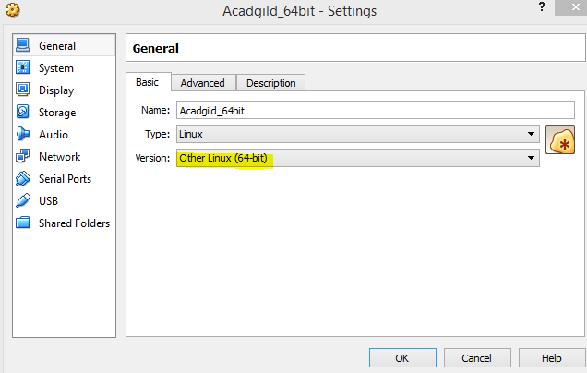



* **Added users in root using the command adduser konuganti and set the password**

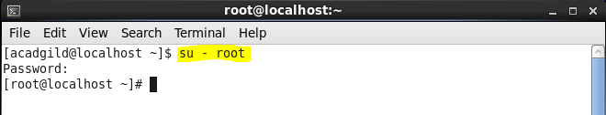

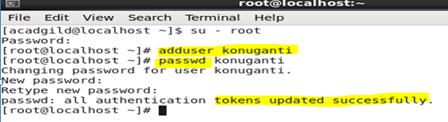

* **Disabled the firewall in the CentOS**

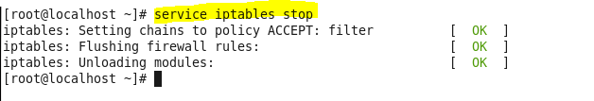

* **Added the user konuganti into visudo file to give the administrator rights to the created user**

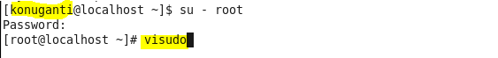

* **Downloaded and moved the "jdk-8u73-linux-64.tar.gz" and "hadoop-2.6.0.tar.gz" to /home/konugani.**



* **Untar the jdk and extract the java file**





* **Untar the hadoop-2.6.0 and extract the file**





* **Updated the .bashrc file Java and hadoop path.**

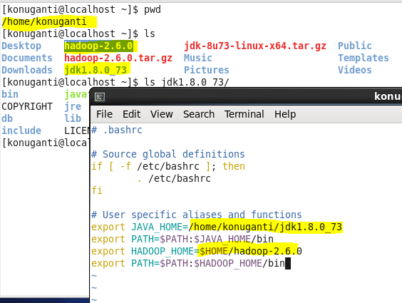

* **Created two directories to store NameNode metadata and DataNode blocks** 
  + **Changed permission for directories.**

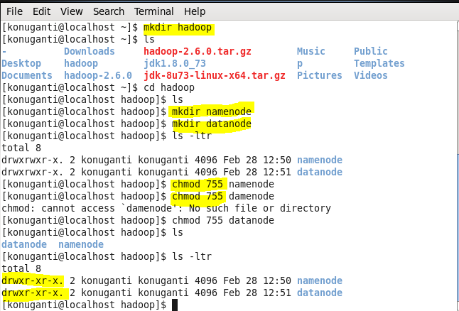

* **Changed the directory to the location where hadoop is installed.**

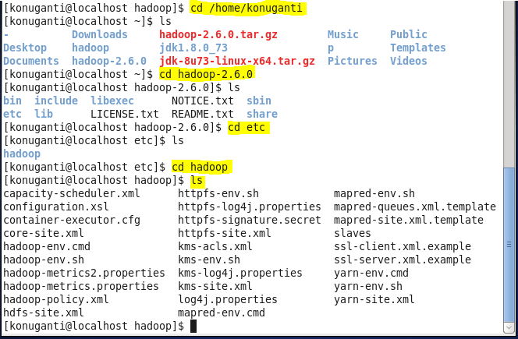

* **Added the java home(path) and hadoop home(path) in "hadoop-env.sh" .**

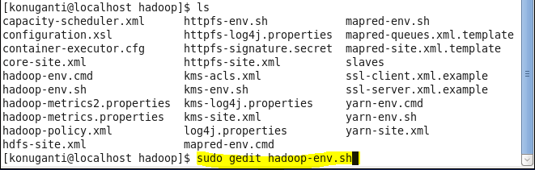

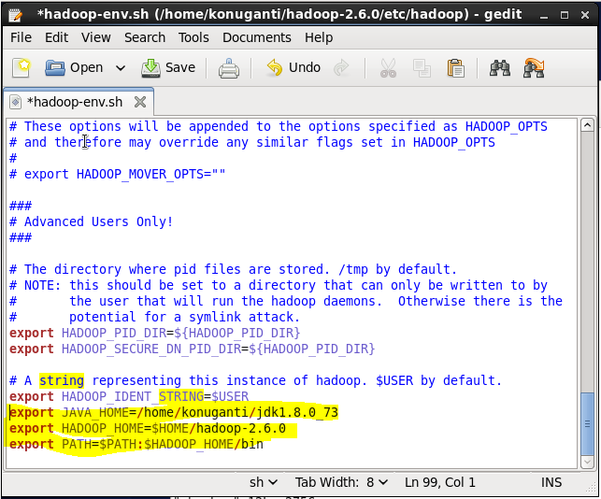

* **Added properties in between configuration tag of core-site.xml**



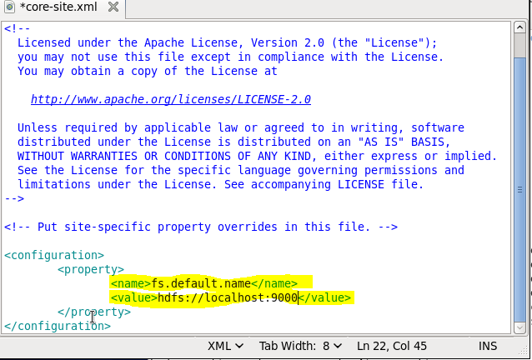

* **Add the below properties in between configuration tag of hdfs-site.xml**



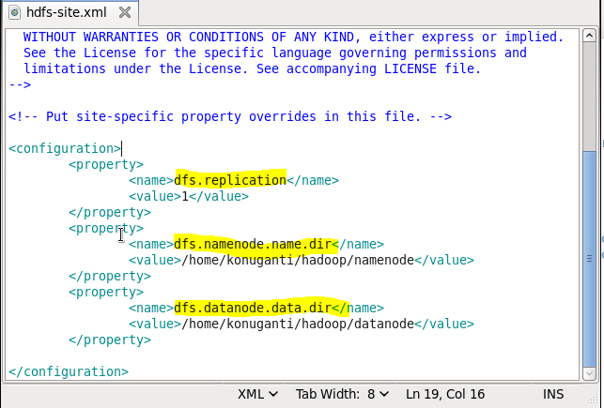

* **Opened "Yarn-site.xml" and added the following lines in between configuration tags**



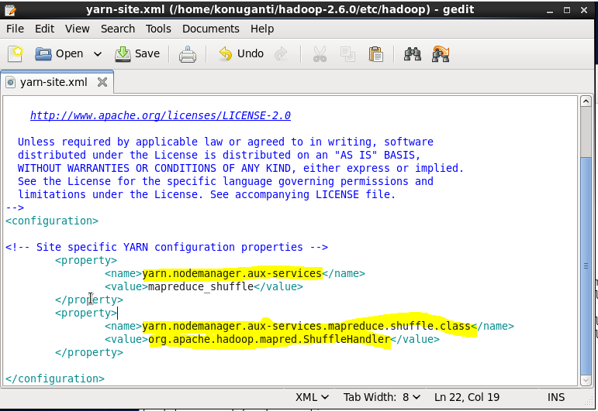

* **Copied the "mapred-site.xml.template" into "mapred-site.xml" and then add the following properties**



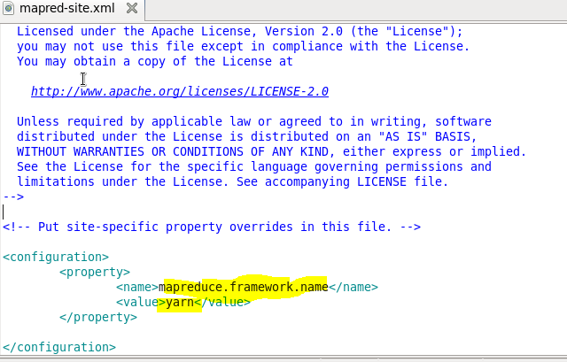

* **Login to the root user and then install openssh server in the CentOS.**



* **Generate ssh key for hadoop user.**

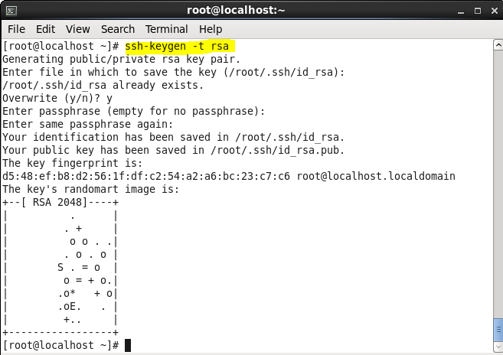

* **Copied the public key from .ssh directory to authorized_keys folder.**
* **Changed the directory to .ssh and then type the below command to copy the files into the authorized _keys folder.**

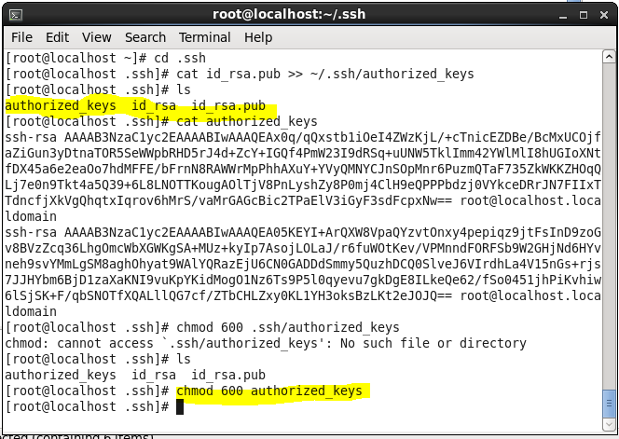

* **Restarted the ssh service**

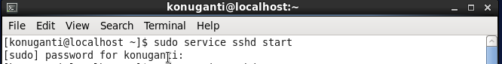

* **To start all the daemons:**
  + **Format the NameNode**

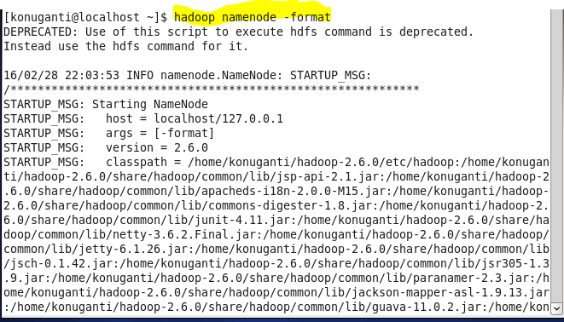

* **Change the directory to sbin of hadoop before starting the daemon.**
  + **StartingNameNode,**
  + **DataNode,**
  + **ResourceManager,**
  + **NodeManager**
  + **Jobhistoryserver**
* **Check Health of Daemons by executing JPS**

