**Problem Statement :**

* Find the total number of medals of each country won in swimming.

**Mapper code:**

import java.io.IOException;  
import java.util.StringTokenizer;  
import org.apache.hadoop.io.IntWritable;  
import org.apache.hadoop.io.LongWritable;  
import org.apache.hadoop.io.Text;  
import org.apache.commons.logging.*;  
import org.apache.hadoop.mapreduce.Mapper;

@SuppressWarnings("unused")  
public class MyMapper extends Mapper <LongWritable, Text, Text, IntWritable>   
 {  
 **//Reading each line**  
 public void map (LongWritable offset, Text value, Context context) throws IOException, InterruptedException {  
 String currentline=value.toString();  
 System.out.println("MYMapper map() offset"+offset+"::   
 currentLine = "+currentline);  
 String SportData[]=currentline.split("\t");  
 String Sport=SportData[5].trim();  
 int GMedal = Integer.parseInt(SportData[6]);  
 int SMedal = Integer.parseInt(SportData[7]);  
 int BMedal = Integer.parseInt(SportData[8]);  
 int TMedal = Integer.parseInt(SportData[9]);  
 String Country = SportData[2];  
 int TotalMedal = GMedal+SMedal+BMedal+TMedal;  
 **//Get Country only for Swimming Sport** if (Sport.equals("Swimming")){  
 System.out.println("Country :"+Country+", total Medal :"+TotalMedal);  
 context.write(new Text(Country) ,new IntWritable(TotalMedal));  
 }  
 }  
}

**MyReducer Code :**

import java.io.IOException;  
import org.apache.hadoop.io.IntWritable;  
import org.apache.hadoop.io.Text;  
import org.apache.hadoop.mapreduce.Reducer;

public class MyReducer extends Reducer<Text,IntWritable,Text,IntWritable>{

@Override  
 public void reduce(Text value,Iterable<IntWritable> TotalMedal, Context context) throws IOException, InterruptedException

{   
 int sum=0;  
 for(IntWritable Medal:TotalMedal)  
 {  
 System.out.println(" Medal Detils " +Medal.get());  
 sum=sum + Medal.get();  
 }  
 context.write(value, new IntWritable(sum/2));  
 }

}

**CountryDriver:**

import org.apache.hadoop.conf.Configuration;  
import org.apache.hadoop.fs.Path;  
import org.apache.hadoop.io.IntWritable;  
import org.apache.hadoop.io.Text;  
import org.apache.hadoop.mapreduce.Job;  
import org.apache.hadoop.mapreduce.lib.input.FileInputFormat;  
import org.apache.hadoop.mapreduce.lib.output.FileOutputFormat;

public class CountryDriver {

public static void main(String[] args) throws Exception

{

Configuration conf = new Configuration();  
 @SuppressWarnings("deprecation")  
 Job job = new Job(conf, "Total Medals for each country");  
 job.setJarByClass(CountryDriver.class);  
 job.setMapperClass(MyMapper.class);  
 job.setReducerClass(MyReducer.class);  
 //job.setNumReduceTasks(0);  
 job.setOutputKeyClass(Text.class);  
 job.setOutputValueClass(IntWritable.class);  
 FileInputFormat.addInputPath(job, new Path(args[0]));  
 FileOutputFormat.setOutputPath(job, new Path(args[1]));  
 System.exit(job.waitForCompletion(true) ? 0 : 1);

}

}

**Output :**

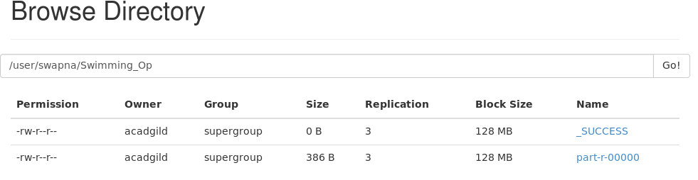

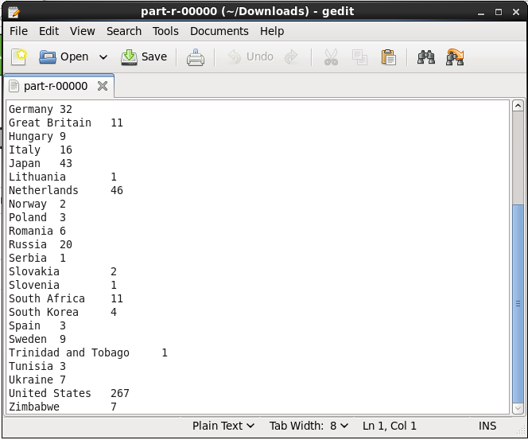

**Executing Jar file using command prompt :**

