**Input Dataset:**

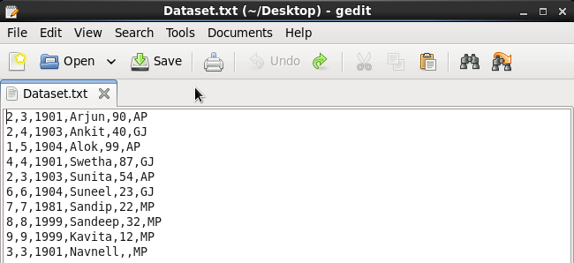

**Pig Commands definations:**

**CONCAT :** Concatenates two fields of type chararray  
**TOKENIZE:** splits the line into a field for each word.  
**SUM:** sum of the numeric values in a single-column  
**Min :** Minimum of the numeric values pr chararrays in single-column **MAX:** maximum of the numeric values or chararrays in a single-column  
**LIMIT:** Limits the number of output tuples.  
**STORE:** Stores or saves results to the file system **DISTINCT:** Removes duplicate tuples in a relation  
**FLATTEN:** will the collection of records returned by TOKENIZE and produce separate record for each one.  
**IsEmpty:** Check if a bag or Map is empty , this function can be used for filter data

Load input dataset to temporary alias as schema line 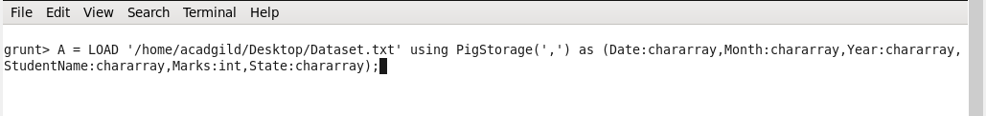

Dump A :

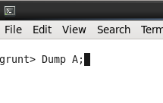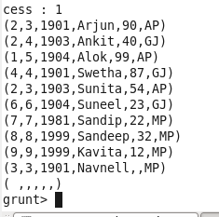

* **CONCAT :** 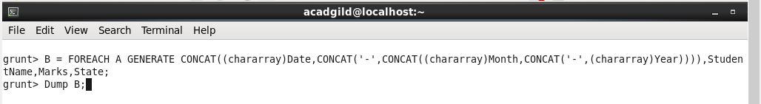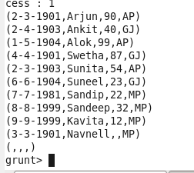
* **GROUP:**

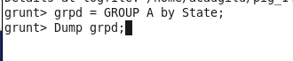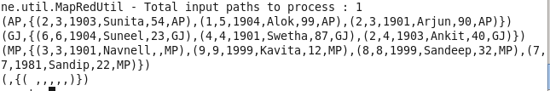

* **SUM:**

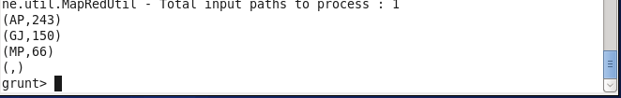

* **Min and MAX:**

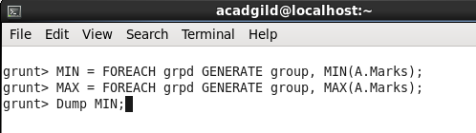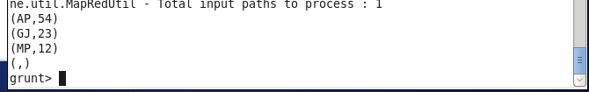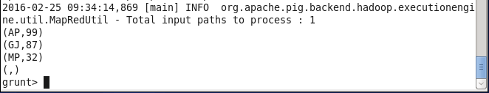

* **LIMIT:**

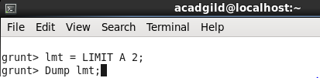

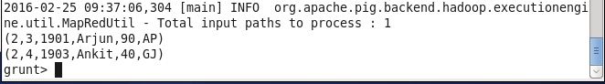

* **IsEmpty:**

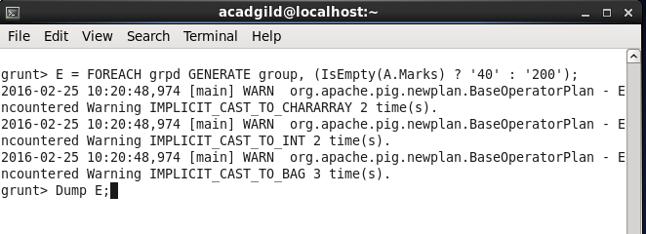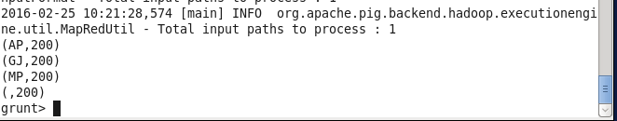

* **DISTINCT, TOKENIZE, FLATTEN**

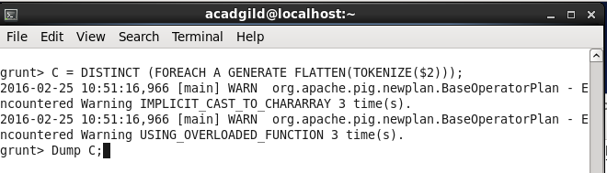

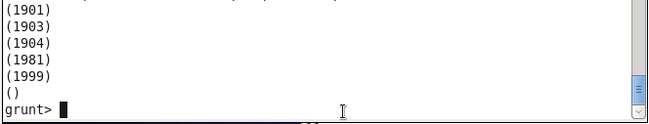

* **Store:**

**grunt>** **Store C into '/home/acadgild/Desktop/Dataset_Result.txt'**