Criterion A: Knowing and Understanding

Question 1 — State which of the following correctly describes the particle arrangement and movement in a solid.
A. Particles are packed closely together and vibrate in fixed positions.
B. Particles are loosely arranged and can flow past one another.
C. Particles have no movement at all and are perfectly still.
D. Particles are spread far apart and move freely in all directions.

Question 2 — Identify the temperature at which pure water changes from a liquid to a solid (freezes).
A. −100°C
B. 0°C-Pure water freezes at 0°C.
C. 37°C
D. 100°C

Question 3 — Identify the change of state in which a liquid changes into a gas from its surface at temperatures below its boiling point.
A. Condensation
B. Melting
C. Sublimation
D. Evaporation-Evaporation is the change of a liquid into a gas from its surface, and it can happen below the boiling point.

Question 4 —Identify the process by which a solid changes directly into a gas without passing through the liquid state.
A. Boiling
B. Condensation
C. Sublimation
D. Freezing

Question 5 — Identify the state of matter that has both a fixed shape and a fixed volume.
A. Gas
B. Plasma
C. Liquid
D. Solid

Question 6 — Outline the three states of matter. For each state, state whether it has a fixed shape and a fixed volume.

State of matter | Fixed shape? | Fixed volume?

Solid | Yes | Yes

Liquid | No | Yes

Gas | No | No

Question 7 — Identify the correct name for each change of state and complete the table.
Starting state | Final state | Name of change
Solid | Liquid | MELTING
Gas | Liquid | CONDENSATION
Liquid | Solid | FREEZING

Question 8 — Describe what happens to the particles in ice when it is heated and melts into liquid water. Refer to particle energy, movement and arrangement in your answer.

When ice is heated, its particles gain kinetic energy and vibrate faster. During melting, the particles overcome some of the forces of attraction holding them in fixed positions. They can then move past one another, forming liquid water.

Question 9 —Water droplets form on the outside of a cold glass of juice on a humid day.
Identify the statement that best explains this observation.
A. The juice inside the glass evaporates and forms droplets on the outer surface.
B. Water from inside the glass seeps through the glass walls to the outside.
C. The glass absorbs moisture from the air and stores it inside the glass.
D. Water vapour in the air cools against the cold glass and turns into liquid water droplets.

Question 10 — Engineers leave small gaps between sections when building a metal bridge.
Identify the statement that best explains why these gaps are necessary.
A. Gaps reduce the weight of the bridge, making it safer for heavy vehicles.
B. Metals expand when heated, so gaps allow the bridge sections to expand in hot weather without buckling or cracking.
C. Gaps allow rainwater to drain away so that the bridge does not become slippery.
D. Metals contract when heated, so gaps prevent the sections from pulling apart in hot weather.

Question 11 — After swimming, Mia notices that she feels cold when she gets out of the pool, even on a warm day.
Explain why Mia feels cold using your knowledge of evaporation and particle energy.
Water on Mia's skin evaporates. The particles with more kinetic energy escape from the liquid into the air. They take energy from Mia's skin, so her skin loses thermal energy and feels cooler.

Question 12 — A bottle of perfume is opened at one end of a classroom. After a short time, students at the other end of the classroom can smell it.
Explain why the perfume smell spreads across the room. Refer to the kinetic theory of particles and diffusion in your answer.
Perfume particles are constantly moving randomly because they have kinetic energy. They spread from an area of high concentration near the bottle to areas of lower concentration around the classroom.
This movement of particles from high concentration to low concentration is called diffusion.

Question 13 — Salt is spread on icy roads during winter.
Using your knowledge of melting points, identify the statement that best explains why salt helps to keep roads clear of ice.
A. Salt absorbs heat from sunlight and directly heats the road above 0°C, melting the ice.
B. Salt lowers the melting/freezing point of water, allowing ice to melt at temperatures below 0°C.
C. Salt raises the melting point of ice, causing the ice to remain solid for longer.
D. Salt reacts chemically with ice to produce a new substance that is not slippery.

Question 14 —The graph below shows how the temperature of a sample of a pure substance changes as it is heated over time.
The graph shows:
- Temperature rises from −10°C to 0°C from 0–2 minutes.
- A flat plateau X occurs at 0°C from 2–4.5 minutes.
- Temperature rises from 0°C to 100°C from 4.5–8.5 minutes.
- A flat plateau Y occurs at 100°C from 8.5–11 minutes.
- Temperature rises above 100°C after 11 minutes.

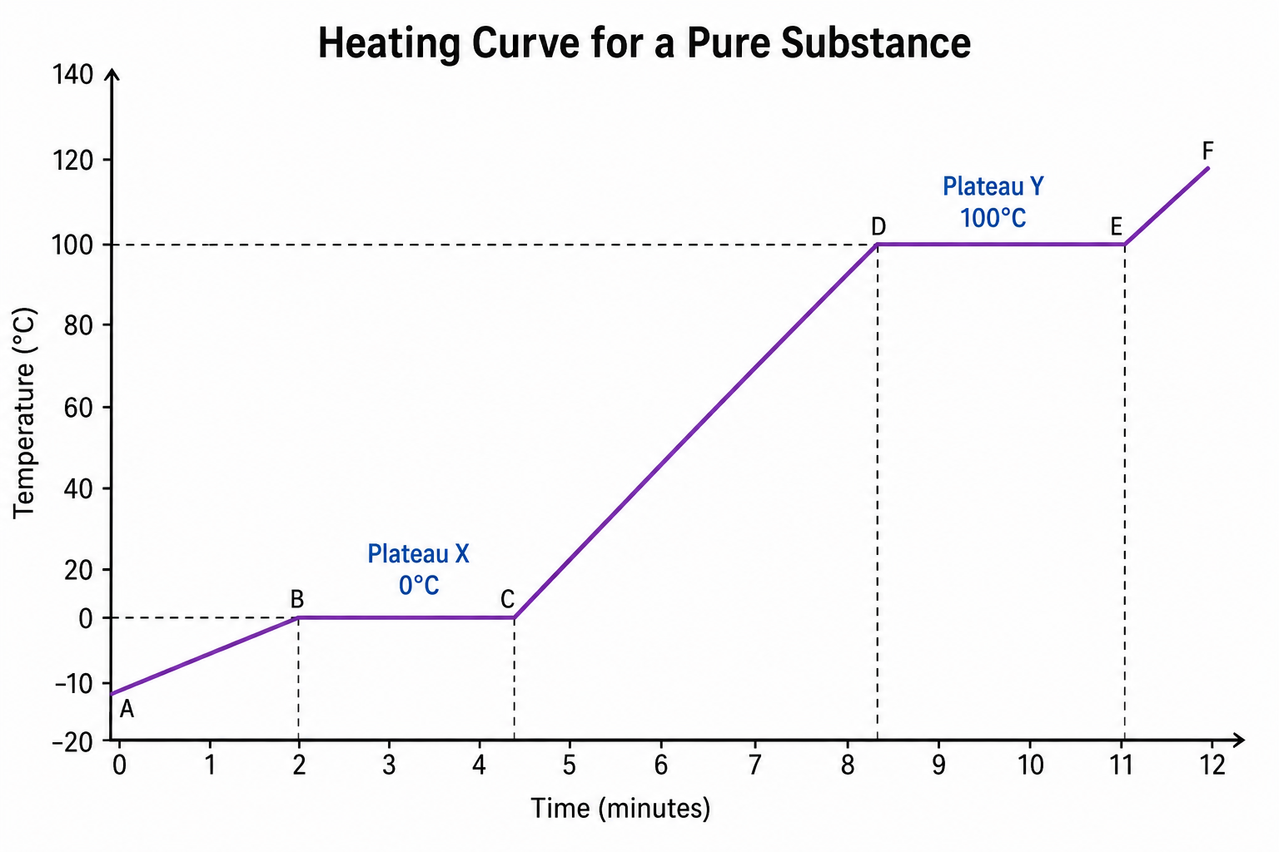
(a) Identify the change of state occurring at plateau X.
(b) Identify the change of state occurring at plateau Y.
(c) Explain why the temperature does not increase during the plateaus even though heat is still being supplied.

a) Plateau X: Melting — the substance changes from solid → liquid at 0°C.
b) Plateau Y: Boiling — the substance changes from liquid → gas at 100°C.
c) During the flat sections, heat energy is still being absorbed, but it is used to overcome the forces of attraction between particles and change the state of the substance. Therefore, the temperature remains constant until the change of state is complete.

Question 15 — A student investigates diffusion by placing one drop of red food colouring into two beakers containing equal amounts of still water.
- Beaker A contains cold water at 5°C.
- Beaker B contains warm water at 60°C.
The student observes that the red colour spreads throughout the warm water much faster than it spreads through the cold water.
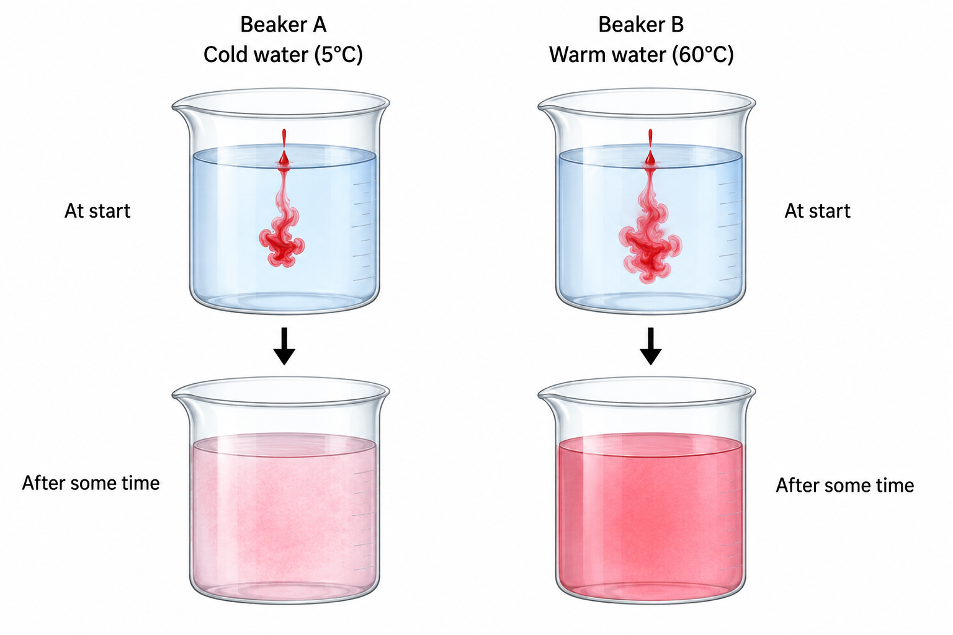
Analyse the student's observation.
In your answer:
- Explain why the food colouring spreads faster in the warm water using the kinetic theory of particles.
Particles in warm water have more kinetic energy than particles in cold water. They move faster and mix with the food-colouring particles more quickly. Therefore, diffusion occurs faster at a higher temperature.
- Predict what would happen to the rate of diffusion if the temperature of the water were increased further. Give a reason for your prediction.
The rate of diffusion would increase. At a higher temperature, particles have more kinetic energy and move faster, so the food colouring spreads through the water more quickly.
- Suggest one way the student could make the investigation a fair test.
The student should keep other variables the same. For example:
- use the same amount of water in each beaker;
- use the same amount of food colouring;
- use the same size and type of beaker.
Only the temperature of the water should be changed.

