ADVERTISEMENT ANALYSIS TASK SHEET

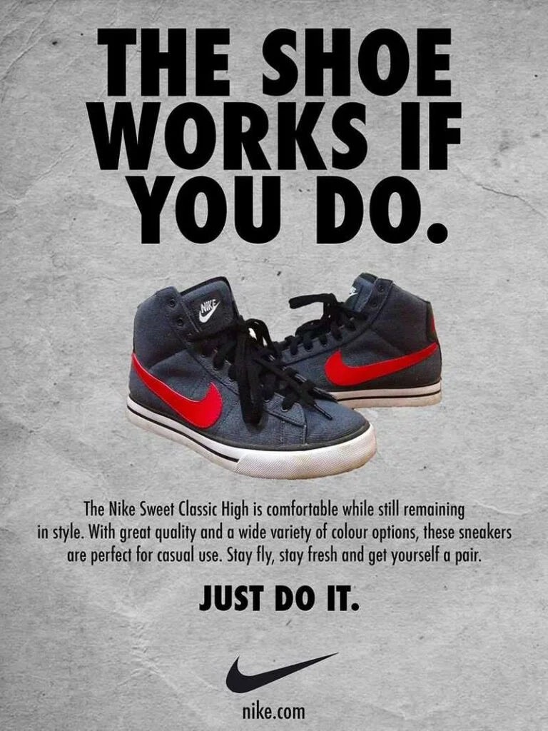
Advertisement: Nike Sweet Classic High

Task Overview
Study the advertisement carefully. Then read the original jingle written for this task. Answer the questions using specific evidence from the advertisement and the jingle. For comparison questions, discuss both texts.

Useful Command Terms
Identify – name or point out a feature. Explain – give reasons and show how something works. Analyse – examine how a choice creates meaning or an effect. Compare – show similarities. Contrast – show differences.

Original Jingle for the Advertisement
Lace up, step out, feel the beat,
Style and comfort on every street.
Move with confidence, run your way,
Make every step count every day.
Just do it — start today,
Nike on your feet, lead the way!

A. Picture / Advertisement Analysis
1. Identify two visual features that immediately attract the viewer’s attention. Explain why each feature is effective.
________________________________________________________________________________
________________________________________________________________________________
2. How do the large words “THE SHOE WORKS IF YOU DO.” help communicate the main message of the advertisement?
________________________________________________________________________________
________________________________________________________________________________
3. Analyse the use of colour in the advertisement. How do the colours of the shoes contrast with the background? What effect does this create?
________________________________________________________________________________
________________________________________________________________________________
4. How does the photograph of the shoes make the product look appealing to the target audience? Refer to at least two details.
________________________________________________________________________________
________________________________________________________________________________

5. Who do you think is the target audience for this advertisement? Give two pieces of evidence from the visual and written elements.
________________________________________________________________________________
________________________________________________________________________________
6. How do the product description and the image work together to persuade the audience to buy the shoes?
________________________________________________________________________________
________________________________________________________________________________

B. Jingle Analysis
1. Identify two rhyming pairs in the jingle. How does rhyme make the jingle easier to remember?
________________________________________________________________________________
________________________________________________________________________________
2. What is the effect of the action words such as “Lace up,” “step out,” “Move,” and “Make”?
________________________________________________________________________________
________________________________________________________________________________
3. How does the jingle create a positive and energetic tone? Support your answer with two examples.
________________________________________________________________________________
________________________________________________________________________________
4. Explain how the line “Make every step count every day” connects the product with a lifestyle or attitude.
________________________________________________________________________________
________________________________________________________________________________
5. How does the final line, “Nike on your feet, lead the way!”, encourage the audience to associate the brand with confidence and action?
________________________________________________________________________________
________________________________________________________________________________
6. Which line from the jingle do you think is most memorable? Explain why it would work well in an advertisement.
________________________________________________________________________________
________________________________________________________________________________

C. Compare and Contrast: Advertisement and Jingle
Remember: a strong comparison uses evidence from BOTH the advertisement and the jingle.
1. Compare the messages of the advertisement and the jingle. What similar idea about the product do they communicate?
________________________________________________________________________________
________________________________________________________________________________
________________________________________________________________________________
2. How do the advertisement and the jingle use different techniques to persuade the audience? Compare one visual technique with one language or sound technique.
________________________________________________________________________________
________________________________________________________________________________
________________________________________________________________________________
3. Compare the tone of the advertisement with the tone of the jingle. How does each create a particular feeling in the audience?
________________________________________________________________________________
________________________________________________________________________________
________________________________________________________________________________
4. Both texts encourage the audience to take action. Compare how this idea is communicated in the advertisement and in the jingle.
________________________________________________________________________________
________________________________________________________________________________
________________________________________________________________________________
5. Which is more persuasive for you: the visual advertisement or the jingle? Compare their strengths and explain your choice using evidence from both.
________________________________________________________________________________
________________________________________________________________________________
________________________________________________________________________________

D. PEEL Writing Support
Point – make your main idea. Evidence – give a word, phrase or visual detail. Explain – show how the evidence creates meaning or an effect. Link – connect your explanation back to the question.
Useful sentence starters:
The advertisement suggests that …
One important visual feature is … This is effective because …
Similarly, the jingle …
In contrast, the advertisement … whereas the jingle …
Both texts persuade the audience by … However, they differ because …

