IB MYP-1
Revision for Summative Assessment-2
2026-27

Student Name: |  | Grade: MYP -1____ | Date:
Subject: English Language and Literature | Unit Title : Pitch perfect-Art of persuasion

Text-1-JINGLE
BRIGHT START, HAPPY HEART!
Wake up, wake up, start your day,
A tasty bowl to lead the way!
Like sunshine, warm and bright,
It fills your morning with delight!
Bright Start! Bright Start! — say it twice,
A yummy bowl that tastes so nice!
Bright Start! Bright Start! — every day,
A happy choice to start your way!
Fresh and tasty, full of cheer,
Bright Start! is always here!

TEXT-2
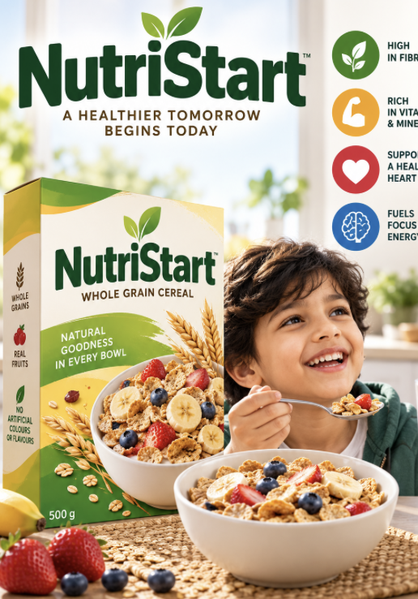

CRITERIA | Text -1 | Text-2
Main message
Target Audience
Persuasive technique used

1.Identify the example of a simile in the jingle. Explain how it creates a positive image of the cereal.
2.Examine how the writer uses rhyme to make the jingle appealing to the target audience.
3.Analyse how the rhythm and repetition of the jingle contribute to its persuasive purpose.
4.Compare the language used in the poster and the jingle. Which one uses more descriptive or imaginative language?
5.Explain why the advertiser presents the cereal as a “Healthy Breakfast Cereal.”

***********************

