MYP 1 Design
PictoBlox Block Categories

Learning Objective
By the end of this lesson, you will be able to:
- Identify the different PictoBlox block categories.
- Tell what each category is used for.
- Create simple programs using different blocks.
What are Block Categories?
- PictoBlox groups similar coding blocks into different categories.
- Each category has a special job.
- Think of them like tools in a toolbox—each tool is used for a different task.
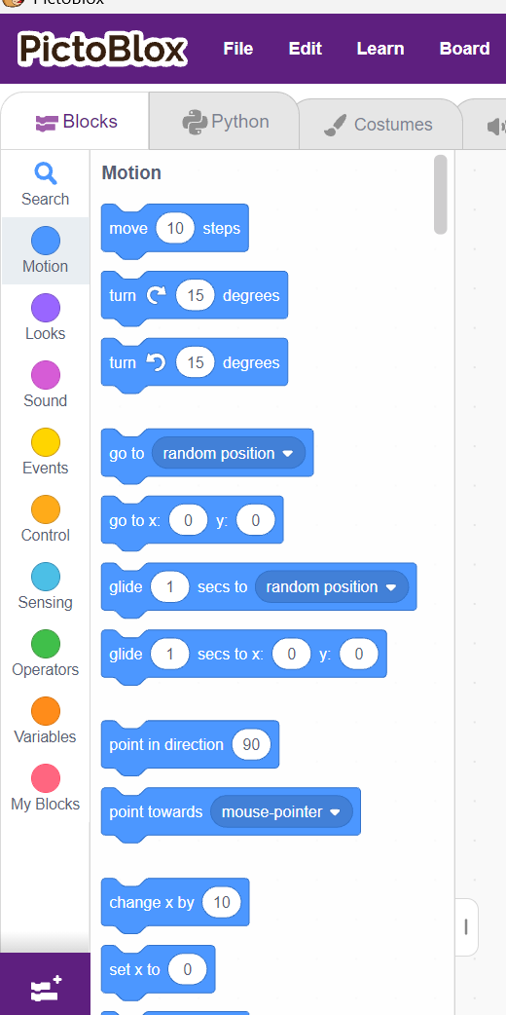
1. Motion Blocks: Motion blocks help a sprite move.
Examples
- Move steps
- Turn right
- Turn left
- Go to x: y:
- Glide
Activity
Try these blocks:
- When Green Flag Clicked
- Move 100 Steps

Challenge: Can you make the sprite:
- ✓ Move forward
- ✓ Turn right
- ✓ Move again

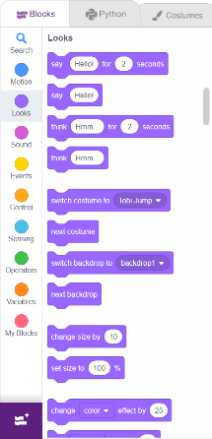
2. Looks Blocks: Looks blocks change how a sprite appears.
They can:
- Speak
- Think
- Change costumes
- Change size
- Show or hide

Examples
- Say "Hello!"
- Think "Hmm..."
- Change costume
- Hide
- Show
Activity: Create this program.
When Green Flag Clicked
↓
Say
Hello!
for 2 seconds
↓
Think
I like coding!
for 2 seconds

Challenge: Can your sprite say: "My name is ______."

3. Sound Blocks: Sound blocks allow the sprite to make sounds or play music.
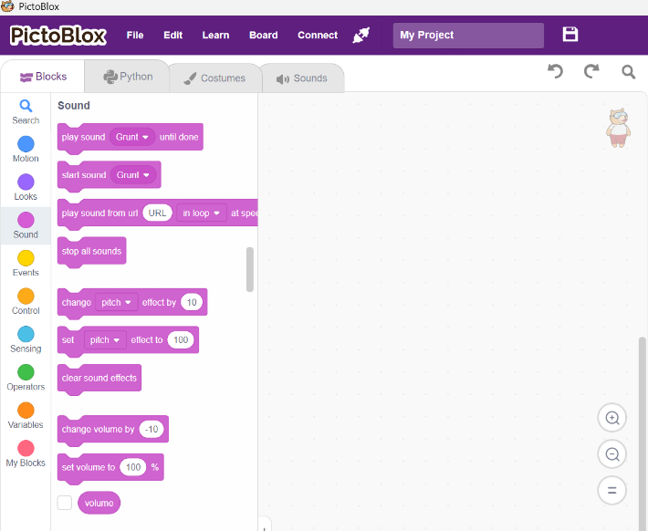
Examples
- Play Sound
- Start Sound
- Stop All Sounds
Activity
Choose any sound.
When Green Flag Clicked
↓
Play Sound
Challenge
Try a different sound.
Which one do you like most?

4. Events Blocks: Events tell the program when to start. They begin actions.
Examples
- When Green Flag Clicked
- When Sprite Clicked
- When Key Pressed
Activity
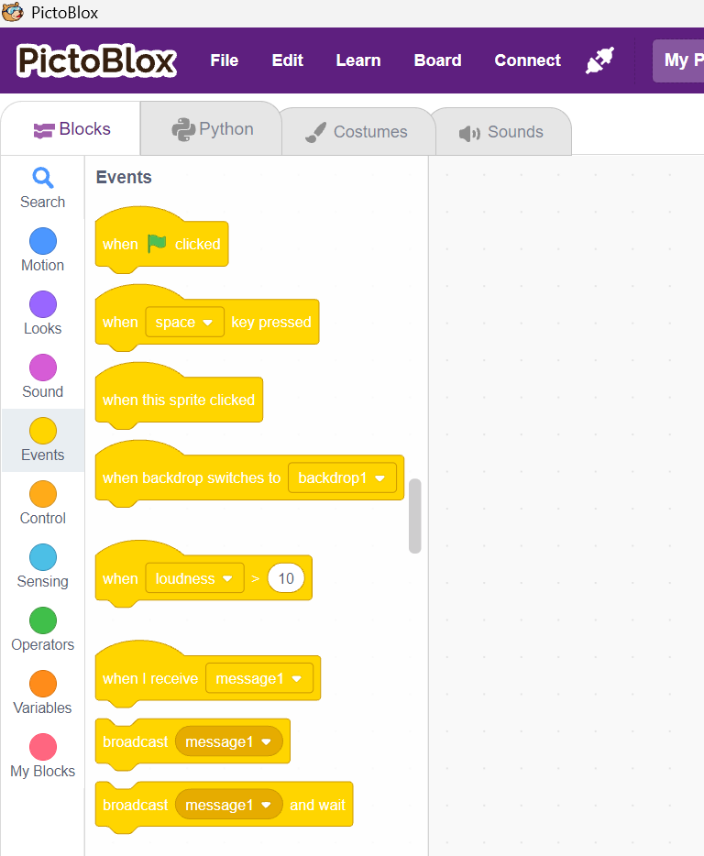
Use:
When Sprite Clicked
↓
Say
"You clicked me!"
Try It
Click the sprite.
What happened?
Challenge
Try changing the event.
Instead of clicking the sprite,
use:
When Space Key Pressed
What happens?
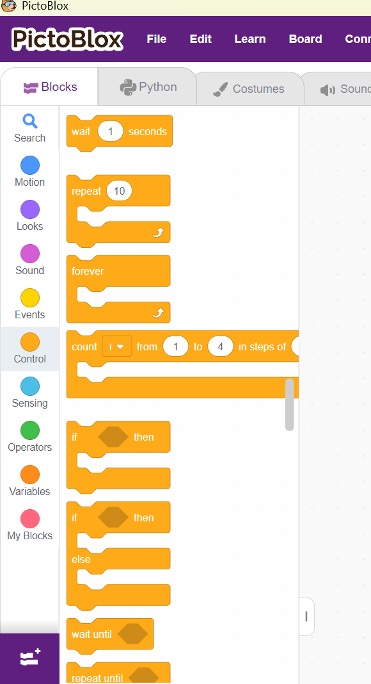
5. Control Blocks: Control blocks manage the flow of the program.
They help repeat actions or make the sprite wait.
Examples
- Wait
- Repeat
- Forever
Activity
Create this:
When Green Flag Clicked
Repeat (5)
Move 20 Steps
Wait 1 SecondChallenge
Add:
Wait 1 Second
inside the Repeat block.
What changed?

6. Sensing Blocks: Sensing blocks help the sprite detect actions.
The sprite can know if:
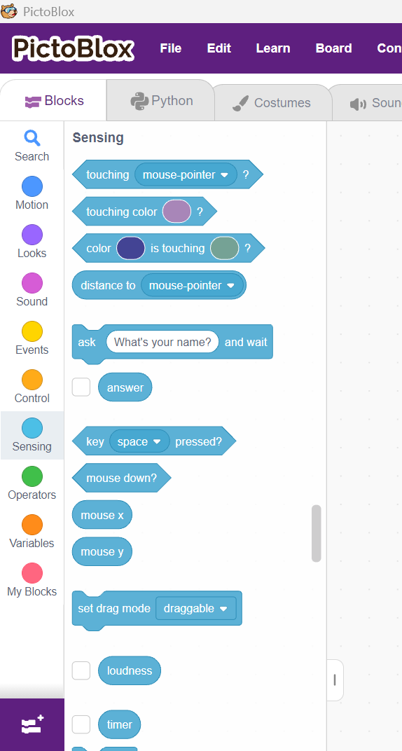
- A key is pressed
- The mouse is touching it
- It is touching another object
Examples
- Touching Mouse Pointer?
- Key Pressed?
- Ask and Wait
Activity
Use:
When Green Flag Clicked
↓
Ask
"What is your name?"
↓
Wait
Challenge
Type your name.
Did the sprite wait until you answered?
Yes / No

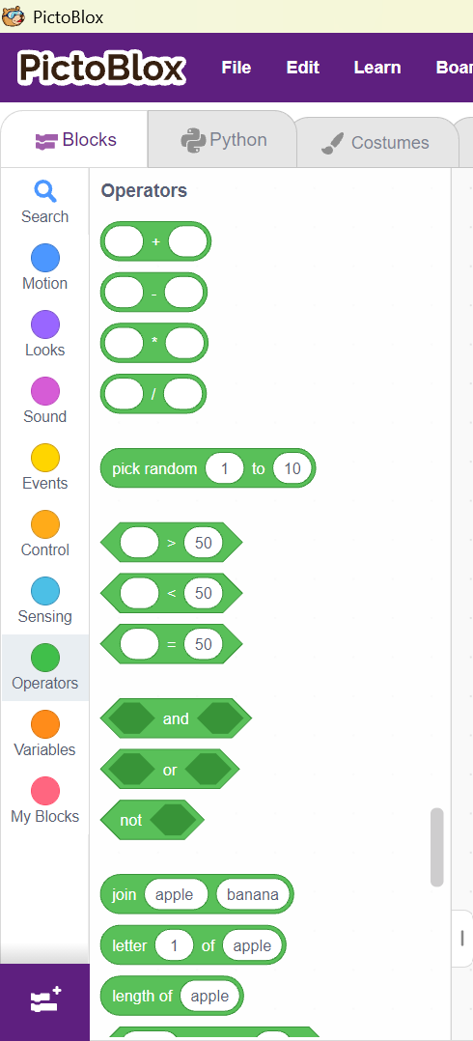
7. Operators Blocks: Operators help perform calculations and compare values.
They can:
- Add
- Subtract
- Multiply
- Compare numbers
- Join words
Examples
- 5 + 3
- 10 > 6
- Join Hello + World
- Join "Hello" and "Friends!"
Activity
Use:
Join
Hello
and
Friends!
inside a Say block.
Output
Hello Friends!
Challenge
Change the words.
Write your own message.

Quick Summary
Block Category | What it Does
Motion | Moves the sprite
Looks | Changes the sprite's appearance
Sound | Plays sounds
Events | Starts the program
Control | Repeats actions and waits
Sensing | Detects actions or asks questions
Operators | Performs calculations and joins text

Home Work Task:
Create your own program using at least four different block categories.
Your program should:
- Start with the Green Flag.
- Make the sprite say a message.
- Move the sprite.
- Wait for 1 second.
- Play a sound.
Reflection
- Which block categories did you use?
- Which category was your favourite?
- What new thing did you learn today?
- Which block category would you like to explore more?

