MYP 1 Design
PictoBlox Basics
Learning Objective
By the end of this lesson, students will be able to:
- Identify the PictoBlox interface.
- Create simple programs using blocks.
- Make a sprite move and speak.
- Run and stop a program.

What is PictoBlox?
PictoBlox is a block-based coding software that helps us create animations, games, stories, and AI projects without typing complex code.
Parts of the PictoBlox Interface
1. Stage
The area where sprites perform actions.
2. Sprite
A character or object that performs actions.
3. Block Palette
Contains different coding blocks.
4. Scripts Area
Where blocks are joined together to create programs.
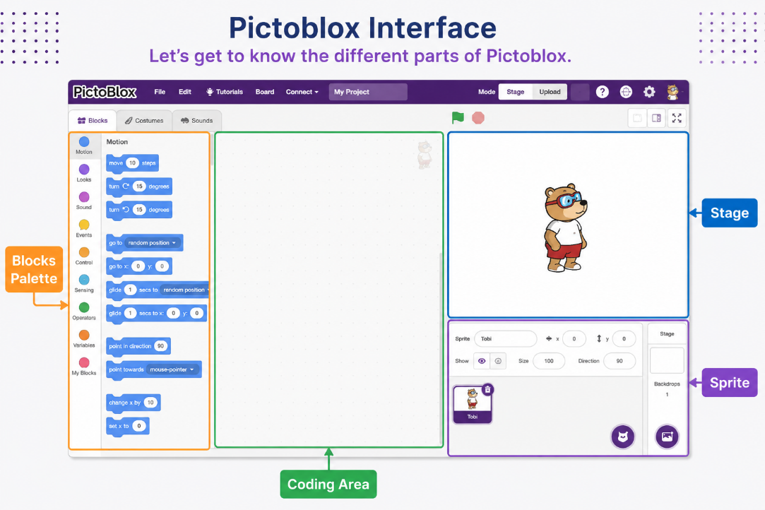
5. Green Flag
Starts the program.
6. Stop Button
Stops the program.

Activity 1: Make the Sprite Speak
Blocks Used
- When Green Flag Clicked
- Say "Hello, World!" for 2 seconds
Steps
- Drag the "When Green Flag Clicked" block.
- Attach the "Say" block.
- Type:
Hello, World!
- Click the Green Flag.

Output:

The sprite will say:
"Hello, World!"

Activity 2: Move the Sprite

Blocks Used
- When Green Flag Clicked
- Move 50 Steps

Steps
- Add the Move block.
- Change the value to 50.
- Run the program.

Output

The sprite moves forward.

Activity 3: Speak and Move
Blocks Used
- When Green Flag Clicked
- Say "I am learning coding!"
- Move 100 Steps
Output
The sprite speaks and then moves.

Block Categories
Category | Purpose
Motion | Move sprites
Looks | Change appearance
Sound | Play sounds
Events | Start actions
Control | Repeat and wait
Sensing | Detect actions
Operators | Perform calculations

Homework
PictoBlox Practice
Task 1
Create a program where the sprite:
- Says your name.
- Waits for 2 seconds.
- Moves 50 steps.

Task 2
Create a program where the sprite:
- Says:
Welcome to Coding!
- Moves 100 steps.
- Says:
Thank You!

Task 3
Answer the following:
- What is PictoBlox?
- What is a Sprite?
- What is the purpose of the Green Flag?
- Which block category helps a sprite move?
- Name any three block categories.
Challenge Task
Create a program where the sprite:
- Says "Hello!"
- Moves 50 steps
- Says "I love coding!"
- Moves another 50 steps

Take a screenshot of your project and submit it.

