Resistor Cheat Sheet

Resistance (in ohms) of a resistor can be read by sequence of colored bands.

Calculate it yourself:
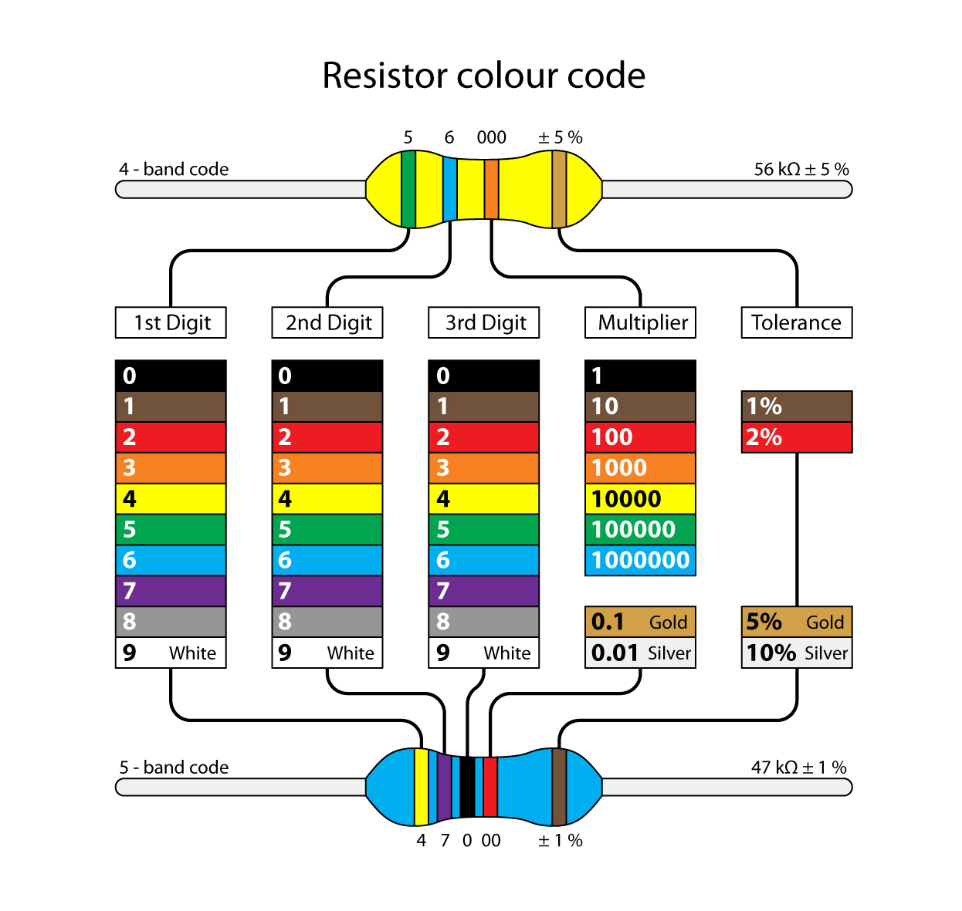

Or have an online calculator do it:

http://www.digikey.com/en/resources/conversion-calculators/conversion-calculator-resistor-color-code-4-band

Often used resistors:

LED's in the pack want 220 ohm:
red-red-brown-gold
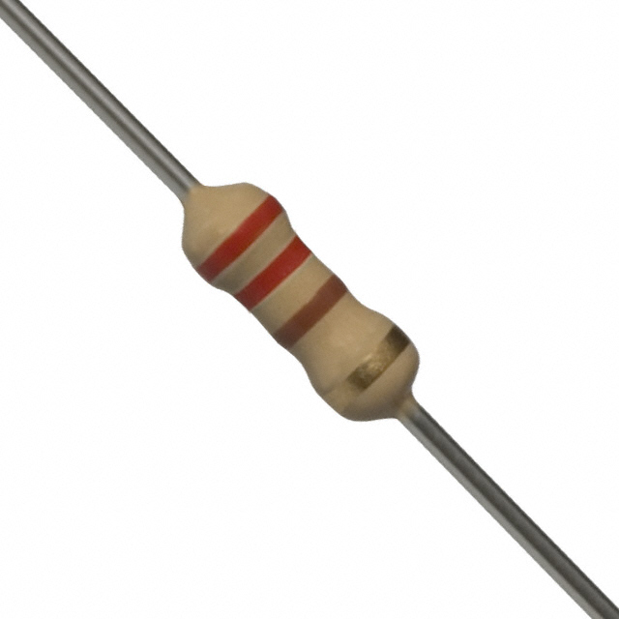

Light sensor's want 2600 ohm:
red-blue-red-gold

