Interfacing a Remote Control with an Arduino
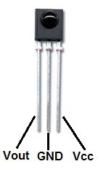
Download and install the IR library:
https://github.com/shirriff/Arduino-IRremote

Note: the IR sensor has three pins. Pin 1: VOUT (outputs HIGH when no signal is present). Pin 2: GND. Pin3: VCC.

Create the following circuit:
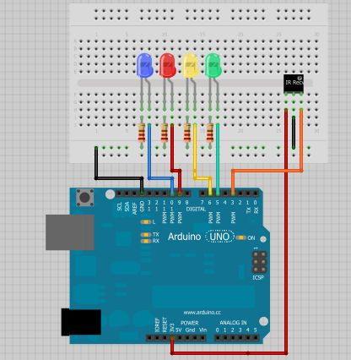

Upload in-built example code to your Arduino:
File > Examples > IRRemote > IRRecvDemo

Open the serial monitor and use the remote to see what values you're receiving. Hexadecimal alues you might get:
Power: E240
Forward: E250
Reverse: E248
Volume+: E244
Volume-: E254
Mute: E24C7

Upload demo_ir_remote.ino to your Arduino and run!

