Anthem Digital Portfolio DigitalQ MVP

[DRAFT]

A methodological manual is being drafted for the DigitalQ work intake process for Digital Portfolio at Anthem based on analysis of historical examples for Broker and Employer.

Version History

Version | Name | Comments | Contributor(s)
0.1 | Anthem-DigitalQ-V0.1.docx | [DRAFT] Example work is Broker Onboarding and Smart Broker Assistant | James Flynn james.flynn2@anthem.com

Contents
Version History 2
Contents 3
Digital Portfolio Scope 5
Background 5
Foundry 5
10x Engineering 6
Platform Teams 6
DigitalQ Flow 7
Phase 1: From Proposal to Classification 7
Why Classification is the First Phase 7
Outcomes 7
Process 8
Question A - Is the proposed solution an improvement to an existing solution? 8
Why do we ask this question? 8
Question B - Is the proposed solution understood? 9
Why do we ask this question? 9
Question C - (If the answer to B is no) Can we reduce risk by dividing into MVPs? 9
Why do we ask this question? 10
Process Diagram 10
Phase 2: From Classification to Value Assessment 12
Why Value Assessment is the Second Phase 12
Value Assessment for Platform-Appropriate Work 12
V1: Value Comparison - Solution Improvement 12
Step 1 - Gather Data on Existing Solution 12
Step 2 - Estimate Impact of Proposed Solution 13
Step 3 - Estimate Cost to Implement 13
Step 4 - Calculate Delivered Value and Return on Investment of Proposed Solution 13
EXAMPLE Value Comparison: Broker Onboarding 14
V2: Value Estimation - New Solution 15
Step 1 - Estimate Impact of Proposed Solution 15
Step 2 - Estimate Cost to Implement 15
Step 3 - Calculate Delivered Value and Return on Investment of Proposed Solution 15
Comparing Apples to Apples 16
Value Assessment for Foundry-Appropriate Work 17
V3: Value Validation - Solution Improvement [PLACEHOLDER] 17
V4: Value Validation - New Solution [PLACEHOLDER] 17
References 17

Digital Portfolio Scope
Functional Scope: Classify, evaluate, prioritize, and assign incoming work to Foundry and Platform teams such that maximum value is delivered to Anthem stakeholders.

Where value is realized by:
- Revenue increase
- Cost reduction
- Risk mitigation
- Higher rates of software utilization
- Employee productivity increase
- Customer satisfaction increase
- ...

Background

Product development teams under the Anthem Digital organization are of the following types:

- Foundry (Discovery Teams)
- Platform (Delivery Teams)
- 10x (Process Support Teams) - ??

Foundry
The Foundry comprises cross-functional teams with expertise in prototyping, UX, and rapid testing of software in pseudo-real-world environments — building and deploying MVPs. Their core function is to (in)validate hypotheses quickly. They are not expected to deliver production grade code.
MVP - “The minimum set of features required to validate a hypothesis”

Because Foundry are conducting a search among novel configurations and technologies - the long-run value delivered by the Foundry will be directly impacted by the speed at which they can iterate. Most hypotheses fail, so it is crucially important that they fail fast.

Therefore, the Foundry is structured, operationalized, and assigned work such that the maximum time between hypotheses statements and results from an MVP test is <12> weeks.

Longer projects are not appropriate for Foundry as they severely impact the foundational value proposition.

Foundry Objective: Rapid Value Discovery
Foundry Priorities: Identification of Value, Usability, Technical Feasibility, Business Viability

10x Engineering

[[[[[TBD - Placeholder What is 10x differentiation? How is their operation and structure differentiated. Tech-for-tech? Dev Ops?]]]]]

Platform Teams
The Platform Teams implement production-quality work with a greater emphasis on quality, and reliability.

Platform Team Objective: Consistently Provisioning Value
Platform Priorities: Reliability, Scalability, Performance, Maintainability

DigitalQ Flow

Phase 1: From Proposal to Classification

The first stage of the DigitalQ flow is to classify the proposed work as appropriate for Foundry, Platform Teams, or neither.

Why Classification is the First Phase
We classify the work first because all following methods of value assessment differ, based on what is knowable about the proposal. The classification ultimately directs work into the Foundry or Platform Team pipelines based on the feasibility of understanding likely value at this pre-implementation stage.

Outcomes

Proposed work is classified as..

- SOLUTION IMPROVEMENT [Platform Pipeline V1]
  - Moves into Value Comparison Process (the comparison is between the value delivered by the proposed solution and that of the current solution)
- NEW SOLUTION [Platform Pipeline V2]
  - Moves into Value Estimation Process (Estimation is the delivered value of proposed solution)
- SOLUTION IMPROVEMENT HYPOTHESIS [Foundry Pipeline V3]
  - Moves into Value Hypothesis Process
- NEW SOLUTION HYPOTHESIS, [Foundry Pipeline V4]
  - Moves into Value Hypothesis Process
- POSTPONED [V5]
  - Moves to back of DigitalQ due to technical/implementation risk being over threshold (unknown technology + indivisible hypotheses)

Process
Refer to Diagram Below

Question A - Is the proposed solution an improvement to an existing solution?

Is there a way, today, for a user with this need, to have that need met, no matter how inefficient it might be currently?

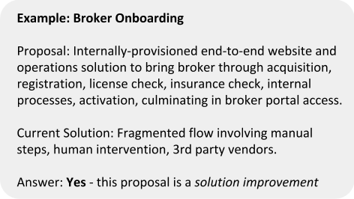

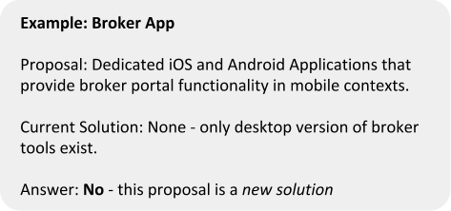

Why do we ask this question?

When a solution currently exists, we have a benchmark for delivered value, and we can better estimate the value of the proposed solution using existing internal data - an important step in the next phase. When a solution does not yet exist, we will need to employ different value-determination methods.

Question B - Is the proposed solution understood?

Can we provision the proposed solution using a set of familiar technologies - technologies where we have a high degree of implementation certainty.

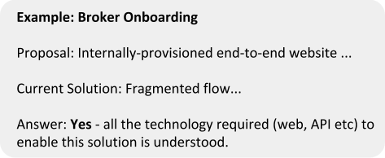

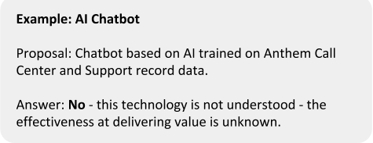

Why do we ask this question?

When a technology is familiar, we know how it works, and what it can do. This allows us to understand how it will deliver value when implemented. This, in turn allows us to estimate business value with a much higher degree of certainty.

When the performance of a technology is unknown, we cannot estimate the delivered business value that will result, because that value will be directly affected by the performance of this technology. It is impossible to estimate business value with certainty, and it is therefore risky to implement.

Question C - (If the answer to B is no) Can we reduce risk by dividing into MVPs?

Can we divide up the hypotheses and design fast self-contained experiments such that each one is possible to resolve in an amount of time appropriate for our business?

Why do we ask this question?

With new technologies, the overwhelming majority of hypotheses turn out to be invalid. For our process of value discovery to be worthwhile - we must understand the performance of new technologies very quickly. We must fail fast, therefore the experiments must occur in a short time, therefore they must be small.

Process Diagram

<See next page>

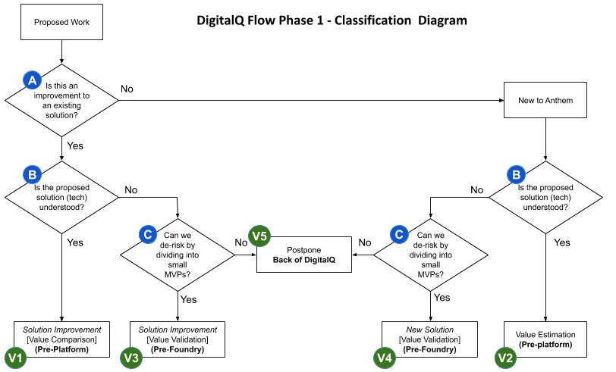

Phase 2: From Classification to Value Assessment

The second stage of the DigitalQ flow is to assess the business value of the proposed work
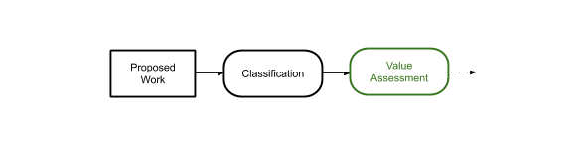

Why Value Assessment is the Second Phase
Having classified proposed work in Phase 1, we now need to understand the business value of the work proposal. Depending on the classification of the work, this is done differently, but ultimately will provide an apples-to-apples comparison.

For the work headed to Platform teams (knowable value) we calculate Delivered Value (sometimes called Net Present Value - NPV) and Return on Investment (ROI).

For the work headed to Foundry teams (less-knowable value) we calculate Risk-Adjusted Hypothetical Value (If this works what will it be worth? And what is the chance it will work?)

[We need to understand the standalone business impact of projects before we can move into the next phase, which will factor in resource availability, cross-project dependencies, and strategic alignment.]

Value Assessment for Platform-Appropriate Work

V1: Value Comparison - Solution Improvement

If the proposed work is classified in Phase 1 - Classification, as a solution improvement, we assess the value of the project by the Value Comparison method.

This process may vary in specific details but is generally always applicable - if we generalize the concept of a ‘user’ as someone, or some system, trying to get a ‘job’ done.

Step 1 - Gather Data on Existing Solution  - Number of Users/Incidents  - Value of User Success  - Operating Costs (OpEx)  - 3rd Party Costs  - Vendors  - Licenses  - ...  - Support Costs  - Customer Support  - ...  - Provisioning Costs  - Infrastructure Costs  - ...  - Performance  - Number of Users at top of funnel  - Number of successful journeys through solution  - Attrition/failure rate  - …  Step 2 - Estimate Impact of Proposed Solution  - Value of User given proposed solution  - Operating Costs of proposed solution  - Performance of proposed solution  Step 3 - Estimate Cost to Implement  - NRE +  - Capital Expenditure | Abbr.  N  V_{E}  OpEx_{E}  P_{E}  V_{P}  OpEx_{P}  P_{P}  C_{P} | Units  units  S  $  %  $  $  %  $

Step 4 - Calculate Delivered Value and Return on Investment of Proposed Solution

First, in English:

The amount of business value we are realizing from an operating solution is the number of users or incidents, multiplied by the value of those users/incidents conditional on success, multiplied by the performance of the solution, minus the cost of providing that solution.

Current Solution Delivered Value = N . V_{E} . P_{E} - OpEx_{E}
Proposed Solution Delivered Value = N . V_{P} . P_{P} - OpEx_{P}

Therefore the delivered business value of the proposed solution is the difference between the value of the proposed solution and the value of the current solution.

Delivered Value (DV) = Proposed Solution Delivered Value - Current Solution Delivered Value

DV = N . [ (V_{P} . P_{P} - OpEx_{P}) - (V_{E} . P_{E} - OpEx_{E})]

And the ROI of the proposed solution is this delivered value divided by the implementation cost.

ROI = DV / C_{P}

EXAMPLE Value Comparison: Broker Onboarding
[[All data except Implementation Cost is placeholder - waiting on Broker Team]]

Internal Data from Current Solution:

Lifetime Value of a Broker: V_{E} = $100,000
Brokers acquired at top of Onboarding Funnel: N = 3000
Performance of Current Solution: P_{E} = 73% success rate
OpEx of Current Solution: OpEx_{E} = $1409** per broker (due to high frequency of support calls, 3rd party licenses etc)

Estimated Impact of Proposed Solution:

Lifetime Value of a Broker (stays the same): V_{P} = $100,000
Brokers acquired at top of Onboarding Funnel (stays the same): N = 3000
Target Performance of proposed Solution: P_{E} = 91% success rate (increase is due to improved UX, reductions in delay, and automation)
Target OpEx of proposed Solution: OpEx_{P} = $217 per broker due to automation and removal of 3rd party dependencies

Estimated Cost to Implement:

USD 2.9M

Current Solution Delivered Value = 3000 x $100,000 x 0.73 - 3000 x $1409
= 21M

Proposed Solution Delivered Value = 3000 x $100,000 x 0.91 - 3000 x $217
= 27M

DV = 27M - 21M
= 8 M
ROI = 8M / 2.9M
= 275%

So this proposal has a direct Business Value of $8,000,000 with a Return on Investment of 275%

V2: Value Estimation - New Solution

If the proposed work is classified in Phase 1 - Classification, as a new solution, we assess the value of the project by the Value Estimation method.

Step 1 - Estimate Impact of Proposed Solution  - Value of User  - Operating Costs of proposed solution  - Performance of proposed solution  Step 2 - Estimate Cost to Implement  - NRE +  - Capital Expenditure | V_{P}  OpEx_{P}  P_{P}  C_{P}

Step 3 - Calculate Delivered Value and Return on Investment of Proposed Solution

We use the same process as in Steps 2 and 3 above for Value Comparison. This time we do not have data upon which to benchmark the numbers of users, and their value.

[[[ WIP - Summarize some high-level methods to get data from existing interactions, from market research, and modeling ]]]

Estimated Impact of Proposed Solution:

Lifetime Value of a User - Estimated via market research, data, and modeling
Users acquired at top of Funnel - Estimated via market research, data, and modeling
Target Performance of proposed Solution: P_{E}
Target OpEx of proposed Solution: OpEx_{P}

Estimated Cost to Implement: C_{P}

Delivered Value (DV) = Proposed Solution Delivered Value

DV = N . V_{P} . P_{P} - OpEx_{P}

And the ROI of the proposed solution is this delivered value divided by how much it costs to implement.

ROI = DV / C_{P}

Comparing Apples to Apples

We will consider the two values for each proposal to help prioritize work, but we’re not done yet, we have to factor in resource availability, cross-project dependencies, and strategic alignment, which will happen in subsequent phases.

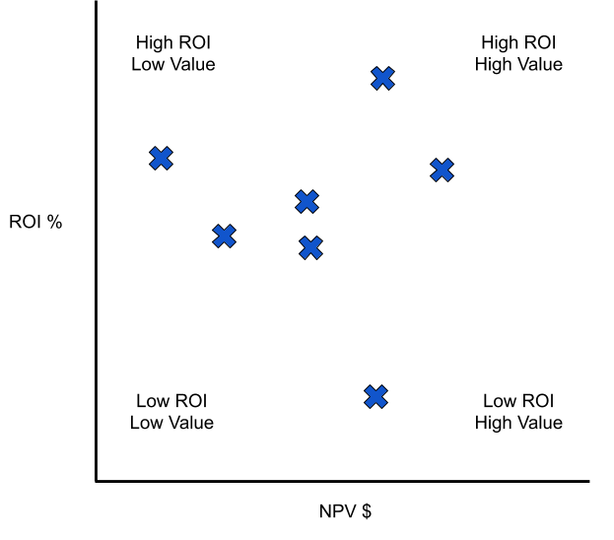

Value Assessment for Foundry-Appropriate Work

Let’s recap the type of work that makes it to this stage. This is work where the proposed technology is not well understood, but the hypotheses can be divided into appropriately-sized experiments.

V3: Value Validation - Solution Improvement [PLACEHOLDER]

The Value Validation for Solution Improvement process is the same as Value Comparison - Solution Improvement (X1) except that the Proposed Solution performance variable (P_{E}) is unknown. Recall:

Delivered Value (DV) = Proposed Solution Delivered Value - Current Solution Delivered Value

DV = N . [ (V_{P} . P_{P} - OpEx_{P}) - (V_{E} . P_{E} - OpEx_{E})]

And this time we are unsure of P_{E}

But we can build a model of the delivered value of a project by trying different values for P_{E} in our delivered value equation and estimating the likelihood of achieving that performance.

Step 1 -

V4: Value Validation - New Solution [PLACEHOLDER]

The Value Validation for New Solution process is the same as V2 except

References

“NPV and Capital Budgeting” - Timothy Luehrman - Harvard Business School Core Curriculum [link]

<<<<<<SCRATCH>>>>>>>

- Value Estimation [Platform Teams]

By estimating the absolute value of the proposed solution, we can determine the expected business value of the completed project, and the return on capital invested.

- Value Hypothesis [Foundry]

(causal modeling etc)
By asking ‘What would this be worth, if it works?’, and ‘What are the chances it will work?’ we can determine the statistical expected value of a project, and work on projects in order from highest to lowest expected value.

