TMCC AI Governance
Salt Security AI Security Capability Roadmap
Proposed structure, capability research and commentary (AI-SPM & AI-DR)
Status: Working draft for internal Deloitte review — not client-ready
Date: October 28, 2026
Prepared by: Stas Kosovskih
Basis: Publicly available Salt Security material; TMCC environment context from client documents and status calls. Salt NDA renewal is pending, so nothing here is confirmed by Salt.

1. Purpose and scope
This document proposes the sections and logic for a 12-month roadmap that helps TMCC move from its existing Salt Security API protection deployment to the platform’s AI security capabilities. It is a starting point for alignment, not a finished roadmap.
- In scope: AI Security Posture Management (AI-SPM) and AI Detection and Response (AI-DR) as delivered by Salt, broken down into the features that enable each, and a phased, pilot-first rollout plan.
- Out of scope: API security roadmap items. TMCC has stated its API security programme is on track; the client’s existing project plan is used only as environment context.

Commentary: The client-provided roadmap document is API-security focused and very high level. Per direction from the engagement lead, this roadmap is built from scratch around AI capabilities; we only reuse the environment facts (AWS/Bedrock, MuleSoft, GitHub) from it.

2. Salt’s AI security platform at a glance
Salt now markets its AI capabilities as the Salt Agentic Security Platform (launched March 2026), made of two capabilities that map to what we refer to internally as AISPM and AIDR:
Our term | Salt term | What it does (per Salt public material)
AISPM | Agentic Security Posture Management (AG-SPM) | Continuous discovery and governance of LLM connectivity, AI agents, MCP servers, APIs and the relationships between them; surfaces posture gaps such as excessive agent tool permissions.
AIDR | Agentic Detection and Response (AG-DR), incl. native AI-DR (added Sept 2026) | Runtime detection of abuse, misuse and anomalous behaviour across LLM traffic, agent activity, MCP servers and APIs. Native AI-DR adds LLM-layer detection of direct/indirect prompt injection, jailbreaks and unsafe model behaviour.
— | Agentic Security Graph | Shared context layer that links agents → models → MCP servers → tools → downstream APIs. Both capabilities sit on it; it is what lets Salt connect a prompt injection to a later API attack.

Commentary: Use Salt’s own names (AG-SPM / AG-DR / AI-DR) in the client version so TMCC can map the roadmap directly to licence line items. AI-DR is very new (Sept 2026) — we must confirm with Salt whether TMCC’s current licence includes it and whether it is GA for their deployment model.

3. Capability decomposition
Each capability is enabled by a set of underlying features. The roadmap sequences these features one at a time rather than switching everything on at once.
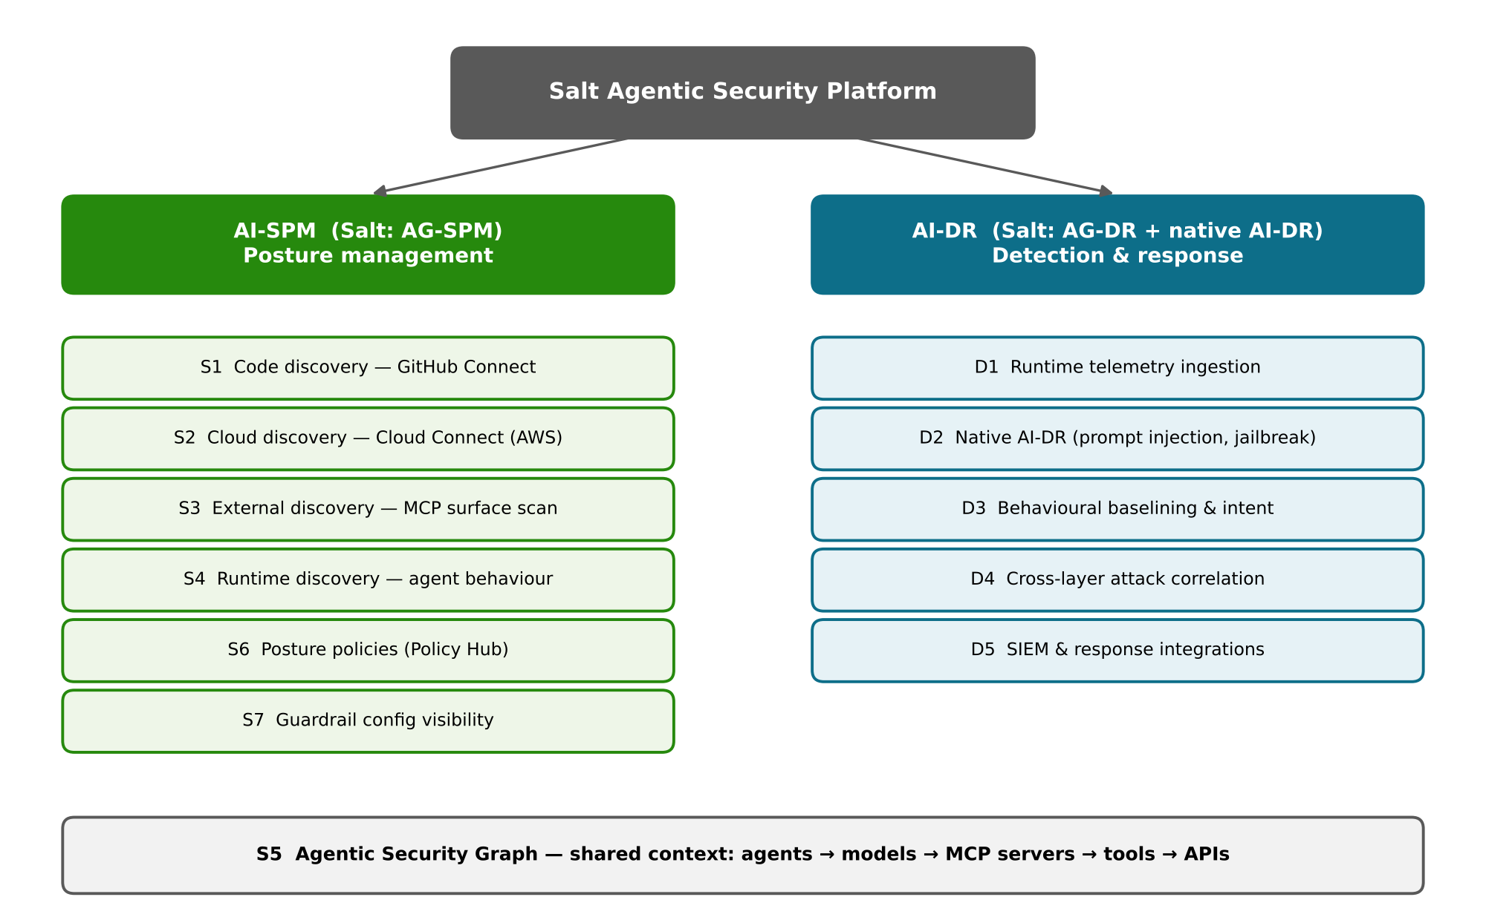
Figure 1. Salt AI security capabilities decomposed into enabling features

3.1 AI-SPM (posture management) — enabling features
# | Feature | How it works | TMCC relevance
S1 | Code discovery — GitHub Connect | Connects public/private GitHub repos to Salt; inspects code for MCP definitions, shadow APIs, AI integrations and config patterns before deployment. | High. GitHub integration call is already planned for next week (~6 weeks estimated delivery). Natural first pilot.
S2 | Cloud discovery — Cloud Connect for AWS | Agentless, read-only connection that queries AWS services (incl. API Gateway) for inventory and posture; also available for Azure/GCP. | High. Most TMCC development runs on AWS; relevant to the planned AWS API Gateway rollout. Confirm Bedrock / AgentCore coverage with Salt.
S3 | External discovery — Salt Surface / MCP surface scan | Finds internet-exposed MCP servers and AI-related endpoints, including misconfigured or abandoned ones. | Medium. Quick win with no internal integration; good for an outside-in baseline.
S4 | Runtime discovery — agentic behaviour mapping | Analyses live agent traffic to see which MCP servers and tools are actually used and how data flows. | High, but depends on traffic source (MuleSoft today vs AWS API Gateway going forward).
S5 | Agentic Security Graph | Correlates the above into one map of agents, models, MCP servers, APIs, identities and sensitive data. | Becomes useful once 2+ discovery sources are on; basis for AI inventory reporting to governance.
S6 | Posture governance policies | Policy Hub with ~100 pre-loaded posture rules plus custom policies; violations raise posture gaps. | Map to TMCC AI Security Standards and exception management process already drafted on this engagement.
S7 | Guardrail configuration visibility | One view of AI guardrail configurations across cloud platforms, AI gateways and managed AI services, and the agents they protect. | Useful to check consistency of Bedrock Guardrails and gateway controls across use cases.

Commentary: The three discovery layers (external, code, runtime) match what Salt describes for its MCP Finder technology. Cloud Connect is a fourth, agentless source and is likely the fastest win in an AWS-heavy estate. Suggested AISPM order: S1 → S2 → S3 → S4 → S5/S6 → S7.

3.2 AI-DR (detection and response) — enabling features
# | Feature | How it works | TMCC relevance
D1 | Runtime telemetry ingestion | Salt consumes traffic/telemetry from AI gateways, API gateways, traffic mirroring or CrowdStrike Falcon sensors. | Prerequisite for all of AI-DR. Decide source: MuleSoft (current) vs AWS API Gateway (strategic) — see §8.
D2 | Native AI-DR (LLM layer) | Real-time detection of direct and indirect prompt injection, jailbreaks and unsafe model behaviour. | Core need for GenAI and agentic use cases; also fills gaps for homegrown agents without guardrails.
D3 | Behavioural baselining & intent analysis | Baselines agent behaviour per agentic identity; flags multi-step sequences that depart from it. | Needs a few weeks of clean traffic per use case before alerting is meaningful.
D4 | Cross-layer attack correlation | Links a model-level attack to follow-on MCP and API activity via the Agentic Security Graph. | Key differentiator for agentic use cases; depends on S5.
D5 | SIEM & response integrations | Findings and detections sent to SIEM (e.g., CrowdStrike Falcon Next-Gen SIEM); automated response via Falcon Firewall Management; Salt managed rules for AWS WAF. | Ties into TMCC SOC workflow. Note client’s Falcon interest — see §8.

Commentary: Recommend running AI-DR in detect/alert-only mode for the full pilot period. Blocking or automated response should only be enabled per use case after false-positive rates are understood and the SOC has a runbook.

4. TMCC environment context
What we know today (high level only — we do not have a full view of the environment):
- Salt Security already deployed for API discovery and protection.
- AWS is the primary development platform; Amazon Bedrock in use for GenAI workloads.
- MuleSoft is the current API gateway; AWS API Gateway is being stood up as a replacement (CTO/CIO direction).
- GitHub is the source code platform.
- Five AI use-case categories assessed on this engagement: vendor AI, productivity AI, developer AI, generative and agentic.
- Client is primarily interested in CrowdStrike Falcon for AI security gateway; vendor evaluation is ongoing.

Commentary: Open items to confirm before finalising: number of GitHub orgs/repos; AWS account structure; which use cases run through which gateway; whether any agents/MCP servers are in production; SOC tooling and SIEM of record.

5. Roadmap principles
- One feature at a time. Each feature goes through enable → pilot → tune → roll out before the next one starts its broad rollout.
- Pilot in a limited scope first. E.g., GitHub Connect on one GitHub org, Cloud Connect on one AWS account, AI-DR on one use case — not the whole estate (data volume and noise).
- Posture before detection. Discovery and inventory (AI-SPM) give AI-DR the context it needs; detection without inventory produces unexplained alerts.
- Detect before block. Monitor-only modes during pilots; enforcement only with exit criteria met.
- Reuse what exists. Map Salt policies to the TMCC AI Security Standards and route exceptions through the exception management process.

6. Proposed phased roadmap (12 months)
First ~6 months: enable and pilot features one by one with feedback loops. Remaining months: phased rollout across the organisation and operationalisation.
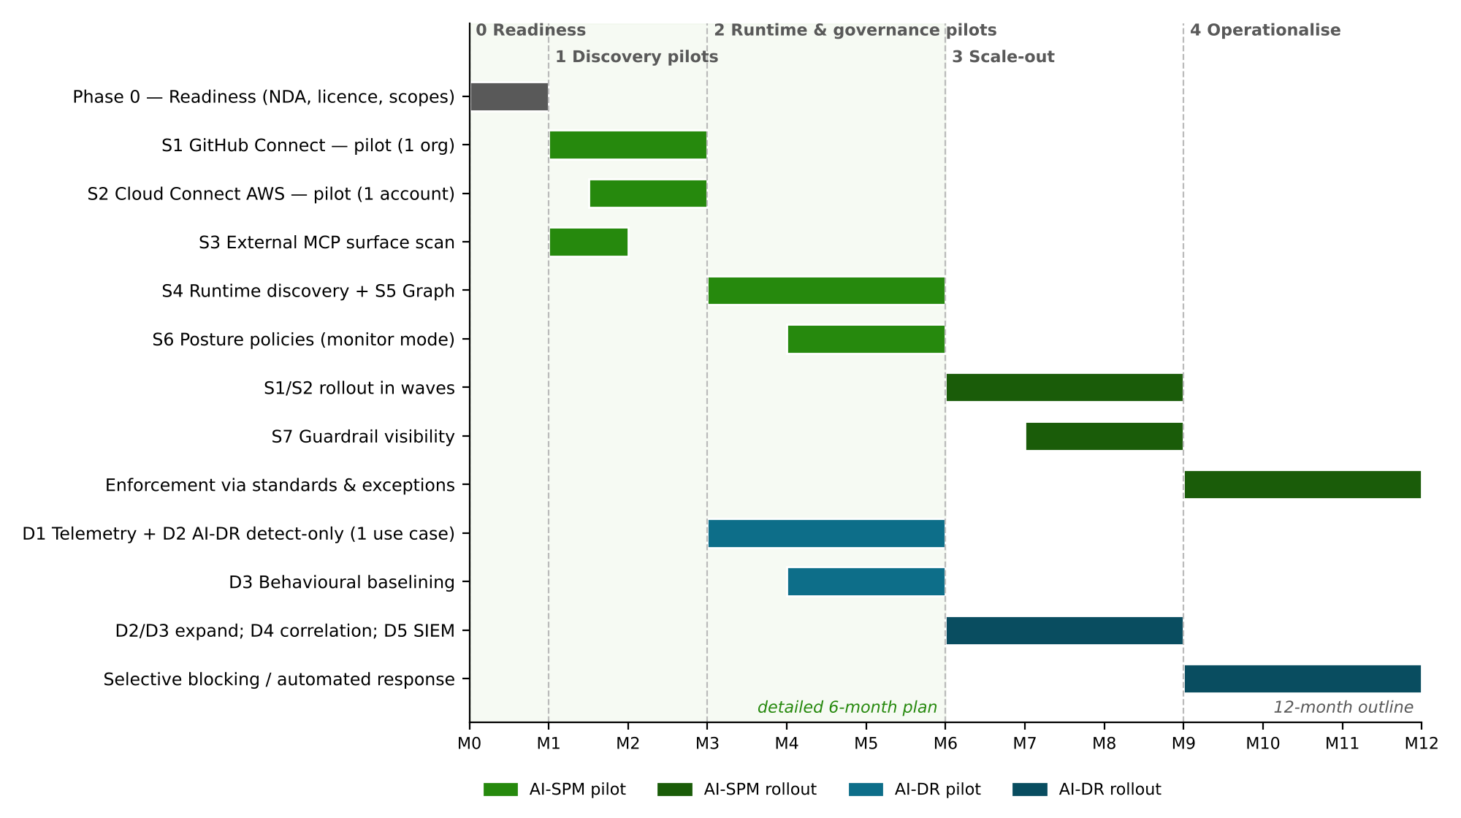
Figure 2. Indicative 12-month timeline by feature (durations are placeholders)
Phase | Timing | AI-SPM | AI-DR | Exit criteria
0. Readiness | Month 0–1 | Salt NDA renewed; licence/entitlements confirmed (AG-SPM, AI-DR); owners named; pilot scopes chosen. | Decide telemetry source (D1); agree SOC owner. | Signed NDA; RACI; pilot scope list; success metrics agreed.
1. Discovery pilots | Months 1–3 | S1 GitHub Connect on one org; S2 Cloud Connect on one AWS account with Bedrock workloads; S3 external surface scan. | — | AI asset inventory for pilot scope reviewed with app owners; false-positive rate acceptable; tuning documented.
2. Runtime & governance pilots | Months 3–6 | S4 runtime discovery; S5 Agentic Security Graph; S6 posture policies in monitor mode mapped to AI Security Standards. | D1 telemetry for one AI use case; D2 native AI-DR in detect-only; D3 baselining starts. | Policy set agreed; detections triaged for 4+ weeks; runbook drafted.
3. Scale-out | Months 6–9 | Roll S1/S2 out across GitHub orgs and AWS accounts in waves; S7 guardrail visibility. | Expand D2/D3 to further use cases (agentic, generative first); D4 correlation; D5 SIEM integration. | Coverage targets per wave met; alerts flowing into SOC.
4. Operationalise | Months 9–12 | Posture gaps enforced via standards & exception process; periodic AI inventory reporting to governance. | Selective blocking / automated response for mature use cases; KPIs reported. | BAU ownership handed over; metrics in governance pack; next-year backlog.

Commentary: Timeline tension: on today’s client call a six-month horizon was recommended (3–4 months pilot, then lessons learned and rollout), while internal direction is a one-year layout. Suggest presenting a detailed 6-month plan (Phases 0–2) plus a 12-month outline (Phases 3–4). Durations are placeholders until Salt confirms effort per feature; the ~6 weeks for GitHub integration is the only estimate we have.

7. Per-feature pilot pattern
Every feature in §3 follows the same loop, which keeps the roadmap consistent and easy to track:
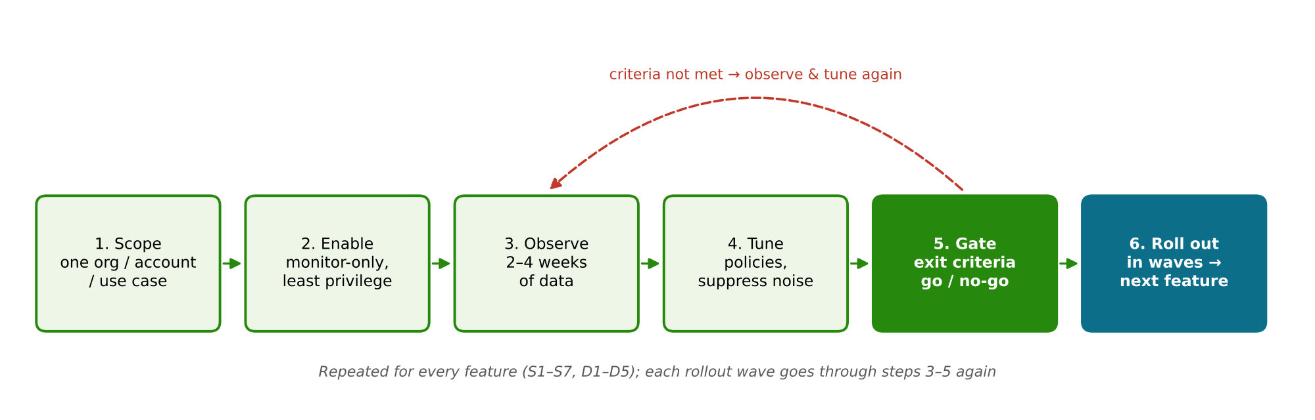
Figure 3. Per-feature pilot loop
Step | Activities | Output
1. Scope | Pick a contained slice (one org, account, gateway route or use case); name owner. | Pilot charter
2. Enable | Configure the Salt feature with least-privilege access; monitor-only. | Integration live
3. Observe | 2–4 weeks of data; review findings with app/platform owners. | Findings log
4. Tune | Adjust policies, suppress noise, fix data gaps; capture lessons learned. | Tuning record
5. Gate | Check exit criteria; go/no-go for wider rollout. | Rollout decision
6. Roll out | Expand in waves; repeat observe/tune per wave. | Coverage report

8. High-level guidance, dependencies and risks

8.1 Guidance by environment component
- GitHub: start with the org that hosts AI/agent projects; read-only scopes; agree who acts on findings (AppSec vs product teams).
- AWS / Bedrock: use Cloud Connect (agentless) first; confirm what Bedrock, AgentCore and guardrail objects Salt can inventory.
- Gateways: avoid building AI-DR telemetry on MuleSoft if it is being retired; align runtime phases with the AWS API Gateway rollout.
- SOC: define alert routing and triage before AI-DR leaves detect-only mode.

8.2 Dependencies and risks
Item | Impact | Proposed handling
Salt NDA expired, renewal in OGC review | Blocks direct Salt engagement and confirmation of feature details | Track weekly; draft roadmap on public info in the meantime
AI-DR is newly released (Sept 2026) | Licensing, maturity and deployment options unclear | Confirm entitlement and GA status with Salt before committing timelines
MuleSoft → AWS API Gateway transition | Runtime discovery and AI-DR depend on traffic source | Sequence runtime phases after gateway decision; pilot on AWS-side traffic if possible
Overlap with CrowdStrike Falcon (AIDR / AI gateway evaluation) | Risk of duplicate detection controls | Salt integrates with Falcon NG-SIEM / Foundry; define which tool owns which layer
Data volume / alert noise at scale | SOC fatigue, loss of trust in tool | Pilot-first; tuning gate before each wave
Limited view of full TMCC environment | Guidance may not fit all teams | Keep guidance high level; validate with Neil and platform owners

9. Suggested success metrics
- % of GitHub orgs / AWS accounts connected to Salt AI discovery
- Number of AI assets inventoried (agents, MCP servers, LLM connections), incl. previously unknown/shadow
- Open vs remediated AI posture gaps; mean time to remediate
- AI use cases covered by AI-DR; detection precision after tuning
- Exceptions raised and resolved via the exception management process

10. Next steps
- Align this outline with the roadmap template Rashi and Moksh share tomorrow; move content into it.
- Use the GitHub integration call next week to validate S1 scope and the ~6-week estimate.
- Prepare questions for Salt (licence, AI-DR availability, Bedrock coverage, telemetry options) for when the NDA is in place.
- Bring the storyboard to the brainstorming session with Neil early next week.

Sources (public)
- Salt Security — Agentic Security Platform launch (Mar 18, 2026): salt.security/press-releases/salt-security-launches-industrys-first-agentic-security-platform-for-the-ai-stack-across-llms-mcp-servers-and-apis
- Salt Security — Native AI Detection and Response announcement (Sept 22, 2026), via CIO Influence / PR Newswire
- Salt Security — GitHub Connect launch (Nov 18, 2025): salt.security/press-releases/salt-security-launches-github-connect-to-proactively-discover-shadow-apis-and-mcp-risks-in-code
- Salt Security — MCP Finder technology (Nov 25, 2025): salt.security/press-releases/salt-security-launches-salt-mcp-finder-technology-the-discovery-engine-for-mcp-servers-in-agentic-ai-deployments
- Salt Security — Cloud Connect for AWS (Jun 18, 2025): salt.security/press-releases/salt-security-introduces-cloud-connect-for-aws-instant-agentless-api-security-with-full-visibility-in-minutes
- Salt Security blog — Salt and CrowdStrike, “Secure what agents do, not just what they say”: salt.security/blog/secure-what-agents-do-not-just-what-they-say
- AWS Marketplace — Salt Managed Rules for AWS WAF; Salt Agentic Security Platform listing
- AppSec Santa — Salt Security review 2026 (Policy Hub details)

