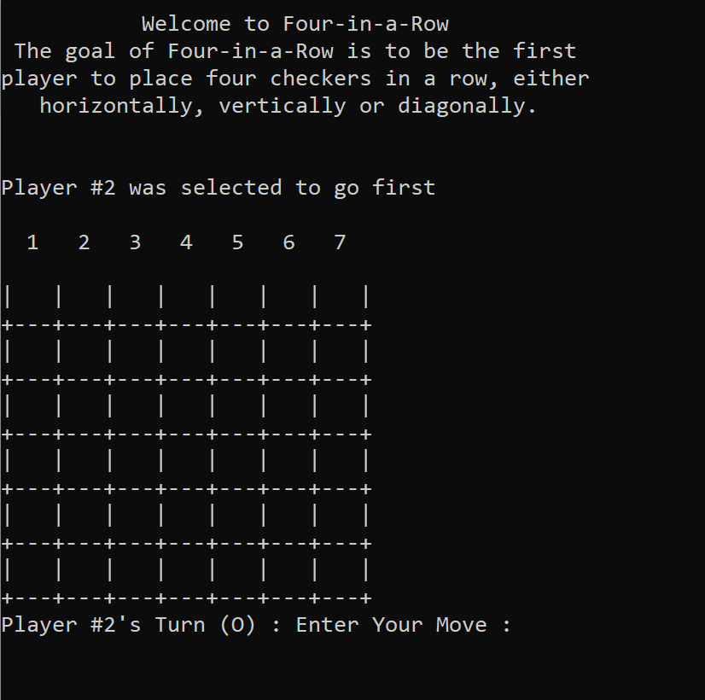

1. Welcome Screen

This is the main menu screen for when the game begins

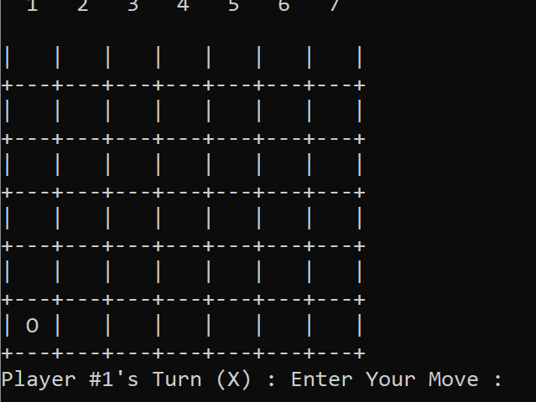

1. Player X input screen

This is the screen for player one to input their inputs. The character ‘X’ will be inputted

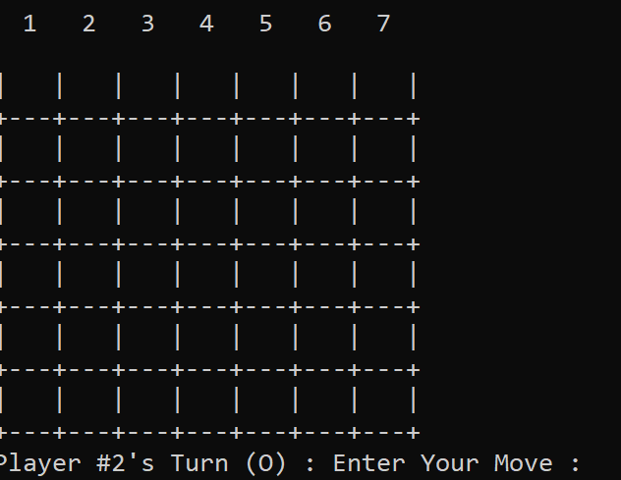

1. Player O Input Screen

This is the screen for player one to input their inputs. The character ‘O’ will be inputted

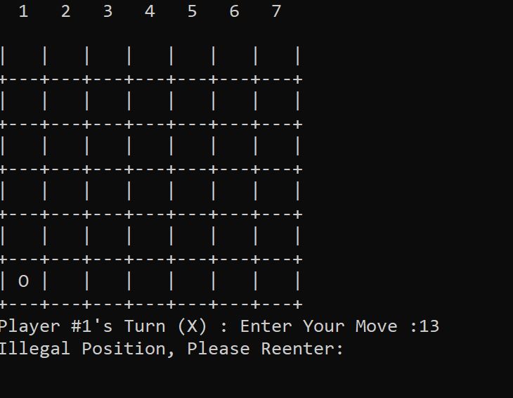

1. Illegal Move Screen

“Illegal Position. Please Reenter” will appear if user inputs a value less than 1 and greater than 7

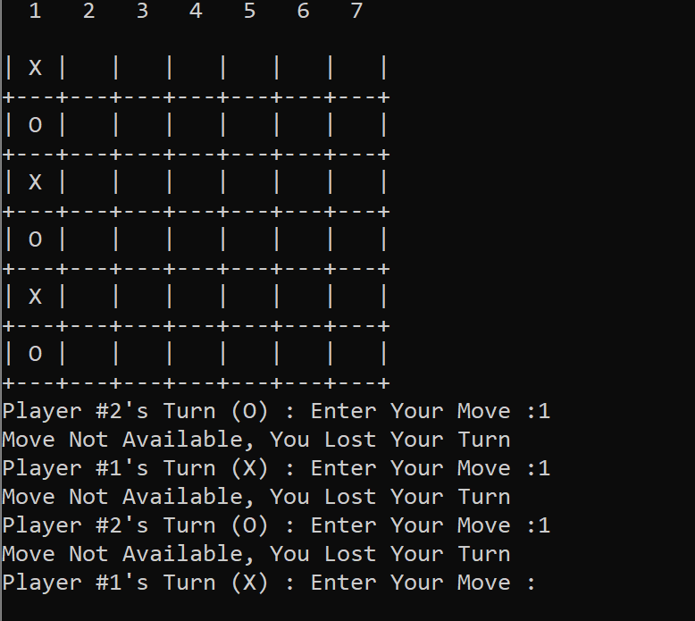

1. Player Lose your turn screen

Players alternate when you fill up a column (lose a turn)

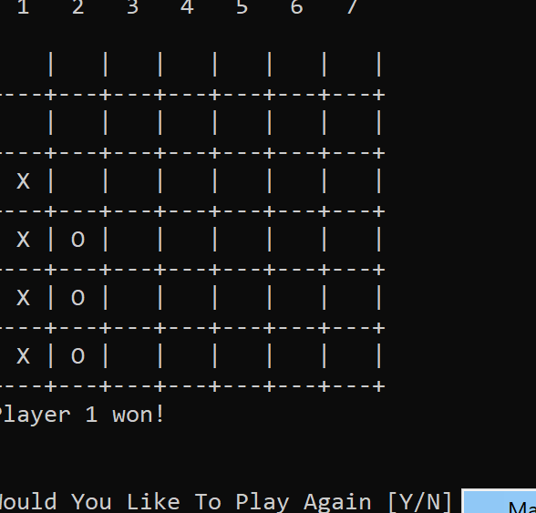

1. Vertical win

This is a vertical win combination for player 1

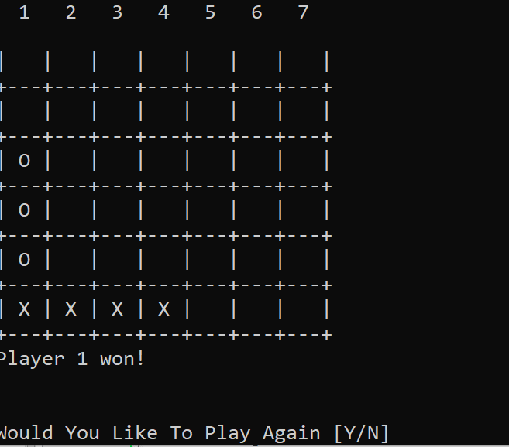

1. Horizontal win

This is a horizontal win combination for player 1

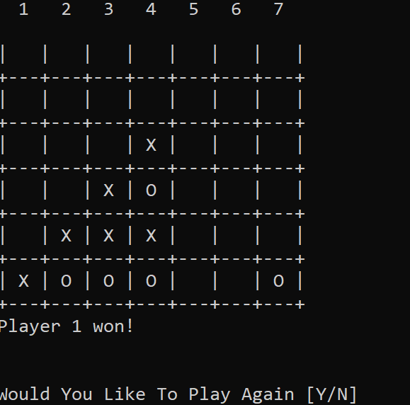

1. Left diagonal win

Player 1 wins diagonally from the left

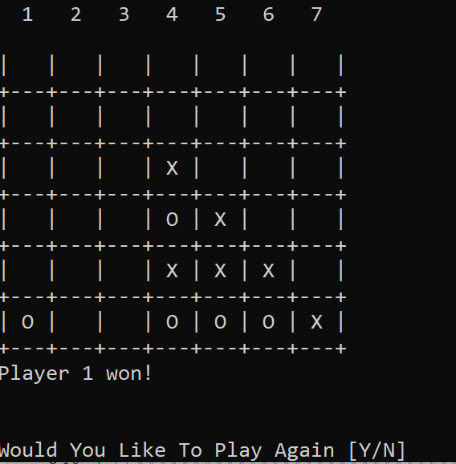

1. Right Diagonal Win

Player 1 win screen diagonally from the right

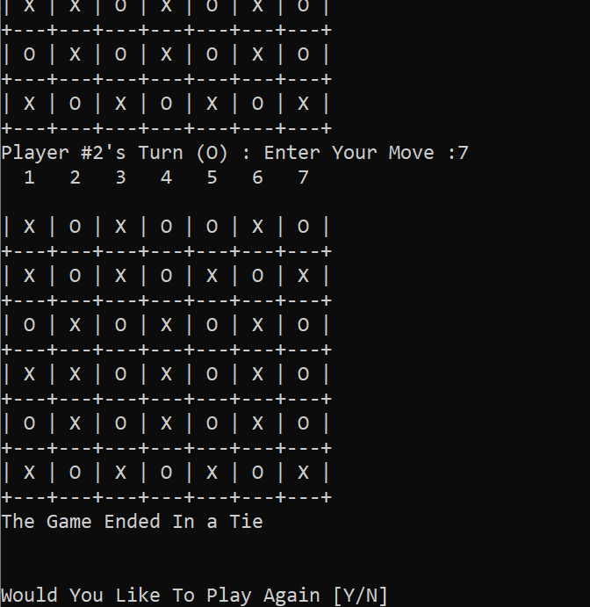

1. Game Tie

This Screen shows when a player achieves a tied game.

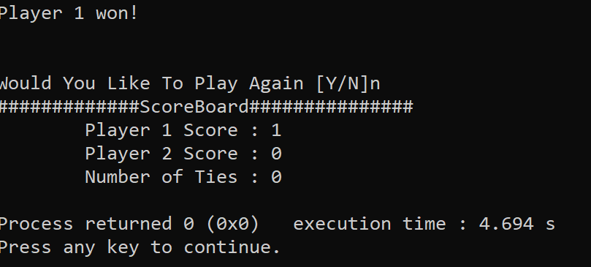

11. Tally Screen

This is the screen that displays when you end the game