**Question 2.1:**

Following is the screenshot of the console window:

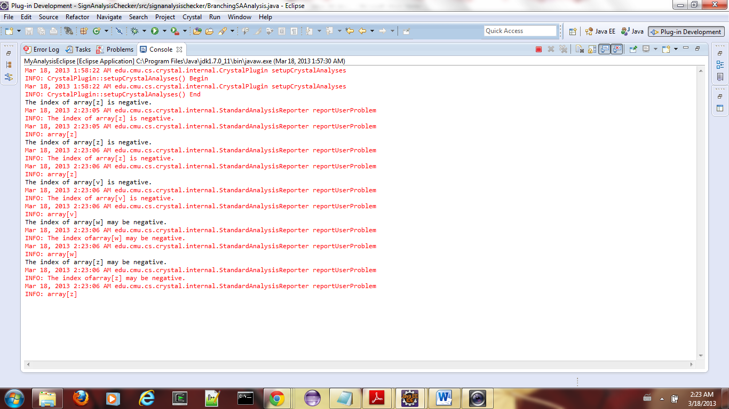

Following is the screenshot of the Problems window: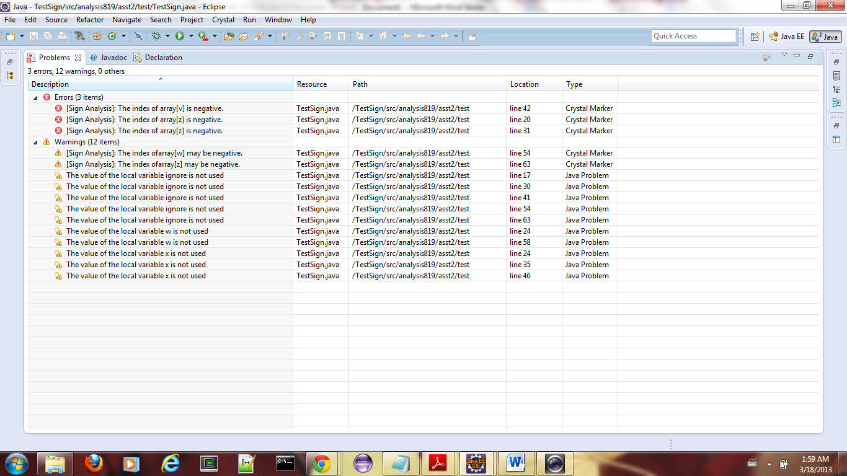

Other detailed screenshots: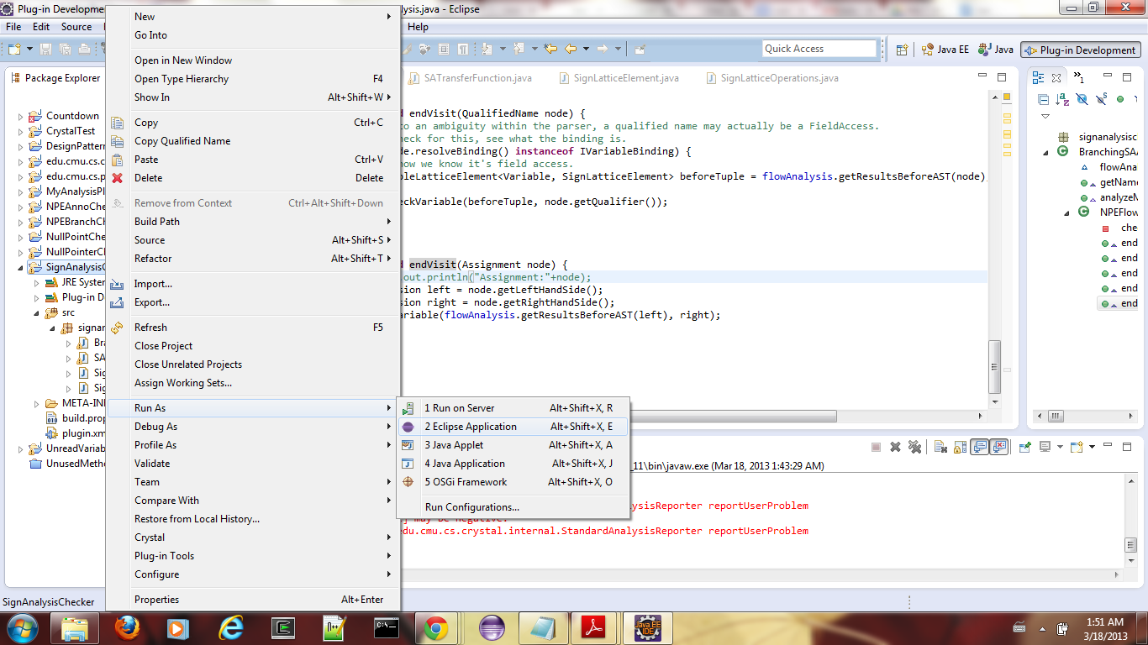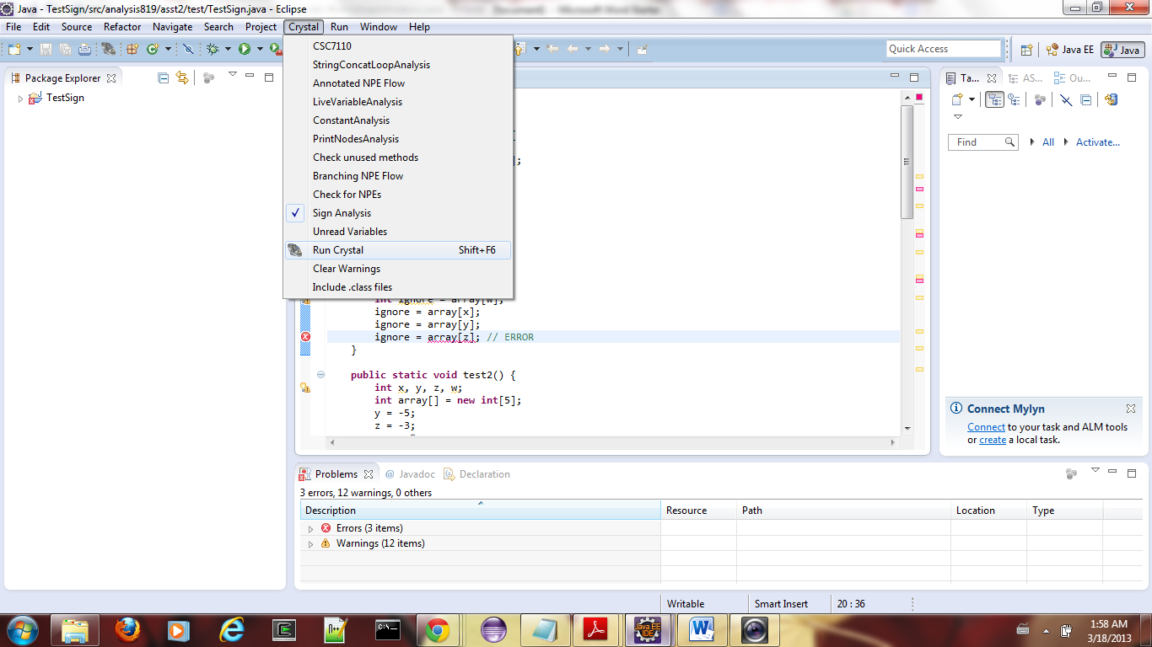

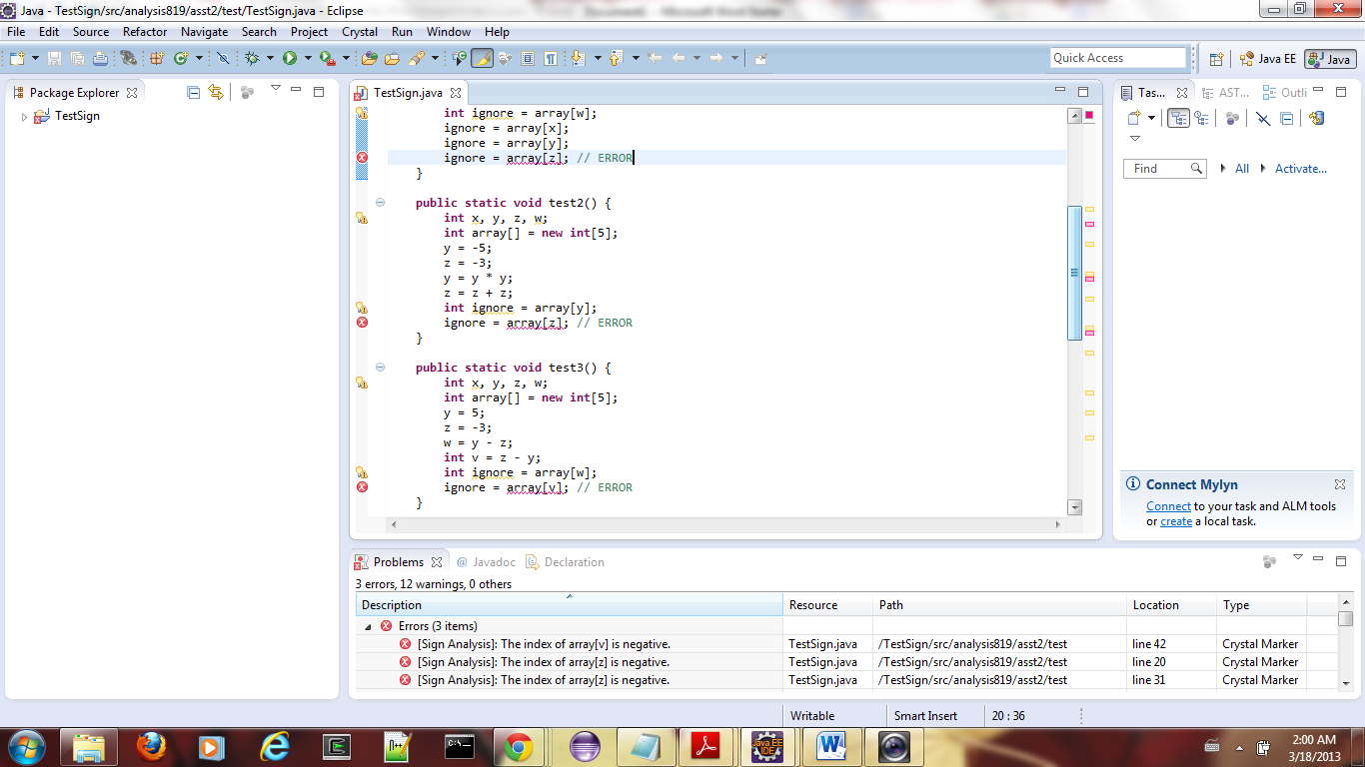

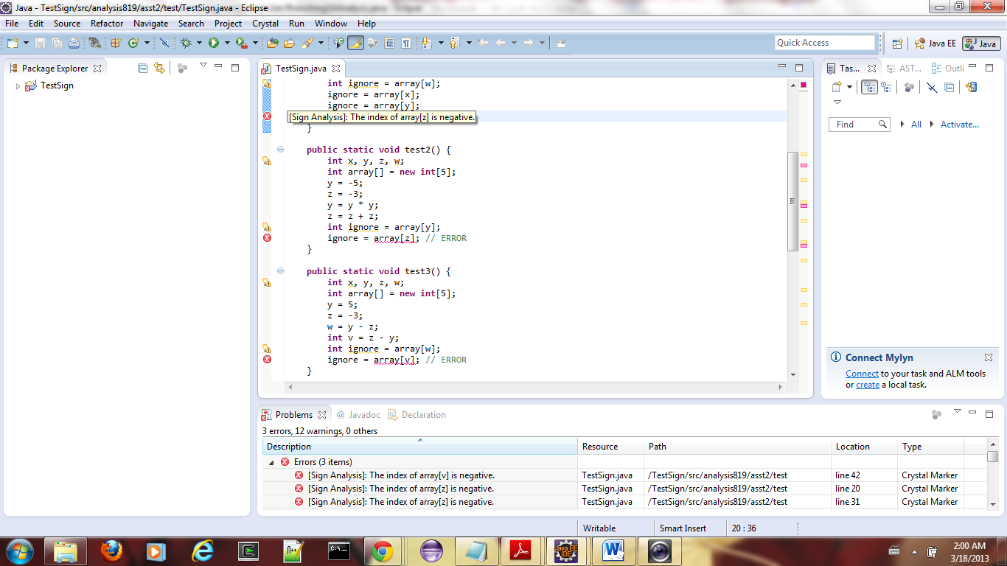

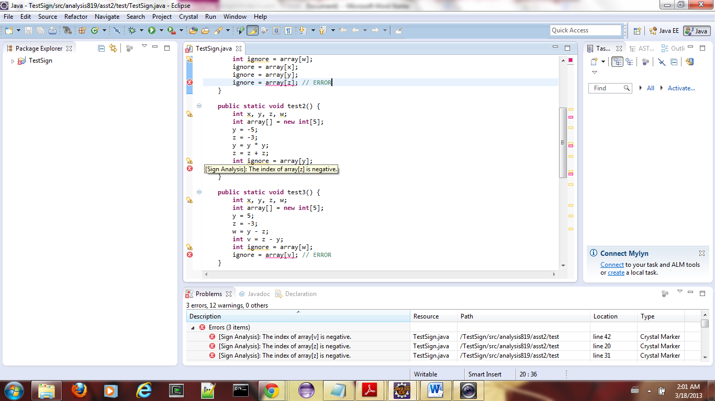

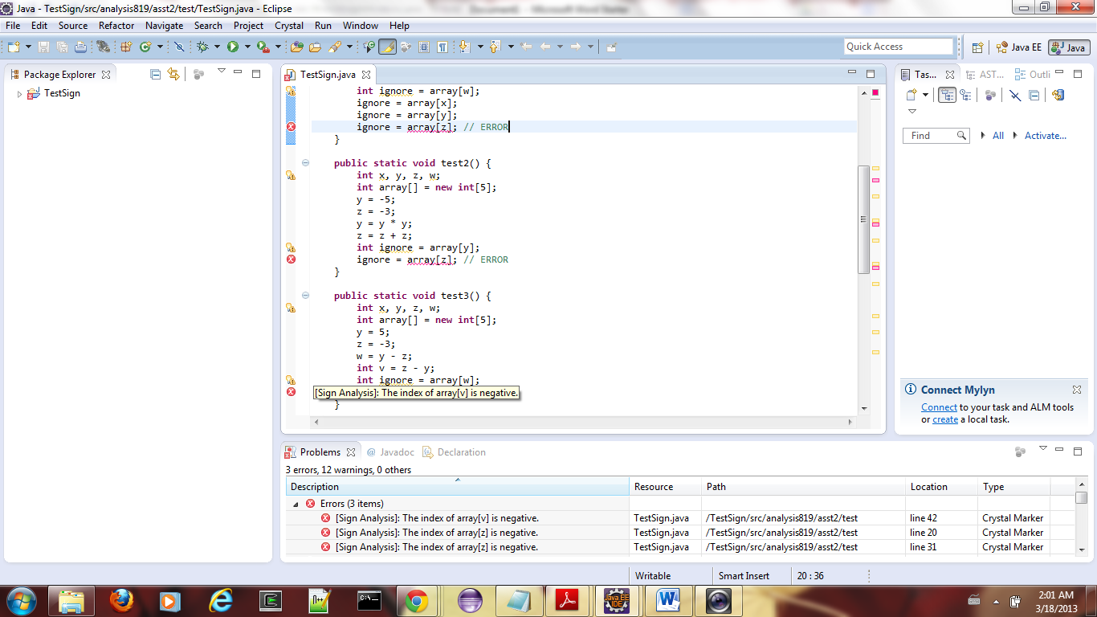

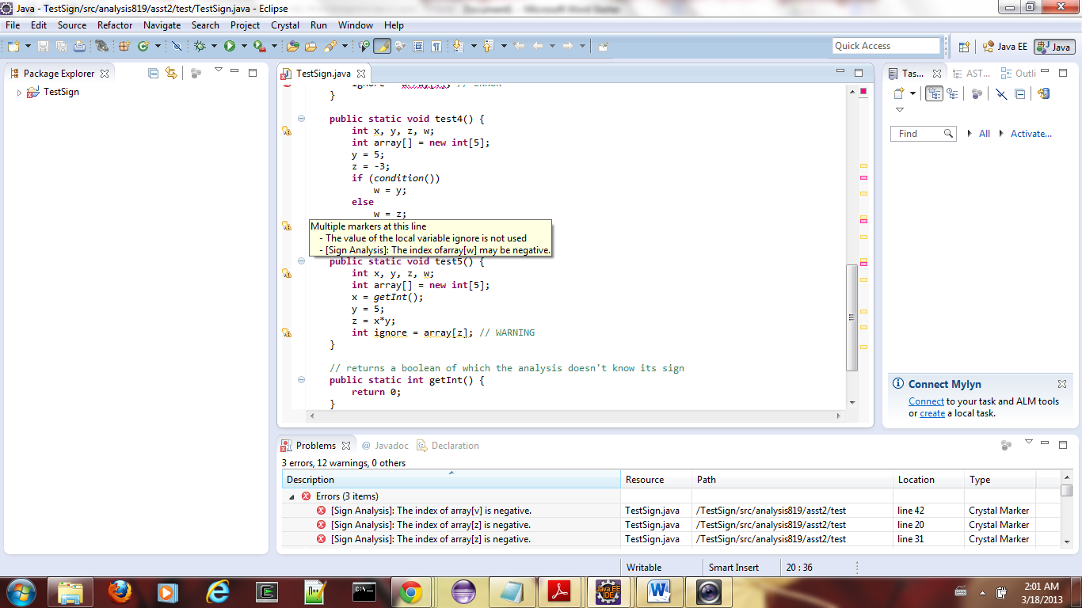

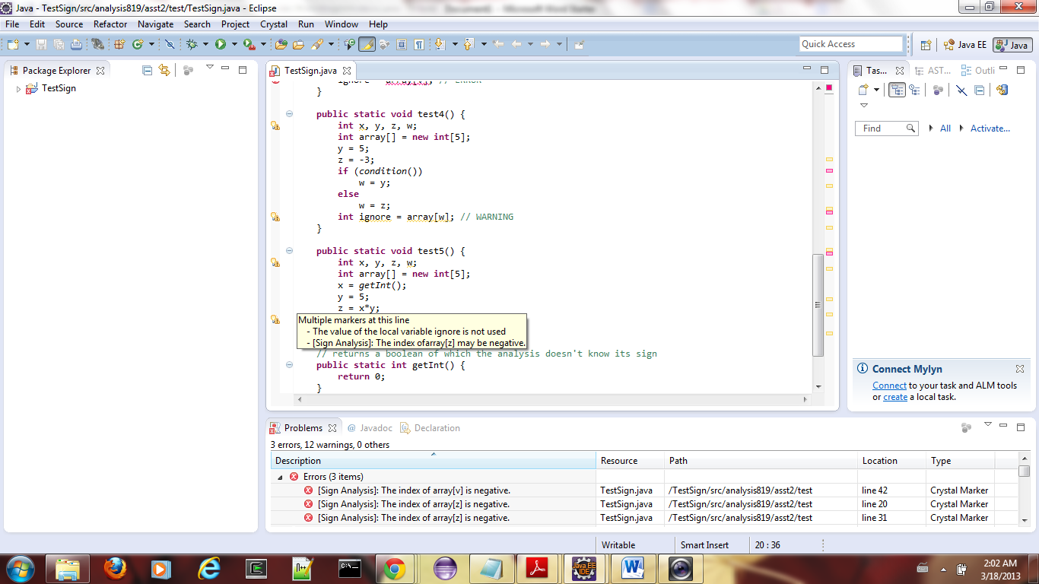

**References:**

* <http://help.eclipse.org/indigo/index.jsp?topic=%2Forg.eclipse.jdt.doc.isv%2Freference%2Fapi%2Forg%2Feclipse%2Fjdt%2Fcore%2Fdom%2Fclass-use%2FASTNode.html>
* <http://crystalsaf.googlecode.com/svn-history/r269/trunk/CrystalPlugin/doc/edu/cmu/cs/crystal/tac/model/package-tree.html>