**Database Management Project**

Title: Student Counselling Management System

Project Manager: Surya Vyshnav Kothakota, s.kothakota@vikes.csuohio.edu

CSU ID: 2808570

Mobile Number: +1 (216) 246-8716

Submitted to: Dr. Wei Chang, Enterprise Database (Term Project)

Due date: 05-26-2021

**INSTRUCTION MANUAL**

1. **Download NetBeans IDE using** [**https://netbeans.apache.org/download/index.html**](https://netbeans.apache.org/download/index.html) **as shown in the screen shot.**Text

   Description automatically generated
2. **Click on Apache NetBeans 12.4 windows version**

1. **Next, click on the link as shown, which then it will start downloading.**

1. **Next, click on the downloaded file and start installing as shown in the following way.**

1. **Accept the license Agreement, and then click next.**

1. **Choose the installation folder and JDE, as shown below.**

1. **Finally click on install and wait till it downloads.**

**B. Downloading and Installing MYSQL workbench.**

**1.    First step is launching the Workbench MySQL. What you see is called Home Window**

**[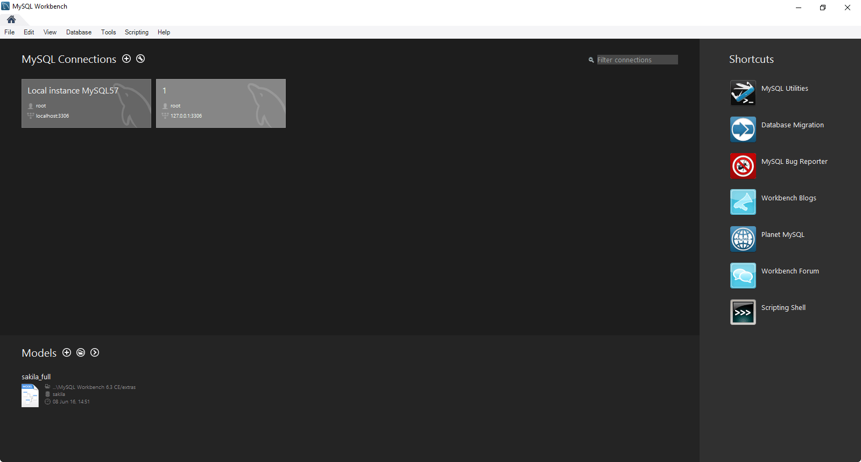](https://www.guru99.com/images/mysql_work_bench_home.png)**

**2. Next you need to create your MySQL Server Connection which contains details about target database server including how to connect to it. Click " +  " in MySQL Workbench Home Window. This will open Setup New Connection. Wizard**

[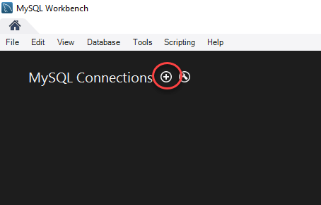](https://www.guru99.com/images/workbench-instance-1.png)

**3. As a beginner you can create a connection for a locally installed server. Click Configure Server Management button in Setup New Connection window to check the configuration of the MySQL server.**

[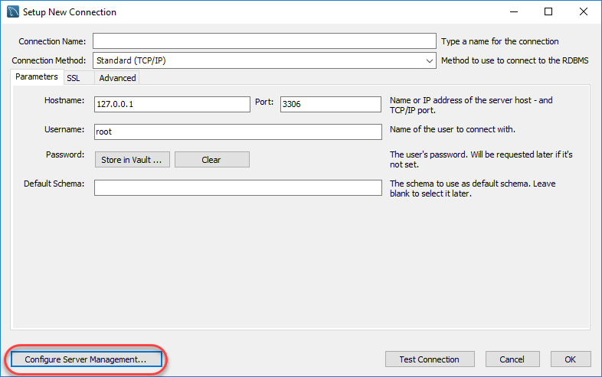](https://www.guru99.com/images/workbench-instance-2.png)

**4. A new window opens named Configure Local Management. Click Next button to continue.**

[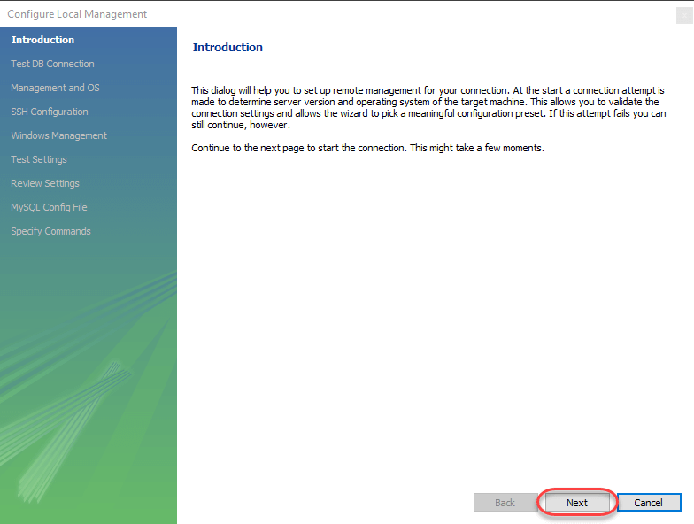](https://www.guru99.com/images/workbench-instance-3.png)

**5. Next the Wizard will test connections to database. If test fails, go back and correct database connection parameters.5. Next it will open a pop-up window asking your root password to test your connection with the local MySQL server instance. The password is the one you set during installation of MySQL Workbench. Enter your password and press OK**

[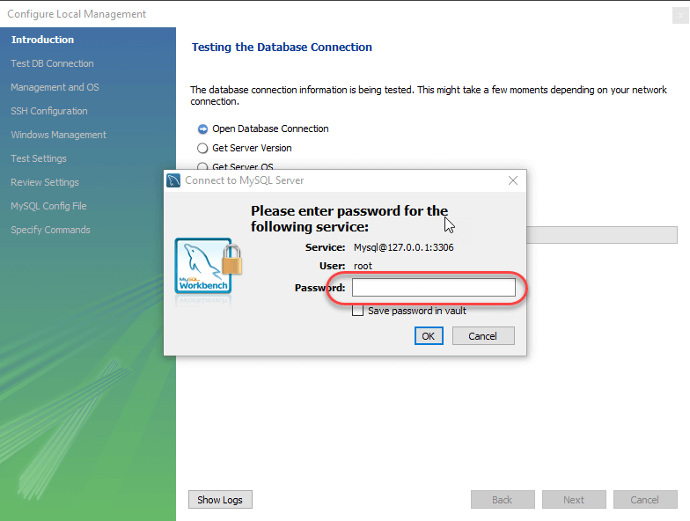](https://www.guru99.com/images/workbench-instance-4.png)

**6. Next the Wizard will test connections to database. If test fails, go back and correct database connection parameters. Else if all tests are sucessful click Next to continue.**

[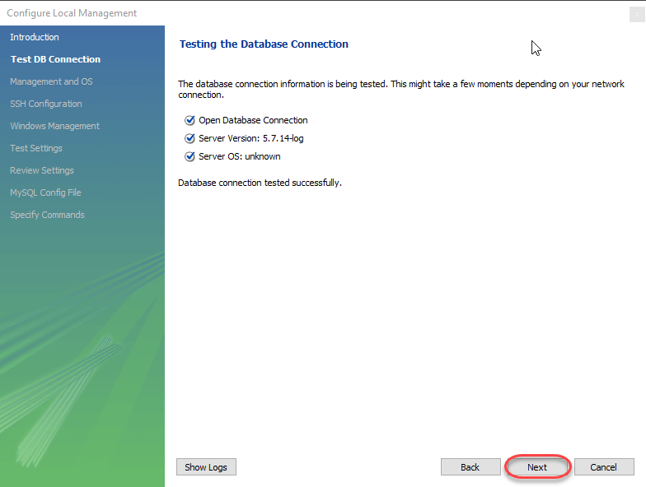](https://www.guru99.com/images/workbench-instance-5.png)

**7. After that a new wizard will open about Local Service Management - It lets you switch between multiple MySQL severs installed on one machines. As a beginner you can bypass this and click Next to continue**.

[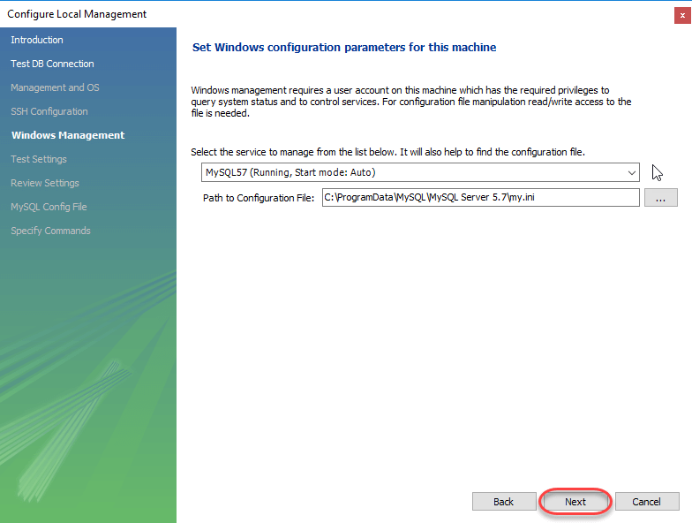](https://www.guru99.com/images/workbench-instance-6.png)

**8. The Wizard will then check ability to access MySQL Server Configuration File, and test start/stop commands.**

[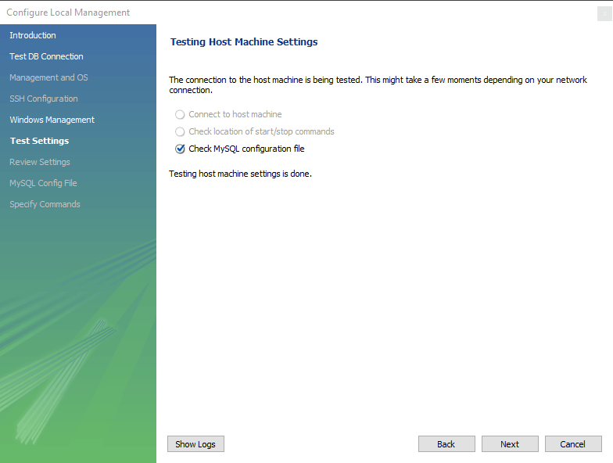](https://www.guru99.com/images/workbench-instance-7.png)

**9. Next you can review current configurations. After reviewing the configurations, Click Finish to finish server configuration**

[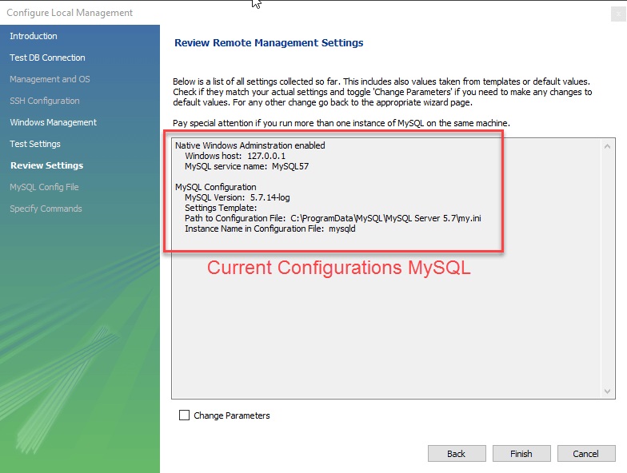](https://www.guru99.com/images/workbench-instance-7-1.png)

**10. Next Step is to setup a connection, which can be used to connect to server. If you have not created a connection already, you can use the default values given. Click on Test Connection [ 2] after entering the Connection Name [ 1 ].**

[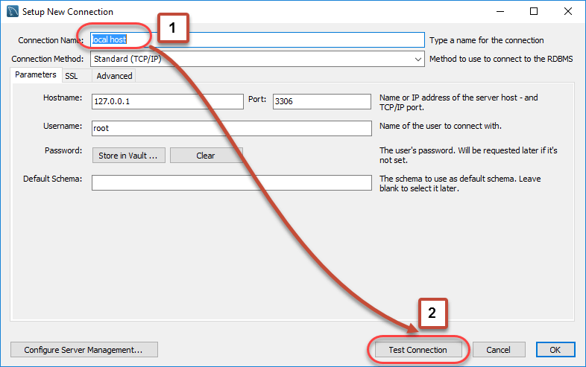](https://www.guru99.com/images/workbench-instance-8.png)

**11. A new dialog box will open asking you password to root/selected user. If your MySQL root user has a password, you can enter that using Store in Vault feature. Click OK.**

[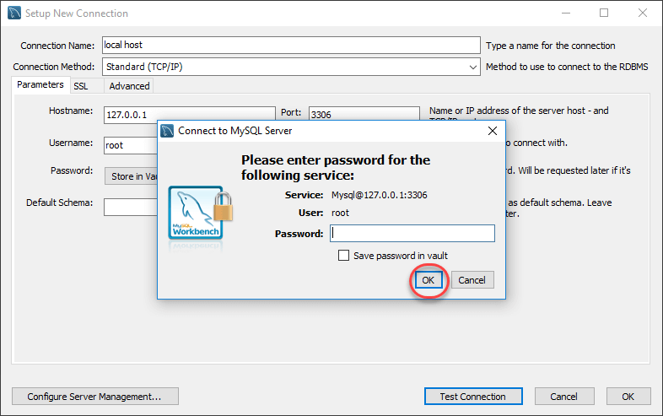](https://www.guru99.com/images/workbench-instance-9.png)

**If the entered password for the user is correct then the following screen will show. Click on both OK buttons and you will be good to go.**

[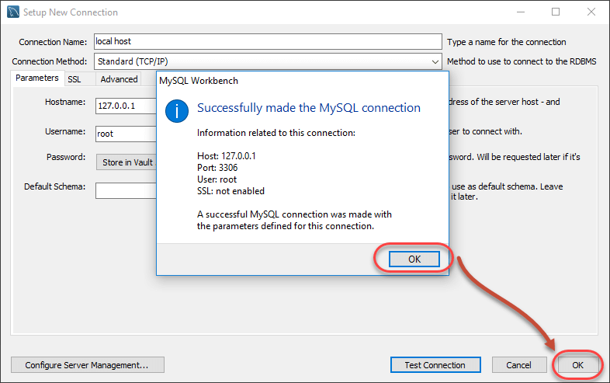](https://www.guru99.com/images/workbench-instance-10.png)

**A new instance is shown in the homepage**.

[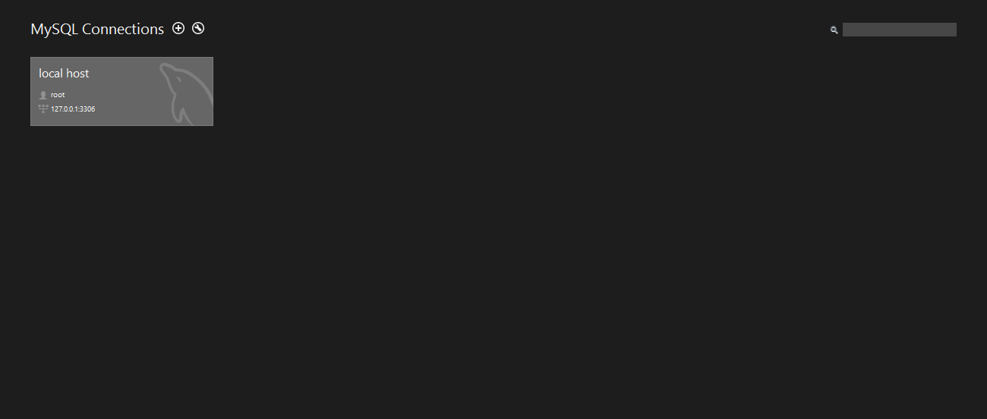](https://www.guru99.com/images/workbench-instance-11.png)

**Homepage of student counselling management system.**

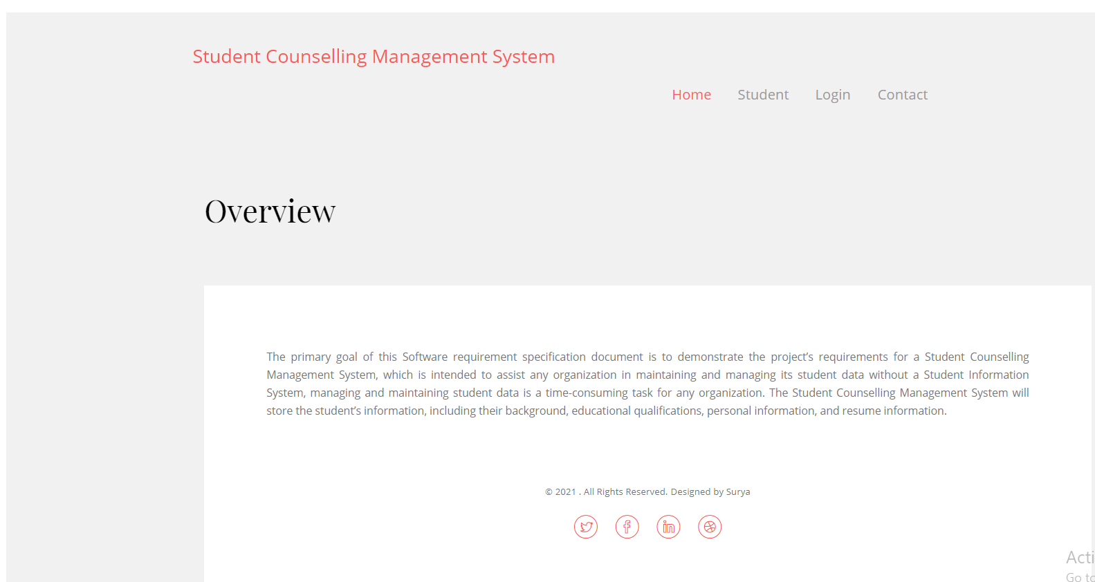

**Student Registration Page**: Here in this student registration page, the students can give the details of them and should be registering here, after they register the admin should authorise the student so they can get access to the student login.

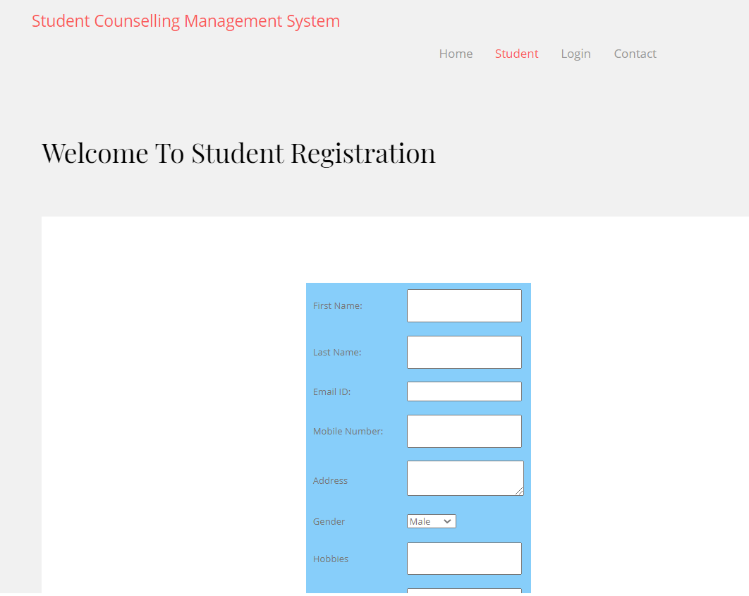

**Counsellor Login page:** Here in this login page the counsellors should fill the required details and they will be registered, and they will have their unique id and password which they can use to login to the counsellor portal.

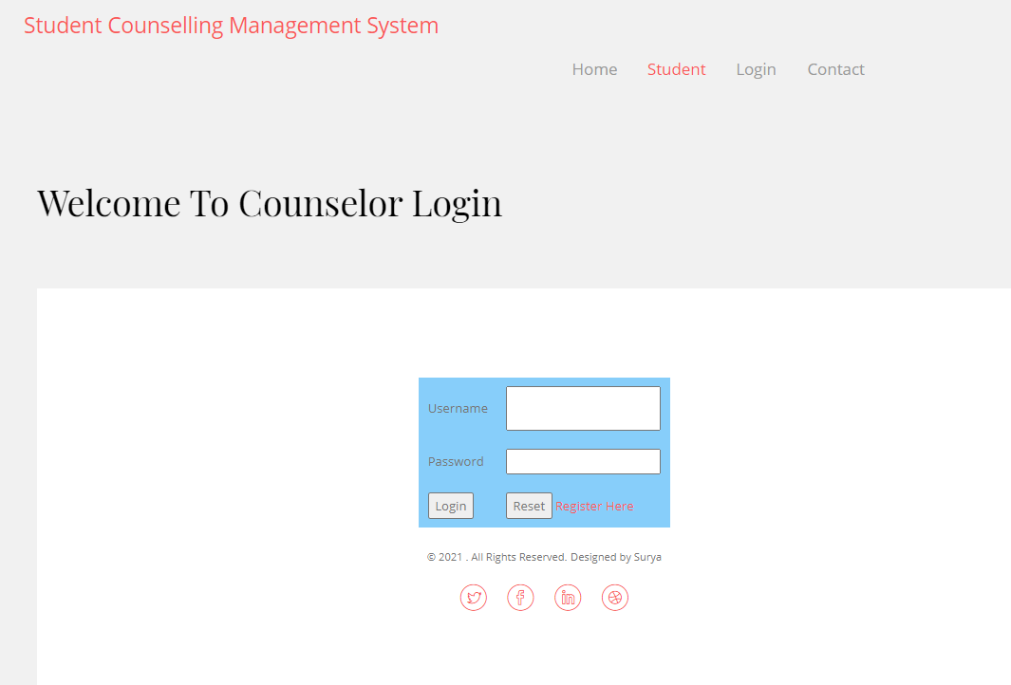

**Admin Login:** Here in this page the admin can login and the admin will have access to everything in this website and the admin should give authorisation to the student or else the student won’t have access to the student login page.

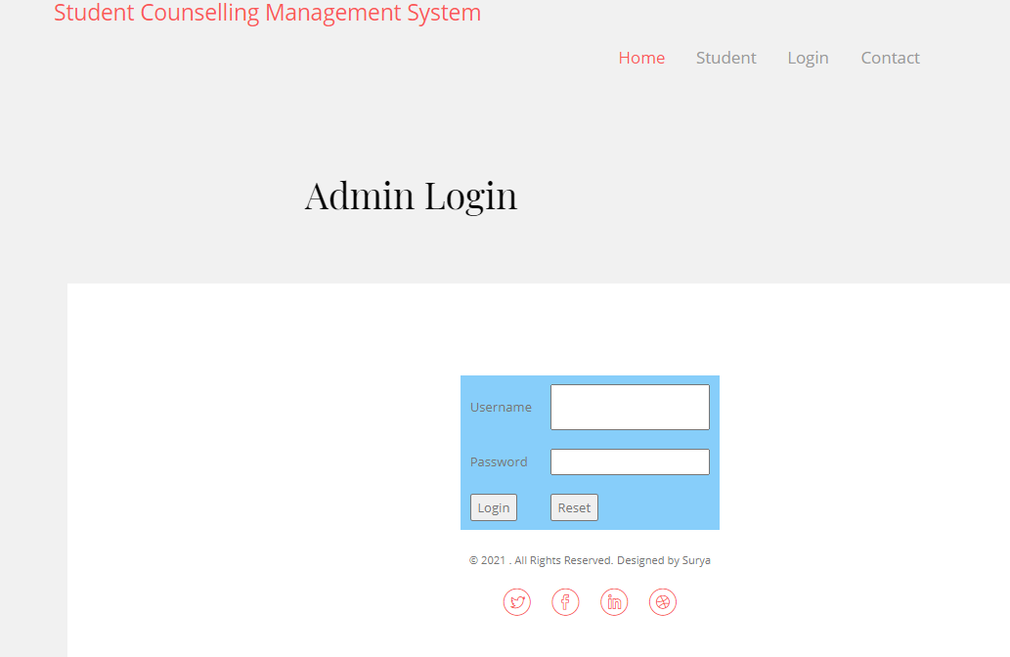

**Student Login page**: Here in this page the student can login after that they can fill the counselling form and they need to give all the details in the form, and they can give feedback.

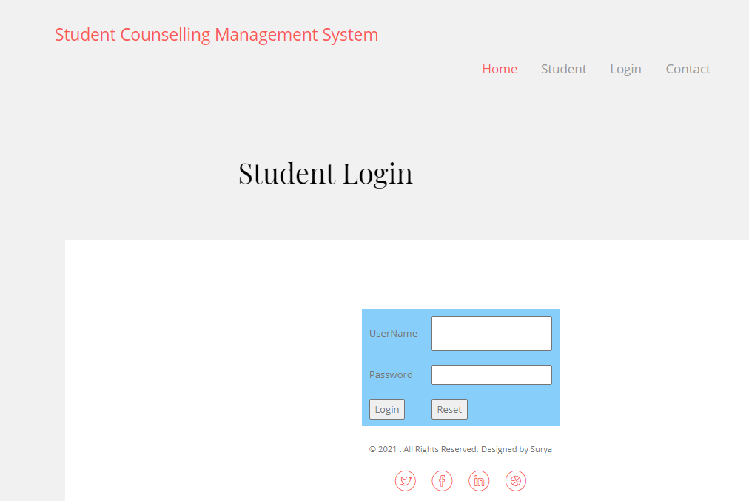

**Faculty Login:** Here in this page the faculty can login and they can view the details of each, and every student and they can update any necessary changes to the counsellor.

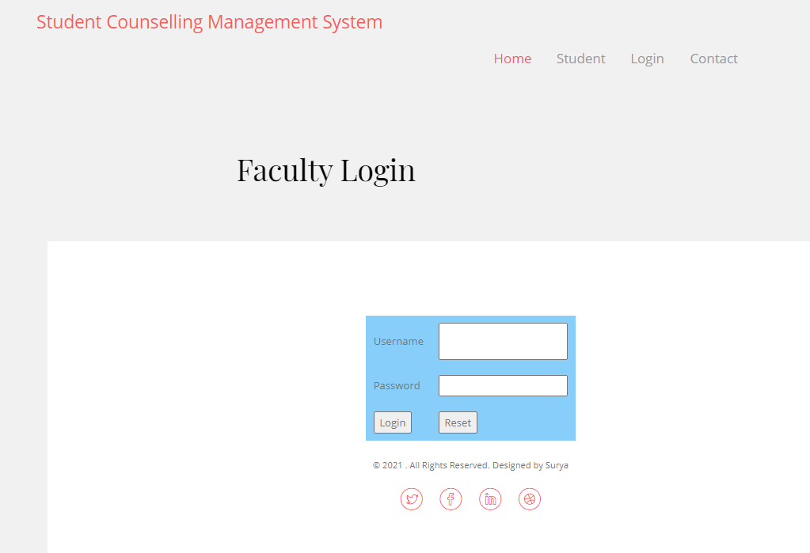

**How to open a file in NetBeans:**

* First need to unzip the file (SURYA)
* Open NetBeans, go to “file” option
* Select the option “open project”
* Select the source file (student counselling management system)
* Run the source file (student counselling management system)
* It automatically redirects to the final web page.

**If it doesn’t open and says the jar file is missing, follow these steps:**

* Right click on student counselling management system folder and go to properties
* Then in the categories go to libraries which is on the left side
* Then add jar folder which I have zipped and sent
* Then press ok. Now it will run