Scott Forsyth

SDEV 300 7983

5/10/2020

LAB 8 – Flask3 Test cases

|  |  |  |  |  |
| --- | --- | --- | --- | --- |
| Test Case | Input | Expected OUT | Actual OUT | Pass? |
| 1  Page displays on default assigned port | <instance URL>:8080 | Page Displays | Page Displays | YES |
| 2  Submit without modification of input | Submit button | /login route called  “invalid credentials” displayed, and date,time,ip logged in log.csv | /login route called  “invalid credentials” displayed, and date,time,ip logged in log.csv | YES |
| 3  Successful login | Admin  Admin  Submit button | Password checked, successful, logs.csv cleared,  Login successful page displayed | Password checked, successful, logs.csv cleared,  Login successful page displayed | YES |
| 4  Change password null value | Blank ‘new password’ field | Less than 8 characters error | Invalid Change: less than 8 characters Please select a different password. | YES |
| 5  Too long password | sahdflkashdflkjahsdlfkjhasldkfjhasldkfjhasldkfjhaslkdfjhaslkdjfhasldkjfhasldkjfhaslkdfjhasldkfjhasldfkjh | Invalid Change: more than 64 characters Please select a different password. | Invalid Change: more than 64 characters Please select a different password. | YES |
| 6  Password on common list | Superman | Password is weak | Invalid Change: Password is weak (found in common passwords list) Please select a different password. | YES |
| 7  Good password change | Newadmin | Password Changed Successfully  And updated auth.csv for the admin account | Password Changed Successfully  And updated auth.csv for the admin account | YES |
| 8  Rate limit | 15 bad attempts in 5 min | Error page saying rate was exceeded  15 logs in log.csv | Error page saying rate was exceeded  15 logs in log.csv | YES |
| 9  Log analyzer | Click “check logs”  After login | Displays logs (if any) at the bottom of the form from the failures log | Displays logs (if any) at the bottom of the form from the failures log | YES |
| 10  Logout | Click logout | Returns user to login page and displays “You have logged out” | Returns user to login page and displays “You have logged out” | YES |

Test Case 1 Screen Cap

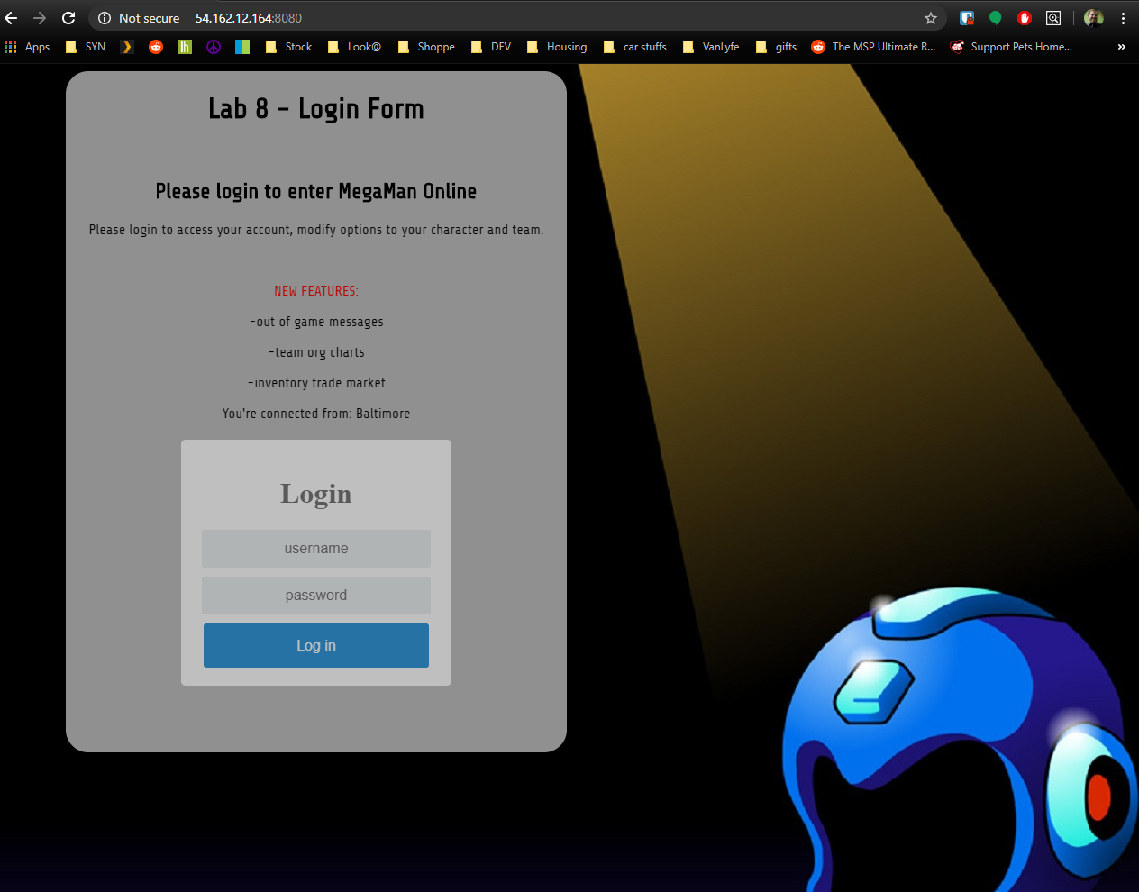

Test Case 2 Screen Cap

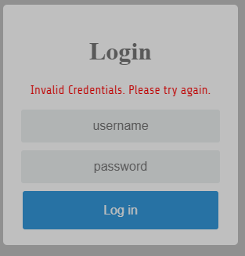

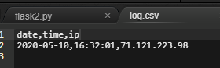

Test Case 3 Screen Cap

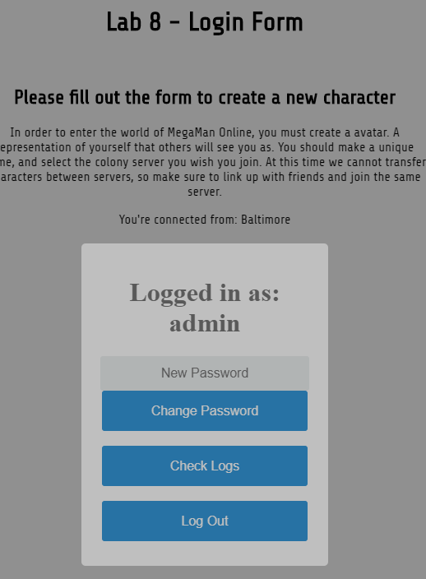

Log is cleared of IP logs with failed attempts *more than 5 attempts are logged in “failures.log” for permanent reference via the log analyzer

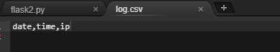

Test Case 4 Screen Captures

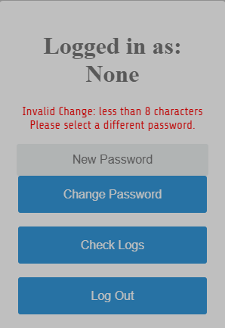

Test Case 5 Screen Captures

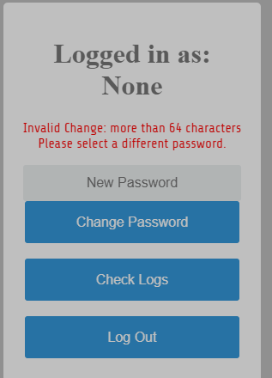

Test Case 6 Screen capture

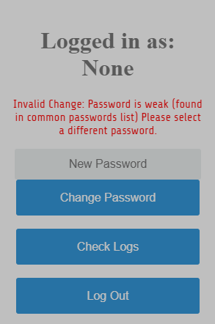

Test case 7 screen captures

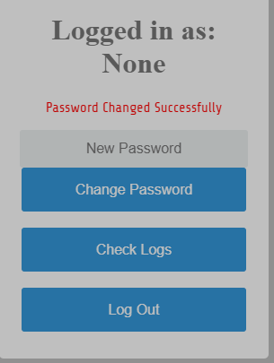

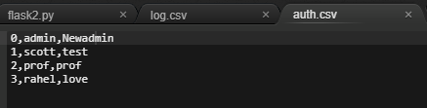

Test Case 8 (rate limit) screen shots

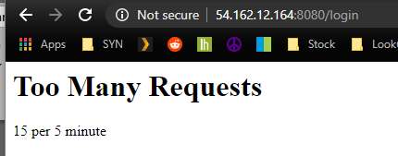

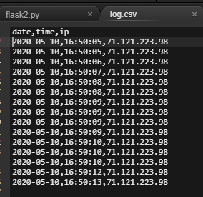

Test case 9 screen shots ( log analyzer)

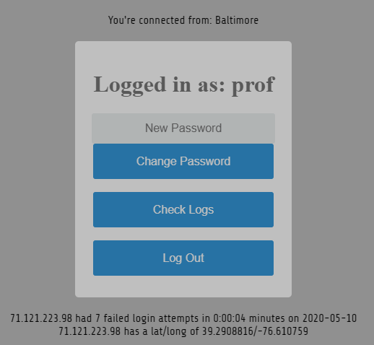

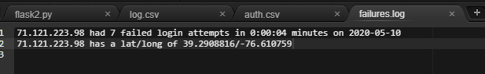

Test case 10 (log out) screen shots

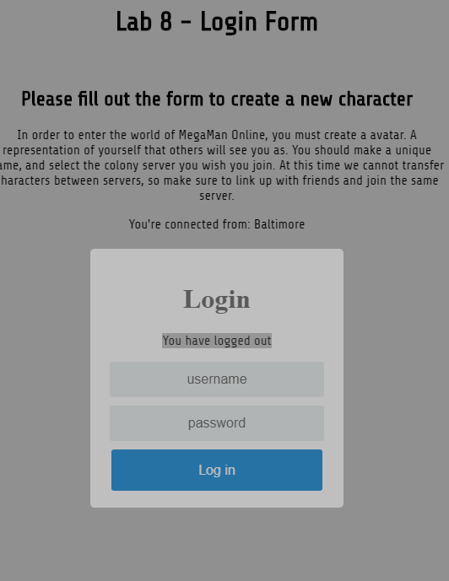

Cryptographic puzzles Results

1. Morris encoded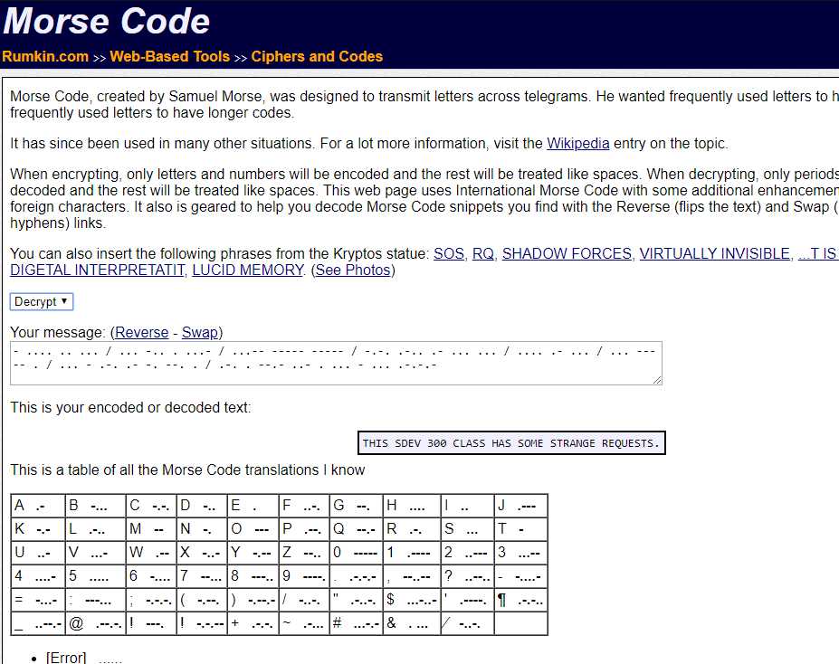

Have to admit I thought my pdf doc was corrupted for a second. Lol

Results: “THIS SDEV 300 CLASS HAS SOME STRANGE REQUESTS.”

1. Base64 encoded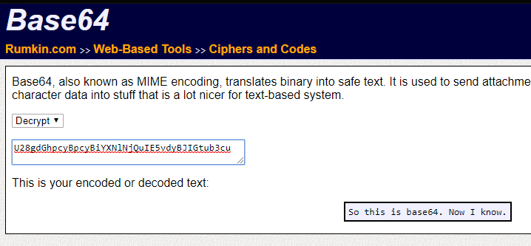

I work with a LOT of base 64 certificates, this was pretty easy

Results: “So this is base64. Now I know.”

… and knowing is half the battle

1. Caesar Cipher 38 shift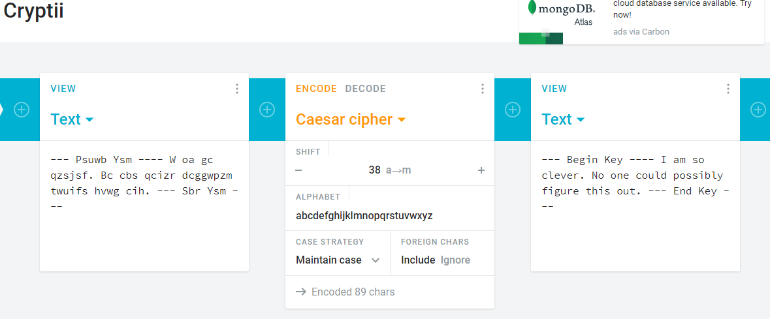

This one was hard, had to just play around with the shift until the words made sense, which makes me wonder if that there is a way to fake it so that if you have the wrong shift it’ll display one thing, and the right shift displays another.

Results: “I am so clever. No one could possible figure this out.”