Trading Strategy Lab
Functional specification, implementation, deployment, and testing
Final project report | Version 1.1 | 10 October 2026
Executive summary
Trading Strategy Lab turns a strategy write-up into a versioned Markdown document, reviews it with Indian options charges, and trades only a frozen copy of a version a person has approved. The Review Crew runs inside the API. The Trade Crew runs as a separate process. Paper and Sandbox are the broker adapters in this repository. No exchange broker ships here.
A markets screen shows delayed quotes and candle charts from Yahoo Finance and accepts manual paper orders with Indian charges. Those orders are separate from the Trade Crew.
Three databases keep the records. The research database stores strategies, reports, simulated trades, reviews, manual paper orders, and a hash-chained audit log. The live database stores approvals, orders, fills, credentials, and its own audit log. The market database stores NSE end-of-day prices, events, and headlines, and it is not audited.
An LLM may extract a strategy, explain a proposal, or comment on an entry the rules already approved. It does not open or close a trade. A veto, when explicitly enabled, can only skip or shrink that entry.
This report states the behaviour the current code implements. It does not add service-level percentages the repository does not measure.
Report navigation
Section
Content
1–3
Problem, functional specification, security and API contracts
4–7
Architecture, implementation, workflows, simulation and orders
8–10
Database, data lifecycle, review and evaluation
11–12
Deployment configuration and runbook
13–14
Tests and the checks the code enforces
15
Limitations and source register
1 Problem statement and objectives
Business problem
A retail options idea usually arrives as a video, a caption, a note, or Markdown. Rewriting it into rules, costing the trades, and then placing orders that still match the reviewed text is a manual process. The write-up and the orders can diverge, and a later edit can erase the version that was approved.
Proposed solution
The lab ingests the source, stores each strategy version, and runs a Review Crew over backtest and forward windows. Approval copies one version into the live database with its content hash and rules hash. A Trade Crew ticks that frozen copy. If the hashes no longer match, the deployment halts.
Stakeholders
Stakeholder
Need
What the system stores
Strategy author
Turn a source into rules
ingest_runs, strategy_versions, Gaps
Reviewer
See net results after costs
reports, sim_trades, trade_reviews
Operator
Approve one version and watch it
deployed_strategies, deployments, heartbeats
Risk owner
Cap loss, drawdown, and size
Frozen risk_limits, drawdown and capital events
Objectives and boundaries
The objectives are an auditable version history, a costed review, and orders that come from the approved rules. The scenario verdict is not evidence that the strategy's own rules: block made money. That replay is the approval backtest. Live trading still needs a registered live-capable broker. Paper and Sandbox are the adapters in this tree. Sandbox live mode exists only when SANDBOX_ALLOW_LIVE=true, and it does not send orders to an exchange.
2 Functional specification
ID
Function
Required behaviour
FR01
Ingest
Accept youtube, instagram, document (HTML), notebooklm, or markdown. Reject PDF URLs.
FR02
Extract
Produce Markdown with a rules: block. Unexpressed rules go into Gaps. Do not invent thresholds. Return clarifying questions; answers re-extract from the stored source into a new version.
FR03
Review
Run audit, scenarios, simulation, hard-stop sweep, per-trade review, verdict, and improvements.
FR04
Journal
List simulated and live trades with entry reason, target, net, and outcome.
FR05
Improvements
Record accepted, rejected, or applied. Applied saves a new strategy version.
FR06
Archive
Soft-delete a strategy. The row stays.
FR07
Approve
Freeze one version onto a broker account. Refuse when rules fail, Gaps remain, or the hash confirmation does not match.
FR08
Trade
Tick only while the deployment is started. Rules in code decide entries and exits.
FR09
Kill switch
Stop first, then cancel working orders. Flatten, which closes positions, requires an API token.
FR10
Audit
Append a hash-chained event for research writes and for live writes. Expose a verify route for each chain.
FR11
Markets
Show delayed quotes and candles. Place manual paper orders with charges and net them into positions. Commodities are view-only.
The dashboard is /. Markets is /markets. The lab is /lab. Deploy is /deploy. Deployments is /deployments.
3 Security and interface contracts
Authentication
API_TOKENS holds name:sha256(token) pairs. A valid Bearer token sets the audit actor and ignores X-Actor. An invalid token is 401. When API_TOKENS is empty, research and paper mutating routes accept X-Actor, which is not authenticated.
These actions return 403 until a token exists, even if API_TOKENS is empty: broker credentials, creating a live account, live approval, live start, live veto, live capital events, and stop with flatten.
CORS_ORIGINS=* is refused at startup when any token is configured.
Broker secrets are Fernet ciphertext under BROKER_CREDENTIALS_KEY. API responses and audit details store a fingerprint, not the value.
Principal API contracts
Method and path
Contract
GET /api/health
Liveness.
POST /api/ingest/extract
Extract a strategy and store the ingest run.
POST /api/ingest/clarify
Re-extract with the author's answers. Needs an LLM key and an ingested version.
POST /api/review/run
Run the Review Crew and store the report.
POST /api/demo/run
Run the bundled fixture.
GET /api/journal
Merge simulated and live trades.
GET /api/audit/verify
Recompute the research hash chain.
GET /api/market/quotes, GET /api/market/candles
Delayed Yahoo data. 400 for an unknown symbol.
POST /api/paper/orders
Record a manual paper order with charges.
GET /api/paper/positions
Positions netted from paper orders, marked at the latest quote.
GET /api/live/approvals/preview
Rules, hash, blockers, verdict.
POST /api/live/approvals/backtest
Rules only versus rules with policy and ladder.
POST /api/live/approvals
Freeze the version and create the deployment.
POST /api/live/deployments/{id}/start
Start from approved or paused.
POST /api/live/deployments/{id}/stop
Kill switch. flatten: true closes positions.
GET /api/live/audit/verify
Recompute the live hash chain.
Live reads return 503 until alembic -n live upgrade head has been applied. The full route list is in backend/README.md.
4 System architecture
The browser talks only to FastAPI. FastAPI fetches quotes and candles from Yahoo Finance per request. The Review Crew runs in that process. The Trade Crew does not. A supervisor starts one crew subprocess per started deployment.

Research, live, and market data are three databases. Approval copies the strategy text and hashes into the live database. It does not foreign-key back to research.
vendor/TradingAgents is not imported. Langfuse keys in .env.example are not read.
5 Implementation design
Technology
Role
FastAPI and Uvicorn
HTTP API and OpenAPI
Pydantic and pydantic-settings
Requests and Settings
SQLAlchemy 2 and Alembic
Research and live schemas. Market tables use create_all
LangGraph
Review Crew and Trade Crew graphs
LangChain OpenAI or Anthropic
The one provider selected by LLM_PROVIDER
HTTPX, Beautiful Soup, lxml
HTML ingest. HTTPX also fetches Yahoo market data
youtube-transcript-api
YouTube transcripts
cryptography
Fernet for broker credentials
Next.js 15, React 19, Tailwind 4
Dashboard, markets, lab, deploy, and deployments pages
lightweight-charts
Candle charts on the markets page
pytest
Backend tests. No test calls a real LLM or a real broker
There is no vector store, no Auth0, and no separate metrics service.
6 Workflows

Review order is fixed: audit, scenarios, simulate, hard-stop sweep, trade review, verdict, improve. The sweep can propose a capital stop. It does not set verdict_label. The label is Not executable, Profitable, Conditional, Too few trades, or Not profitable.
A Trade Crew tick verifies the frozen hashes, checks that the deployment is started, checks market hours on the broker feed, observes, reconciles, exits, applies drawdown and the capital floor, then considers an entry. Once an entry is reached, risk, opinion, explain, and execute all run. Opinion changes lots only in veto mode, and only downward.
7 Simulation and orders
Backtests walk the strategy rules on end-of-day closes. Charges use the cost profile and, when the trade date is known, the STT and exchange schedules. Without imported NSE data, the bundled sample is used and the report says so.
Orders go through backend/app/trading/orders.py for paper and live. Hedges are sent before short legs. An unfilled order is cancelled and re-priced within MAX_SLIPPAGE_BPS. A failed entry unwinds filled legs and halts. With protective stops enabled, each filled short leg gets a broker stop-limit wider than the strategy stop.
8 Database diagram

Research head is Alembic 0006_paper_orders. Live head is 0005_broker_credentials. The market database has no Alembic revision. Column definitions are in CURRENT_DATABASE_ARCHITECTURE.md.
9 Data model and lifecycle
Table group
Purpose
strategies, strategy_versions, ingest_runs
Identity, immutable text, extract record
reports, simulation_runs, sim_trades
One review and its trades
trade_reviews, strategy_improvements, improvement_decisions
Reviews and human decisions
paper_orders
Manual paper orders from the markets screen
audit_events
Research hash chain
deployed_strategies, deployments, deployment_events
Frozen approval and status
trade_intents, orders, order_events, fills, live_trades
Decisions and broker activity
capital_events, drawdown_events, position_snapshots
Money, ladder, marks
trade_opinions, phantom_trades, live_trade_reviews
LLM comments and lessons
broker_credentials, crew_heartbeats, live_audit_events
Secrets, liveness, live audit
index_bars, option_eod, import_files, market_events, news_items
Reference data
strategies can be updated and cannot be deleted. Every other research and live table rejects update and delete in the ORM and with database triggers. A review correction is a new row. Credential rotation is a new row. Market rows may be updated. Importers skip a file whose sha256 is already in import_files.
10 Review and evaluation
Check
What it decides
Where it is stored
Scenario verdict
Whether the fixed windows passed after costs
reports.verdict_label
Hard-stop sweep
A recommended capital stop
reports.payload
Trade review
Process verdict and mistake tags
trade_reviews
Approval backtest
Rules only versus rules with policy and ladder
Returned by the API. Not a report row
Opinion evaluation
Rules versus following the opinion, after enough samples
Computed by GET /api/live/opinions/evaluation
There is no RAGAS score and no latency SLO in this repository. OPINION_EVAL_MIN_SAMPLES defaults to 30 before an opinion comparison is treated as having enough closed samples.
11 Deployment design and configuration
Piece
How it runs
API
uvicorn app.main:app on port 8841
UI
npm run dev -- -p 8842
Trade Crew
python -m app.agents.trade_crew or python -m app.live supervise
Supervisor service
backend/deploy/com.genesis.supervisor.plist or genesis-supervisor.service
There is no Dockerfile and no compose file. PostgreSQL is supported for the research and live URLs. The psycopg driver is not declared in backend/pyproject.toml.
Unset variables use the defaults in Settings. A copied .env.example overrides capital, lots, portfolio caps, and the common risk rules. The table is in CURRENT_SYSTEM_ARCHITECTURE_ANALYSIS.md. Strategy frontmatter overrides cost and size. For common risk keys, the stricter of the environment value and the strategy value wins.
12 Deployment and operations runbook
1. Copy .env.example to .env. Set LLM_PROVIDER and one API key only if extract or opinions should call a model. The demo fixture runs without a key.
2. From backend/, run uv sync, uv run alembic upgrade head, and uv run alembic -n live upgrade head.
3. Start the API on port 8841 and the UI on port 8842.
4. Import NSE data, events, and holidays before relying on backtests or blackouts. Without them, simulations use the sample and a blackout rule blocks entries.
5. Create a paper account, preview the rules, confirm rules_sha256, and approve. Then start the deployment and run the supervisor or one crew process.
6. For live mode, set API_TOKENS, BROKER_CREDENTIALS_KEY, LIVE_TRADING_ENABLED, and a live-capable adapter. This repository does not include that adapter. Sandbox can exercise the gates when SANDBOX_ALLOW_LIVE=true.
Halt, missed heartbeats, floor pauses, and a kill switch that fails to cancel or flatten send alerts when Telegram or SMTP is configured. A failed alert is logged and does not block trading.
13 Functional and integration test plan
The automated suite is uv run pytest in backend/. Tests migrate temporary SQLite files, so the append-only triggers run. They do not call a real LLM, a real broker, or the network.
Area
What the tests cover
Research schema
Versioning, immutability, audit chain, journal, import
Markets and clarify
Yahoo parsing, paper charges and netting, clarifying questions
Review
Rules, costs, hard-stop sweep, improvements
Trade Crew
Entry, exits, blocked intents, tampered snapshots, kill switch
Money
Drawdown ladder, capital floor, withdrawal, odds gate, policy
Live plumbing
Sandbox orders, margin, protective stops, credentials, auth, supervisor
A release check is: migrations apply, GET /api/health returns, the demo run writes a report, audit verify passes, and a paper approval is refused when Gaps are present. The demo strategy omits short_distance and cannot be approved.
14 Checks the code enforces
Check
Gate
Audit
Both verify routes recompute the hash chain and report the first broken row
Money
Amounts are Numeric(18, 4)
Approval
Parsed rules, empty Gaps, matching confirm_rules_sha256, a completed report, actor or token, matching account mode, no other active deployment of that strategy in that mode
Live approval
LIVE_TRADING_ENABLED, registered live broker, credentials, structure on LIVE_ALLOWED_STRUCTURES, and LIVE_MIN_PAPER_DAYS when set
Crew
Hash mismatch, position mismatch, or a failed order halts the deployment
Secrets
Credential routes never return the stored value
These are code gates. They are not measured latency or accuracy percentages.
15 Limitations and source register
Limitations
• No Zerodha, Upstox, Dhan, or Angel One adapter is registered.
• Report verdicts do not replay the strategy rules: block. The approval backtest does.
• Protective stops are per short leg and wider than the strategy stop. A gap can pass the limit.
• SQLite allows one writer. Several crews on SQLite will contend. PostgreSQL is the documented alternative.
• The credential key sits on the same host as the database.
• Reconciliation halts on any manual trade in the account.
• Daily broker login is manual.
• Langfuse is not integrated.
• PDF ingest is rejected.
• Market quotes come from Yahoo's unofficial API. They are delayed, can break without notice, and have no MCX data. Paper option positions are not marked.
Source register
Source
Use in this report
DocumentsAndDiagrams/Readme.md
Problem statement and goals
CURRENT_SYSTEM_ARCHITECTURE_ANALYSIS.md
Components, API, configuration precedence
CURRENT_DATABASE_ARCHITECTURE.md
Tables, revisions, relationships
DATABASE_TABLE_REFERENCE.md
Writers and readers
LIBRARIES_AND_DEPENDENCIES.md
Libraries and unused declarations
backend/README.md
Operator procedures and live gates
diagrams/architecture.svg
Section 4
diagrams/workflow.svg
Section 6
diagrams/database.svg
Section 8
Analysis date: 10 October 2026. Schema claims come from the ORM and the Alembic heads. No live database was opened to produce this report.
Figures
Figure 1. Current architecture
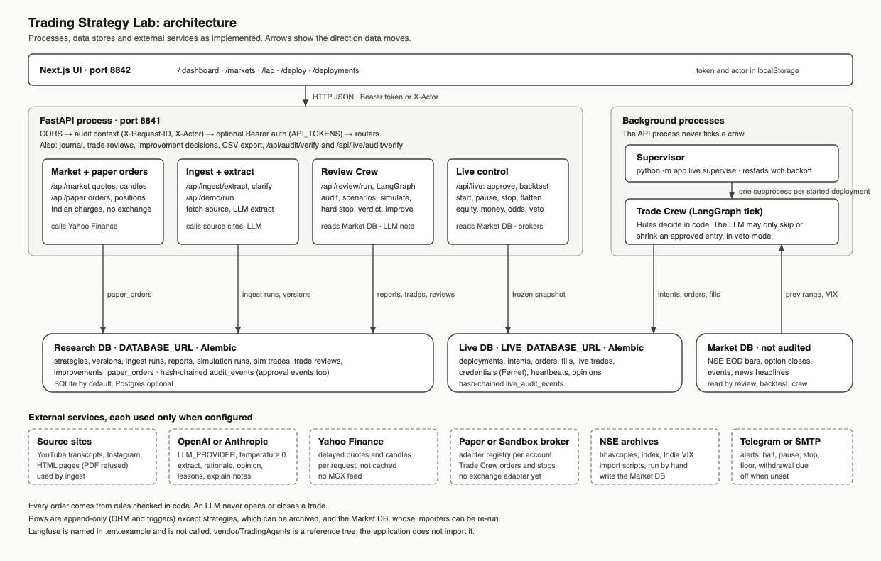
Figure 2. Review Crew and Trade Crew
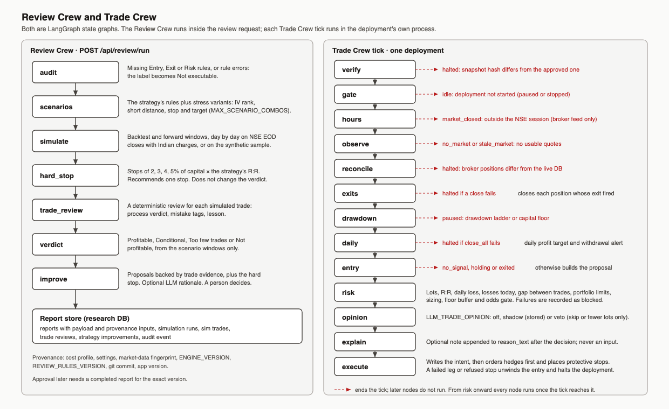
Figure 3. The three databases
