Wellbeing Coach
April 2026
1. Functional Requirements and Problem Context
Problem Statement
Wellbeing Coach is a personalized 5-minute mental booster designed for people facing stress, anxiety, and burnout in a fast-paced digital lifestyle.
Context
People are increasingly affected by long working hours, continuous screen exposure, and reduced personal interaction. Many wellness tools require long sessions or heavy manual input, which lowers consistency and long-term engagement.
Key Real-World Challenges
- Early signs of stress often go unnoticed.
- Most wellness apps provide limited personalization.
- Users need quick, low-effort support, not lengthy commitments.
- Overwhelming data and fragmented user experiences reduce engagement.
Project Goal
Design an AI-powered Wellbeing Coach that recommends personalized 5-minute micro-activities to improve emotional wellbeing. The solution should clearly justify what user data and context it uses to generate useful, safe, and practical suggestions.
Problem Description
- Understand user inputs and surrounding context to infer emotional state.
- Generate relevant 5-minute activities that provide quick relief, grounding, or focus.
- Learn from interaction history and feedback to improve future recommendations.
- Use LLM-based assistance to provide intuitive, supportive, and human-friendly responses.
Functional Requirements
The implementation can vary, but it must support the core intent: helping users feel better within 5 minutes.
Your solution should include:
- Emotion and context understanding from user text or other available signals.
- Fast activity recommendations (for example: mindfulness, short movement, journaling prompts, breathing, or music-based resets).
- Feedback-aware personalization that adapts recommendations over time.
- AI-generated, user-specific coaching responses that are concise, empathetic, and actionable.
Demonstration Expectation
The technical and functional design is flexible, but the prototype must show end-to-end behavior aligned with these goals in a working, testable flow.
2. Project Structure (Architect View)
C1-Wellbeing-Coach/
|- app/
| |- main.py # FastAPI app bootstrap, router registration, startup hooks
| |- config/
| | |- database.py # SQLAlchemy engine/session/base + schema initialization
| | |- settings.py # Environment-driven settings accessor
| | |- logging_config.py # Central logging setup
| |- models/
| | |- user_input.py # Input contract for emotion analysis
| | |- response.py # API response contract
| | |- feedback.py # Feedback input contract
| | |- interactions.py # SQLAlchemy ORM table model
| |- routes/
| | |- wellbeing.py # /wellbeing/analyze and /wellbeing/history/{user_id}
| | |- feedback.py # /feedback/store
| |- services/
| | |- emotion_service.py # Emotion detection (gibberish check + LLM call/fallback)
| | |- recommendation_service.py # Recommendation generation from emotion + trend/history
| | |- memory_service.py # Interaction persistence/history retrieval
| | |- feedback_service.py # Feedback validation and update workflow
| | |- llm_service.py # Gemini/Gemma client adapters
| | |- service_factory.py # DI provider methods for FastAPI Depends
| |- exceptions/
| | |- Custom_Exceptions.py # Domain-specific exceptions
| |- utils/
| |- prompts.py # Prompt templates used by LLM-dependent services
|- data/
| |- activities.json # Static recommendation support data
|- scripts/
| |- create_test_db.py # Creates PostgreSQL test DB
| |- populate_test_data.py # Seeds test data when needed
|- tests/
| |- configTest/ # Shared fixtures, env, DB setup for tests
| |- unit/ # Unit tests (services, models, config)
| |- integration/ # Route-level integration tests
|- run.py # App launch entrypoint (uvicorn host 0.0.0.0, port 9000)
|- requirements.txt # Runtime dependencies
|- requirements-test.txt # Test dependencies
|- pytest.ini # Test discovery and pytest defaults
|- ENV_SETUP.md # Environment setup details
|- QUICKSTART.md # Quick execution and testing commands

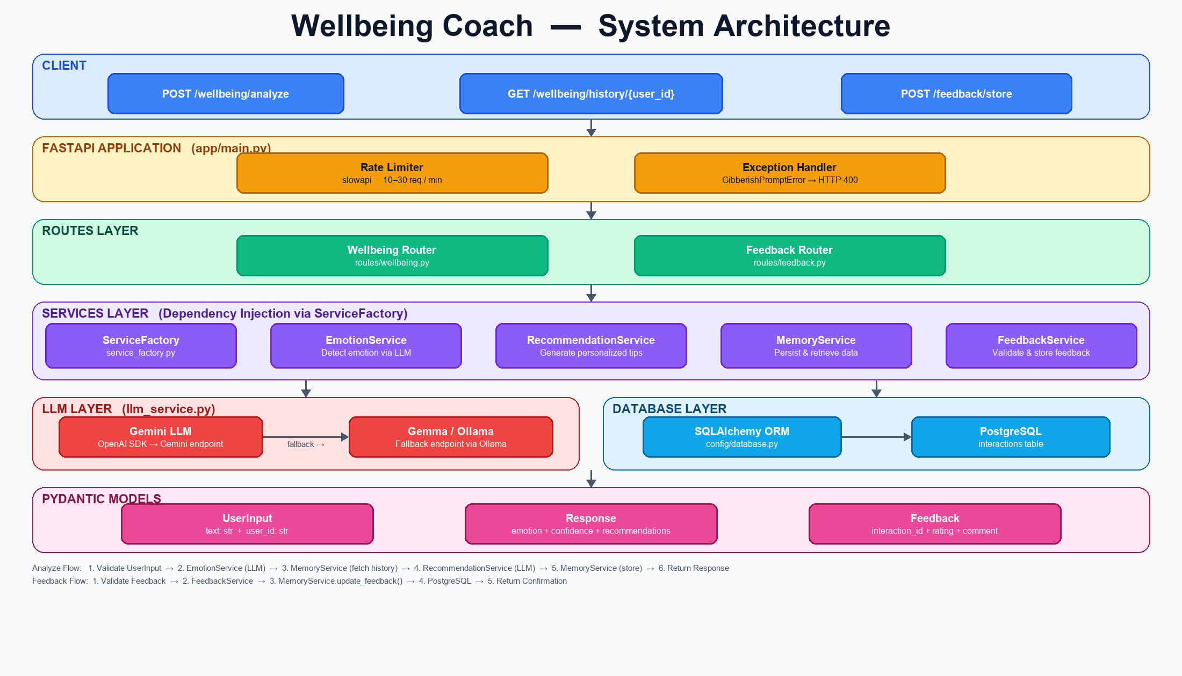
3. End-to-End Application Flow
3.1 Wellbeing Flow
Client
-> FastAPI route (/wellbeing/analyze)
-> EmotionService.detect_emotion(text)
-> gibberish validation
-> Gemini call (fallback to Gemma)
-> MemoryService.get_history(user_id)
-> fetch recent interactions from DB
-> RecommendationService.generate_recommendation(...)
-> build context from emotion + trend + prior feedback
-> Gemini call (fallback to Gemma)
-> MemoryService.store_interaction(...)
-> persist interaction row in interactions table
-> API Response (interaction_id + emotion + recommendation)

3.2 Feedback flow
Client
-> FastAPI route (/feedback/store)
-> FeedBackService.store_feedback(...)
-> validate rating/comment/feedback payload
-> MemoryService.update_feedback(interaction_id, ...)
-> update rating/feedback/comment on existing interaction row
-> API Response (feedback accepted status)

3.3 Startup flow
Process start (run.py)
-> app.main FastAPI initialization
-> startup event
-> initialize_database()
-> Base.metadata.create_all(engine)
-> API ready

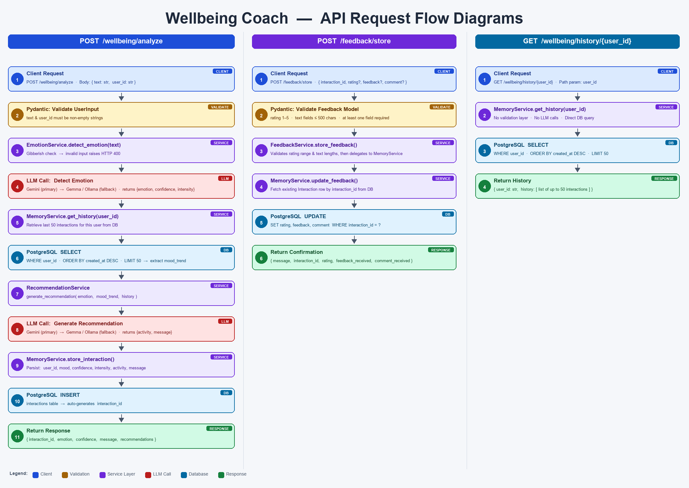
4. API Surface (Current)
Wellbeing Routes
- POST /wellbeing/analyze
- Input: user_id, text
- Output: interaction_id, emotion, confidence, message, recommendations
- GET /wellbeing/history/{user_id}
- Output: user interaction history (latest first, capped in service)
Feedback Route
- POST /feedback/store
- Input: interaction_id, optional rating, optional feedback, optional comment
- Output: feedback submission acknowledgement
5. Database Tables
The codebase currently defines one SQLAlchemy table.
5.1 `interactions` table
Column | Type | Null | Notes
interaction_id | Integer | No | Primary key, auto-increment
user_id | String | No | Logical user identifier
user_input | Text | No | Original user message
mood | String | Yes | Emotion label from analysis
intensity | Float | Yes | Emotion intensity (numeric)
confidence | Float | Yes | Confidence score
activity | Text | Yes | Recommended activity
message | Text | Yes | Recommendation message
rating | Integer | Yes | User rating (typically 1–5)
feedback | Text | Yes | Optional feedback text
comment | Text | Yes | Optional comment text
created_at | DateTime (timezone) | Yes | Server default now()

5.2 Table ownership by feature
- Interaction lifecycle (analyze + persist): MemoryService.store_interaction
- History retrieval: MemoryService.get_history
- Feedback mutation: MemoryService.update_feedback

6. Requirements
6.1 Platform and tooling
- Python >=3.12
- PostgreSQL running and reachable (default: localhost:5432)
- uv package manager (recommended by project docs)
6.2 Runtime dependencies (requirements.txt)
- fastapi==0.104.1
- uvicorn[standard]==0.24.0
- pydantic==2.5.0
- pydantic-settings==2.1.0
- openai>=1.55.3,<2.0.0
- httpx<0.28
- python-dotenv>=1.2.2
- psycopg[binary]==3.2.13
- SQLAlchemy==2.0.34
- slowapi>=0.1.9
6.3 Test dependencies (requirements-test.txt)
- pytest==7.4.3
- pytest-cov==4.1.0
- pytest-asyncio==0.21.1
- pytest-mock==3.12.0
- httpx==0.25.2
6.4 Required environment variables
You can use DATABASE_URL, or the split DB_* values:
- DB_USER
- DB_PASSWORD
- DB_HOST
- DB_PORT
- DB_NAME
LLM-related settings used by the service layer:
- OPENAI_API_KEY
- OPENAI_BASE_URL
- OPENAI_MODEL
- OLLAMA_API_KEY
- OLLAMA_BASE_URL
- OLLAMA_MODEL

Useful runtime controls:
- RATE_LIMIT_PER_MINUTE
- TEST_WITH_MOCK_DATA — set true for deterministic testing scenarios
7. How To Run the App
7.1 Install dependencies
uv pip install -r requirements.txt
7.2 Configure environment
1. Copy .env.example to .env.
2. Set PostgreSQL credentials or DATABASE_URL.
3. Set LLM credentials/endpoints.
7.3 Ensure database exists
Create the main database (example):
createdb -h localhost -U skoust wellbeing_coach
On app startup, schema creation is automatic through initialize_database().
7.4 Start the API server
uv run python -m run
Default URL: http://localhost:9000
8. How To Run Test Cases
8.1 Install test dependencies
uv pip install -r requirements-test.txt
8.2 Create test database (first time)
uv run python scripts/create_test_db.py
8.3 Execute tests
Run all tests:
uv run python -m pytest tests/ -v
Run unit tests only:
uv run python -m pytest tests/unit/ -v
Run integration tests only:
uv run python -m pytest tests/integration/ -v
Run service tests only:
uv run python -m pytest tests/unit/services/ -v
Run with coverage:
uv run python -m pytest tests/ --cov=app --cov-report=html
9. Architecture Notes and Recommendations
- The project follows a clean route → service → persistence layering style.
- ServiceFactory keeps route handlers decoupled from concrete service construction.
- Current data model stores both interaction output and feedback in a single table; this is simple and works for early-stage products.
- If scale increases, a future split into interactions and feedback tables can improve normalisation and reporting flexibility.

