AI Real Estate Assistant
Technical Demo & Architecture Reference
May 2026

- Functional Requirements and Problem Context

Problem Context
Finding the right home is often a complex and overwhelming process. Users must browse through numerous listings across multiple platforms while also evaluating neighbourhoods, commute convenience, nearby amenities, and lifestyle suitability. Most real-estate platforms provide limited personalization and lack contextual understanding of user preferences, leading to inefficient decision-making and poor user experience.
The Real Estate Assistant aims to simplify this journey through an AI-powered conversational experience that helps users discover suitable homes based on budget, preferred locations, commute needs, family requirements, and lifestyle preferences while maintaining session context and delivering intelligent recommendations.

Functional Requirements
The system should provide a conversational AI assistant capable of understanding user preferences such as budget, location, commute requirements, family size, and amenities. It should integrate with geolocation and neighbourhoods APIs to fetch coordinates, nearby facilities, and locality insights. The assistant must recommend suitable properties, provide neighbourhoods and commute analysis, and deliver lifestyle-based suggestions tailored to the user. Additionally, the application should support session memory, multi-step workflow orchestration, secure backend APIs, optional authentication with Auth0, and observability using Langfuse for monitoring agent workflows and API interactions.

- Project Structure (Architect View)
The application follows a modular AI-driven architecture with a clear separation between the frontend, backend APIs, orchestration layer, and AI tool ecosystem.
Core Architecture Components
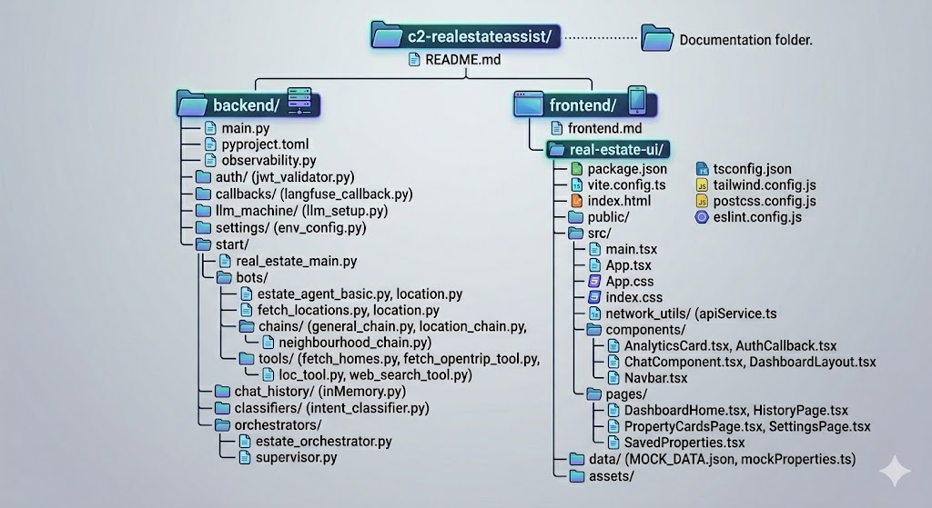

High-Level Architecture Flow
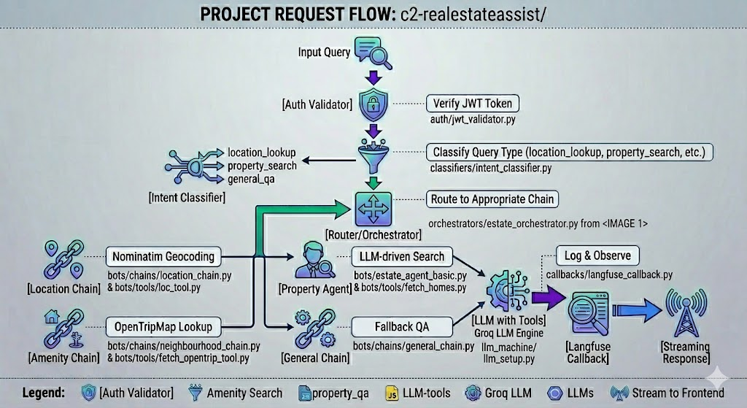
2. End-to-End Application Flow
- User authenticates through Auth0 and receives a bearer access token.
- Frontend attaches the JWT token and session identifier to API requests.
- FastAPI validates the JWT token and resolves authenticated user context.
- The orchestration layer classifies the incoming query intent.
- The supervisor agent determines the appropriate execution workflow.
- Selected chains invoke required tools such as:
  - geocoding,
  - amenities lookup,
  - property search,
  - external web search.
- The LLM generates contextual responses using chain prompts and tool outputs.
- Backend streams incremental responses to the frontend using Server-Sent Events (SSE).
- Session history is persisted in memory to maintain conversational continuity.
- Langfuse captures traces, execution metrics, and tool-level observability data.

3. API Surface (Current)
Endpoint | Method | Purpose
/chat | POST | Streams AI-generated conversational responses
/new-session | GET | Creates a new conversation session identifier
/check | POST | Developer/testing endpoint for streaming validation

4. Requirements
4.1 Frontend Libraries
Library | Purpose
React | Component-based frontend framework
Vite | Fast frontend build and development tooling
Tailwind CSS | Utility-first responsive styling framework
@auth0/auth0-react | OAuth authentication integration
React Router | Client-side routing and navigation

4.2 Backend Libraries
Library | Purpose
FastAPI | High-performance Python framework for building REST and streaming APIs
uvicorn[standard] | ASGI server used to run FastAPI applications in development and production
python-dotenv | Loads environment variables from .env files into the application runtime
LangChain | AI orchestration framework for chains, agents, prompts, and tool execution
langchain-openai | OpenAI-compatible LangChain integration layer for LLM connectivity
langchain-groq | LangChain integration package for Groq-hosted LLM inference
groq | Official Groq SDK for accessing LLM models and completions
requests | HTTP client library for external API communication
python-jose[cryptography] | JWT token validation and authentication handling for Auth0 integration
Langfuse | LLM observability, tracing, telemetry, and execution monitoring platform
opentelemetry-sdk | Core OpenTelemetry SDK for distributed tracing instrumentation
opentelemetry-api | OpenTelemetry API definitions and telemetry interfaces
opentelemetry-exporter-otlp | Exports telemetry and traces to OTLP-compatible observability backends
tavily-python | Web search integration library for external AI-assisted search workflows
typing-extensions | Backport support for advanced Python typing features and annotations

4.3 Environment Variable Configuration
- Backend Config
  - AUTH0_DOMAIN=your-domain.auth0.com
  - API_AUDIENCE=https://your-api-identifier
  - ALGORITHMS=RS256
  - GROQ_API_KEY=your_groq_api_key_here
  - LLM_MODEL=mixtral-8x7b-32768
  - TAVILY_API_KEY=your_tavily_key_here
  - OPENTRIPMAP_API_KEY=your_opentripmap_key_here
  - LANGFUSE_PUBLIC_KEY=your_langfuse_public_key
  - LANGFUSE_SECRET_KEY=your_langfuse_secret_key
  - LANGFUSE_HOST=https://cloud.langfuse.com

- Frontend Config
  - VITE_AUTH0_DOMAIN= your-domain.auth0.com
  - VITE_AUTH0_CLIENT_ID=<auth0_client_id>
  - VITE_AUTH0_AUDIENCE= https://your-api-identifier

5. How To Run the App
Backend Setup
- uv sync
- uv run main.py
Frontend Setup
- npm install
- npm run dev

Summary
The AI Real Estate Assistant leverages a modular AI orchestration architecture integrating conversational AI, intelligent workflow routing, secure authentication, streaming APIs, and observability tooling to deliver a scalable and enterprise-ready property discovery platform.

