Technical Documentation
Autonomous Investment Strategy Board
Stateful multi-agent financial decision-support prototype
This document describes the system as implemented. The application helps a user inspect market context, import a portfolio, monitor symbols, and obtain evidence-grounded analysis of a portfolio or a single stock. It does not execute trades, connect to a brokerage, or run continuous autonomous agent loops.
1. Architecture Overview
The system is a modular application with a React user interface and a Python backend. The backend exposes a FastAPI HTTP API. Use-case services handle dashboard, portfolio upload, stock lookup, watchlist, and analysis. Only analysis requests enter the LangGraph workflow.
Main components
Layer | Implementation | Role
Frontend | React, TypeScript, Vite | Dashboard, Upload Portfolio, Portfolio Analyzer, Stock Analyzer, Watchlist
API | FastAPI | HTTP entry point for all user actions
Services | Python use-case layer | Upload, retrieval, watchlist, and analysis mapping
Persistence | In-memory stores, or PostgreSQL when DATABASE_URL is set | Staged uploads, imported portfolios, stored analyses, watchlist symbols
Workflow | LangGraph (InvestmentState) | One compiled graph per analysis request
Agents | Specialist agents behind a shared execution wrapper | Market, fundamental, risk, and optimization analysis
Tools | Deterministic Python functions | Indicators, ratios, risk metrics, mean-variance optimization, CSV/XLSX parsing
Providers | Contract-based adapters | LLM, market data, fundamentals, and news

How components interact
The UI calls the API. Dashboard, stock lookup, and watchlist services read the configured market and fundamental adapters and return current information. They do not start the agent graph.
Portfolio and stock analysis services build an InvestmentState, invoke the compiled graph once, map the final state to a public result, and store it. Graph nodes call specialist agents through an execution wrapper. Agents retrieve data through provider contracts and compute figures in Python tools. The LLM interprets structured evidence, classifies the request, critiques findings, and synthesizes the final recommendation. It is not used to invent prices or other missing figures.
LLM and data adapters
- LLM: stub, openai, groq, google, or azure, selected by configuration. An optional fallback adapter is tried once if the primary provider fails.
- Market data: stub or Yahoo Finance.
- Fundamentals: stub or Yahoo Finance.
- News: stub or Yahoo Finance adapters are registered and reported by health checks, but no agent or analysis node currently retrieves news.
Optional Langfuse tracing is enabled only when credentials are configured.
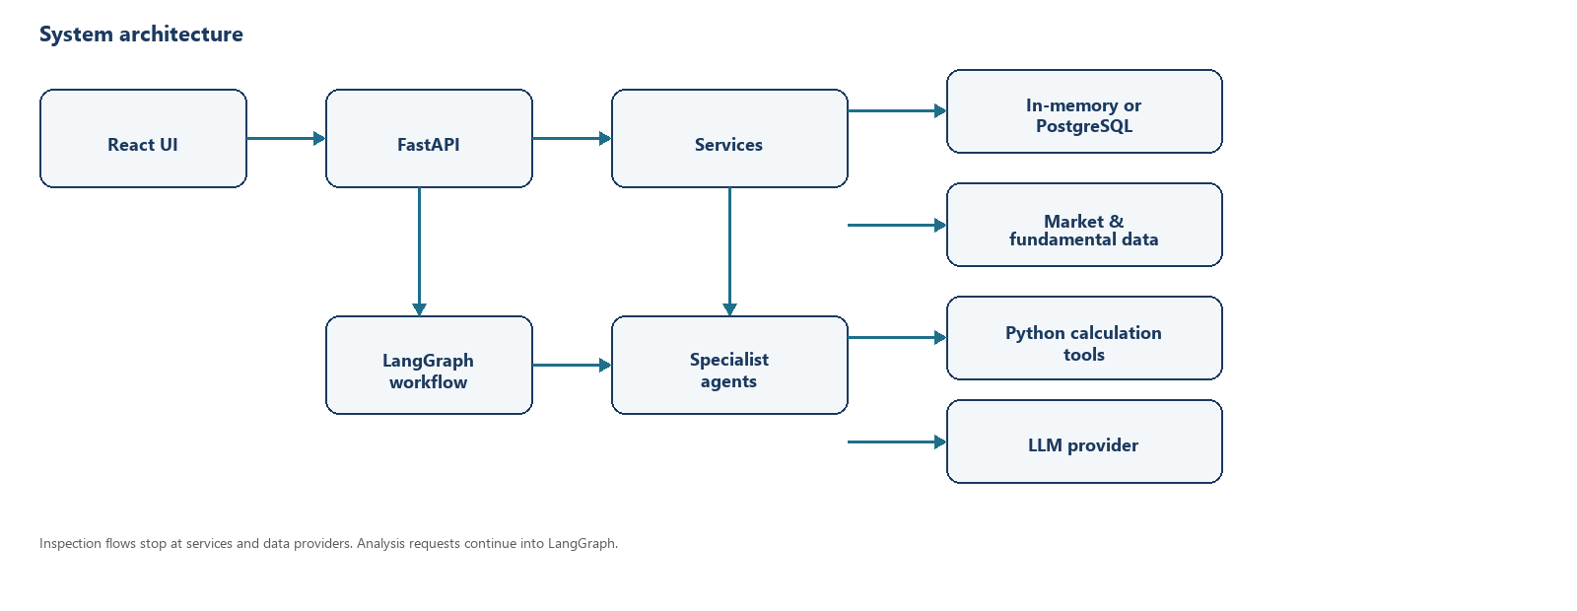
Figure 1. High-level architecture and main component interactions.
2. Agent Role Definitions
Analysis is orchestrated by LangGraph. The Portfolio Manager is not a specialist node. Its planning and synthesis logic runs in the plan and synthesize nodes. A standalone PortfolioManagerAgent class can still run specialists sequentially and is covered by tests, but HTTP analysis uses the compiled graph.
Agent / Node | Role | Main Responsibility
Plan (Portfolio Manager) | Router | Classifies the question into an analysis type (stock_analysis, portfolio_risk, portfolio_review, or portfolio_rebalancing) and selects specialists. Uses the LLM when possible, with a keyword heuristic fallback. Does not fetch market or fundamental data.
Market Analysis Agent | Specialist | Retrieves quotes, history, volume, and index context from the market-data provider. Python tools compute trend, momentum, volatility, and related indicators. The LLM interprets that evidence only.
Fundamental Analysis Agent | Specialist | Retrieves company profile, statements, key metrics, and valuation from the fundamental-data provider. Python tools classify health, profitability, liquidity, and related ratios. The LLM interprets that evidence only.
Join | Coordination | Waits for the selected research specialists, then routes to risk, optimization, or collection. No LLM or data retrieval.
Risk Assessment Agent | Specialist | Measures concentration, diversification, drawdown, volatility, correlation, and related portfolio risk from holdings plus retrieved history. Requires a portfolio (uploaded, or a synthetic unit portfolio for single-stock analysis). The LLM interprets the calculated metrics.
Portfolio Optimization Agent | Specialist | Builds a candidate long-only allocation in Python (minimum volatility or risk-adjusted return). The LLM explains the candidate; it does not choose weights or issue trades. Runs only when the plan requests it and a portfolio is available.
Collect / Detect conflicts | Coordination | Reviews specialist results, records missing analysis, and records disagreements or failures. No LLM.
Critique | Reviewer | Python checks coverage, evidence, disagreement, stale data, and constraint issues. The LLM writes a short review note. Critical, retryable findings may re-run flagged specialists, capped by MAX_REFLECTION_CYCLES (2).
Synthesize (Portfolio Manager) | Synthesizer | Combines specialist summaries into a structured recommendation with findings, risks, assumptions, limitations, and a capped confidence score. Does not execute trades.

Tools and services used by agents
- Market tools: trend classification, moving averages, realized volatility, momentum, relative performance, volume ratios.
- Fundamental tools: health, profitability, liquidity, and cash-generation labels, growth rates, and safe ratios.
- Risk tools: HHI, concentration and diversification labels, max drawdown, beta, tracking error, pairwise correlation.
- Optimization tool: mean-variance candidate weights from historical returns.
- Data access: MarketDataProvider and FundamentalDataProvider only. News retrieval is not used on this path.
3. Workflow Explanation
There are two kinds of user flow. Inspection flows (dashboard, upload, stock lookup, watchlist) stop at services and providers. Analysis flows enter the graph below.
Inspection and data-entry flow
1. The user opens a screen in the React application.
2. FastAPI routes the request to the matching service.
3. Dashboard and watchlist load index levels and quotes from the market-data provider. Missing quotes stay blank; values are not invented.
4. Upload parses CSV/XLSX, returns a staged preview with validation issues, and persists holdings only after the user confirms. Upload does not attach live prices.
5. Stock Analyzer can search, select, and show current market and fundamental information without running AI analysis.
6. Watchlist add, list, refresh, and remove stay on monitoring. Opening a symbol reuses Stock Analyzer selection and does not start the graph.
Analysis flow (Portfolio Analyzer or Stock Analyzer question)
1. The user submits a question against an imported portfolio or a selected symbol.
2. The analysis service builds InvestmentState (question, symbols, optional portfolio, optional investor profile) and calls invoke_strategy_board.
3. The plan node classifies the request and selects specialists.
4. Market and fundamental agents run in parallel when both are requested and symbols exist.
5. After join, risk runs if planned and a portfolio is available, then optimization if planned.
6. Collect and detect conflicts assemble results. If structured critique findings exist, critique runs. Critical issues may reanalyze flagged specialists; remaining issues are recorded as unresolved.
7. Synthesize returns a structured recommendation. The service maps graph state to a public API result (recommendation, specialist summaries, snapshots, evidence, critiques). Graph node names, prompts, and chain-of-thought are not returned.
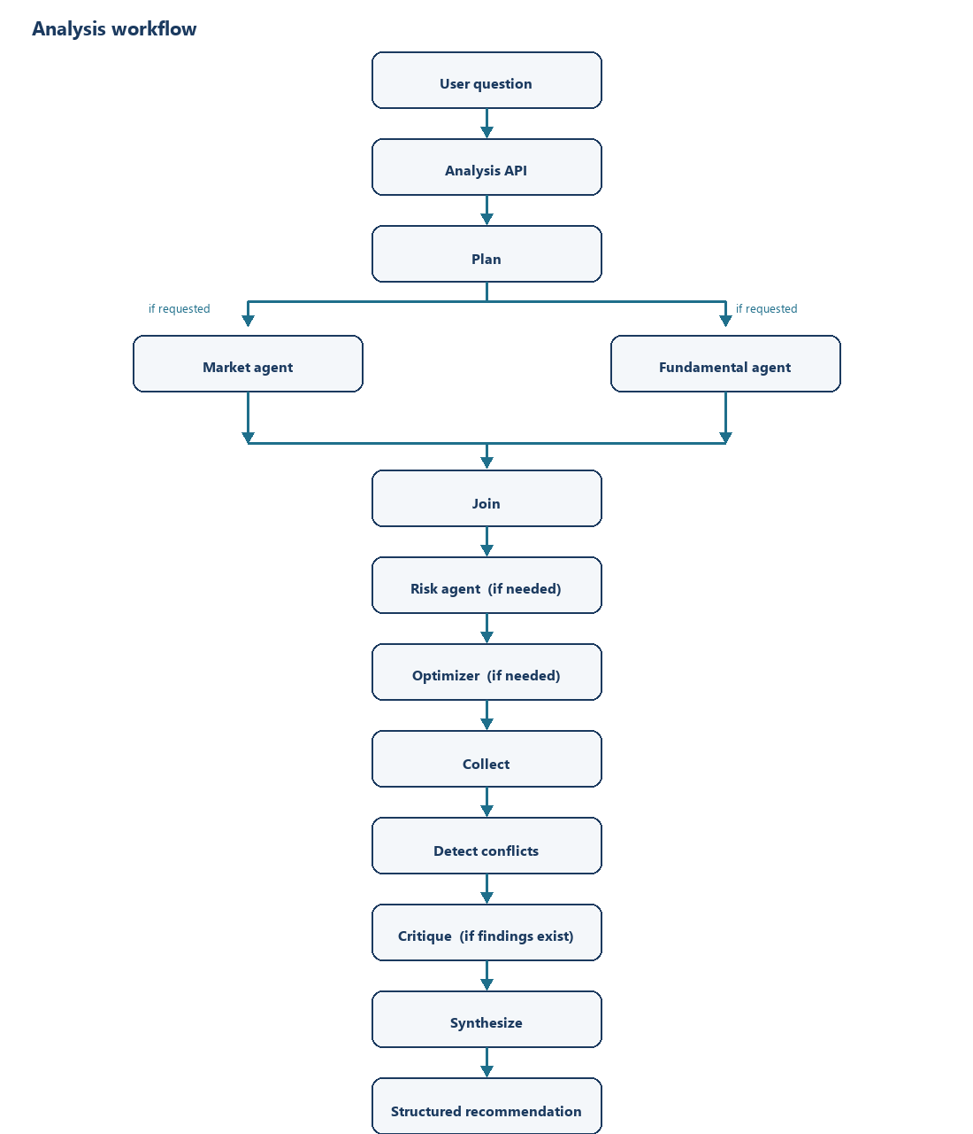
Figure 2. Analysis workflow from user question to structured recommendation. Critical findings may re-run flagged specialists, then return to collect.
4. Design Trade-offs
Design Decision | Reason | Trade-off
Multi-agent specialists instead of one LLM call | Market, fundamental, risk, and allocation questions need different data and different Python calculations. | More moving parts and a longer analysis path than a single prompt, but each specialist has a clear evidence contract.
LangGraph owns orchestration | The graph can run market and fundamental work in parallel, skip unused specialists, and bound critique to a controlled retry. HTTP analysis does not call the sequential manager class. | Routing and node bookkeeping are more complex than a linear script. The sequential manager remains in the codebase for tests, not as the live API path.
Provider contracts for LLM and market data | Agents and services depend on interfaces, so Groq, OpenAI, Google, Azure, stub, or Yahoo can be selected by environment without changing agent code. | A new vendor still requires an adapter. Stub adapters refuse to invent data, so analysis quality depends on a live provider being configured.
Python tools for numbers, LLM for interpretation | Prices, ratios, risk metrics, and candidate weights must come from retrieved data or deterministic math, not from model recall. | The LLM cannot fill gaps when a provider returns nothing. Recommendations stay evidence-bound, even when coverage is incomplete.
In-memory persistence by default, optional PostgreSQL | The prototype can run locally without a database. Setting DATABASE_URL switches stores to PostgreSQL. | Without a database URL, imported portfolios and analyses are process-local and do not survive restart.
One-shot graph with capped reflection, no trade execution | The product is decision support: inspect, analyze, and recommend. Continuous self-running loops and brokerage actions are out of scope. | The system will not place orders or keep iterating until a “better” answer appears. Unresolved critique findings are reported instead.

5. Final Summary
The Autonomous Investment Strategy Board is a decision-support prototype: users view market context, import holdings, monitor symbols, and ask evidence-grounded questions about a portfolio or a stock. The layered design keeps the UI, HTTP API, persistence, and vendor adapters separate from the analysis graph. LangGraph is used only for analysis, where a manager plans the work, specialists retrieve data and compute figures, a bounded critic may retry failed coverage, and a final synthesis returns a structured recommendation. That design fits the objective because investment questions span several data domains, numerical work must stay deterministic, and the system must remain a one-request advisor rather than an autonomous trading loop.

