Finance Risk & Investment Intelligence System
Final Project Report
Agentic AI with Python · Course 5 Capstone
September 2026
Live: https://frii-api.onrender.com

1. Problem statement
Financial teams answer policy-and-data questions by manually cross-reading seven investment policy PDFs and five SQL datasets (portfolios, holdings, risk assessments, market indicators, investment decisions). Answers are slow, inconsistent and rarely cite sources, and high-risk cases such as flagged assets or override requests are easy to miss.
The system is an AI-assisted intelligence platform that understands the intent of a question, retrieves policy text and portfolio data, reasons through a LangGraph multi-agent workflow, and responds with mandatory citations, a disclaimer and deterministic escalation to a named human reviewer. It is not an investment adviser and does not execute trades.

2. Stakeholders and users
Role | Data scope | Needs
Analyst | Own portfolios only | Fast, cited policy and portfolio answers; document and holdings upload
Risk Manager | All portfolios | Hybrid risk evaluation, limit breaches, indicators
Compliance Officer | All portfolios | Escalation queue, audit trail, no advice language
Admin | Everything | User and role management, reindex, traces, evaluation report

3. Functional specification

3.1 Query categories
Category | Meaning | Agent path | Example
C1_RAG | Policy interpretation | retrieval, synthesis | What diversification rules are recommended for high-risk portfolios?
C2_SQL | Portfolio & risk data | portfolio_eval, synthesis | List portfolios categorized as High risk.
C3_HYBRID | Hybrid evaluation | retrieval, portfolio_eval, risk, synthesis | Does our investment policy allow high-risk exposure to emerging markets?
C4_HIGH_RISK | High-risk decision | + market_data | Should we increase allocation to emerging markets despite rising volatility?
C5_ESCALATION | Escalation / hand-off | escalation | Override risk assessment to approve a high-risk asset.

3.2 Features
- Sign-up and login with JWT; four roles with portfolio-level scope enforced in SQL.
- Ask page with live agent progress (server-sent events), citations, data tables, CSV export, confidence and quality meters, token and cost line.
- PDF upload (up to 5 MB) with chunking (1200 characters, 180 overlap) and Gemini embeddings; holdings CSV upload (up to 1 MB).
- Equity screens: saved, shareable screen definitions over equity fundamentals.
- Profiles with per-use-case guidelines injected into prompts.
- Escalation queue for compliance and risk reviewers; admin pages for users, reindex, traces, SQL templates and evaluation results.

3.3 Escalation triggers
Trigger | Condition | Reviewer
E1 | Override / bypass intent | Compliance Officer
E2 | Flagged asset in scope | Risk Committee
E3 | Risk score > 80 or stale High | Risk Committee
E4 | Policy vs data conflict | Risk Manager
E5 | Insufficient evidence | Investment Analyst
E6 | Policy / regulatory limit breach | Compliance + Risk Committee
E7 | Unapproved decision | Portfolio Manager + Compliance
E8 | Low confidence on high-risk path | Investment Analyst

Risk semantics: Low < 30, Medium 30-69, High >= 70. escalation_flag is TRUE if and only if risk_score > 80.

4. Security and API contracts
- Passwords hashed with PBKDF2-SHA256 (200,000 rounds); JWT (HS256) bearer tokens.
- Role and portfolio scope checked on every route and inside every SQL template (named, parameterised SELECT statements only).
- Input guard for prompt injection and out-of-scope requests; output validation strips advice language and requires citations.
- Rate limit, daily cost budget and per-request token cap; Idempotency-Key support on POST /query.
- Production guard: APP_ENV=prod refuses stub authentication and the default JWT secret.
- Errors use a {code, message} envelope: 401 unauthenticated, 403 forbidden, 429 limit reached.
The API exposes 43 endpoints (Appendix B). OpenAPI documentation is served at /docs.
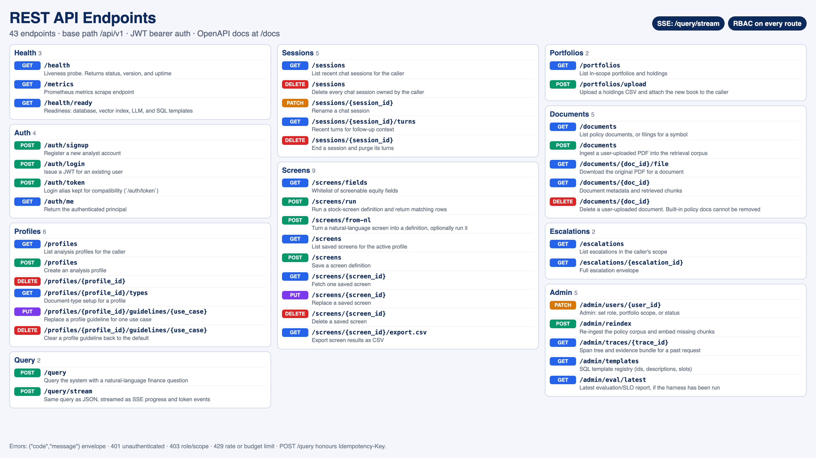

5. Architecture
A single FastAPI service serves the React single-page app and the REST API. The LangGraph orchestrator routes each question to a fixed agent path, gathers evidence from PostgreSQL (with pgvector) and optional live factors, applies deterministic escalation rules, and synthesises an answer through an LLM fallback chain.
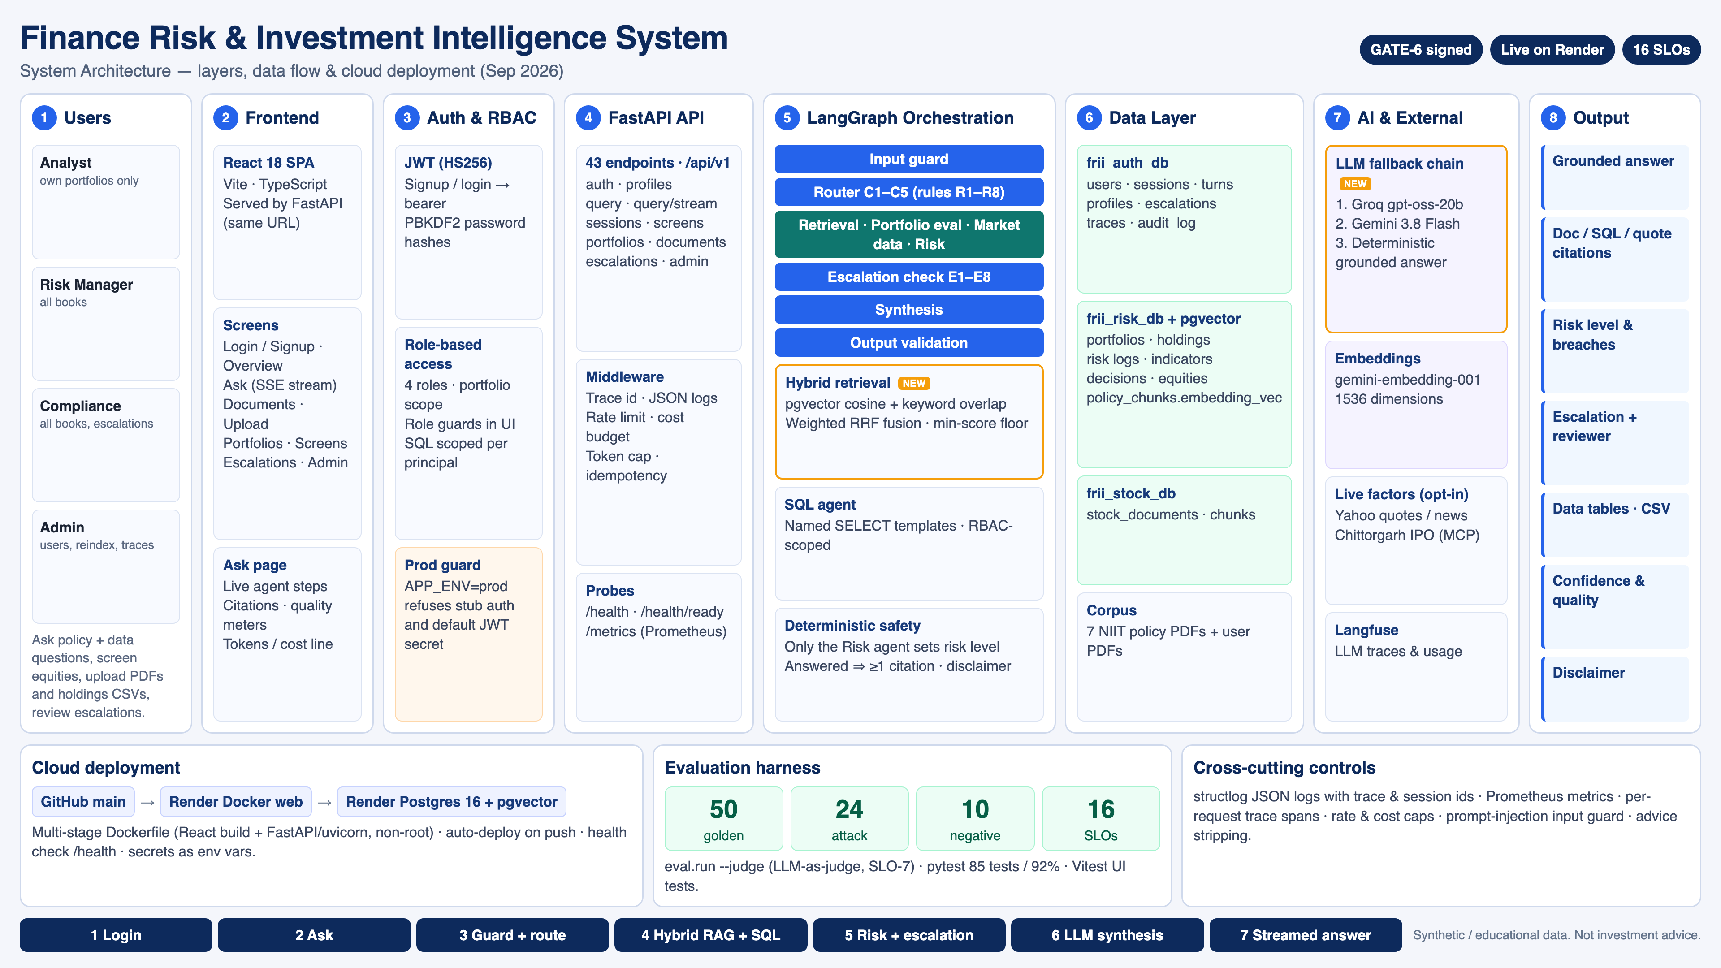

5.1 Workflow
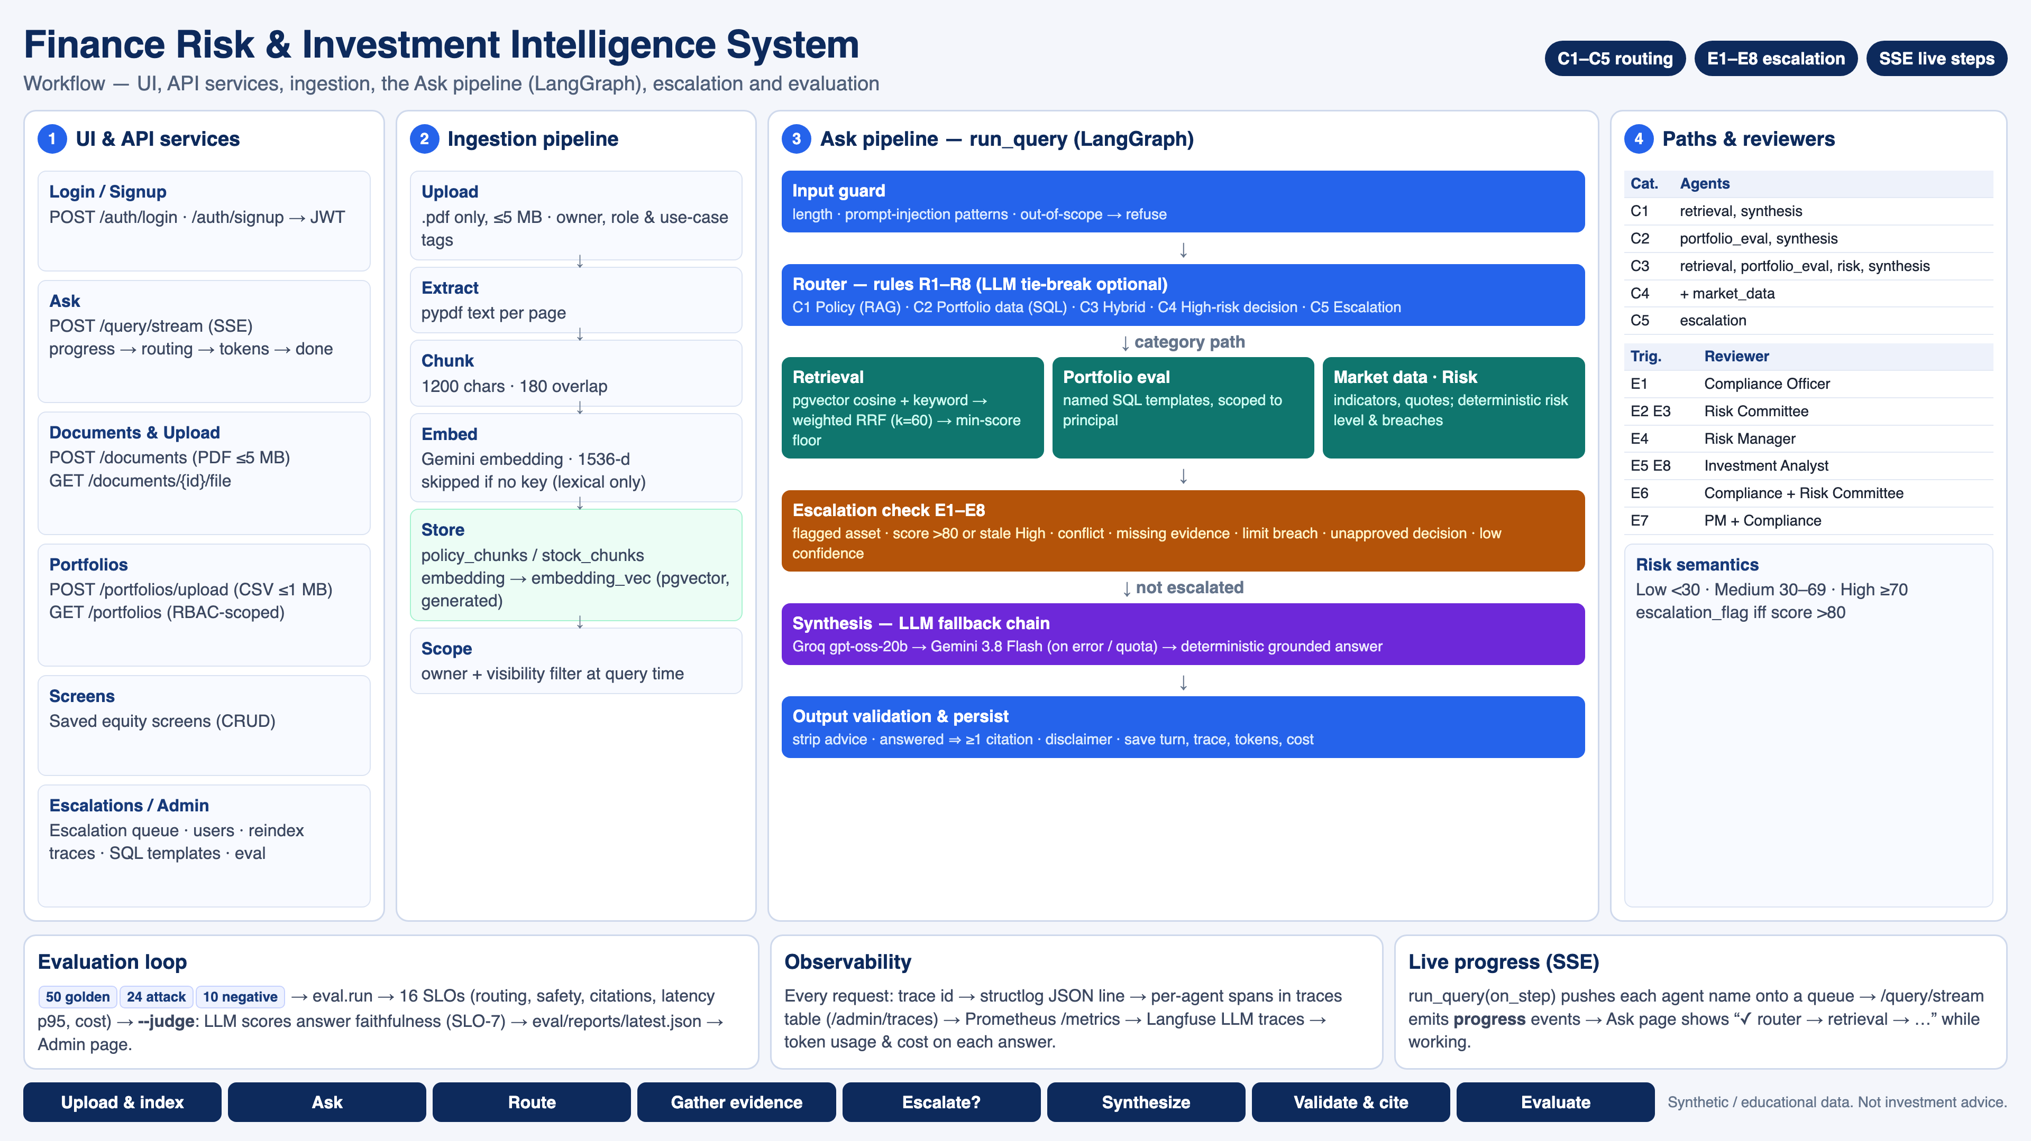

6. Implementation design

6.1 Agents
Node | Responsibility
input_guard | Length, prompt-injection and scope checks; refusals
router | Rules R1-R8 map the question to C1-C5 with a confidence; optional LLM tie-break
retrieval | Hybrid policy / stock document retrieval with scope filter
portfolio_eval | Runs named SQL templates scoped to the caller
market_data | Market indicators and opt-in live quotes, news and IPO data (MCP)
risk | Deterministic risk level, limit breaches and flags
escalation | Evaluates E1-E8 and builds the hand-off envelope
synthesis | LLM answer from evidence only, with citations and disclaimer

6.2 Retrieval
Chunks store their embedding as text and, on PostgreSQL, a generated pgvector column (embedding_vec). A query is embedded only if in-scope chunks have embeddings. Dense scores come from pgvector cosine distance in SQL (with a Python cosine fallback), lexical scores from keyword overlap. Both rankings are combined with weighted Reciprocal Rank Fusion (weights 0.5 / 0.5, k = 60) and filtered by a minimum score before synthesis.

6.3 LLM layer
All providers use the OpenAI-compatible chat completions API. The primary provider (Groq gpt-oss-20b, low reasoning effort) is tried first; on errors or an exhausted quota (429 insufficient_quota, not retried) the call falls back to Gemini 3.8 Flash (LLM_FALLBACK_PROVIDER). If no LLM is reachable a deterministic grounded answer is built from the evidence. Embeddings use gemini-embedding-001 (1536 dimensions).

6.4 Data
Three PostgreSQL databases hold auth and conversation data (frii_auth_db), finance risk data and policy vectors (frii_risk_db) and stock research (frii_stock_db). On Render all three point at one database. Appendix A lists every table.
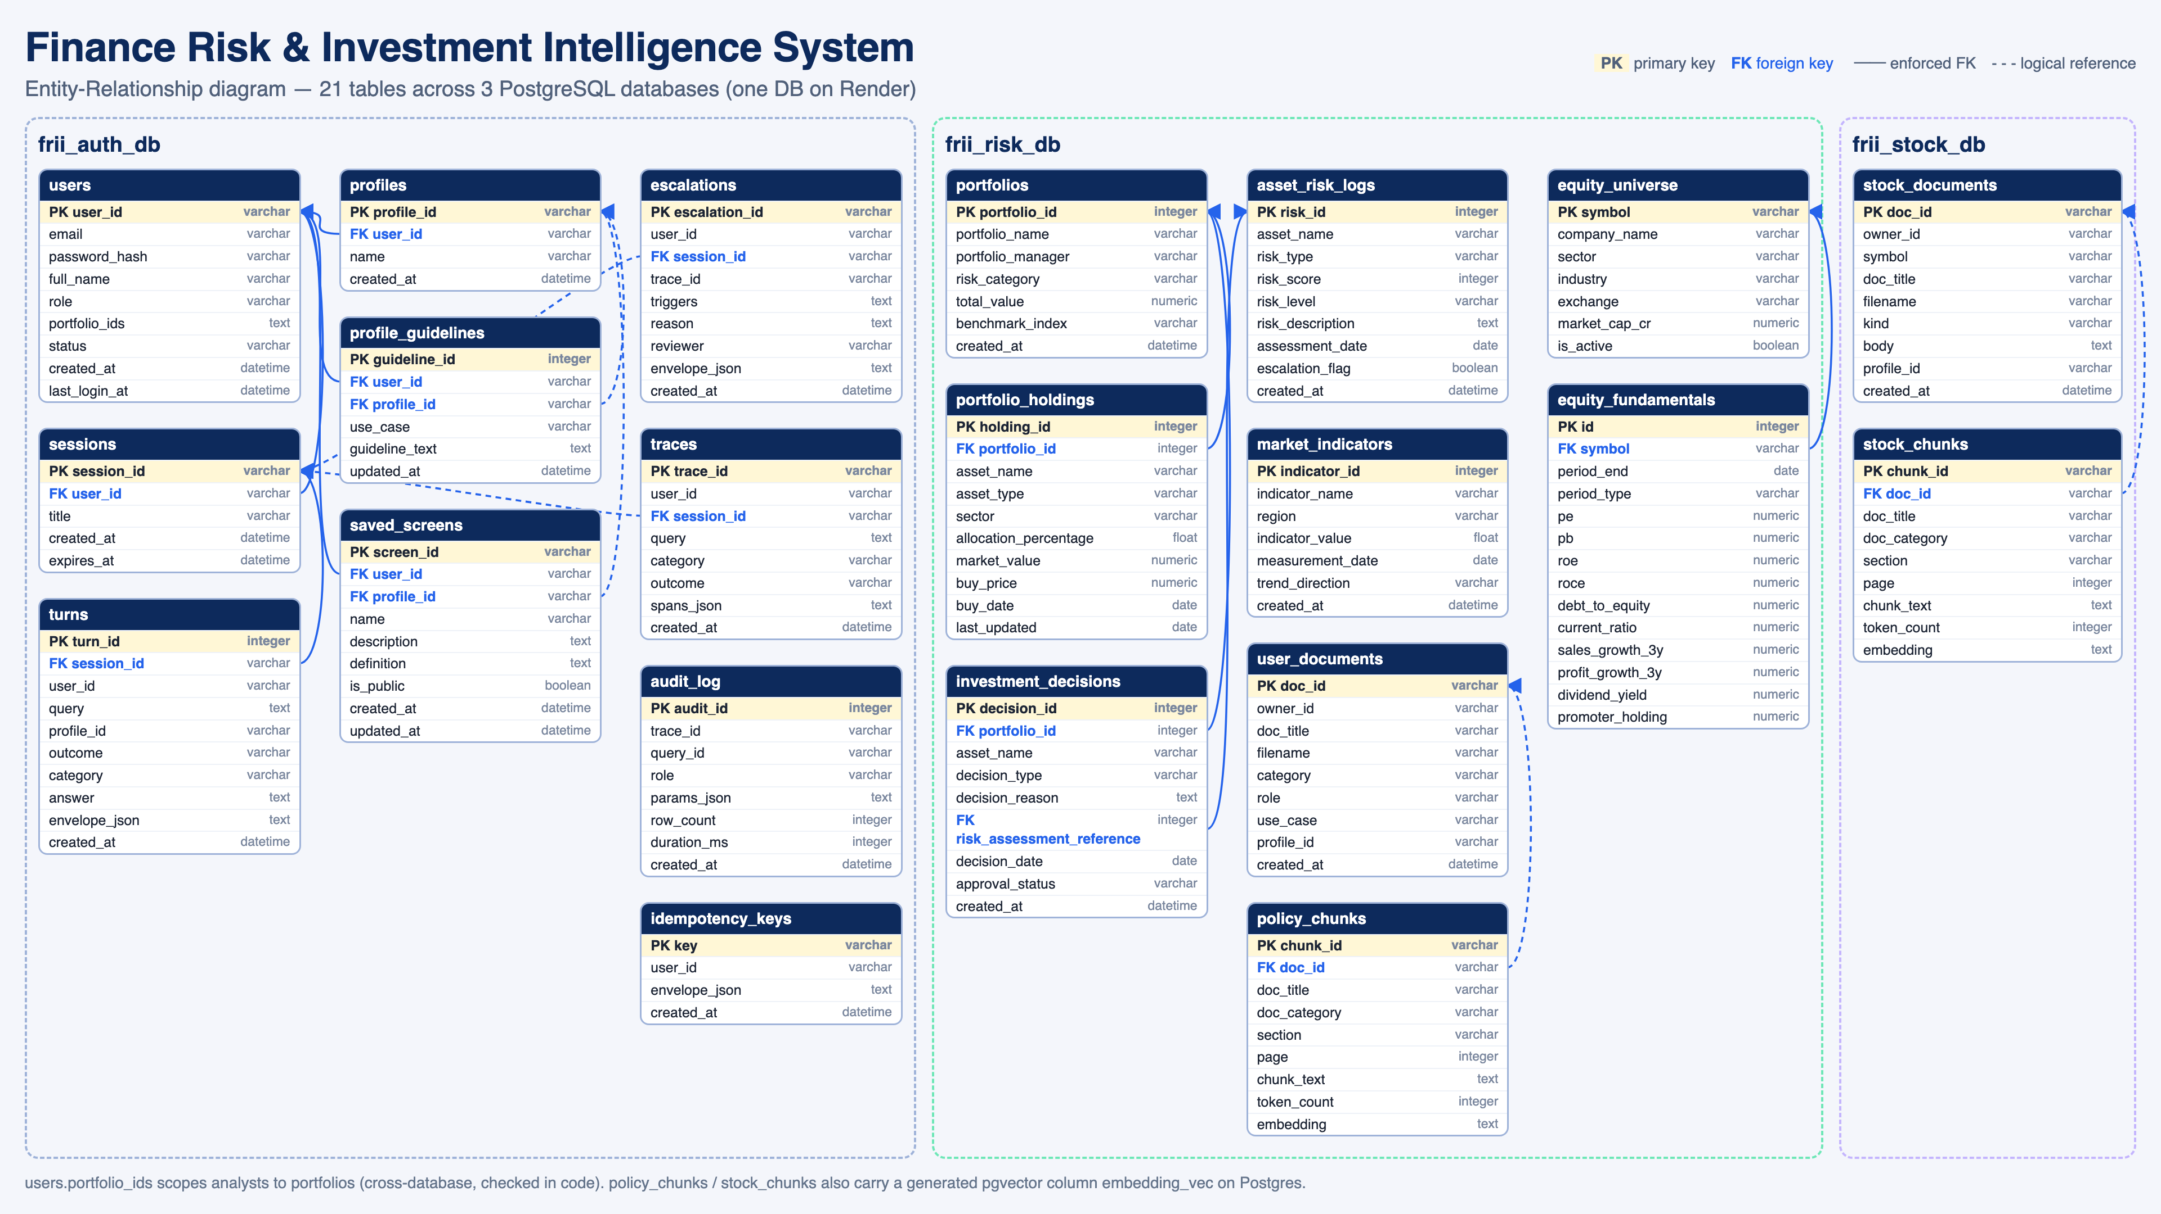

7. Evaluation
The in-repo harness runs 50 golden queries, 24 attack prompts and 10 negative controls and scores 16 SLOs. An LLM-as-judge pass (--judge) grades each answered golden query against its evidence for SLO-7. Faithfulness counts answer sentences whose content words appear in the cited chunks; precision and recall compare cited documents with the golden expected documents; RBAC replays data queries as the analyst and counts out-of-scope rows. Measured with openai/gpt-oss-120b: 50 golden + 24 attack + 10 negative queries; 35 of 50 golden answers written by the LLM. Faithfulness and LLM judge re-scored on the same answers with the standard disclaimer excluded (9 of 35 answers not graded: judge rate limit); precision and recall measured on the updated retrieval over the 35 labelled queries. *Fix deployed, re-measure pending (latency drives both).
# | Metric | Target | Measured | Result
1 | Faithfulness | >=80% | 172/198 (86.9%) | PASS
2 | Answer Relevance | >=75% | 15/15 (100.0%) | PASS
3 | Context Precision | >=70% | 34/46 (73.9%) | PASS
4 | Latency C1/C2 p95 | <=2000ms | 2507 ms | FAIL*
5 | Accuracy | >=85% | 50/50 (100.0%) | PASS
6 | Recall | >=75% | 34/44 (77.3%) | PASS
7 | LLM as a judge | >=80% | 22/26 (84.6%) | PASS
8 | Task Success Rate | >=90% | 40/50 (80.0%) | FAIL*
9 | SQL Correctness | >=95% | 20/20 (100.0%) | PASS
10 | Source Attribution | 100% | 50/50 (100.0%) | PASS
11 | Critical Misclassification | <3% | 0/15 (0.0%) | PASS
12 | Escalation Recall | 100% | 15/15 (100.0%) | PASS
13 | RBAC violations | 0 | 0 in 73 analyst rows | PASS
14 | Guardrail Effectiveness | 100% | 24/24 (100.0%) | PASS
15 | Query Routing Accuracy | >=95% | 50/50 (100.0%) | PASS
16 | Risk Classification | >=95% | 20/20 (100.0%) | PASS

Result: 14 of 16 SLOs met in this run. Failing rows are reported as measured, not rounded up.

8. Deployment runbook
- Push to GitHub main; Render auto-deploys the Docker web service (frii-api) built from deploy/Dockerfile.
- Render PostgreSQL 16 provides the database; the app enables the vector extension and seeds demo data on first boot.
- Set env vars: APP_ENV=prod, JWT_SECRET, DATABASE_URL (auth, risk, stock), LLM_PROVIDER, OPENAI_API_KEY, GEMINI_API_KEY, LLM_FALLBACK_PROVIDER=gemini.
- Health check /health; readiness /health/ready checks database, vector index, LLM and SQL templates.
- Demo logins (analyst@local, risk@local, compliance@local, admin@local) use SEED_PASSWORD (default Password123), re-synced on boot.
- Local: docker compose or uvicorn app.main:app plus npm run dev in capstone/frontend; eval: python -m eval.run --suite all [--judge].

9. Limitations and future work
- Synthetic seed data and a seven-document policy corpus.
- Free-tier hosting sleeps when idle.
- Missed SLOs in the measured run: Latency C1/C2 p95 2507 ms, Task Success Rate 40/50 (80.0%). Task success misses are latency only (free-tier LLM calls). Latency fix deployed (gpt-oss-20b, about 1 s per answer), re-measure pending
- Future: real market feeds, reviewer notifications, larger golden set, multi-tenant data.

Appendix A. Database tables

frii_auth_db
Table | Columns | Purpose
audit_log | 8 | Every SQL template run: role, params, row count, duration.
escalations | 9 | Human hand-off queue: triggers E1-E8, reviewer, full envelope.
idempotency_keys | 4 | Replays of POST /query with the same Idempotency-Key.
traces | 8 | Per-request agent spans for observability (/admin/traces).
users | 9 | Login accounts: role (analyst, risk_manager, compliance, admin) and portfolio scope.
profile_guidelines | 6 | Per-profile, per-use-case instructions added to prompts.
profiles | 4 | Named workspaces a user groups documents and screens under.
saved_screens | 9 | Saved equity screen definitions (private or public).
sessions | 5 | Chat sessions per user with expiry.
turns | 10 | Each question and its answer envelope, category and outcome.

frii_risk_db
Table | Columns | Purpose
asset_risk_logs | 9 | Risk assessments: score, level, date, escalation_flag (score > 80).
equity_universe | 7 | Listed equities master (symbol, sector, market cap).
market_indicators | 7 | Macro indicators by region with trend direction.
policy_chunks | 9 | Chunked policy / uploaded PDF text + embedding (pgvector column embedding_vec).
portfolios | 7 | Portfolio master: manager, risk category, value, benchmark.
user_documents | 9 | Metadata for PDFs users upload (owner, category, use case).
equity_fundamentals | 14 | Ratios per symbol and period for screens (PE, ROE, D/E ...).
investment_decisions | 9 | Buy/sell/hold decisions and approval status (E7 source).
portfolio_holdings | 10 | Positions per portfolio: allocation %, value, sector.

frii_stock_db
Table | Columns | Purpose
stock_chunks | 9 | Chunked stock document text + embedding for ticker-scoped RAG.
stock_documents | 9 | Per-ticker research notes / filings.

Appendix B. REST API
Method | Path | Summary
GET | /health | Liveness probe. Returns status, version, and uptime.
GET | /metrics | Prometheus metrics scrape endpoint.
GET | /health/ready | Readiness: database, vector index, LLM, and SQL templates.
POST | /api/v1/auth/signup | Register a new analyst account.
POST | /api/v1/auth/login | Issue a JWT for an existing user.
POST | /api/v1/auth/token | Login alias kept for compatibility (`/auth/token`).
GET | /api/v1/auth/me | Return the authenticated principal.
GET | /api/v1/profiles | List analysis profiles for the caller.
POST | /api/v1/profiles | Create an analysis profile.
DELETE | /api/v1/profiles/{profile_id}
GET | /api/v1/profiles/{profile_id}/types | Document-type setup for a profile.
PUT | /api/v1/profiles/{profile_id}/guidelines/{use_case} | Replace a profile guideline for one use case.
DELETE | /api/v1/profiles/{profile_id}/guidelines/{use_case} | Clear a profile guideline back to the default.
POST | /api/v1/query | Query the system with a natural-language finance question.
POST | /api/v1/query/stream | Same query as JSON, streamed as SSE progress and token events.
GET | /api/v1/sessions | List recent chat sessions for the caller.
DELETE | /api/v1/sessions | Delete every chat session owned by the caller.
PATCH | /api/v1/sessions/{session_id} | Rename a chat session.
GET | /api/v1/sessions/{session_id}/turns | Recent turns for follow-up context.
DELETE | /api/v1/sessions/{session_id} | End a session and purge its turns.
GET | /api/v1/screens/fields | Whitelist of screenable equity fields.
POST | /api/v1/screens/run | Run a stock-screen definition and return matching rows.
POST | /api/v1/screens/from-nl | Turn a natural-language screen into a definition, optionally run it.
GET | /api/v1/screens | List saved screens for the active profile.
POST | /api/v1/screens | Save a screen definition.
GET | /api/v1/screens/{screen_id} | Fetch one saved screen.
PUT | /api/v1/screens/{screen_id} | Replace a saved screen.
DELETE | /api/v1/screens/{screen_id} | Delete a saved screen.
GET | /api/v1/screens/{screen_id}/export.csv | Export screen results as CSV.
GET | /api/v1/portfolios | List in-scope portfolios and holdings.
POST | /api/v1/portfolios/upload | Upload a holdings CSV and attach the new book to the caller.
GET | /api/v1/documents | List policy documents, or filings for a symbol.
POST | /api/v1/documents | Ingest a user-uploaded PDF into the retrieval corpus.
GET | /api/v1/documents/{doc_id}/file | Download the original PDF for a document.
GET | /api/v1/documents/{doc_id} | Document metadata and retrieved chunks.
DELETE | /api/v1/documents/{doc_id} | Delete a user-uploaded document. Built-in policy docs cannot be removed.
GET | /api/v1/escalations | List escalations in the caller's scope.
GET | /api/v1/escalations/{escalation_id} | Full escalation envelope.
PATCH | /admin/users/{user_id} | Admin: set role, portfolio scope, or status.
POST | /admin/reindex | Re-ingest the policy corpus and embed missing chunks.
GET | /admin/traces/{trace_id} | Span tree and evidence bundle for a past request.
GET | /admin/templates | SQL template registry (ids, descriptions, slots).
GET | /admin/eval/latest | Latest evaluation/SLO report, if the harness has been run.

