MAD Midterm – Chat Application

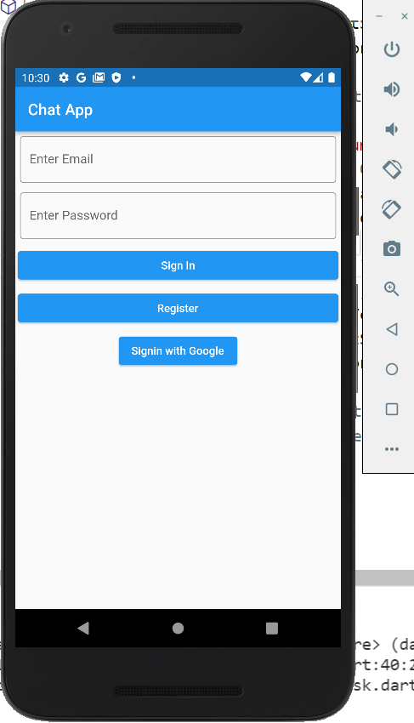 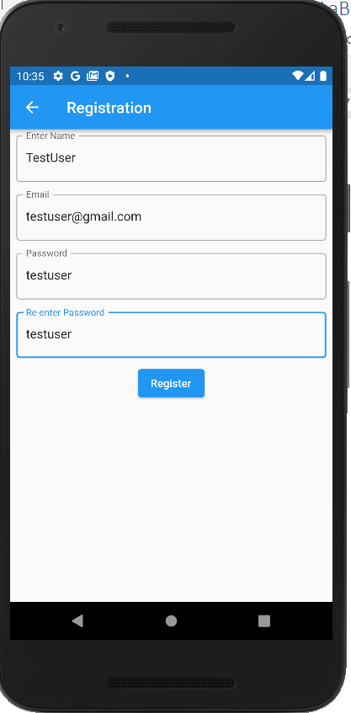

We need to register into the chat application before we login.

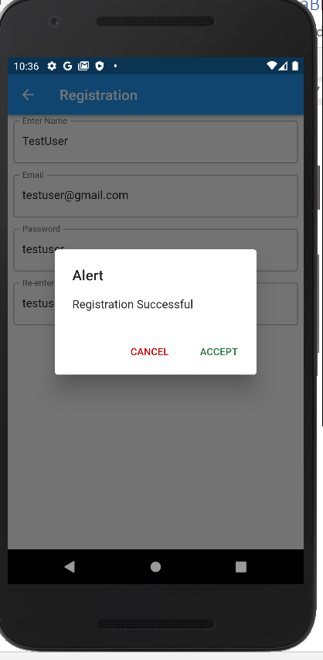 Now we can login with the registered user data.

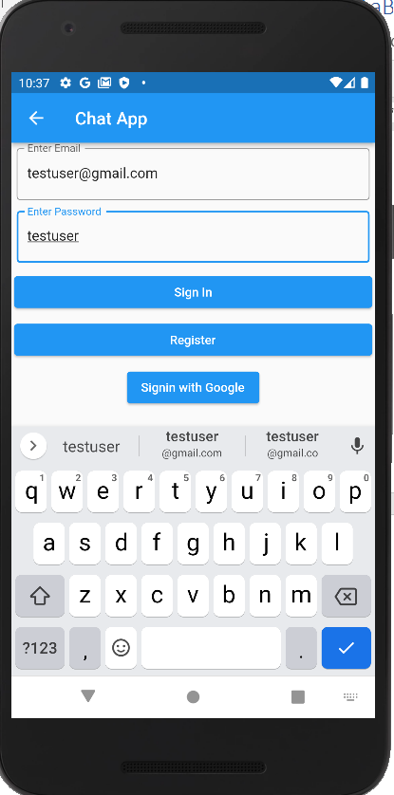 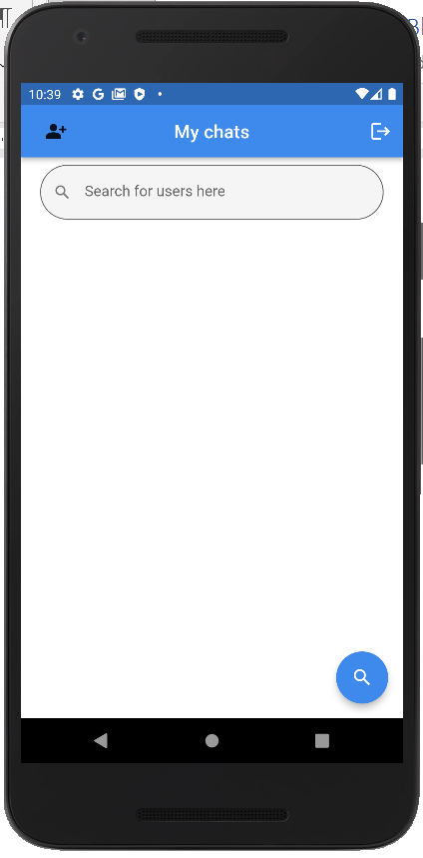

The above image shows me the chats When I login. Currently the new user has no chats. So we need to search the user by clicking floatingActionButton used for search. 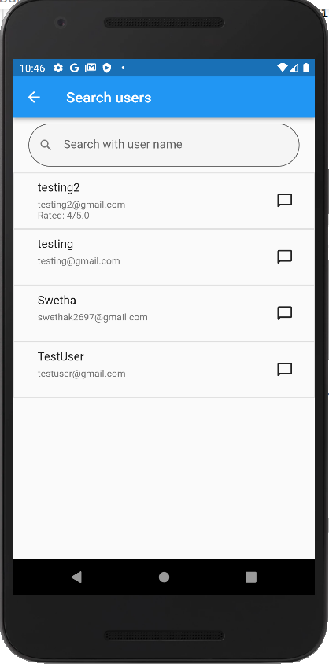

Now I can select the user I want to chat with. If I select the name I can get the other user profile, and If I select the chat box I can chat with the user.

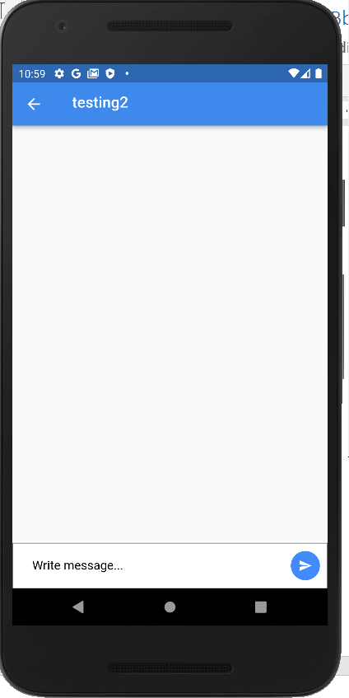 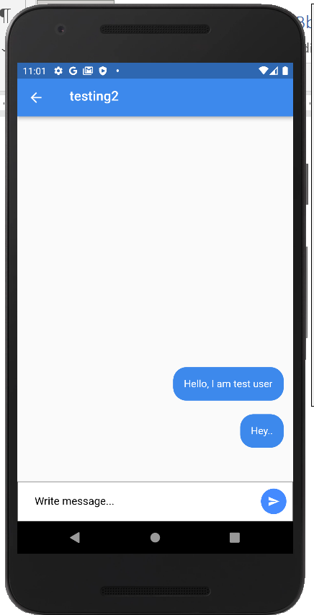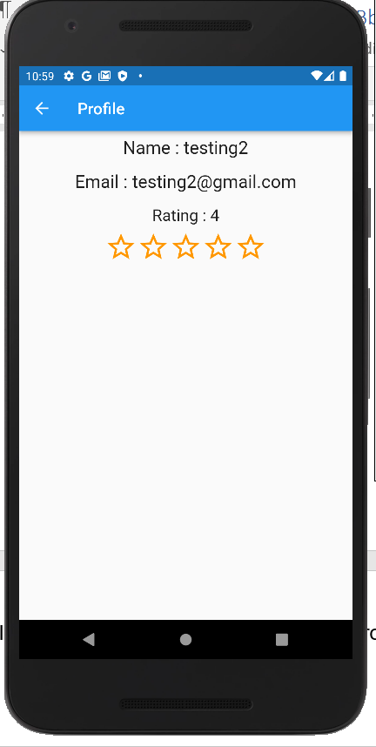 Based on the chat we can even rate the other user by going to their profile page.

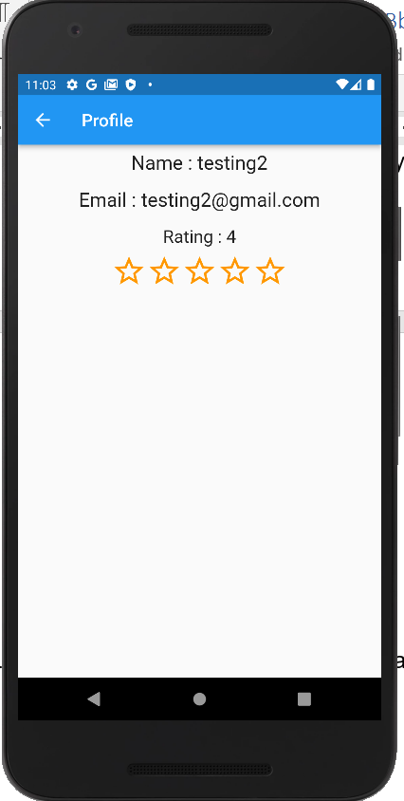 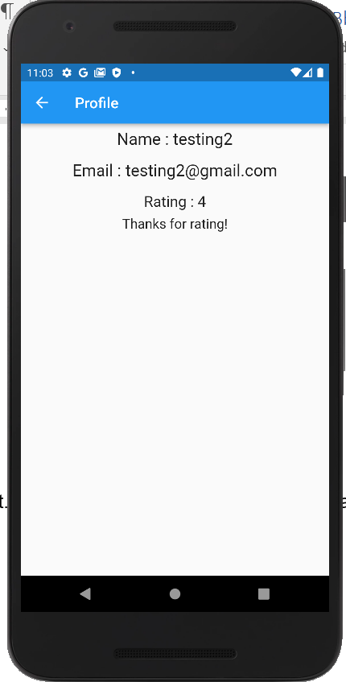

Now all my chats are visible in the home scree.

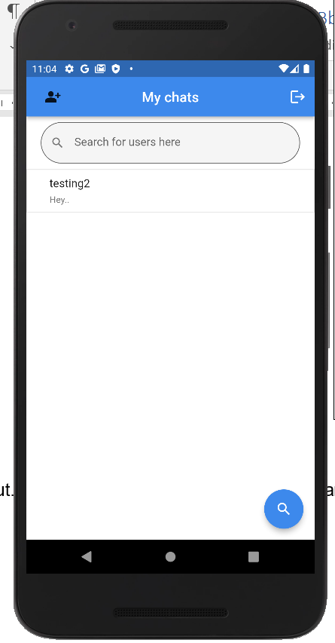

On the app bar I can go to my profile or I can logout. When I click the profile Icon in app, I can see my profile. And I cannot rate myself, so I do not get any option to rate in my own profile.

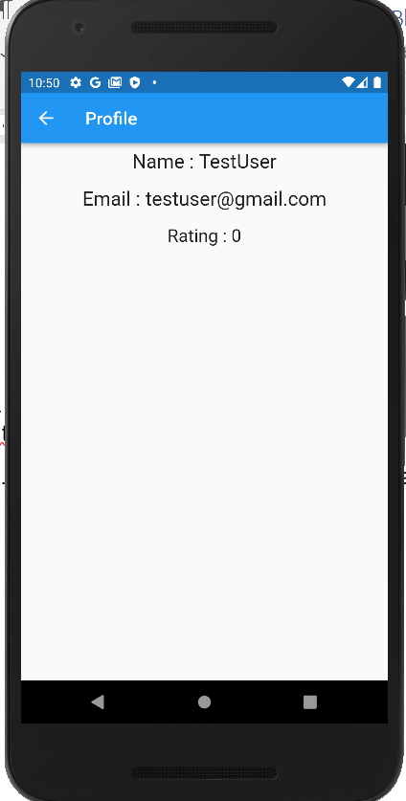 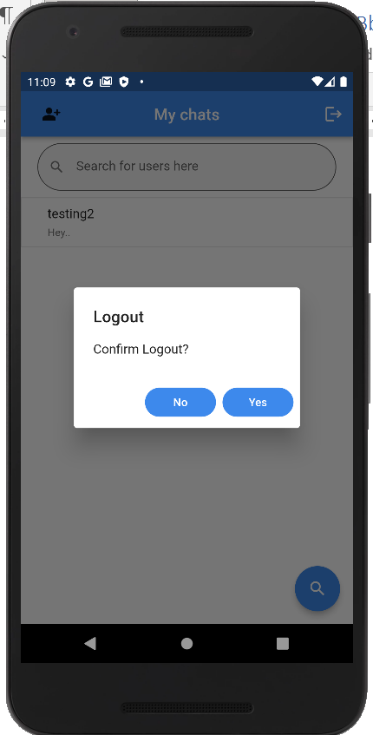

Now I am logging out and will login using testing2 user. I must be able to see my latest message from testUser.

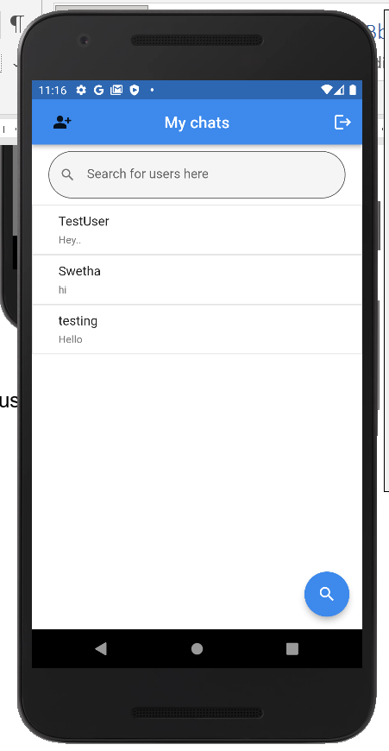 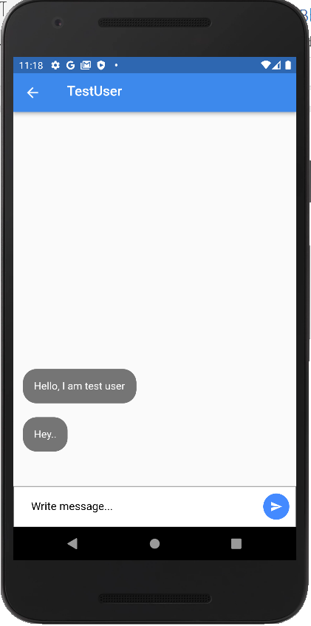

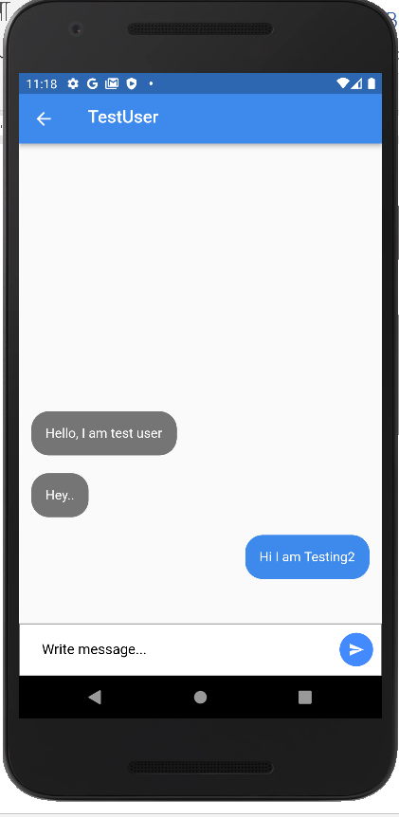 I am replying from testing 2 user.

So in this app,

* I am able to have user login along with google signin.
* Able to search a user to start a conversation.
* Able to start a conversation with the new user.
* Ranking the other user based on the conversation and also the ranking will be average of all the users rating provided.
* Able to go to self user profile and also other user profiles.