**Contact Line Length Measurement using OpenCV functions**

1. Extracted the images from the dataset provided by Smruti Sir
   1. Grayscale Images
   2. Binary Images
2. Used OpenCV functions in Python to find the contours in the image
   1. 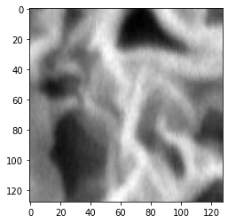**Using Grayscale Images extracted from SEM data**
      1. 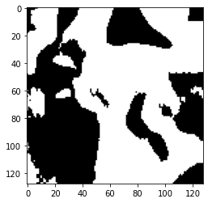Grayscale image converted to binary image using OpenCV thresholding
      2. 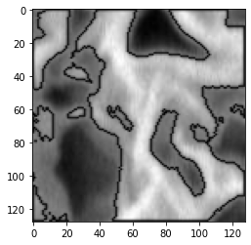Contours were found out in the image
      3. Contour length of each contour calculated using OpenCV arclength function
      4. Add the lengths of all the contours to find the contact length in an image

Contour length of this sample image using this method - 1310 pixels (approx.)

* 1. **Using binary images extracted from SEM data**

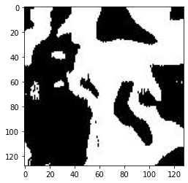

* + 1. 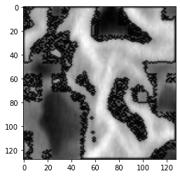Binary image extracted from SEM data and contours are found using OpenCV
    2. Contour length calculated in the same manner

Contour length of this sample image using this method – 5269 pixels (approx.)

|  |  |
| --- | --- |
| Method | Contact Line (pixels) |
| Using Grayscale image from SEM data | 1310 |
| Using binary images from SEM data | 5269 |

**Predicting Effective Diffusivity using CNN**

**Workflow**

1. **Data Loading**
   1. Binary Images are read from excel file using OpenCV library in Python (x)
   2. Diffusivity is read from excel file using pandas library in Python (y)
2. **Normalization and Train/Test split**
   1. Since diffusivity values are very small, we normalize it by a normalizing factor (1.958*10^-9)
   2. Both x and y data is split into train (90%) and test (10%) after normalization
3. **Model Development**
   1. A 2 layer convolutional neural network is developed with functionalities like Convolutions, Pooling, Dropout, Activations, etc. Model is discussed in detail in the next section.
4. **Model Training**
   1. Training is performed on 180 images using Adam Optimizer and learning rates of 10^-3 and 10^-4
   2. Best model checkpoint is saved amongst 50 epochs of training
5. **Evaluation on test set**
   1. Model is saved as a h5 file and the weights are loaded to evaluate the model on test set (20 images) and different models are compared to check the performance
   2. Performance metric – Mean Absolute Percentage Error (MAPE)

**Model Description – Terminologies**

1. **Sequential model** – this model is used for a plain stack of layers where each layer has exactly one input tensor and one output tensor
2. **Convolution layers** - This layer creates a convolution kernel that is convolved with the layer input to produce a tensor of outputs.
3. **Max Pooling layers** - Downsamples the input along its spatial dimensions (height and width) by taking the maximum value over an input window for each channel of the input.
4. **ReLU Activation function** – Applies rectified linear unit activation : max(x, 0) on the input tensor.
5. **Padding** - one of "valid" or "same" (case-insensitive). "valid" means no padding. "same" results in padding with zeros evenly to the left/right or up/down of the input such that output has the same height/width dimension as the input.
6. **Filters** - the dimensionality of the output space (i.e. the number of output filters in the convolution).
7. **Kernel size** - An integer specifying the height and width of the 2D convolution window.
8. **Dropout** - The Dropout layer randomly sets input units to 0 during training time, which helps prevent overfitting.
9. **Dense layers** - Dense layer implements the operation: output = activation (dot(input, kernel) + bias) where activation is the element-wise activation function passed as the activation argument, kernel is a weights matrix created by the layer, and bias is a bias vector created by the layer.

**Sample model development code**

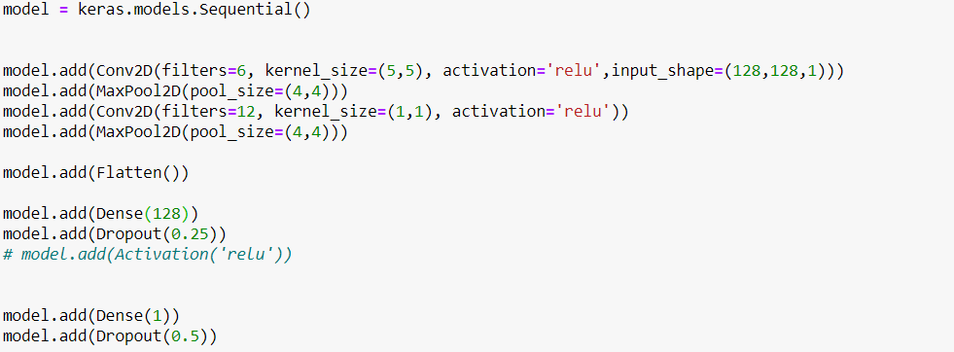

**Results**

Old data

|  |  |  |  |  |  |  |
| --- | --- | --- | --- | --- | --- | --- |
| **Model** | **Padding** | **ReLU** | **Kernel size** | **Learning Rate** | **Train MAPE** | **Test MAPE** |
|  |  |  |  |  |  |  |
| 1 | Valid | Yes | 5x5 | 10e-3 | 68.50 | 73.52 |
| **2** | **Valid** | **No** | **5x5** | **10e-3** | **53.71** | **58.41** |
| 3 | Same | Yes | 5x5 | 10e-3 | 58.67 | 81.72 |
| 4 | Same | No | 5x5 | 10e-3 | 67.84 | 52.76 |
| 5 | Valid | Yes | 5x5 | 10e-4 | 55.72 | 97.99 |
| 6 | Valid | Yes | 3x3 | 10e-3 | 51.27 | 89.01 |
| 7 | Valid | Yes | 7x7 | 10e-3 | 59.15 | 108.67 |

New Data

|  |  |  |  |  |  |  |
| --- | --- | --- | --- | --- | --- | --- |
| **Model** | **Padding** | **ReLU** | **Kernel size** | **Learning Rate** | **Train MAPE** | **Test MAPE** |
|  |  |  |  |  |  |  |
| 1 | Valid | Yes | 5x5 | 10e-3 | 47.56 | 51.21 |
| **2** | **Valid** | **No** | **5x5** | **10e-3** | **45.31** | **44.61** |
| 3 | Same | Yes | 5x5 | 10e-3 | 44.43 | 46.59 |
| 4 | Same | No | 5x5 | 10e-3 | 48.83 | 51.75 |
| 5 | Valid | Yes | 5x5 | 10e-4 | 45.96 | 54.70 |
| 6 | Valid | Yes | 3x3 | 10e-3 | 43.52 | 53.38 |
| 7 | Valid | Yes | 7x7 | 10e-3 | 55.73 | 59.29 |