PROJECT REPORT: Smart Multi-Stop Route Navigator
Course: CENG 3511 - Artificial Intelligence
Project Title: Advanced Shortest Path Finder using Dijkstra's Logic and Real-World Road Networks
Student: Beyza ONAR
Student Number: 220709017

1. Introduction
The objective of this project is to develop a sophisticated web-based geographic information system (GIS) that calculates the most efficient route between multiple user-defined points. Focusing on the Muğla region, the application successfully integrates Dijkstra’s Algorithm principles with real-world OpenStreetMap (OSM) data via the Leaflet.js framework to provide accurate, real-time navigation.

2. Methodology & Algorithm
The application utilizes a hybrid approach to pathfinding, combining classic algorithms with modern API integrations:
- Dijkstra’s Algorithm Logic: The system is built on the core logic of finding the shortest path in a weighted graph. In this implementation, the "nodes" are dynamic coordinates selected by the user, and the "edges" are the actual road segments connecting them.
- Real-Road Integration (OSRM API): To move beyond simple "as the crow flies" distances, the project incorporates the Open Source Routing Machine (OSRM) API. This ensures that the weights (distances) between nodes are based on actual driving/walking paths, accounting for street turns, intersections, and road geometry.
- Haversine & Routing Calculations: Distances are computed using real-world coordinates (Latitude/Longitude), ensuring geographical precision.

3. System Architecture
The project follows a strict modular structure to ensure maintainability and separation of concerns:
- index.html: Defines the user interface, including the map viewport and an interactive info panel for route statistics.
- style.css: Manages the responsive design, ensuring the UI remains usable on various screen sizes.
- script.js: The central orchestrator that manages Leaflet map events, triggers API requests, and renders the dynamic polyline.
- dijkstra.js: Contains the pure logic for shortest path computation, serving as the algorithmic engine.

4. Results and Visualization
The application successfully visualizes complex routes using a colored polyline that snaps precisely to the OpenStreetMap road network.
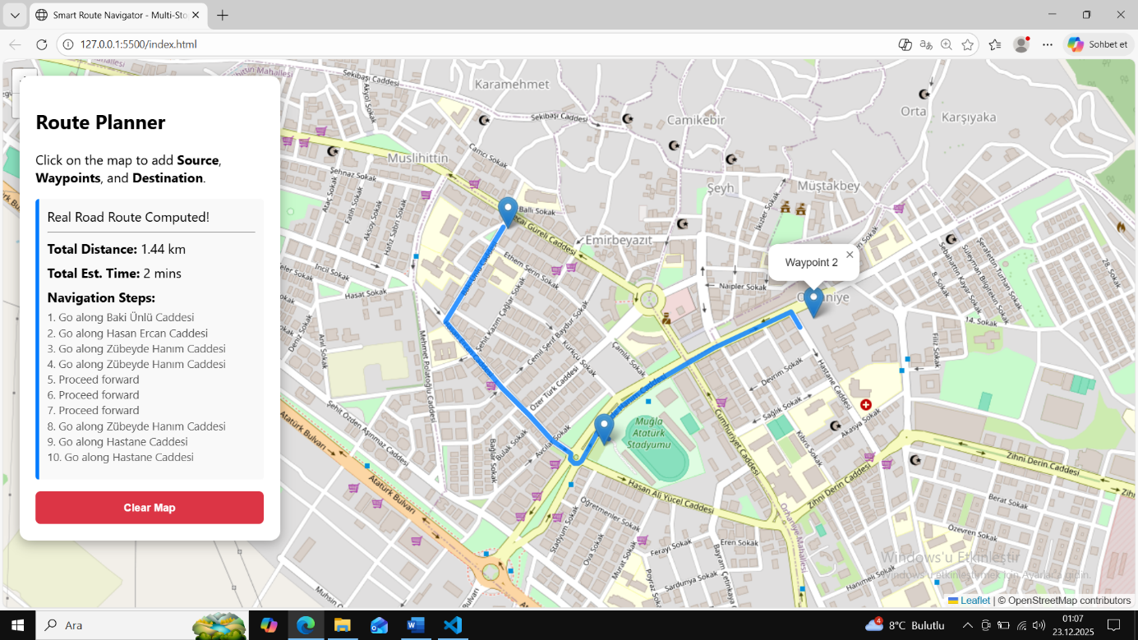

Figure 1: Successful multi-stop route following actual streets in Muğla.
As demonstrated in the results:
- Total Distance: Dynamically calculated for the entire sequence of waypoints in kilometers.
- Estimated Time: Provided in minutes, assuming real-world transit conditions.
- Navigation Steps: A detailed textual guide is generated for every turn and segment, resolving any "undefined" data through custom error-handling logic.

5. Conclusion
The "Smart Route Navigator" effectively demonstrates the practical application of Artificial Intelligence and Graph Theory in modern geographic routing. By supporting multi-stop waypoints and real-road network data, the project fulfills all academic requirements, including interactive map setup, Dijkstra implementation, and high-fidelity path visualization with real-world metrics.
Github link: https://github.com/beyzaonarr/smart.route.navigator.git

