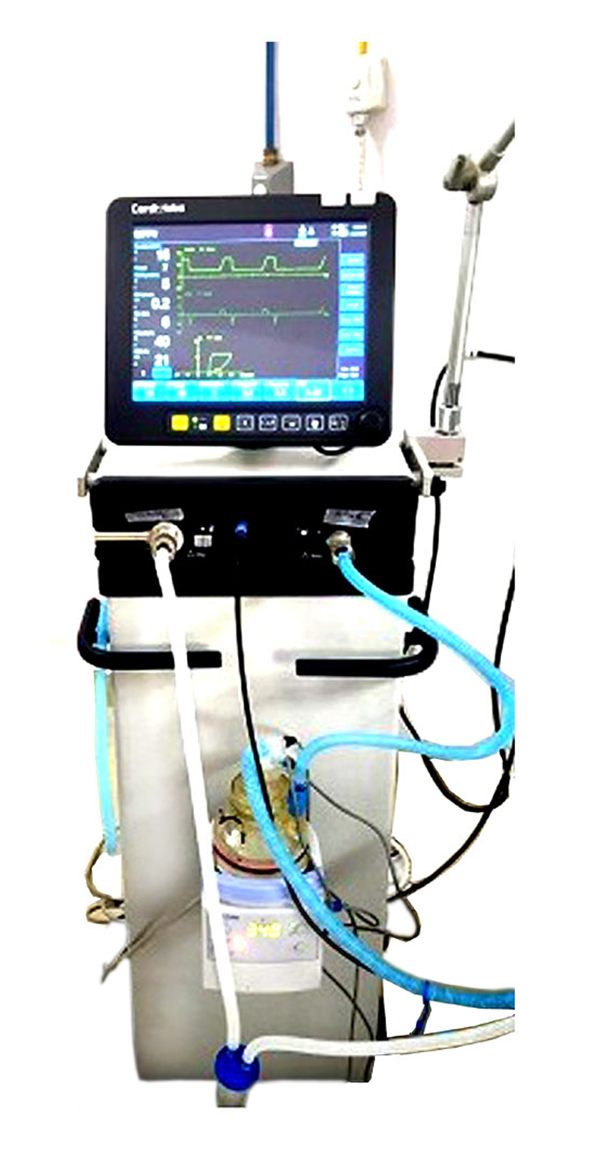
ICU VENTILATOR
APPLICATION: Adult-Pediatric

Tidal volume : 10ml to 2000ml

Modes of Ventilation

- Volume Control : VCV, VCV-SIMV
- Pressure Control with ETS option : PCV, PCV-SIMV, PSV/CPAP with Auto Apnea backup
- Advanced Modes : PRVC , SIMV-PRVC, APRV, Duovent (BiPAP)
- Intelligent Mode : SmartVent ((Automatic Ventilation Mode)
- Non Invasive Modes : NIV & NIV S/T
- O2 Therapy : ( Hi Flow O2 Therapy)

APPLICATION: Neonatal Ventilation

Proximal digital Flow Sensor option for precise flow, volume measurement, faster response time & Low work of breathing
Cvent provides tidal volumes as low as 2 ml with the Neonatal effectively, Safe ventilation even for the
smallest patients.

Incorporates the Proven Technology ‘VIVE’. ( Continuous ﬂow allow independent setting of inspiratory and expiratory circuit ﬂow rate to prevent rebreathing of CO2 from the circuit and maintains PEEP

Modes: Neonatal ( Tidal Volume from 2ml onwards)

Pressure Control: PCV, SIMV-PC, PSV (with Volume Guarantee (VG) Option)
IPPV + VG , SIPPV + VG , SIMV + VG , PSV/SPONT + VG

Non Invasive Modes : nCPAP, O2 therapy- Most effective therapy , used worldwide ,
Cvent also recommend to use NIV option in newborns.
nSIPPV, nSIMV (optional)

ANESTHESIA W/S

Anesthesia machine with Three Gas System (Air,O2 & N2O)
Five Tube flow meter assembly with Hypoxia Guard
Advance venlator with full range of modes VCV,PCV,SIMV,PSV with backup , Manual ,Standby
9 Inch Color TFT Display with Touch & Track operation
Advanced proportional valve technology for precise flow control
Auto compensated Tidal Volume provides accurate delivery from 20ml-2000ml
Smart Driving Gas Shift Technology: In case main Air driving gas fails, atomically shift to Secondary driving gas Oxygen & Visa Versa
Simultaneously display waveforms (PT,FT,VT) & Loops ( PV,FV)
Electronic PEEP & Fio2 Monitoring
Emergency oxygen flish. Flow between 35 to 70 LMP
Twin Select a tec type vaporizers manifold
Inbuilt Yokes for O2 & N2O
Switchable Auxiliary Common gas outlet ACGO)
Inbuilt Dual Drawers with big storage space
Audible Gas failure Alarm
Lithium Ion Baery backup 2 hours
Integrated circle observer (1.5 L) with APL Valve and manual/Vent switch for easy operation

