Introduction to Bayesian Inference
Table of contents

Configuring R
Functions from these packages will be used throughout this document:
library(conflicted) # check for conflicting function definitions
# library(printr) # inserts help-file output into markdown output
library(rmarkdown) # Convert R Markdown documents into a variety of formats.
library(pander) # format tables for markdown
library(ggplot2) # graphics
library(ggfortify) # help with graphics
library(dplyr) # manipulate data
library(tibble) # `tibble`s extend `data.frame`s
library(magrittr) # `%>%` and other additional piping tools
library(haven) # import Stata files
library(knitr) # format R output for markdown
library(tidyr) # Tools to help to create tidy data
library(plotly) # interactive graphics
library(dobson) # datasets from Dobson and Barnett 2018
library(parameters) # format model output tables for markdown
library(haven) # import Stata files
library(latex2exp) # use LaTeX in R code (for figures and tables)
library(fs) # filesystem path manipulations
library(survival) # survival analysis
library(survminer) # survival analysis graphics
library(KMsurv) # datasets from Klein and Moeschberger
library(parameters) # format model output tables for
library(webshot2) # convert interactive content to static for pdf
library(forcats) # functions for categorical variables ("factors")
library(stringr) # functions for dealing with strings
library(lubridate) # functions for dealing with dates and times
library(broom) # Summarizes key information about statistical objects in tidy tibbles
library(broom.helpers) # Provides suite of functions to work with regression model 'broom::tidy()' tibbles
Here are some R settings I use in this document:
rm(list = ls()) # delete any data that's already loaded into R
conflicts_prefer(dplyr::filter)
ggplot2::theme_set(
ggplot2::theme_bw() +
# ggplot2::labs(col = "") +
ggplot2::theme(
legend.position = "bottom",
text = ggplot2::element_text(size = 12, family = "serif")))
knitr::opts_chunk$set(message = FALSE)
options('digits' = 6)
panderOptions("big.mark", ",")
pander::panderOptions("table.emphasize.rownames", FALSE)
pander::panderOptions("table.split.table", Inf)
conflicts_prefer(dplyr::filter) # use the `filter()` function from dplyr() by default
legend_text_size = 9
run_graphs = TRUE

Suppose $X_{1},...,X_{n} ∼_{\text{iid}} N(M,1)$
Suppose $M∼N(0,1)$.
Then:
$$\begin{aligned}p(M=μ|X=x)&∝p(M=μ,X=x) \\ &=p(X=x|M=μ)p(M=μ) \\ &∝\text{exp}\left\{−\frac{1}{2}nμ^{2}−2μn\overset{‾}{x}\right\}\text{exp}\left\{−\frac{1}{2}μ^{2}\right\} \\ &=\text{exp}\left\{−\frac{1}{2}(n+1)μ^{2}−2μn\overset{‾}{x}\right\} \\ &∝\text{exp}\left\{−\frac{1}{2}(n+1)(μ−\frac{n}{n+1}\overset{‾}{x})^{2}\right\}\end{aligned}$$
So:
$$p(M=μ|X=x)∼N(\frac{n}{n+1}\overset{‾}{x},(n+1)^{−1})$$
Let’s put this in perspective.
Here’s a frequentist CI:
set.seed(1)
mu <- 2
sigma <- 1
n <- 20
x <- rnorm(n = n, mean = mu, sd = sigma)
xbar <- mean(x)
se <- sigma / sqrt(n)
CI_freq <- xbar + se * qnorm(c(.025, .975))
print(CI_freq)
#> [1] 1.75226 2.62879
lik0 <- function(mu) dnorm(x = x, mean = mu, sd = 1) |> prod()
lik <- function(mu) {
(2 * pi * sigma^2)^(-n / 2) *
exp(
-1 / (2 * sigma^2) *
(sum(x^2) - 2 * mu * sum(x) + n * (mu^2))
)
}
library(ggplot2)
ngraph <- 1001
plot1 <- ggplot() +
geom_function(fun = lik, aes(col = "likelihood"), n = ngraph) +
xlim(c(-5, 10)) +
theme_bw() +
labs(col = "") +
theme(legend.position = "bottom")
print(plot1)
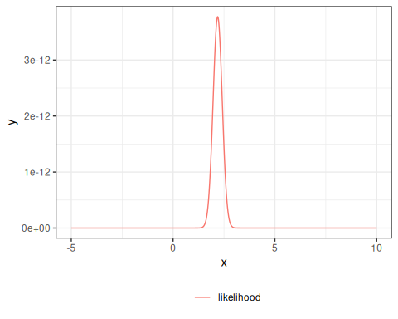
Here’s a Bayesian CI:
mu_prior_mean <- 0
mu_prior_sd <- 1
mu_post_mean <- n / (n + 1) * xbar
mu_post_var <- 1 / (n + 1)
mu_post_sd <- sqrt(mu_post_var)
CI_bayes <- qnorm(
p = c(.025, .975),
mean = mu_post_mean,
sd = mu_post_sd
)
print(CI_bayes)
#> [1] 1.65851 2.51391
prior <- function(mu) dnorm(mu, mean = mu_prior_mean, sd = mu_prior_sd)
posterior <- function(mu) dnorm(mu, mean = mu_post_mean, sd = mu_post_sd)
plot2 <- plot1 +
geom_function(fun = prior, aes(col = "prior"), n = ngraph) +
geom_function(fun = posterior, aes(col = "posterior"), n = ngraph)
print(plot2 + scale_y_log10())
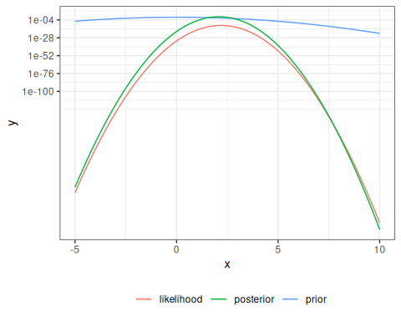
Here’s $p(M∈(l(x),r(x))|X=x)$:
pr_in_CI <- pnorm(
CI_freq,
mean = mu_post_mean,
sd = mu_post_sd
) |> diff()
print(pr_in_CI)
#> [1] 0.930583

1. Example with JAGS
This example demonstrates Bayesian inference using JAGS (Just Another Gibbs Sampler) for a simple Bernoulli model from Dobson’s text.

1.0.1 Load Required Packages
library(rjags)
library(runjags)
runjags::findJAGS()
#> [1] "/usr/bin/jags"

1.0.2 Run the JAGS Model
We’ll use a simple Bernoulli model to estimate a probability parameter using Bayesian inference.
# JAGS chain initialization function
initsfunction <- function(chain) {
stopifnot(chain %in% (1:4)) # max 4 chains allowed
rng_seed <- (1:4)[chain]
rng_name <- c(
"base::Wichmann-Hill", "base::Marsaglia-Multicarry",
"base::Super-Duper", "base::Mersenne-Twister"
)[chain]
return(list(".RNG.seed" = rng_seed, ".RNG.name" = rng_name))
}
# Generate sample data
set.seed(1)
data1 <- rbinom(n = 91, size = 1, prob = .6)
# Run JAGS model
jags_post0 <- run.jags(
n.chains = 2,
inits = initsfunction,
model = system.file("extdata/model.dobson.jags", package = "rme"),
data = list(r = data1, N = length(data1)),
monitor = "p"
)
#> Compiling rjags model...
#> Calling the simulation using the rjags method...
#> Note: the model did not require adaptation
#> Burning in the model for 4000 iterations...
#> Running the model for 10000 iterations...
#> Simulation complete
#> Calculating summary statistics...
#> Calculating the Gelman-Rubin statistic for 1 variables....
#> Finished running the simulation

1.0.3 Examine Results
jags_post0$mcmc |> as.array() |> head()
#> chain
#> iter [,1] [,2]
#> 5001 0.584687 0.550332
#> 5002 0.576621 0.562455
#> 5003 0.651983 0.628144
#> 5004 0.598258 0.604274
#> 5005 0.611863 0.583400
#> 5006 0.565635 0.606325

2. Other resources
UC Davis courses
- STA 015C: “Introduction to Statistical Data Science III”
- STA 035C: “Statistical Data Science III”
- STA 145: “Bayesian Statistical Inference”
- ECL 234: “Bayesian Models - A Statistical Primer”
- PLS 207: “Applied Statistical Modeling for the Environmental Sciences”
- PSC 205H: “Applied Bayesian Statistics for Social Scientists”
- POL 280: “Bayesian Methods: for Social & Behavioral Sciences”
- BAX 442: “Advanced Statistics”
Books
- Ross (2022) is a free online textbook
- “Population health thinking with Bayesian networks” (Aragon 2018) is on my to-read list
- McElreath (2020)
  - very popular recently
  - author used to be a UCD professor
  - ECL 234 uses this book
  - videos: https://www.youtube.com/playlist?list=PLDcUM9US4XdPz-KxHM4XHt7uUVGWWVSus
  - course materials: https://github.com/rmcelreath/stat_rethinking_2024
- Korner-Nievergelt and Korner-Nievergelt (2015)
- Cowles (2013)
- Kéry et al. (2012)
- Hobbs and Hooten (2015) has been used in PLS 207

References
Aragon, Tomas J. 2018. Population Health Thinking with Bayesian Networks. https://escholarship.org/uc/item/8000r5m5.
Cowles, Mary Kathryn. 2013. Applied Bayesian Statistics: With R and OpenBUGS Examples. Vol. 98. Springer Texts in Statistics. Springer Nature. https://doi.org/10.1007/978-1-4614-5696-4.
Hobbs, N. Thompson, and Mevin B Hooten. 2015. Bayesian Models: A Statistical Primer for Ecologists. STU - Student edition. Princeton University Press.
Kéry, Marc., Michael. Schaub, and Steven R. Beissinger. 2012. Bayesian Population Analysis Using WinBUGS : A Hierarchical Perspective. 1st ed. Academic Press. https://shop.elsevier.com/books/bayesian-population-analysis-using-winbugs/kery/978-0-12-387020-9.
Korner-Nievergelt, Fränzi, and Fränzi Korner-Nievergelt. 2015. Bayesian Data Analysis in Ecology Using Linear Models with R, BUGS, and Stan. 1st ed. Academic Press.
McElreath, Richard. 2020. Statistical Rethinking : A Bayesian Course with Examples in R and Stan. Second edition. Chapman & Hall/CRC Texts in Statistical Science Series. CRC Press.
Ross, Kevin. 2022. An Introduction to Bayesian Reasoning and Methods. Online. https://bookdown.org/kevin_davisross/bayesian-reasoning-and-methods/.

