

**CIS 310 – 01**

**Assignment 3**

Aziz Arrak, Kaylee Thomas, Madeline Cowgill, Shivani Patel

Page 108:

**14. Create the table that results from applying a UNION relational operator to the tables shown in Figure Q3.13**.

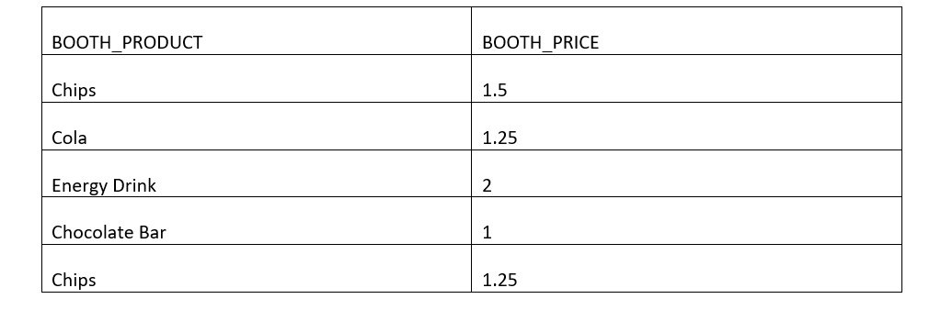

**16. Create the table that results from applying an INTERSECT relational operator to the tables shown in Figure Q3.13**.

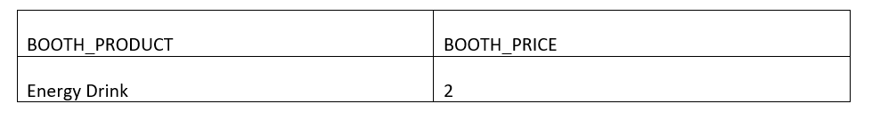

**17. Using the tables in Figure Q3.13, create the table that results from MACHINE DIFFERENCE BOOTH**.

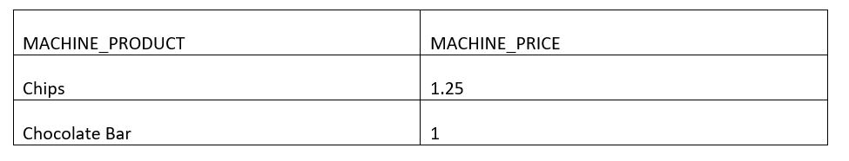

Page 112:   
**17. For each table, identify the primary key and the foreign key(s). If a table does not have a foreign key, write None**.

|  |  |  |
| --- | --- | --- |
| **TABLE** | **PRIMARY KEY** | **FOREIGN KEY(S)** |
| TRUCK | TRUCK_NUM | BASE_CODE, TYPE_CODE |
| BASE | BASE_CODE | None |
| TYPE | TYPE_CODE | None |

**18. Do the tables exhibit entity integrity? Answer yes or no, and then explain your answer**.

|  |  |  |
| --- | --- | --- |
| **TABLE** | **ENTITY INTEGRITY** | **EXPLANATION** |
| TRUCK | Yes | **All** of the values in the primary key are unique, and **no** key attribute in the primary key contains a null. |
| BASE | Yes | **All** of the values in the primary key are unique, and **no** key attribute in the primary key contains a null. |
| TYPE | Yes | **All** of the values in the primary key are unique, and **no** key attribute in the primary key contains a null. |

**19. Do the tables exhibit referential integrity? Answer yes or no, and then explain your answer**. **Write NA (Not Applicable) if the table does not have a foreign key**.

|  |  |  |
| --- | --- | --- |
| **TABLE** | **REFERENTIAL INTEGRITY** | **EXPLANATION** |
| TRUCK | Yes | Every reference to an entity instance by another entity instance is valid. Null foreign keys reference existing primary keys. |
| BASE | NA | Table does not have a foreign key. |
| TYPE | NA | Table does not have a foreign key. |

**20. Identify the TRUCK table’s candidate key(s)**.

Truck_Num and Truck_Serial_Num are the only possible candidate keys for the Truck table.

**21. For each table, identify a superkey and a secondary key**.

|  |  |  |
| --- | --- | --- |
| **Table** | **Superkey** | **Secondary Key** |
| Truck | Truck_Num + Truck_Miles | Base_Code + Type_code |
| Base | Base_code + base_city | Base_City + base_State |
| Type | Type_code + Type_Description | Type_description |

**22. Create the ERD for this database**. (Visio)

