

**CIS 310 – 01**

**Assignment 4**

Aziz Arrak, Madeline Cowgill, Shivani Patel, Kaylee Thomas

**Finish Exercise 11 that starts on page 161**.

**Crow’s Foot ERD**:

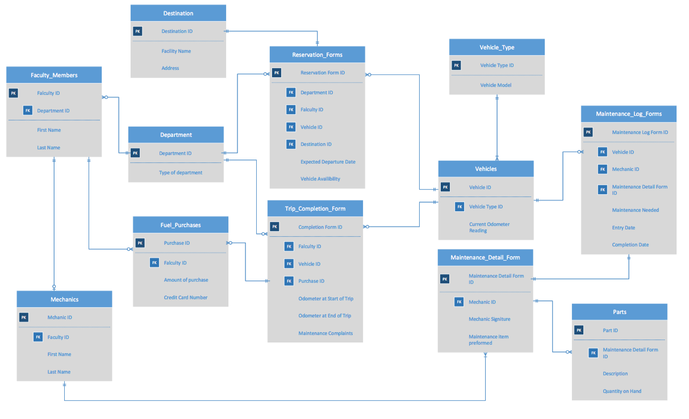

**Business Rules**:

1. Each faculty member belongs to 1 and only 1 department.
2. Each department has 0 to many faculty members.
3. Each faculty member row can appear in the mechanic table 0 to 1 times.
4. Each mechanic has to be a faculty member.
5. Each faculty member can make 0 to many fuel purchases.
6. Each fuel purchase can be made by 1 and only 1 faculty member.
7. Each department can have 0 to many reservation forms.
8. Each reservation form can be associated with 1 and only 1 department.
9. Each department can have 0 to many trip completion forms.
10. Each trip completion form can be associated with 1 and only 1 department.
11. Each fuel purchase can be for 1 and only 1 trip completion form.
12. Each trip completion form can have 0 to many fuel purchases.
13. Each reservation form can have 1 and only 1 destination.
14. Each destination can have 1 and only 1 reservation form.
15. Each reservation form can be assigned to 1 and only 1 vehicle.
16. Each vehicle can have 0 to many reservations forms.
17. Each trip completion form can have 1 and only 1 vehicles.
18. Each vehicle can have 0 to many trip completion forms.
19. Each vehicle can have 1 and only 1 vehicle type.
20. Each vehicle type can be associated with 1 to many vehicles.
21. Each vehicle can be associated with 0 to many maintenance log forms.
22. Each maintenance log forms can have 1 and only 1 vehicle.
23. Each maintenance log form can have 1 and only 1 maintenance detail form.
24. Each maintenance detail form can have 1 and only 1 maintenance log form.
25. Each maintenance detail form can have 0 or more parts.
26. Each part should be associated with 1 and only 1 maintenance detail form.
27. Each mechanic can be can sign 0 or more maintenance detail form.
28. Each maintenance detail form can be signed by 1 and only 1 mechanic.