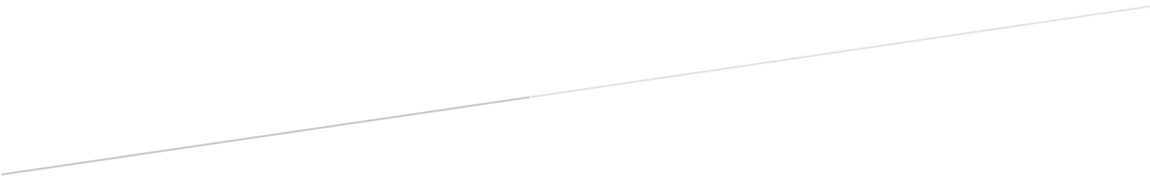

**CIS 310 – 01**

**Assignment 5**

Aziz Arrak, Madeline Cowgill, Shivani Patel, Kaylee Thomas

Finish Exercise 3 on page 238.  
  
1. Create the dependency diagram showing the PK dependency and all the undesirable dependencies.   
2. Normalize the table so the final result is in 3NF for all the tables. You must show intermediate steps such as 1NF, 2NF, and 3NF, as I have done in class.

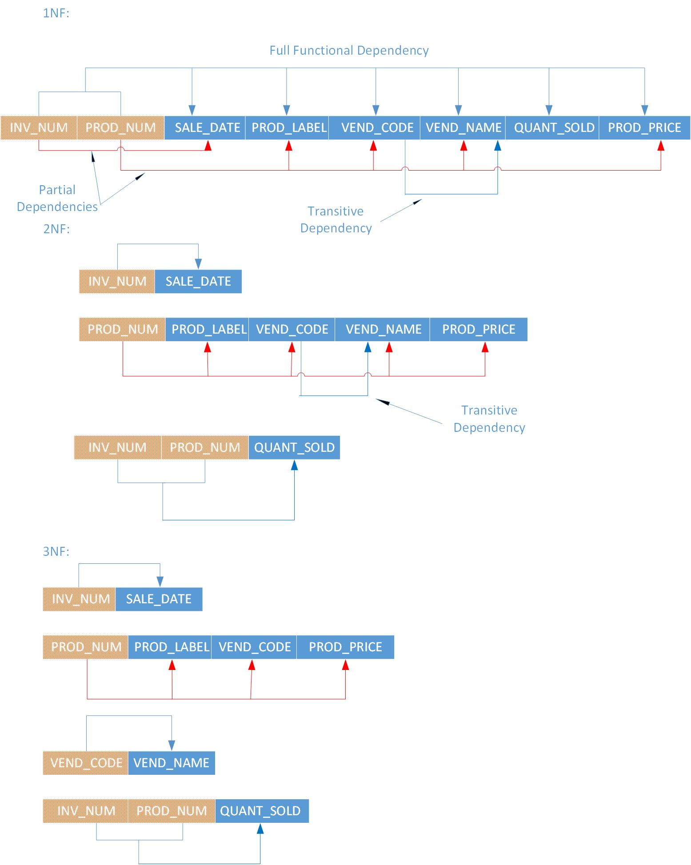

3. Draw a Crow's Foot ERD in Visio for the resulting 3NF database

