

**CIS 310 – 01**

**Assignment 6**

Aziz Arrak, Madeline Cowgill, Shivani Patel, Kaylee Thomas

**Finish exercises 44-64 at the end of Chapter 7.**

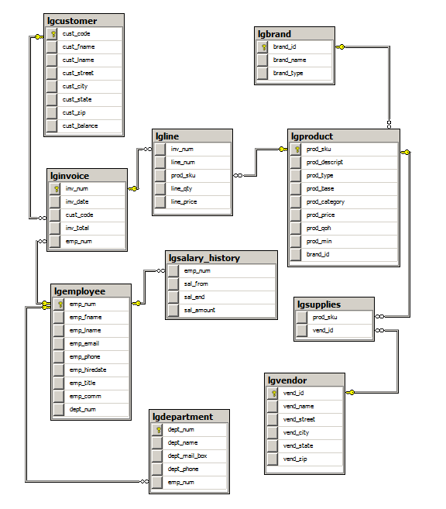

**--A6 SQL**

**-- 44**

**SELECT \***

**FROM LGDEPARTMENT**

**--45**

**SELECT PROD_SKU, PROD_DESCRIPT, PROD_TYPE, PROD_BASE,**

**PROD_CATEGORY, PROD_PRICE**

**FROM LGPRODUCT**

**WHERE PROD_BASE='Water' AND PROD_CATEGORY='Sealer';**

**--46**

**SELECT EMP_FNAME, EMP_LNAME, EMP_EMAIL**

**FROM LGEMPLOYEE**

**WHERE EMP_HIREDATE BETWEEN '01/01/2003' AND '12/31/2012'**

**ORDER BY EMP_LNAME, EMP_FNAME;**

**--47**

**SELECT EMP_FNAME, EMP_LNAME, EMP_PHONE, EMP_TITLE, DEPT_NUM**

**FROM LGEMPLOYEE**

**WHERE DEPT_NUM = 300 OR**

**EMP_TITLE='CLERK I'**

**ORDER BY EMP_LNAME, EMP_FNAME;**

**--48**

**SELECT E.EMP_NUM, E.EMP_LNAME, E.EMP_FNAME, S.SAL_FROM, S.SAL_END,**

**S.SAL_AMOUNT**

**FROM LGEMPLOYEE E INNER JOIN LGSALARY_HISTORY S ON E.EMP_NUM =**

**S.EMP_NUM**

**WHERE E.EMP_NUM IN (83731, 83745, 84039)  
 ORDER BY E.EMP_NUM, S.SAL_FROM**

**--49**

**SELECT DISTINCT C.CUST_FNAME, C.CUST_LNAME, C.CUST_STREET,**

**C.CUST_STREET, C.CUST_CITY, C.CUST_STATE, C.CUST_ZIP**

**FROM LGCUSTOMER C INNER JOIN LGINVOICE I ON C.CUST_CODE =**

**I.CUST_CODE  
 INNER JOIN LGLINE L ON I.INV_NUM = L.INV_NUM   
 INNER JOIN LGPRODUCT P ON L.PROD_SKU = P.PROD_SKU  
 INNER JOIN LGBRAND B ON P.BRAND_ID = B.BRAND_ID**

**WHERE B.BRAND_NAME = 'FORESTERS BEST' AND  
 P.PROD_CATEGORY = 'TOP COAT' AND  
 I.INV_DATE BETWEEN '07-15-2015' AND '07-31-2015'   
ORDER BY C.CUST_STATE, C.CUST_LNAME, C.CUST_FNAME**

**--50**

**SELECT E.EMP_NUM, E.EMP_LNAME, E.EMP_EMAIL, E.EMP_TITLE, D.DEPT_NAME  
FROM LGEMPLOYEE E INNER JOIN LGDEPARTMENT D ON E.DEPT_NUM =**

**D.DEPT_NUM**

**WHERE E.EMP_TITLE LIKE '%ASSOCIATE'  
ORDER BY** DEPT_NAME, E.EMP_TITLE

**--51**

**SELECT B.BRAND_NAME, COUNT(PROD_SKU) AS NUMPRODUCTS  
FROM LGBRAND B INNER JOIN LGPRODUCT P ON B.BRAND_ID = P.BRAND_ID   
GROUP BY B.BRAND_NAME**

**--52**

**SELECT PROD_CATEGORY, COUNT(PROD_SKU) AS NUMPRODUCTS  
FROM LGPRODUCT   
WHERE PROD_BASE = 'WATER'  
GROUP BY PROD_CATEGORY**

**--53**

**SELECT PROD_BASE, PROD_TYPE, COUNT(*) AS NUMPRODUCTS**

**FROM LGPRODUCT**

**GROUP BY PROD_BASE, PROD_TYPE**

**ORDER BY PROD_BASE, PROD_TYPE;**

**--54**

**SELECT B.BRAND_ID, SUM(P.PROD_QOH) AS TOTALINVENTORY  
FROM LGBRAND B INNER JOIN LGPRODUCT P ON B.BRAND_ID = P.BRAND_ID   
GROUP BY B.BRAND_ID   
ORDER BY B.BRAND_ID DESC**

**--55**

**SELECT B.BRAND_ID, B.BRAND_NAME, CAST(AVG(P.PROD_PRICE) AS**

**DECIMAL (12,2)) AS AVGPRICE**

**FROM LGBRAND B INNER JOIN LGPRODUCT P ON B.BRAND_ID = P.BRAND_ID   
 GROUP BY B.BRAND_ID, B.BRAND_NAME   
ORDER BY B.BRAND_NAME**

**--56**

**SELECT D.DEPT_NUM, MAX(E.EMP_HIREDATE) AS MOSTRECENT**

**FROM LGDEPARTMENT D INNER JOIN LGEMPLOYEE E ON D.DEPT_NUM =**

**E.DEPT_NUM**

**GROUP BY D.DEPT_NUM**

**ORDER BY D.DEPT_NUM**

**--57**

**SELECT E.EMP_NUM, E.EMP_FNAME, E.EMP_LNAME, MAX(S.SAL_AMOUNT) AS**

**LARGESTSALARY**

**FROM LGEMPLOYEE E INNER JOIN LGSALARY_HISTORY S ON E.EMP_NUM =**

**S.EMP_NUM**

**WHERE E.DEPT_NUM = 200  
GROUP BY E.EMP_NUM, E.EMP_FNAME, E.EMP_LNAME  
ORDER BY MAX(S.SAL_AMOUNT) DESC**

**--58**

**SELECT C.CUST_CODE, C.CUST_FNAME, C.CUST_LNAME, SUM(I.INV_TOTAL) AS**

**TOTALINVOICES**

**FROM LGCUSTOMER C INNER JOIN LGINVOICE I ON C.CUST_CODE =**

**I.CUST_CODE**

**GROUP BY C.CUST_CODE, C.CUST_FNAME, C.CUST_LNAME  
HAVING SUM(I.INV_TOTAL) > 1500  
ORDER BY SUM(I.INV_TOTAL) DESC**

**--59**

**SELECT D.DEPT_NUM, D.DEPT_NAME, D.DEPT_PHONE, E.EMP_NUM,**

**E.EMP_LNAME**

**FROM LGDEPARTMENT D INNER JOIN LGEMPLOYEE E ON D.EMP_NUM =**

**E.EMP_NUM**

**ORDER BY D.DEPT_NAME**

**--60**

**SELECT V.VEND_ID, V.VEND_NAME, B.BRAND_NAME, COUNT(P.PROD_SKU) AS**

**NUMPRODUCTS**

**FROM LGVENDOR V INNER JOIN LGSUPPLIES S ON V.VEND_ID = S.VEND_ID  
 INNER JOIN LGPRODUCT P ON S.PROD_SKU = P.PROD_SKU  
 INNER JOIN LGBRAND B ON P.BRAND_ID = B.BRAND_ID  
GROUP BY V.VEND_ID, V.VEND_NAME, B.BRAND_NAME  
ORDER BY V.VEND_NAME, B.BRAND_NAME**

**--61**

**SELECT E.EMP_NUM, E.EMP_LNAME, E.EMP_FNAME, SUM(I.INV_TOTAL) AS**

**TOTALINVOICES**

**FROM LGEMPLOYEE E INNER JOIN LGINVOICE I ON E.EMP_NUM =**

**I.EMPLOYEE_ID**

**GROUP BY E.EMP_NUM, E.EMP_LNAME, E.EMP_FNAME  
ORDER BY E.EMP_LNAME, E.EMP_FNAME**

**--62**

**SELECT CAST(AVG(PROD_PRICE) AS DECIMAL (12,2)) AS [LARGEST AVERAGE]  
FROM LGPRODUCT   
GROUP BY BRAND_ID   
HAVING AVG(PROD_PRICE) =  
 (SELECT TOP 1 AVG(PROD_PRICE)  
 FROM LGPRODUCT  
 GROUP BY BRAND_ID   
 ORDER BY AVG(PROD_PRICE) DESC   
 )**

**--63**

**SELECT P.BRAND_ID, B.BRAND_NAME, B.BRAND_TYPE,**

**CAST(AVG(P.PROD_PRICE) AS DECIMAL (12,2)) AS AVGPRICE**

**FROM LGPRODUCT P INNER JOIN LGBRAND B ON P.BRAND_ID = B.BRAND_ID   
GROUP BY P.BRAND_ID, B.BRAND_NAME, B.BRAND_TYPE   
HAVING AVG(PROD_PRICE) =  
 (SELECT TOP 1 AVG(PROD_PRICE)  
 FROM LGPRODUCT  
 GROUP BY BRAND_ID   
 ORDER BY AVG(PROD_PRICE) DESC   
 )**

**--64**

**SELECT M.EMP_FNAME AS [Manager FName], M.EMP_LNAME AS [Manager**

**LName], D.DEPT_NAME,   
 D.DEPT_PHONE, E.EMP_FNAME AS [Employee Fname], E.EMP_LNAME**

**AS [Employee Lname], C.CUST_FNAME AS [Customer FName], C.CUST_LNAME AS [Customer LName], I.INV_DATE, I.INV_TOTAL**

**FROM LGEMPLOYEE E INNER JOIN LGDEPARTMENT D ON D.DEPT_NUM =**

**E.DEPT_NUM  
 INNER JOIN LGEMPLOYEE M ON D.EMP_NUM = M.EMP_NUM   
 INNER JOIN LGINVOICE I ON E.EMP_NUM = I.EMPLOYEE_ID   
 INNER JOIN LGCUSTOMER C ON I.CUST_CODE = C.CUST_CODE**

**WHERE C.CUST_LNAME = 'HAGAN' AND  
 I.INV_DATE = '05-18-2015'**