Lampros technical test:

**Question: 1**

**Write a query to find the average count of transactions per day on polygon.**

**Data table: polygon.transactions**

Sql query :

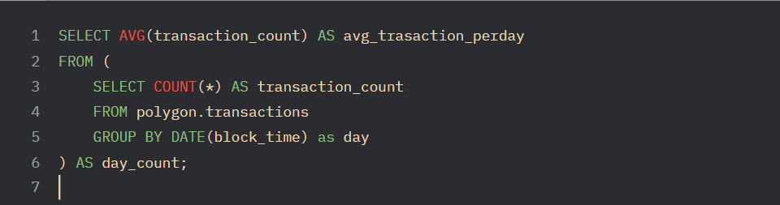

Output:

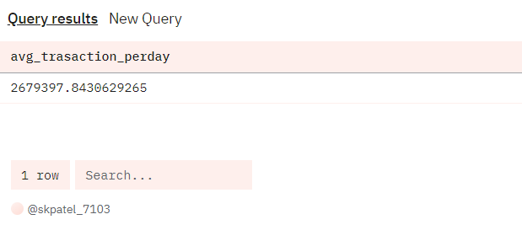

Dashboard:

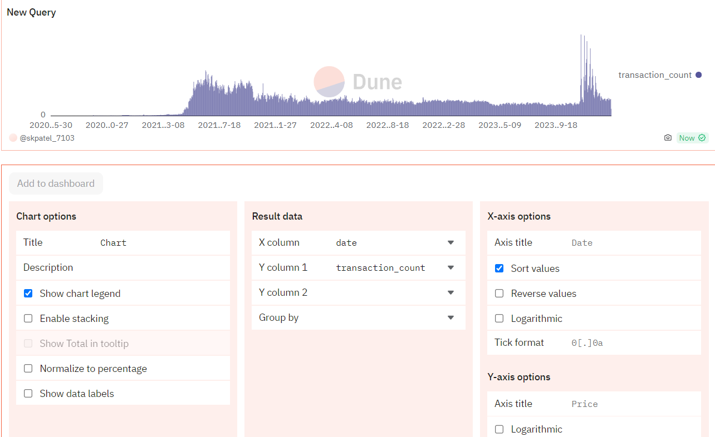

**Question: 2**

**Write a query to find the top 10 holders of OP token.**

**Data table: op_token_distributions_optimism.transfer_mapping**

Sql query:

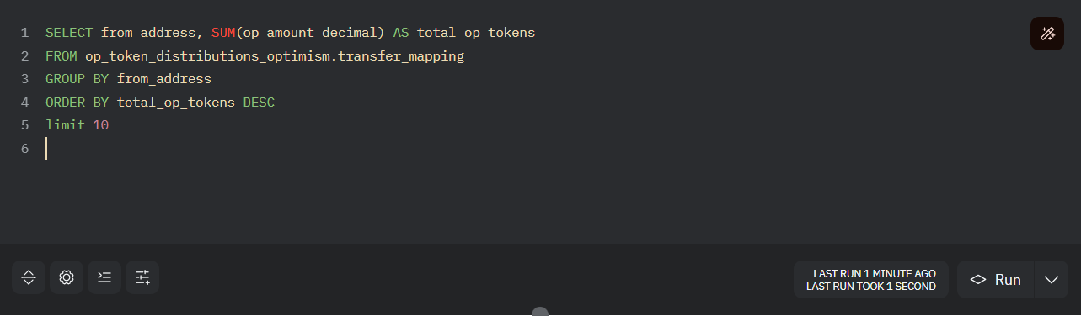

Output:

