Class Diagram

Component Diagram

Deployment Diagram

AWS Best Practices Reflected

* Use of **VPC** with public/private subnets for security and network control.
* **ALB** for load balancing and SSL termination.
* **API Gateway** for API management and serverless integration.
* **Kubernetes** for container orchestration of microservices.
* **AWS Lambda** for scalable, event-driven compute.
* Separation of concerns between components and clear communication paths.
* Use of **AWS S3** for durable, scalable media storage.

Usecase Diagram

Activity Diagram

Sequence Diagram

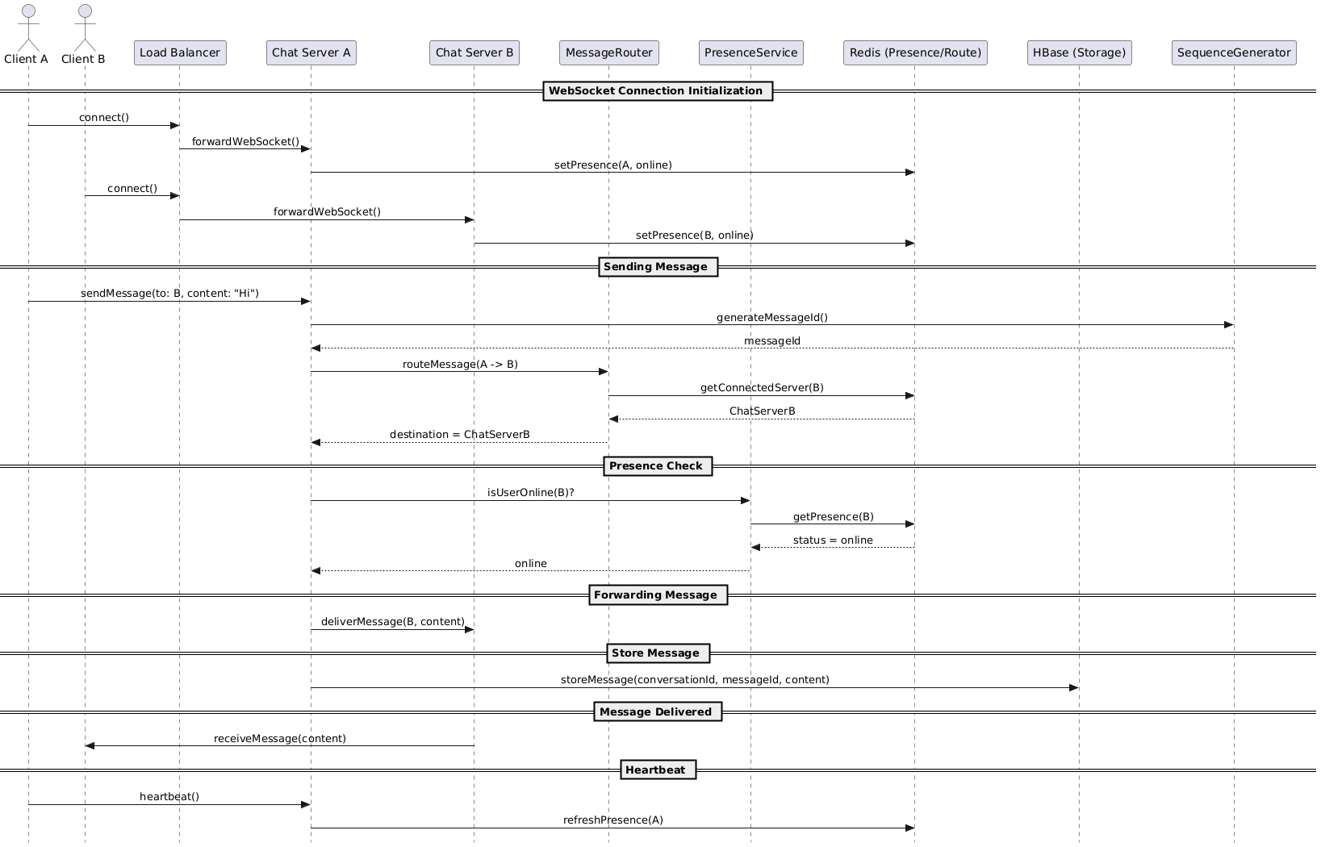

Collaboration Diagram

State Diagram

