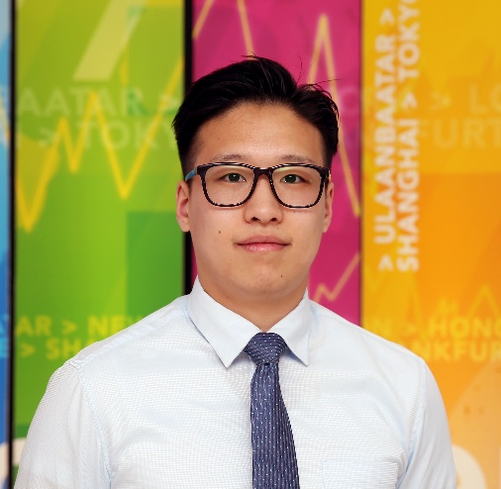**NAMKHAIDORJ GANBAT /Naki/**

**CONTACTS**

Born in Erdenet city, Mongolia

Lives in Ulaanbaatar, Mongolia

address

[naki.mongolia@gmail.com](mailto:naki.mongolia@gmail.com)

namkhaidorj@ihelp.mn

e-mail

976-99757475

phone number

**EXPERIENCES /2013 to present/**

* CEO**, ihelp.mn, Novelist LLC**, *Ulaanbaatar, Mongolia*, Jan 2021 to present
* CEO, **Career Developer Magazine**, Novelist Time LLC, *Ulaanbaatar, Mongolia*, Dec 2021 to present
* COO, **Individual Restaurant LLC**, Ulaanbaatar, Mongolia, Sep 2021 to Nov 2021.
* Deputy CEO, **Forbes Mongolia Magazine**, *Ulaanbaatar, Mongolia*, Aug 2021 to Sep 2021.
* Chief Business Officer, **Asia Mining Magazine LLC**, *Ulaanbaatar, Mongolia,* Mar 2021 to Aug 2021.
* Deputy Sales Director, **Bloomberg TV Mongolia**, *Ulaanbaatar, Mongolia,* Sep 2020 to Aug 2020
* Manager, **National News Corporation LLC**, **Bloomberg TV Mongolia,** *Ulaanbaatar, Mongolia*, February 2018 to Sep 2019
* Chairman, **Ugly Duckling NGO,** *Ulaanbaatar, Mongolia,* February 2018 to present
* Internship, **World Vision Mongolia,** *Ulaanbaatar, Mongolia,* November 2017 to February 2018
* Fellow, **Gegeen Undes NGO,** *Ulaanbaatar, Mongolia,* 2014 to 2016
* Internship, **Erdenet Mining Corporation,** *Erdenet, Mongolia,* September to October 2015
* Math teacher, **Elite education center,** *Ulaanbaatar, Mongolia,* 2013 to 2014
* Vice president, Researcher club, **NUM-SIRPA**, *Ulaanbatar, Mongolia,* 2013 to 2014

**EDUCATION**

* International Business Management & Marketing, Pre-master’s program, *University of Sheffield, UK, 2019-2020*
* Bachelor of International Economic Relations, *National University of Mongolia (NUM), School of International Relations and Public Administration (SIRPA), 2012 to 2016*
* High school education, *Erdmiin san school, Erdenet city, Mongolia, 2009-2012*

**AWARDS**

* Best of the year, Bloomberg TV Mongolia, National News Corporation LLC, 2019
* The Leader Youngman of the Year, Mongolian Youth Organization, 2018
* The first place in the essay contest, “Passport to the world”, Education USA /EARC/, 2016
* The best delegate prize of the Model United Nations, awarded by NUM-SIRPA, 2015
* Student’s scholarship awarded by Zorig Foundation & LG, 2014
* 3rd place in essay contest of World peaceful day, 2012

**COMPUTER SKILLS**

* Basic: Windows software, macOS
* Intermediate: Camtasia Studio, Microsoft Dynamic NAV
* Advanced: Google apps; Microsoft office; other online platforms

**LANGUAGE**

* Native: Mongolian, Advanced: English

**HOBBIES AND INTERESTS**

* Hosting: Morning View Series – Motivational & inspirational content that interviews successful leaders to share their experience, principles & philosophy to youth - www.youtube.com/c/morningviewseries
* Volunteering: One Asia 2015
* Public speaking: World Speech day 2016; NUM-SIRPA UN Model 2015; Mongolian National Orator Championship 2015; Scientific conferences etc.

**DETAILED SKILLS & ACHIEVEMENTS**

* Experienced in business planning, customer acquisition, negotiation, communication and event organization
* Expanded acquaintance and communication
* Increased interpretation skills and ability to make understand individual
* Improved leadership skills
* Enhanced skills in research and development
* Strengthened motivation to reach targeted goals and ambition