Fine-grained truck detection in overhead imagery
Auric AI Labs — Computer Vision Researcher assignment. Kranthi Kumar Sariputi. Submitted 15 Oct 2026.
Main report. Every number, method and run is documented in full in the technical appendix, `REPORT_FULL.pdf`.
---

Summary
0.340 mAP50 (95% CI 0.240–0.429) on the 18 validation images at the training resolution, and 0.297 (0.203–0.370) on all 22 validation images: a fourfold improvement over the 0.073 YOLO11s baseline, built through hypothesis-driven experimentation, domain-specific pretraining and quantitative failure diagnosis. The 18-image subset excludes four validation images that are rescaled about 2× relative to every training image (§3, Finding 4). The final pipeline fuses two RF-DETR detectors initialised from a public xView-pretrained checkpoint and normalises the scale of images outside the training size range. Each step was an individually tested gain: 2× upsampling +0.034, dense test-time views +0.069, fusion +0.048, scale normalisation +0.023.
The 0.75 target was not reached; the analysis shows where the remaining AP is lost and which experiment should come next. One caveat: the pretrained checkpoint's training data includes the validation imagery, so generalisation to external imagery is not yet verified.
What I did
- Built a frozen, verified evaluation pipeline on day 1: full-image, class-aware AP50 matching pycocotools, paired image bootstraps for every comparison, and an adoption rule fixed before the second experiment.
- Ran 101 hypothesis-driven configurations in seven days. Each was declared with its predicted effect before it was scored, on about 45 GPU-hours of free Kaggle and Colab GPUs, informed by 65 papers screened and 29 read in full.
- Built a 4× stronger pipeline through a chain of tested decisions (upsampling, ensembling, an xView-pretrained RF-DETR, dense test-time views, fusion, scale normalisation), and diagnosed why fine-tuning on the 443 training images collapses the rare classes.
- Diagnosed three dataset inconsistencies, each measured, and turned one into a fix. Four validation images are rescaled about 2× relative to all training images (a label-free rule from training image sizes recovers +0.023); the rare-class training labels disagree with xView's in one direction; about 16% of training boxes have no object under them.
- Answered all four research questions quantitatively (§5): perfect boxes reach 0.43; hard examples split into a size problem and a confusion problem; 500 more random labels are worth about +0.001; the smallest tested subset reaching 90% of full-data performance is 80% of the labelled instances (300 selected images reach 96%).
Table 1. Results (COCO 101-point AP50, full images; 95% CI over images).
Pipeline | 18 images at training resolution | All 22 validation images | Initialisation
Final pipeline | 0.340 (0.240–0.429) | 0.297 (0.203–0.370) | xView-pretrained RF-DETR
Same pipeline before scale normalisation | 0.340 (0.240–0.429) | 0.274 (0.175–0.357) | xView-pretrained RF-DETR
Best detector trained only on the provided images | 0.161 (0.090–0.268) | 0.139 (0.082–0.214) | COCO
Baseline (YOLO11s) | — | 0.073 (0.049–0.109) | COCO

Per class (final pipeline, all 22): Cargo 0.226, Box 0.375, Flatbed 0.394, Tractor 0.042, Liquid 0.451.
---

1. Approach
- Data. 443 training and 22 validation images, about 3,000 px at 0.3 m; 7,618 and 1,552 boxes. Trucks are tiny (median 15–20 px on the short side), the classes are imbalanced 20:1 (Liquid has 20 validation boxes), and validation scenes are dense depots (median 76 boxes per image vs 7 in train).
- Protocol, fixed on day 1. One frozen evaluator (matches pycocotools; ground truth scores 1.000). A change is adopted only if the paired image-bootstrap Δ ≥ +0.01 with P(Δ > 0) ≥ 0.90. Every hypothesis, change and prediction was written into experiments/LOG.md before the first score.
- How decisions were made. Each experiment tested one hypothesis; error types were measured before choosing the next lever; competing explanations were tested rather than assumed; negative results were kept and used to redirect effort. Two independent references were kept throughout: a YOLO pipeline trained only on the provided data, and 74 training images the pretrained checkpoint never saw, which gate every classifier and re-scoring decision.
- Scope. Seven days; 101 configurations scored; about 45 GPU-hours on free Kaggle (2× T4) and Colab (T4) GPUs, plus a laptop for analysis; 65 papers screened and 29 read in full.
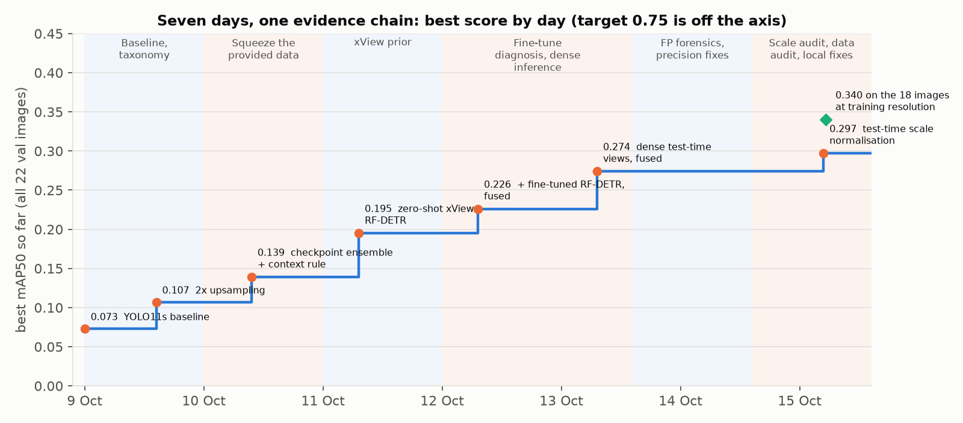
Figure 1. Best score on all 22 validation images by the day it was logged, with the phase of work behind each step. Every step passed a rule declared before scoring.
---

2. How the score was built
Table 2. Each step, tested against the previous best with a paired bootstrap over images.
Step | Change | mAP50 (all 22) | Paired Δ (95% CI)
Baseline | YOLO11s from COCO, 640 px tiles | 0.073 | —
2× upsampling | 2× upsampled tiles: the gain sits in trucks under 24 px | 0.107 | +0.034 (+0.002..+0.093)
Ensemble + context rule | 4-checkpoint ensemble (Weighted Boxes Fusion, WBF) + neighbourhood-class context rule | 0.139 | +0.032 (+0.005..+0.064) vs 2× upsampling
Zero-shot RF-DETR | RF-DETR from a public xView checkpoint, used without training | 0.195 | new detector prior
+ fine-tuned RF-DETR | a fine-tuned copy (2×, frozen class head, rare-class sampling), fused with the zero-shot model | 0.226 | +0.031 (−0.010..+0.079)
Dense test-time views | the zero-shot model run on 50%-overlapping tiles × 4 flips | 0.264 | +0.069 (+0.019..+0.097) vs zero-shot RF-DETR
Dense views + fine-tuned model, fused | the dense-view model fused with the fine-tuned model | 0.274 | +0.048 (+0.020..+0.070)
Scale normalisation (final pipeline) | images outside the training size range rescaled before inference | 0.297 | +0.023 (+0.003..+0.049)

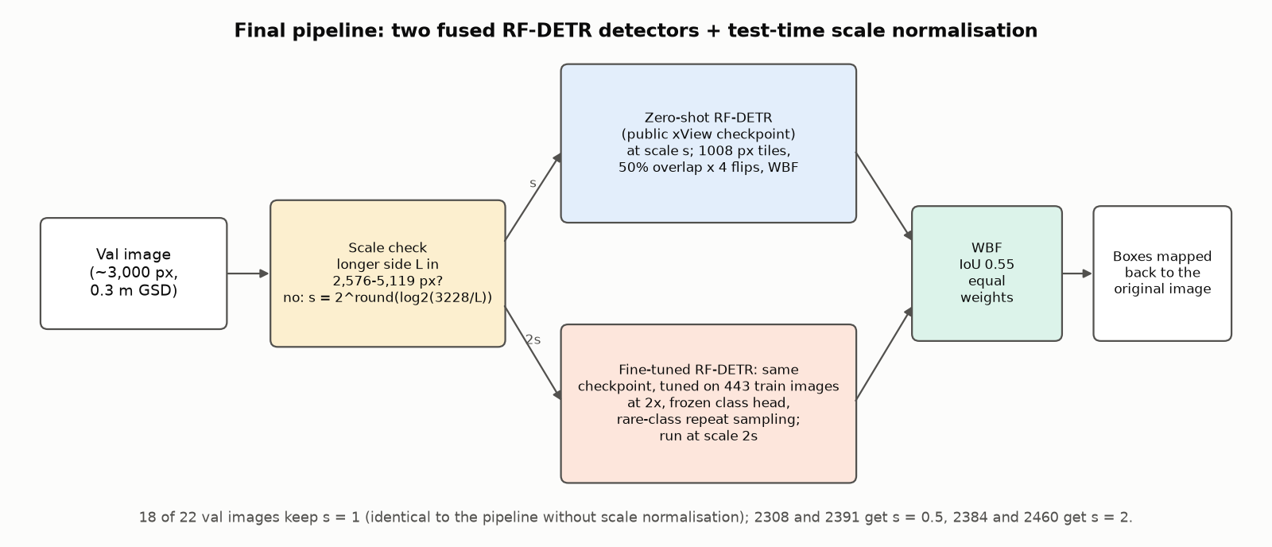
Figure 2. The final pipeline. An image whose longer side is outside the training range is rescaled by a power of two towards the training median; both RF-DETR members run at their own scale; boxes are fused and mapped back.
What fine-tuning alone revealed. Fine-tuning the checkpoint on the 443 images scored 0.067–0.113, below zero-shot (0.195). A diagnosis chain with no extra training ruled out BatchNorm drift and train/eval mismatch, and showed that boxes got better while classes got worse: Flatbed, Tractor and Liquid are predicted as Cargo or Box even on the training images. The fused pipeline keeps the zero-shot model's class prior and adds the fine-tuned model's rare-class gains.
---

3. What limits the score
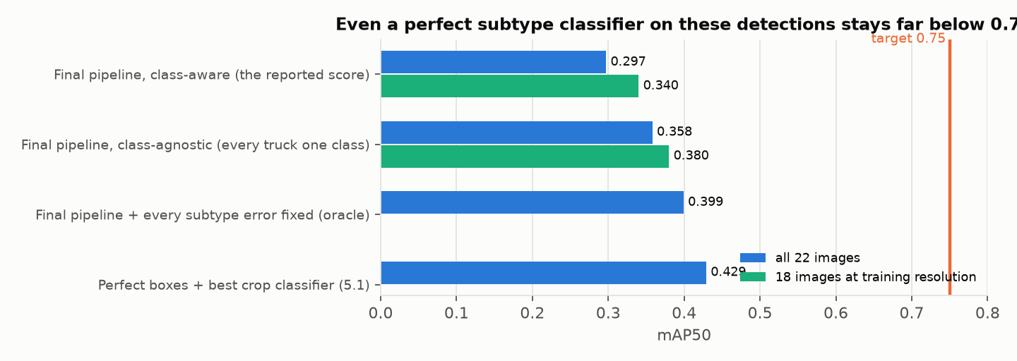
Figure 3. The reported score against two ceilings computed from the same detections. Fixing every subtype error lifts the score only to about 0.40.
Finding 1 — Detection ranking is weak even when subtype is ignored. Class-agnostic AP50 is 0.358 (0.380 on the 18). 72–100% of trucks are found at some confidence, but they are ranked below other vehicles and background: highly ranked false positives cost +0.119 AP. Using xView's own 60-class labels, 48–65% of the most damaging false positives turn out to be real vehicles (a neighbouring subtype, generic trucks, trailers), not clutter. Annotating the trucks missing from the validation labels turns only 6% of operating-point false positives into hits.
Finding 2 — Subtypes are confused on correctly located trucks, above all Tractor: only 26% of matched Tractor boxes get the right class (fixing subtype is worth +0.21 AP for Tractor, +0.10 overall). The confusion runs Cargo ↔ Box and rare → Cargo in every model tried, including classifiers given perfect boxes.
Finding 3 — The rare-class training labels disagree with xView's. Aligning xView's labels to our images and comparing classes box by box:
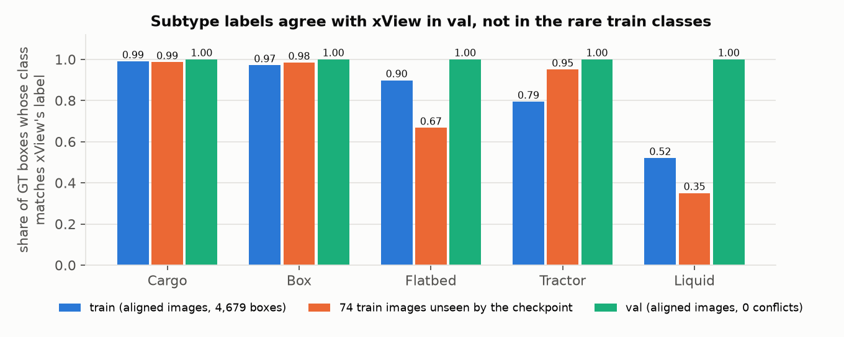
Figure 4. Share of boxes whose class matches xView's label for the same object. Train agrees for Cargo and Box but only 0.79 for Tractor and 0.52 for Liquid; validation agrees for every class.
The conflicts run one way (rare → Cargo/Box), matching the direction of the model's confusions, and about 16% of training boxes have no object under them. This inconsistency is measured; its causal contribution to the model's errors is not yet established, because a fine-tune on xView-corrected labels did not improve the score (§4).
Finding 4 — Four validation images are rescaled about 2×. Truck sizes in images 2308 and 2391 are 2.05–2.13× xView's, and in 2384 and 2460 0.50–0.55×; no training image is rescaled this way. In the enlarged pair, cars appear at the size of a typical training truck and are detected as Cargo Truck. The final pipeline normalises such images with a rule built from training image sizes only: +0.023, and never-detected trucks fall from 50 to 10.
---

4. What the other experiments established
Each idea was declared with a predicted effect before it was scored once. Results that did not pass the rule were kept, because each one settled a question and redirected the next experiment.
Table 3. What each non-adopted experiment established, and the decision it led to.
Experiment | Result | What it established → decision
Longer training (100 epochs) | Δ −0.0001 | training length is not the limit (validation loss rises after about 30 epochs) → effort moved to resolution, ensembling and pretraining
A small-object (P2) head, 3× upsampling, a larger YOLO11m, an aerial (DOTA) backbone, a tiny-object loss (NWD), Faster R-CNN | none passed | the provided-data line plateaus at 0.139 regardless of architecture → move to a domain-specific prior (xView)
Fine-tuning the xView checkpoint alone | 0.067–0.113 vs 0.195 zero-shot | fine-tuning improves boxes but collapses the rare classes → keep the zero-shot model and fuse the fine-tuned one
Size-prior re-scoring (drop detections with non-truck size or shape) | Δ −0.004 | damaging false positives have truck geometry → look at what they are (xView forensics) instead
Crop-classifier fusion (re-score detections with a separate subtype classifier) | Δ −0.128 | a classifier weaker than the detector hurts → any future classifier must first beat the detector on held-out images
Two stand-alone subtype classifiers, tested on 74 unseen images | macro-recall 0.350 / 0.376 vs detector 0.370 | the gate worked: neither was fused; clean labels did help the classifier (Tractor 0.125 → 0.250)
Box-only re-scoring, tested on 74 unseen images | Box AP Δ −0.033 / −0.021 | the detector's own scores rank best → validation never touched
8-view inference (adds transposed views to the 4 flips) | Δ −0.040 | the dense-view gain is saturated at 4 flips → stop adding views
Fusion re-weighting (2:1 towards the zero-shot model) | Δ +0.010, P 0.84 | a consistent but sub-threshold gain → not adopted; noted as a candidate for a larger validation set
Clean-label fine-tune (on xView-corrected labels) | Δ −0.019 (−0.065..+0.007) | inconclusive: cleaning also cut Liquid training boxes by 29% → the next step is an expert audit with counts held equal

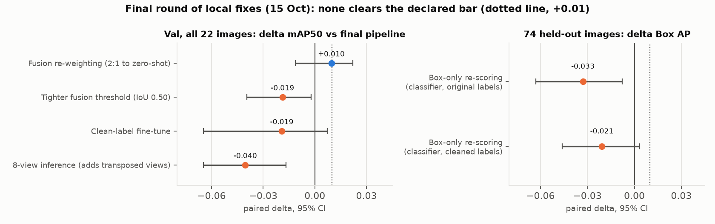
Figure 5. The final round of local fixes, each against the final pipeline (left) or on 74 images the checkpoint never saw (right). None clears the declared bar.
---

5. Research investigations
5.1 — Perfect localisation. A crop classifier given ground-truth boxes reaches 0.43 mAP50 (ConvNeXt-T; DINOv2 0.40; a satellite-pretrained DINOv3 0.35). Even with perfect boxes, more than half the AP is lost to subtype classification, with the same Cargo ↔ Box and rare → Cargo confusions. Train/val shift, head capacity and classifier family were each tested and ruled out as the cause.
5.2 — Hard training examples. Dataset cartography over 11 checkpoints splits them into two populations: hard-missed (581 instances, median 13.7 px: a size problem) and hard-confused (975 instances, consistently assigned another class: 89% of Liquid, 45% of Flatbed, 35% of Tractor). Whether an instance will be learned is predictable on a frozen holdout (AUC 0.70 from size alone, 0.82 with early training dynamics). The hard-confused directions match the label disagreements of Finding 3.
5.3 — Value of 500 more labels. A learning curve over nested random subsets gives +0.015 mAP50 per doubling of data (95% CI +0.006..+0.025), so 500 more random labels ≈ +0.0014: smaller than the seed-to-seed spread. A labelling budget is better spent on auditing the rare-class labels and on targeted Tractor and Liquid examples.
5.4 — Smallest subset reaching 90% of full performance: 80% of the labelled instances. At 12.5%, 25% and 50% no subset passed (50% random gives 73%). Following the declared rule's provision for one extra size, an 80% subset was then trained under the same recipe, and both arms passed the 0.079 bar (90% of full data): the selected subset scored 0.085 (96% of full) with 300 images (68% of the images, 79% of the instances), and the random subset 0.080 (91%) with 357 images. Selected vs random is +0.005 (CI −0.007..+0.016), so the rule ties random here, after losing at 25%, where it had removed the small, confused trucks that validation is full of. Selected vs full data is −0.003 (CI −0.019..+0.010). This is the smallest successful size tested, not a proven minimum: sizes between 50% and 80% were not tested, each arm is one seed, and the random arm passes by a margin smaller than the seed spread seen at smaller sizes.
---

6. Conclusions and next step
- Supported by measurement: detection ranking is the first bottleneck and subtype confusion (Tractor above all) the second; the rare-class training labels disagree with xView's while validation agrees; image scale matters, and normalising it helps.
- Open: whether the label inconsistency causes the rare-class collapse, and how the pipeline performs on external imagery.
- Ruled out by experiment: that more resolution or views close the gap; that post-hoc re-scoring fixes subtypes; that missing validation annotations explain the false positives; that more random labels are a good buy.
Next step: an expert audit of the rare-class training labels. Two annotators, blind to both label sources, label about 400 stratified Tractor, Liquid and empty boxes under a written visual protocol. If the audit confirms the noise, retrain on the audited labels with rare-class counts held equal and 3 seeds per arm, gated on held-out images before validation. Then score the final pipeline once on an untouched test set from outside xView.
---

7. Deliverables and reproduction
Table 4. Final model and artefacts.
Item | Detail
Final pipeline | WBF (IoU 0.55, equal weights) of the zero-shot and fine-tuned members, with test-time scale normalisation: images with longer side outside 2,576–5,119 px rescaled by s = 2^round(log₂(3,228 / longer side))
Zero-shot member | public RF-DETR xView checkpoint (ShotaroFukunaga/rfdetr_xview, 1008/checkpoint0099.pth), zero-shot; 1008 px tiles, 50% overlap, 4 flips, WBF; classes mapped to xView ids 11 / 12 / 15 / 13 / 16
Fine-tuned member | the same checkpoint fine-tuned on the 443 training images at 2×, class head frozen, rare-class repeat sampling, 5 epochs; weights/rfx3_ep5.pt
YOLO reference | YOLO11s, 2× tiles, WBF of epochs 40 / 60 / 80 / last + context rule; weights/E2_*.pt
Reproduce | bash reproduce_rfx.sh (final pipeline, expected 0.2975; re-run from the documented commands before submission and reproduced exactly, per class included); bash reproduce.sh (YOLO line, expected 0.139). Weights are checksummed in weights/SHA256SUMS*
Evidence | every scored configuration with its declared prediction in experiments/LOG.md; metrics in experiments/results/; full diagnostics in REPORT_FULL.pdf, which also maps these names to the run codes used there (Table 0)

Limitations. The pretrained checkpoint's training data includes the validation imagery, so external generalisation is not yet verified. The validation set is 22 images (per-class claims for Tractor and Liquid are thin; differences under about 0.02 are not resolved). The best configuration was selected on validation, models are single-seed, and the 18-image subset was identified by a validation audit. Full discussion in REPORT_FULL.pdf §7 and §13.

