(Victor Modified on 3/5/14)
第六章 谁是亚洲人的祖先？

一．北京猿人不是中国人的祖先

1.北京猿人是这样被确立为中国人的祖先
1929年12月2日，在中国北京郊区发现第一个北京猿人的头盖骨，从头盖骨的厚度，脑容量大小 ，眉骨厚突和低前额等特点，就推断是从爪哇猿人到北京猿人、再到欧洲的尼安德特猿人、再到现代人的进化过程。并将北京猿人定名为“北京人”。 26天以后的1929年12月28日，中国地质学会就召开了隆重的庆祝大会，宣布找到了中国人祖先化石。以后以铀系测年法确定他生活在50到40万年前（最新的研究确定为77万年前—2009年3月号“自然”期刊），从此北京猿人就有着不可挑战的、中国人祖先的地位。但是，北京猿人真是中国人的祖先吗？
Ⅰ. Peking Man is not the ancestor of the Chinese people

1. Peking Man is so established as Chinese people are the ancestors
The first Peking Man’s skull was discovered in the suburb of Beijing on December 2, 1929. From the thickness of the skull, brain capacity size, thick protruding brow and low forehead and other characteristics, it was inferred that from the Java man to the Peking Man, and then Neanderthal ape in Europe, was the evolution process of modern man. And the Beijing man was named "Peking Man." Exactly 26 days after December 28, 1929, the Geological Society of China held a grand celebration on the General Assembly, and announced that the fossils of the ancestors of the Chinese people had been found. Well, it seems so very easy to draw its conclusion, isn’t it? Then after using the uranium-series dating method that determine this fossil lived between 500,000 to 400,000 years ago (although, recent studies have identified it as much as 770,000 years ago, in the March 2009 issue of "Nature" journal). Since then this undisputable premise of the Peking Man, the Chinese people ancestral position was established. But indeed, is it true?

2.祖先是从非洲来的吗？

夏娃理论和亚当理论出现之后，对世界各地的古人类研究学者都带来很大的冲击。在中国，知名的中国科学院古人类研究所的吴新智院士提出了反击。他提出“多地区进化学说”在中国有充分的化石根据，“现代中国人的主要来源是几十万年前生活在这里的古人，仅少量地接受了外来的基因” [注释1]，也就是现代中国人大多数是本地猿人—北京猿人进化来的。
2. Did our ancestors come from Africa?

When the Adam and Eve theory emerged, it created a great impact among the circle of ancient human researchers. In China, paleoanthropologist and Chinese Academy of academician Dr. Wu Xinzhi made ​​a counter attack. He proposed "multi-regional evolution theory" and that in China it have sufficient fossil-based evidence to support his theory. “The main source of modern China men are local ancients who lived here hundreds of thousands of years ago, only a small portion of them received foreign genes.” [Reference 1], that is to say, the modern Chinese people are mostly evolved from our local ape – evolved from the Peking Man.

曾经是斯坦福大学Y染色体研究课题主要研究成员的金力，直接面对了这个挑战，他也想：说不定存在有当地进化来的人。金力教授后来说过： “我心想我是中国人，祖先是从非洲来的吗？我非要找出一个人，不是非洲人的后代。做了覆盖整个东亚，东南亚，西伯利亚……的 12000人、163个群体以后，我都傻眼了。我都不信这个结果。我对学生说，你把数据拿来看一下，看上去比较模糊的，你给我重新做一遍。又有400多个样本重做了，结果，还是这样子，那我没办法，我只能说，大概就是这样是对的。”

Once a key member of Stanford University’s Y chromosome research, Dr. Jin Li, faced this challenge head on. He thought that there are local people who had evolved? Professor Jin Li later said: ”I thought that since I am Chinese, how can my ancestor come from Africa? I must find a person who is not an African descendant. After covering the entire East Asia, southeast Asia, Siberia’s 12,000 individuals belonging to 163 ethnic groups, I was dumbfounded. I simply cannot believe the results. I told my students telling them to take another look at the data. Re analysis data which seems vague to you. Over 400 sample shad to be re analyzed. The final result was exactly the same as before. What can I do? All I can say at this point is that the original results must be accurate.”

2000年，上海复旦大学组成了一个国研究际团队。这个国际团队22人名单上打头的是金力教授的学生柯越海，一个名不见经传的新人，下面含括的却是来自美国、英国以及印度尼西亚著名大学的分子人类学家们，其中有那个斯坦福大学21人国际团队的领军人物皮特.昂和皮特.奥以及后来是复旦大学副校长的金力教授，还有那位非常有名的“出非洲记”一书的作者、还有现任美国国家地理-基因地理网站的主持人斯宾塞。韦尔斯（Dr. Spencer Wells）。他们在东亚人群中，包括：西伯利亚、中国大陆、台湾原住民 、韩国、日本、印度尼西亚、马来西亚、新几内亚、美拉尼西亚和印度东北部等地，采取的12,127个男人的血液样本，测试他们的Y染色体DNA序列。

In 2000, Fudan University in Shanghai established an internal team of 22 individuals headed by Professor Jinli’s student Keyue Haie, a little-known newcomer. The rest of the team consisted of molecular anthropologists from well known universities from the U.S., UK, and the University of Indonesia. On this research team were Dr. Peter Underhill and Pete Oefner Who once headed Stanford University’s 21 internal research team, Professor Jin Li who later became the vice president at Fudan University . Also Dr. Spence Wells, who is very well known for his "out of Africa" as well as the current U.S. national Geography - the Genographic Project site moderator. They took blood samples from 12,127 men from countries in East Asia, including Siberia, China, Taiwan aborigines, Korea, Japan, Indonesia, Malaysia, New Guinea, Melanesia and northeastern India, etc. to study their Y-chromosome DNA sequences

他们的研究结果发布在2001年五月美国“科学”期刊上（Science 11 May 2001）。其标题是“东亚现代人源于非洲的DNA证据（意译）” [注释2]。结论是：“为了测试在东亚现代人类起源的假说，我们163人群中抽取从12127男性个体来测定3个Y染色体DNA标记（YAP，M89，M130）。发现所有的个体都携带了这三个突变标记中的一个。这三个突变（YAP，M89，M130）合并到另一个突变（M168），M168约起源于35,000至89,000年前的非洲。”
Their findings were published in the May 2001 issue of Science entitled:” African Origin of Modern Humans in East Asia: A Tale of 12,000 Y Chromosomes.” (Reference 2)
The conclusion of this article is this: "To test the hypotheses of modern human origin in East Asia, we sampled 12,127 male individuals from 163 populations and typed for three Y chromosome biallelic markers (YAP, M89, and M130). All the individuals carried a mutation at one of the three sites. These three mutations (YAP1, M89T, and M130T) coalesce to another mutation (M168T), which originated in Africa about 35,000 to 89,000 years ago. Therefore, the data do not support even a minimal in situ hominid contribution in the origin of anatomically modern humans in East Asia.”

换句话说，东亚的现代人全部都是“源于非洲Y染色体亚当的后代”，中国人谁也不是北京猿人的子孙。
In other words, are all modern humans in East Asia ”originated from the descendants of Africa’s Y chromosome Adam”. Chinese people who are not descendants of Peking Man.

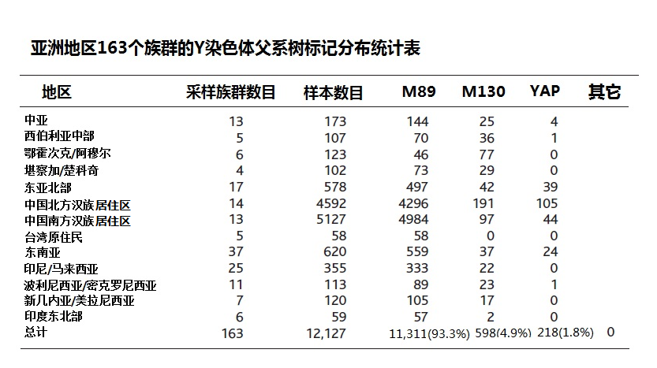
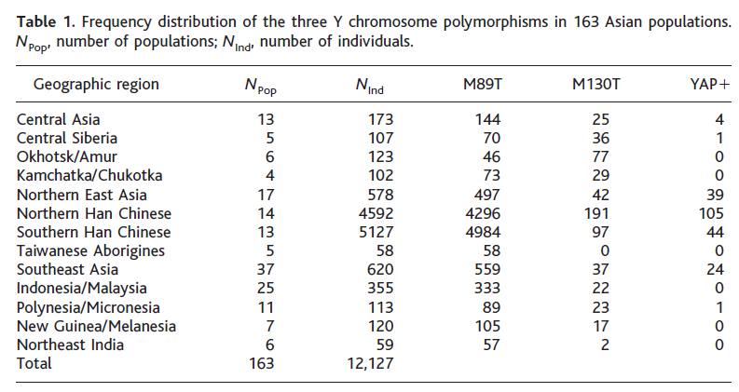图6-1 东亚洲地区163个族群的Y染色体父系树标记分布统计表

Figure 6-1 Frequency distribution of the three Y chromosome polymorphisms in 163 populations

当这个研究结果发表后，吴新智院士仍然不以为然，他说：“你们的抽样太少，可能有漏掉的‘本地进化人的后裔’”，金力教授回答：“我们计算过，漏掉的概率大约有百万分之一的可能”（见电视片“谁是夏娃”）。自2001年以后的十几年中，复旦大学通过免费和收费，至少为十几万人做了DNA的Y染色体DNA和线粒体DNA测试，仍然没有发现一个“本地进化人的后裔”， 复旦大学的这一成果得到了中国国家科技奖。

这是分子人类学用DNA解码和进化论成果进行的第一次个役，最终以分子人类学研究者们的大胜，以世界级进化论者吴新智院士为首的一方大败为结局。
Even after the results of the research was published, academician Wu Xinzhi still did not think much of it. He said:”The sample size was too small and there might be missing ‘descendants of local evolution’”.
Professor Jin Li’s response was this:”We have calculated that the probability of missing the ‘descendants of local evolution’ is about one in a million.” Since 2001, Fudan University had conducted Y chromosome DNA and mitochondrial DNA analyses of thousands of people either free of charge or paid and yet not a single “descendant of local evolution” was found. For this accomplishment, Fudan University was given the Chinese National Science and Technology Award.

This was the first battle between molecular anthropology using DNA genetic codes and the traditional evolutionists. At the end, the molecular anthropologist won this battle brilliantly over the utter defeat of the world-class evolutionist academician Wu Xinzhi.

轻易将北京猿人确定为中国人的祖先，这不仅仅是一个考古学的失误，也不仅仅是一个进化论结论的失误，这说明于建立在骨骼解剖学上的考古方法，本身是不可靠的。由此可以看到用人类DNA解码去寻找人来源的方法是正确的，只有这个方法才能确定出人类血统的继承关系。
To easily claim Peking Man as the ancestor of the Chinese people, was not just a
anthropological mistake, not just a mistake in evolutionary conclusion, but also pointed out the unreliability of the archaeological method based on skeletal anatomy. From this we can see that to use human DNA decoding to trace the origin of mankind is an accurate approach.

二．“柳江人”很可能是中国人的祖先

1958年9月24日，在广西壮族自治区柳州市柳江县的新兴劳改农场，犯人在通天岩，挖岩泥集肥时，发现了一具人类颅骨和脊椎骨、肋骨、骨盆、大腿骨等化石多块。经中国科学院古脊椎动物与古人类研究室吴汝康教授鉴定，定名“柳江人”，开始了对他的研究。
Ⅱ “ Liujiang Man” The most likely ancestor of the Chinese People

September 24, 1958, in Liuzhou Liujiang County emerging penal farm, when one prisoner dug the mud at the Tutain cave, he found a human skull and vertebrae, ribs, pelvis, femur and other fossil multi-blocks. From the Institute of Vertebrate Paleontology and Paleoanthropology (IVPP), the Chinese Academy of Sciences, Professor Wu Rukang’s confirmation of these fossils and named it “Liujiang Man” and started his research.

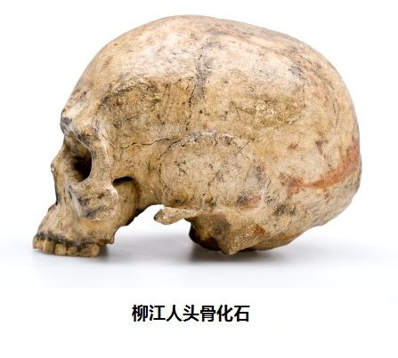
图6-2 柳江人头骨化石

1. 柳江人与现代中国人之间的形态几乎没有差别
2006年，中国科学院古人类研究所和纽约市立大学的科学家刘武等发表了“柳江人头骨形态特征及柳江人演化的一些问题”的论文[注释3]。文中详细地对比了柳江人、山顶洞人和现代中国人头骨各项尺寸指标，其中前9项值见表：
Figure 6-2 The fossil of Liujian cranium

1.There is no morphological difference between Liujiang Man and modern Chinese
In 2006, scientists from the Chinese academy of Paleoanthropology and the City College of New York including Dr. Liu Wu published an article entitled:” Some Problems for the Late Pleistocene Human Cranium Found in Lujiang of South China Based on Morphological Analysis” (Reference 3). In this article, there was a detailed comparison of the size and shape of the cranial bones of the Liujiang Man, the cave man and modern Chinese. The first nine items are shown in the following Table:

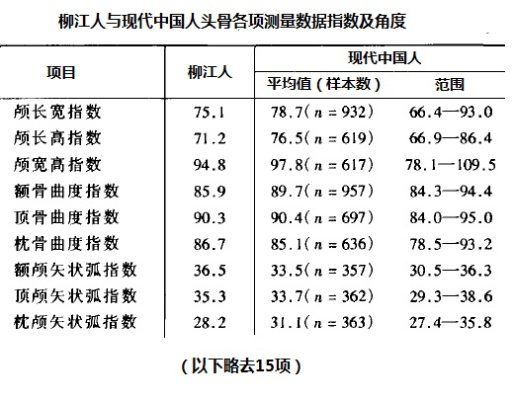
图6-3 柳江人与现代中国人头骨各项测量数据指数及角度
Figure 6-3 The cranial measurement and indices of Liujiang and modern Chinese

其它15项参数都是如此。结论是：柳江人头骨的参数，都在现代中国人的参数范围内，并且接近平均值。也对枕部形态、眼眶形态、面部形态和其他特征等作了比较和分析。他们最后得出的结论是“头骨整体特征在柳江人的表现与多数现代中国人完全一致”，“而一些可能代表人群特点或演化程度的特征，如鼻根与鼻梁形态、上颌颧突下缘形态、颧骨额蝶突朝向、枕区突隆、顶孔至人字区凹陷、枕外隆凸，在柳江人与现代中国人之间也没有呈现出明显可见的差别。”“ 柳江人头骨具有的不同于现代中国人的特征数量很少。” 因此，柳江人的形态与现代中国人已经非常接。

The other 15 parameters are similar. The conclusion was this :The cranial bone parameters of the Liujiang Man was not only within the range of comparable parameter in modern Chinese but also close to the average value. These researchers did further comparison and analyses of the morphology of the occipital bone, the shape of the orbit, the face etc. Their final conclusion was this:” The overall characteristics of the Lijiang Man’s cranium is exactly the same as those in modern Chinese.” ” Based on these findings, we suggest that the cranial morphology of Liujiang is very close to those of modern Chinese and very few differences exist between them. “ Therefore, the morphology of the Liujiang Man and modern Chinese is closely connected.

2.柳江人生活年代考证
柳江人生活的年代对确定中国人的来源有着重要的意义，其原因在于他的头骨与中国现代人非常接近，如果他存在于十几万年前，那么，他就不可能来自非洲。如果是这样，就存在一个疑问，他们的子孙是现代的中国人吗？

1.Confirmation of the date when Liujiang Man lived
To confirm the date when Liujiang Man lived has great significance in tracing the origin of Chinese
people because of the similarity in Liujiang Man’s cranium and that of modern Chinese. If Liujiang Man lived over one hundred thousand years ago, then it is unlikely that he came from Africa. If this is the case, there exists a question: Are modern Chinese their descendants?

然而，柳江人生活年代考证却遇到很大的困难。对柳江人年代的测定数据，主要是通过对头骨化石所处位置的“次生碳酸岩”，进行铀系法测定年代，来判定柳江人生活的年代，而不是来自人骨化石本身。该处地层是几层“碳酸岩”薄板夹杂着土或砾石碎块的结构，接近头骨的3层碳酸岩薄板分别形成在1.6万、6.5万和15万年前。30～40厘米的土层深度变化，对应的年代就会有1～2万年的差别。头骨是农场工人挖岩泥时得到的，当时在现场的人员只是收藏了头骨化石，一周后，市博物館專家才接穫通知，前来考察。可以想象，泥土一定挖去了很多，已经不可能断定头骨化石所处的准确位置了。在以后的年代断定中，先后有着距今3万年、4万年、6.7万年、8万年直至15万年前。比较多的倾向7至6万年前。
However, to confirm the date when Liujiang Man lived encountered great deal of difficulty. The estimation of the time when Liujiang Man lived is primarily dependent on using the uranium dating method on the cranium fossil’s location of the “speleothems” and not on the cranium fossil itself. Where the fossil was found consisted of strata with layers of structure containing a sheet of “carbonate” mixed with soil or gravel . The three carbonate sheets closest to the cranium fossil were formed 16,000, 6,5000 and 150,000 years ago respectively. To determine the date subsequently, there could be difference of 30,000, 40,000, 60,000, 70,000, 80,000 up to 150,000 years from the present time. Most experts believe the date to be between 60,000 to 70,000 years ago.
(3-1 5:30PM 完成以上再校)
3.柳江人是中国人的祖先吗？
柳江人作为中国人的祖先有一个条件已经具备，那就是柳江人头骨和于现代中国人头骨的特征
非常相似。如果我们承认前面Y染色体的测试结果--“东亚现代人源于非洲的DNA证据”，那么他的Y染色体还有必须有着M130或YAP或M89的标记。然而，6万多年前的染色体早已销蚀，不可能得到，进一步判定柳江人的身份，就要借助世界其它地区的资料了。

在遥远澳大利亚，著名考古学家索恩(Alan．Thorne)认为，“芒戈湖发现的古人遗骸则属于瘦长人，瘦长人和柳江人头骨有着明显的相似性状，显示他们之间有着一定的亲缘关系。芒戈湖人很可能是从南中国经由印度尼西亚来到澳洲的。” [注释4]，他给我们带来了线索。
- Was Liujiang Man the ancestor of the Chinese people?
That Liujiang Man was the ancestor of the Chinese people has met one necessary condition, namely that there is great similarity in the cranial bones of Liujiang Man and modern Chinese. If we accept the result of the aforementioned analysis based on Y chromosome, namely “the DNA evidence that East Asians originated from Africa”, then Liujiang Man’s Y chromosome must contain M130 or YAP or M89 genetic markers. However, the chromosomes are unobtainable from 60,000 years ago since they were already eroded? To further determine the identity of Liujiang Man, it is necessary to use data from other parts of the world.

From Australia, the famous archaeologist Alan Thorne felt that “Ancient remains discovered from Lake Mungo in Australia belonged to a person who was “Gracile forms” man. In view of the obvious similarity in the cranial bones between this “Gracile forms” man and the Liujiang Man, there must exist a certain kinship between them. May be this “Gracile forms” man from Lake Mungo came from southern china via Indonesia and the to Australia.” (Reference 4). Dr. Thorne gave us a new clue.

澳大利亚是在一亿多年前从欧亚大陆分离分离出去的，它是唯一从来没有大型灵长类如猿、猩猩和猴子生活过的地方，连它们的化石也没有发现过，因此，那里的原住民唯一的可能是从外地移民来到。碳14和铀系测年法已经确定，最早的原住民在6到5万年前已经在澳大利亚生活。Y染色体DNA的研究证明，60%澳大利亚原住民身上有着M130的标记（见第9章“神奇的澳洲之旅”），在柳江人所处的中国南方，有2%的现代中国人身上也带有M130的标记。现代人的祖先从非洲出来，一路经由印度、东南亚，在6万年前到达澳大利亚，那么，他们很可能在7万年前已经到达了亚洲南部，到达了柳江。在下面一节的内容会看到非洲来的移民很可能是在8万年前到达印度的，这又是一个支持柳江人来自非洲的有力的证据。
About 100 million years ago, Australia was separated from Eurasia. It is the only place where large apes, chimpanzees and monkeys had never lived, not even found in fossil. For this reason, the aborigines only could have migrated from elsewhere. Based on carbon 14 and uranium dating methods, as early as 50,000 to 60,000 years ago, these aborigines already lived in Australia. Evidence from Y chromosome research revealed that the M130 genetic marker exists in 60% of the aborigines of Australia (please see Chapter 9” A magical trip to Australia”). In the southern part of China where the Liujiang Man once lived
About 2% of modern Chinese also carry the M130 genetic marker. The ancestors of modern man came from Africa. From there, they migrated to India, Southeast Asia and to Australia about 60,000 years ago. Then, it is likely that about 70,000 years ago, they already reached southern Asia to Liujiang. In the following paragraph, the immigrants from Africa came to India 80,000 years ago, another piece of hard evidence to support the hypothesis that Liujiang Man came from Africa.

根据这些结果，我们是否做出这样的判断：柳江人所属的群体是由非洲最早来到中国移民，也是一部分中国人的祖先。
Based on these evidence can we arrive at this conclusion: the ethnic group to whom the Liujiang Man belonged was the earliest immigrant to China from Africa and also part of the ancestors of Chinese people.

从上面图6-1东亚人Y染色体分布表中可以看到，大多数中国人是M89的子孙，M89的后裔M175比柳江人晚几万年进入中国。生活在4万年前的田园洞人和3万年以前的山顶洞人，年代不能准确判断的河套人、资阳人等古人都可能是中国人的祖先，但我们也无法确定他们属于分布表中的哪一个支派。

From “Figure 6-1 Frequency distribution of the three Y chromosome polymorphisms in 163 populations”, one can see that most Chinese are the descendants of M89. M89’s descendants M175 came to China later than Liujiang Man by several thousand years. Other possible ancestors of the Chinese people include the Tianyuan cave who lived 40,000 years ago, Upper Cave Men who lived 30,000 years ago, Ordos Man people who lived at an undetermined time, Ziyang and other ancient people. There is no way we could tell which one of the tribe they belong to the distribution table .
（以上还需要校核）(以下需要校核 3-4 5：20PM)
7万年的岁月对于人类来说，不是一个很短的时间，人类发生了进化吗？从前面“头骨整体特征在柳江人的表现与多数现代中国人完全一致”的结论，我们可以看到的是，从柳江人到现代人的骨骼比较上看不到进化，这也是人类的DNA遗传信息是以数码方式拷贝复制的结果。
Seventy thousand years is not a short period of time for us human. Could mankind evolve during this period? The aforementioned conclusion, namely “Based on these findings, we suggest that the cranial morphology of Liujiang is very close to those of modern Chinese and very few differences exist between them.”, what we can see is that from Liujiang Man to modern Chinese there is no evidence of evolution in when we compare the bone morphology. This is the same result we obtain from human DNA genetic
information based on the replication of nucleobase pairs.

按照上面的资料：凡10万年以前的猿人、“古人”，都不会是现代中国人的祖先，这里包括
马坝人（距今约13万年）、大荔人（距今年代大约为20至15万年）、金牛山人（距今约28万年前）、北京猿人（距今77万年到50万年前）、蓝田人（比北京猿人更早）等等，因为全部东南亚的现代人都是8到7万年前由非洲来的移民的后裔。那么，那些猿人和直立人的后代到哪里去了？恐怕我们永远没有确切的答案。但是有一点是肯定的，就是它们没有进化成人。
Based on the material presented above, any ape man, or ancient people who lived over 100,000 years ago could not be the ancestors of modern Chinese people including the Maba people who lived over 130,000 years ago, Dali Man who lived 150,000 to 200,000 years ago, Jinniushan Man who lived 280,000 years ago, Peking Man who lived 500,000 to 770,000 years ago, Lantian Man who lived even earlier than Peking Man etc. The reason being that modern southeast Asians are immigrants from Africa from 70,000 to 80,000 years ago. Where did the descendants of apes and Homo erectus go? I am afraid we will never know the accurate answer. What we can be sure of is this: they did not evolve into man.

当然，“爪哇人”（距今约70万至50万年）也不会是东南亚群岛人的祖先。

Of course, “Java man” who lived from 50,000 to 70,000 years ago, can not be the ancestor of southeast Asians.

三．在火山灰尘下生活的印度古人

在印度南部的安德拉邦，有一个5万人的小城名字叫贝塔姆切里亚（Betamcherla,Andhra Pradesh），小城以西10公里的地方，有一个重要的考古重地，名叫“加拉普姆（Jwalapuram）”，在它方圆500米的范围内，有着许多古代的火山灰和人类的石器工具交互层叠的遗址。对火山灰的研究证实，这些火山灰来自3000公里以外的印度尼西亚的苏门答腊火山，已经有七万多年的年龄了。
Ⅲ. Ancient Indians Living Under the volcano Dust
In a small city, Betamcherla, with 50,000 inhabitants in the southern part of India’s Andhra Pradesh region, there is an important archaeological site 10 miles west of the city. The name of this site is “Jwalapuram”. Within a circumference of 500 meters, there are ancient ruins consisted of strata of ancient volcano dust and stone tools from ancient people. Research on the volcanic dust confirmed that it came from the Sumatra volcano in Indonesia which is 70,000 years old.
七万四千年前，苏门答腊火山有一次超级爆发，那是过去二百万年来最大的 一次火山爆发，大量的喷发物蔽天盖日，一直降落到了远至格陵兰地区，让整个世界经受了火山爆发形成的长达百年的寒冷时期。 在这个时期中，古人类是如何生存的，成为了长期以来考古工作者关心的课题，因此，有着火山灰和人类石器工具相伴存在的加拉普姆地区，就倍受关注。
About 74,000 years ago, there was a huge eruption from the Sumatra volcano, the largest one in that last two million years. The tremendous eruption darkened the sun and the dust settled as far as Greenland. This eruption even ushered in a 100 year ice age around the world. How the ancient people survived this ice age has become a topic of interest to archaeologists. No wonder, the strata of volcanic dust plus stone tools found in Jwalapuram had received added attention.

近年来，在加拉普姆的第三考古点，进行了仔细的发掘[注释5]。这里的火山灰沉积厚度约有一米，在火山灰层以下，发现了215件属于旧石器时代中期的石器，经光释光测年法（OSL）鉴定
所在层的年代，确定这些石器埋藏时间距今为7.7万年。在火山灰层以上，发现了108件石器，距今时间为7.4万年，也是属于旧石器时代中期的作品。

In recent years, a careful excavation started at the third archaeological site in Jwalapuram (Reference 5). At this site, the volcanic dust accumulation is approximately one meter. Underneath the volcanic ash 215 items belonging to the middle Paleolithic period was found. With the OSL dating method, it was
confirmed that the time between the burial of these stone tools was approximately 77,000 from the
present time. Above the volcanic ash, 108 stone tools were found which also belong to the same middle Paleolithic period about 74,000 years from the present time.

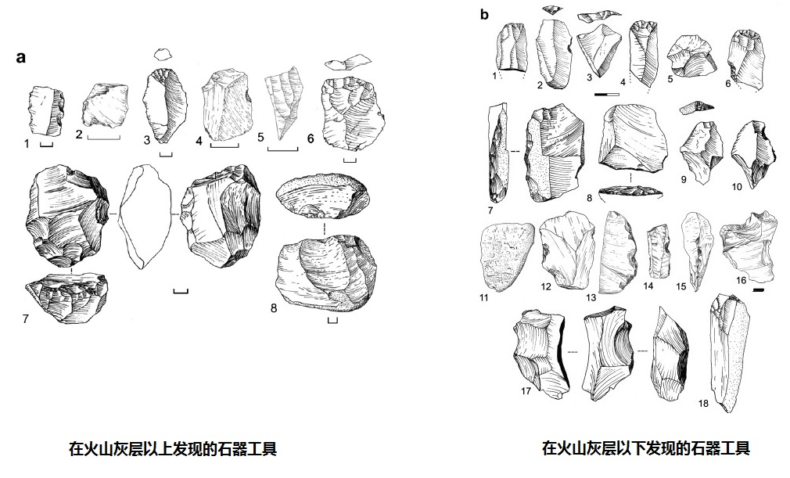
图6-4 在印度加拉普姆的火山灰层上、下发现的石器工具
Figure 6-4 Stone tools above and below the India’s Jwalapuram volcanic ash layer
牛津大学的考古学家皮瑞格利亚（Michael Petraglia）与他的研究小组把他们发现的那些工具与在非洲不同时期发现的工具作了比较，印度的这些工具看起来更像非洲中石器时期，大约是在10万年前左右的产品。那时，现代人已经在非洲地区存在了。他说：“不管在印度的是什么人，他们的行为与在非洲的现代人是类似的。”进一步证据还有在欧洲发现的穴居人（尼安德特人）使用的工具与之完全不同，因此他们认为在被火山灰覆盖的加拉普姆居住的是现代人。
Professor Michael Petraglia and his research team from the Archeology Department at Oxford University tried to compare the stone tools which they discovered from Jwalapuram volcano with those from Africa discovered at different times. Those stone tools from India greatly resemble those from the Stone Age in Africa dated 100,000 years ago. At that time, humans already lived in the continent of Africa. The stone tools also pointed to a more exciting possibility. The stone tool assemblages found in Jwalapuram were “very similar to ones that we see produced in Africa at the same time,” said Michael Petraglia. Further evidence to support this comes from the European caveman (Neanderthal) who used stone tools completely different. Therefore, the Oxford group considered the ash-covered people living in Jwalapuram represented modern humans.
对于这些看法，也有人持怀疑的观点，毕竟没有象柳江人那样，有一个头骨化石可以佐证。然而，如果我们将澳洲原住民的DNA（“神奇澳洲之旅”一章）、澳洲原住民的出现在6万年以前、东亚现代人的DNA、6.7万年以前的柳江人头骨以及7.7万年以前印度火山灰下人工打磨的石器这些信息串联起来，岂不是描绘出一个现代人的祖先，大约在9万年以前，从非洲走向澳洲的情景线了吗？
对于亚洲人的远古祖先，我们目前只能看到这些。
Some people are still skeptical about the aforementioned viewpoint. After all, there is nothing like the Liujiang Man with cranial bones as evidence. Yet, if we weave together all the evidence, namely the DNA from the aborigines from Australia (see the Chapter 9” A magical trip to Australia” ), who lived 60,000 years ago, DNA from modern East Asians, Liujiang Man’s cranium from 67,000 years ago, and the stone tools from the volcanic ash from India over 77,000 years ago, one clearly sees the tapestry of the ancestor of modern humans who lived approximately 90,000 years ago. Can you see the scene of the migration from Africa to Australia?
[注释1]吴新智，现代人起源的多地区进化学说在中国的实证，Quaternary Science，Sep. 2006
[Note 1] Wu Xinzhi, modern evolutionary theory of the origin of multi-region empirical in China, Quaternary Science, Sep. 2006
[注释2]Yuehai Ke, et. al., African Origin of Modern Humans in East Asia: A Tale of 12,000 Y Chromosomes, Science Vol 292, May 11 2001
[注释3] Wu Liu, et. al., 柳江人头骨形态特征及柳江人演化的一些问题,
人类学学报 Acta Anthropologica Sinica, Aug．2006
[NOTE 3] Wu Liu, et. Al., :” Some Problems for the Late Pleistocene Human Cranium Found in Lujiang of South China Based on Morphological Analysis” , Acta Anthropologica of Sinica, Aug. 2006
[注释4] Peter Brown, Australian Pleistocene variation and the sex of Lake Mungo 3，Journal of Human Evolution (2000)38
[注释5] Michael Haslam,et. al., The 74 ka Toba super-eruption and southern Indian hominids: archaeology, lithic technology and environments at Jwalapuram Locality 3

