AI-Based Image Enhancement, Reconstruction, and Captioning System using Deep Learning

Problem Statement:
In real-world scenarios, images captured under poor lighting conditions or low-quality devices often suffer from noise, distortion, and missing information. Additionally, storing high-resolution images efficiently while maintaining quality is a major challenge.
Traditional image processing techniques fail to effectively:
- Remove complex noise patterns
- Reconstruct missing or damaged regions
- Generate realistic image content
- Provide semantic understanding of images
Hence, there is a need for an intelligent system that can:
- Enhance image quality
- Compress and reconstruct images efficiently
- Generate realistic image content
- Understand and describe images using natural language

Objective:
The objective of this project is to design and implement an AI-based system that:
- Removes noise using Denoising Autoencoders
- Compresses and reconstructs images using Variational Autoencoders (VAE)
- Generates realistic images using Generative Adversarial Networks (GAN)
- Produces captions using deep learning-based models

System Architecture:
The system consists of multiple modules working sequentially:
- Image Acquisition Module
- Preprocessing Module
- Image Enhancement Module
- Compression & Reconstruction Module
- Image Generation Module
- Captioning Module
- Output & Storage Module

Architecture Diagram:
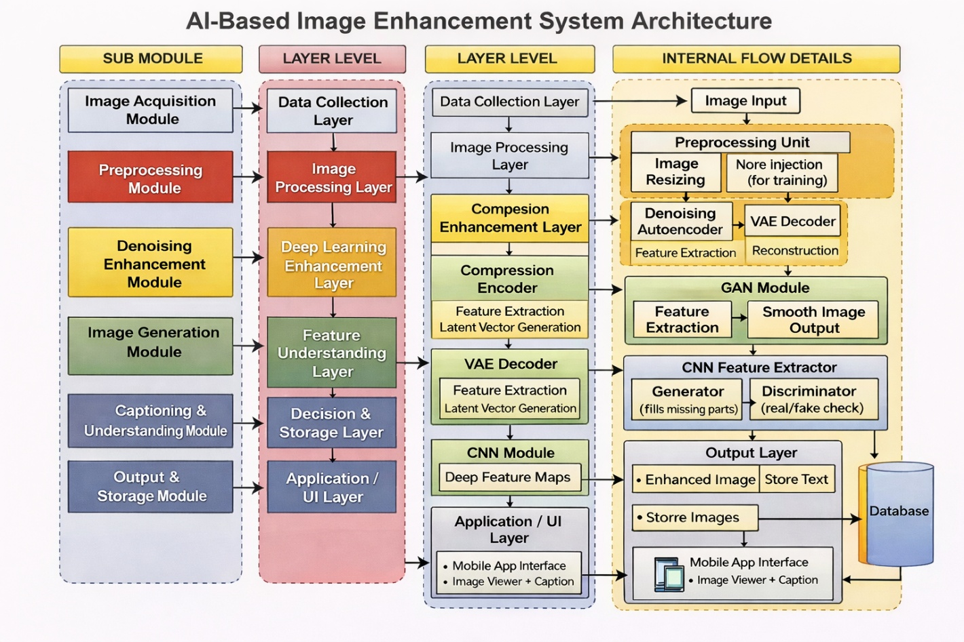

Inference Workflow:
During inference (testing phase), the system processes a given input image and produces enhanced outputs.
Step-by-Step Flow:
- Input Image
  - User provides an image (via file path or upload)
- Preprocessing
  - Resize image to fixed dimensions (32×32)
  - Normalise pixel values

- Denoising (Autoencoder)
  - Removes noise from the input image
  - Produces a cleaner version
- Reconstruction (VAE)
  - Encodes image into latent space
  - Decodes it back to reconstruct a smoother image
- Image Generation (GAN)
  - Generates realistic content or fills missing regions
  - Produces visually enhanced output
- Caption Generation
  - Extracts features using CNN
  - Generates text description using LSTM/Transformer
- Final Output
  - Enhanced Image
  - Reconstructed Image
  - Generated Image
  - Caption Text

Output:
The system produces the following outputs:
- Denoised Image
- VAE Reconstructed Image
- GAN Generated Image
- Original Image
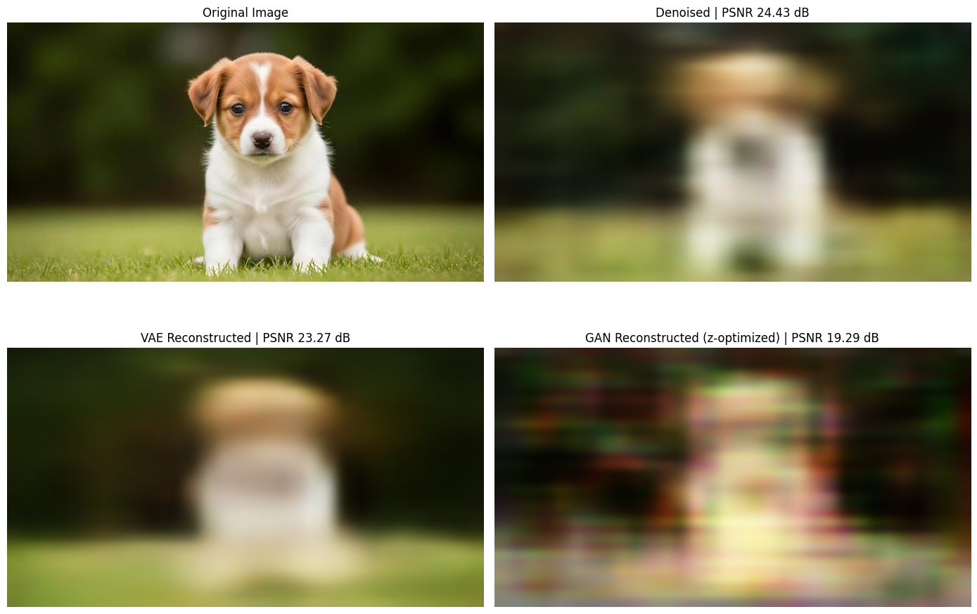

Advantages:
- Improves image quality automatically
- Efficient image compression
- Generates realistic image content
- Provides semantic understanding of images

Conclusion:
The proposed AI-based system successfully integrates multiple deep learning models to enhance, reconstruct, and understand images. It demonstrates how modern AI techniques can overcome limitations of traditional image processing methods and provide intelligent, automated solutions.

