Breadth First Search
Input: A labelled graph 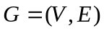.
Output: A tree T (a set of edges) and the order in which the vertices were
traversed (BFI).
Method: Label each vertex v with BFI(v), which is the order in which it is traversed, until all vertices have be reached. Uses a queue.
- for all 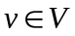 do 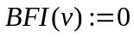
- 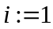
- 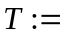Ø
- 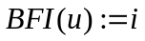
- add u to the queue
- while the queue is not empty do begin
- remove a vertex from the queue, call it w
- for all 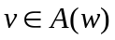 do begin
- if 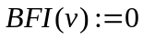 then begin
- 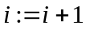
- 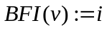
- 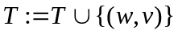
- add v to the queue
- end
- end
- end

