Depth First Search
Input: A labelled graph 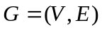 (not necessarily connected).
Output: A forest F (a set of edges) and the order in which the vertices were
traversed (DFI).
Method: Label each vertex v with DFI(v), which is the order in which it is traversed, until all vertices have be reached. Uses recursion.
- 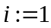
- 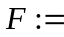Ø
- for all 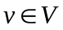 do 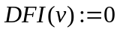
- while for some u, 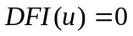do begin
- DFS(u)
- end
Procedure DFS(v)
- 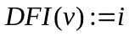
- 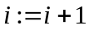
- for all 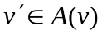 do begin
- if 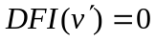then begin
- 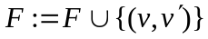
- DFS(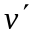)
- end
- end

