Prim’s Minimum-Weight-Spanning-Tree Algorithm
Input: A simple connected weighted graph 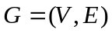.
Output: A minimum weight spanning tree T of G.
Method: Expand the set 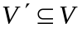 from 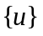 to V, using the minimum weight edge
from V to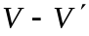.
- Ø
- 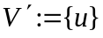
- for all , 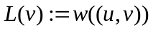
- while 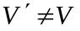do begin
- find a for which 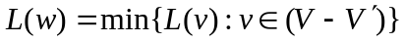and denote the associated
edge from 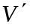to w by e.
- 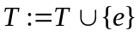
- 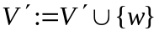
- for all
if 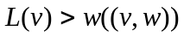then 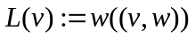
- end

