

**6CS007**

**PROJECT AND PROFESSIONALISM**

**PROJECT PROPOSAL REPORT-**

**SPORTS HUB BOOKING SYSTEM**

University Id : 2065882

Group : L6MCG1

Reader : Mr. Aatiz Ghimire

Supervisor : Mr. Bhanu Aryal

Student Name : Sakar Gautam

Award/Course : BSc (Hons) Computer Science

Submitted on : 08/12/2023

Word Count : 3300

**Acknowledgement**

As a Herald College student, I'd want to offer my heartfelt appreciation to my reader and supervisor Mr. Aatiz Ghimire and Mr. Bhanu Aryal for their important suggestions, comments, and guidance throughout the project. Their insights were helpful to me in improving my project.

I would also like to thank Module Leader Mr. Biraj Dulal for providing the necessary final year project materials which is very important for completing the project.

Contents

1. Statement of Project Details 1

1.1 Academic Question 1

1.2 Aims 1

1.3 Objectives 1

1.4 Problem Statement 2

1.5 My project as a Solution 3

1.6 Artefact (proposed) to be developed 4

2. Project Proposal 5

2.1 Background 5

2.2 Introduction 6

2.3 Initial research into sources of information 7

Similar Applications 7

2.3.1 Features Comparison Checklist 9

Research Papers 10

2.4 Artefact (proposed) 12

2.4.1 Work Breakdown Structure (WBS) 12

2.4.2 Artefact in brief 13

2.4.3 Justification of Software Development Methodology 14

2.4.4 Tools and Technologies 16

2.4.5 System Testing 18

3. Plan/Schedule 19

3.1 Gantt chart 19

4. References 20

Appendix 22

**Table of Figures**

Figure 1: Upper Hand 7

Figure 2: Make my Trip 8

Figure 3: WBS 12

Figure 4: Agile Scrum methodology 15

Figure 5: Gantt Chart 19

# **1. Statement of Project Details**

Project Title - SPORTS HUB BOOKING SYSTEM

## **1.1 Academic Question**

* How the Sports Hub Booking System can makes use of role-based access control (RBAC) to improve the management of user accounts and access permissions?
* How can the Sports Hub Booking System ensure correct and up-to-date booking information by integrating real-time facility availability checks?

## **1.2 Aims**

* To develop a complete Sports Hub Booking System that meets the needs of both sporting venues and users as individuals.
* To develop an ease web interface that enables users to quickly and efficiently browse and book sporting activities.
* To put in place a multi-role login system with unique privileges for Managers, Employees, and Users in order to ensure safe access and effective administration.
* To improve sports facility administration by enabling efficient tracking of bookings and facility availability via the Manager and Employee logins.
* To promote a better and more active lifestyle among Users by making booking sports activities easier and boosting regular physical engagements.

## **1.3 Objectives**

* To create a user-centric design for Booking System's frontend, delivering an easy and smooth booking experience for Users.
* To implement a method of payment to allow for secure and dependable payment via the internet for sports activity reservations.
* To make a database to efficiently store and handle sports facility data, activity schedules, and user reservations.
* To provide smooth interface for managers and employees to properly manage facility your availability, track bookings
* To conduct usability testing and collect user input to continuously improve and optimize the Sports Hub Booking System.

## **1.4 Problem Statement**

Manually reserving sporting venues in Nepal can significantly affect people's life, posing many obstacles and restrictions. Following the traditional approach, users in Nepal frequently need to physically visit or phone the sports centers to check availability and make bookings. This process can be extremely time-consuming and inconvenient, especially during times of high facility usage. Additionally, it could be difficult to have access to real-time information regarding available slots, which could result in scheduling conflicts or missed opportunities to engage in favorite sporting activities.

For both customers and facility management, the lack of a reliable online booking system for sports facilities in Nepal can lead to inefficiencies and irritation. Long wait periods, trouble getting requested slots, and confusion about reservations are common among users. On the other side, facility managers can struggle with manual record-keeping, which could result in mistakes and make monitoring reservations difficult.

Manual sports booking has an impact that extends beyond discomfort; it can discourage people from participating in regular physical activities due to the hassle involved. To overcome these concerns, a modern, effective, and user-friendly online booking system that responds to the unique challenges and expectations of Nepalese sports enthusiasts and facility management is required. Sports booking businesses should consider moving to or incorporating online booking systems to foster business growth, as digital solutions improve accessibility, streamline operations, provide convenience, and provide valuable data insights, ultimately increasing customer satisfaction and business revenue.

## **1.5 My project as a Solution**

The Sports Hub Booking System offers a unique solution to overcome above difficulties and revolutionize the sports booking experience. Users have rapid access to real-time facility availability by utilizing a simple web interface, reducing the need for manual requests. Users may quickly browse, choose, and book their favorite sports facilities from anywhere, at any time, with only a few clicks. The automation of the system streamlines the booking process, assuring smooth and efficient transactions.

The Sports Hub Booking System solves the difficulties of manual sports booking, allowing users to live more active and rewarding lives. Individuals are encouraged to engage in regular physical activities as sports facilities become more accessible and booking experiences become more streamlined, encouraging enhanced physical health and general well-being. The user-centric approach of the system brings in a new era of efficiency and simplicity, making sports and fitness available to everybody and cultivating a healthier and happier community.

## **1.6 Artefact (proposed) to be developed**

* User Management: There are three types of users in the sports hub booking system: managers, employees, and regular users. Role-based access control is used to ensure appropriate degrees of access by granting different rights to different user types such as consumers, employees, and managers. User management is critical in designing the user experience, since it includes activities such as managing user accounts and profiles to provide a seamless and safe interaction for all users, including both consumers and administrators.
* Payment Management: Payment management is a necessary artefact to create since it guarantees that payments are processed securely and effectively. A well-designed payment management system will protect consumers' financial information while also making payments simple. This is critical for users as well as businesses.
* Membership Management: Membership management is essential for dealing with a differed variety of users, including regular visits, long-term members, and occasional guests. The sports hub can respond to the particular demands of each user type, increase user engagement, and build a sense of belonging within the sports community by adopting a strong membership management system.
* Booking Management: Customer satisfaction is one of the key reasons for the significance of booking management. Businesses can provide ease and simplicity of access to their offerings by providing a simple and user-friendly booking system. Many of the procedures involved in arranging appointments or services can be automated using a booking management system.

# **2. Project Proposal**

## **2.1 Background**

With a weight of 114 kilo, it was discovered six months ago that I suffered from both emotional and physical stress. The lack of confidence in one's personal choices sparked motivation for change, leading to the decision to go on a journey to improve one's fitness and general health. A new way of life was happily adopted, which included regular gym attendance, futsal matches, and intense swimming sessions. In order to pursue this newfound lifestyle, complete dedication and self-discipline were required. The final outcome was amazing, with a remarkable 34 kilo weight loss completed over a period of six months, taking the weight down to a proud 80 kilo. This huge change demonstrated the huge effect that a healthy lifestyle and physical fitness can have on mental and physical health.

The individual's personal quest for health and happiness served as the inspiration for this project. This transformation aims to establish a platform called the Sports Hub Booking System in order to help others begin their transforming journeys. The objective is to provide a solution that can improve the lives of many people by relying on the individual's own successes in fitness and sports.

## **2.2 Introduction**

Recreational and sports event plays an important part in sustaining a healthy lifestyle and establishing a feeling of community in today's fast-paced and fitness-conscious environment. However, hiring sporting facilities may be a time-consuming and difficult procedure, leaving enthusiasts disheartened and facilities neglected.

Welcome to the "Sports Hub Booking System," a revolutionary system designed to change the way individual’s access and reserve sporting facilities. This system intends to develop a streamlined, user-friendly platform that streamlines the scheduling process, allowing people to live an active lifestyle more conveniently. User can book different sports activities according to their interest and make the payment. Beyond meeting individual needs, the Sports Hub Booking System will help to improve facility management by increasing facility use and enhancing the potential impact on the community.

This system is an effective and user-friendly sports booking platform which includes user registration, user profile management, real time activities management, easy bookings, and secure payment gateway with role based access control. This system provides a selection of booking choices to accommodate different needs and preferences. This offers the option to book sessions, make bulk purchases, or select subscription-based programs. Because of this versatility, consumers can select a solution that fits their tastes and usage patterns. This system also determines the responsibilities and skills that each role is given. For instance, while an employee can view and manage bookings, a manager may have the authority to add or change sports facilities. This booking system gives consumer the option for selecting the time zone and displays the sporting facility depending on the provided time zone. This system uses khalti or international payment gateway which is much secure. This system help in reducing costs for users brought on by the platform's simple booking process. For instance, lower membership dues or cheaper prices can encourage customers to exercise more regularly.

## **2.3 Initial research into sources of information**

### **Similar Applications**

**Research 1: Upper Hand (Web application)**

Description: The "Upper Hand" sports management software platform provides web apps and tools to assist sports organizations, coaches, and businesses in managing many areas of their operations. Online registration, scheduling, payment processing, athlete administration, communication, and reporting are all available through the platform. (Upper Hand, 2011)

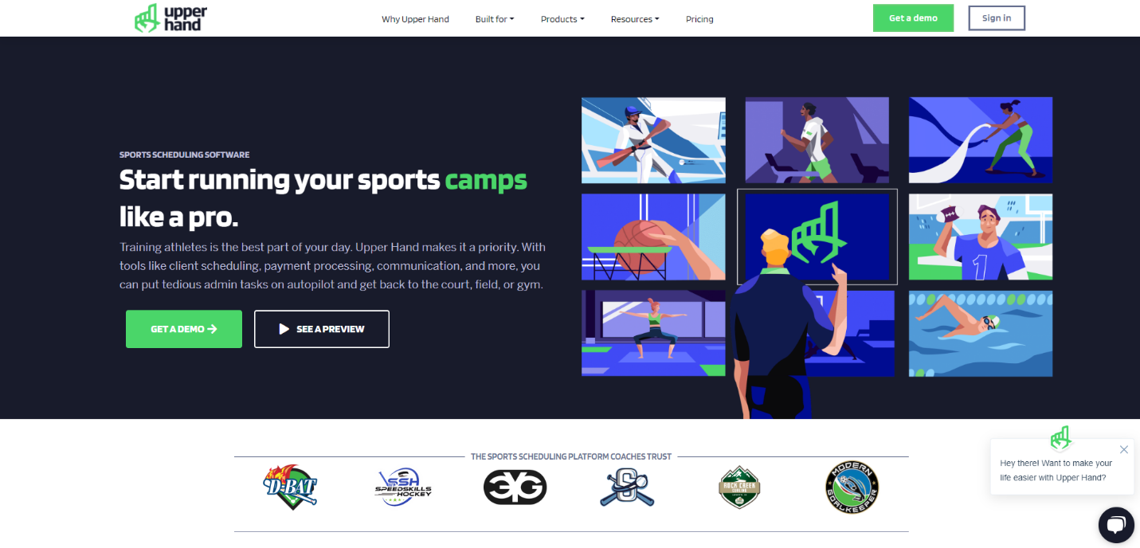Evaluation: Upper Hand's goal is to help athletic organizations focus more on providing high-quality sports programs and services by streamlining administrative processes, improving customer experience, and increasing overall efficiency.

Figure 1: Upper Hand

**Research 2: Make my Trip (Web application)**

Description: MakeMyTrip is India's top travel online company and one of the country's biggest travel booking platforms. It was founded in 2000 and offers a variety of travel-related services such as flight reservations, lodging reservations, train bookings, bus ticketing, vacation packages, and auto rentals. (MAKEMYTRIP PVT. LTD., 2000)

Evaluation: MakeMyTrip's website is well-known for its simple and secure payment process, which offers users a variety of payment choices. The site also provides customer service via multiple channels, which assists consumers with their questions and issues.

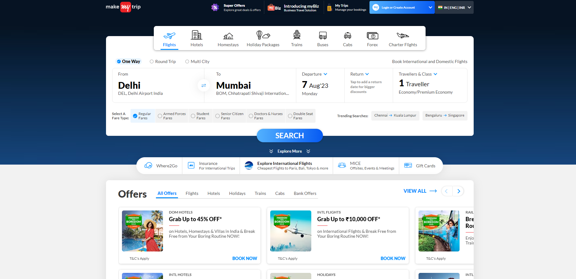

Figure 2: Make my Trip

### **2.3.1 Features Comparison Checklist**

|  |  |  |  |  |
| --- | --- | --- | --- | --- |
|  |  | **Similar Applications** | | **My Application** |
| **SN** | **Features** | **Make my Trip** | **Upper Hand** | **Sports Hub Booking System** |
| **1** | User Registration | YES | YES | YES |
| **2** | User Login | YES | YES | YES |
| **3** | Search Function | YES | NO | NO |
| **4** | Online Payment | YES | YES | YES |
| **5** | Select Date and Time | YES | NO | NO |
| **6** | Web Based Application | YES | YES | YES |
| **7** | Mobile Based Application | YES | NO | NO |
| **8** | Attractive UI | YES | NO | YES |
| **9** | Booking System | YES | YES | YES |
| **10** | Blog Section | NO | YES | NO |
| **11** | Membership | NO | NO | YES |
| **12** | User Profile | YES | YES | YES |
| **13** | Multiple Booking Options | YES | YES | NO |
| **14** | Easy Navigation | YES | NO | YES |

### **Research Papers**

**Research 3: Loyalty points in Sports Booking Apps**

Description: The use of a loyalty points system in sports ticketing systems is covered in this journal. It describes how users can accumulate points to get deals and promotions on next reservations. (Spiryn, 2022)

Evaluation: This is useful since it supports the project's decision to incorporate a points system for users that would reward loyalty and promote repeat reservations.

Implementation on Sports Hub Booking System: The sports booking system not actually has loyalty points but has a membership component that provides customers with savings on future bookings. Users who become members receive special benefits such as lower prices or discounts applied automatically to subsequent bookings. The membership structure encourages users to participate in athletic activities on a regular basis, creating loyalty and engagement on the platform. By offering such discounts, the system hopes to encourage users to live a more active and healthy lifestyle by participating in sports on a regular basis.

**Research 4: Structured web Application**

Description: However, the current technology does not provide ID booking and confirmation delegation to users. The study intends to incorporate the Stripe payment method into the WordPress platform, generating QR codes with XAMPP, MySQL, PHP, and HTML. Users receive email alerts and QR codes after an administrator confirms their booking and payment. The results reveal an 86.66% increase in online utilization for sports center bookings over the previous method, demonstrating greater efficiency. (Awang, et al., 2020)

Evaluation: The source is useful since it enables the project's usage of business intelligence to give analytics to each user via graphs and improve the application's decision-making skills.

Implementation on Sports Hub Booking System: Flask is used as the framework, HTML/CSS/JS for frontend , and SQLite as the database management system in the sports booking system. Flask provides a strong and adaptable backend infrastructure for data processing and business logic, while the frontend is built with common web technologies to create a user-friendly experience. SQLite is the database used to store and handle booking-related data. The combination of these technologies enables the system to provide a consistent and responsive user experience while managing sports facility bookings and user data efficiently.

**Research 5: Sports Facility Reservation**

Description: Sri Lanka has a thriving sports culture, with many fans and well-maintained sporting facilities such as cricket pitches, football/futsal fields, and badminton courts. However, difficulties in obtaining reservations have deterred many sports lovers from participating in activities. To overcome these challenges, this project intends to create an application with an automated reservation system that would benefit both users and venue owners. By giving graphical images of locations, augmented reality will improve the user experience. A points system will also reward users with discounts and promotions. Flutter and Google API were used to create this app. (Mendis, 2020)

Evaluation: Data mining, intelligence for business, and augmented reality are considered as important components for improving user experience and providing valuable insights.

Implementation on Sports Hub Booking System: Users can utilize the sports booking system to simply select their preferred time and date and search for available sports facilities without using the suggested booking feature. If the required facility is available at the provided period, users can book it. Furthermore, the system uses API for a secure payment gateway for easy payment processing. The application guarantees a seamless user experience and a fast booking process for sports by leveraging Google's authentication services and incorporating a dependable payment system.

## **2.4 Artefact (proposed)**

### **2.4.1 Work Breakdown Structure (WBS)**

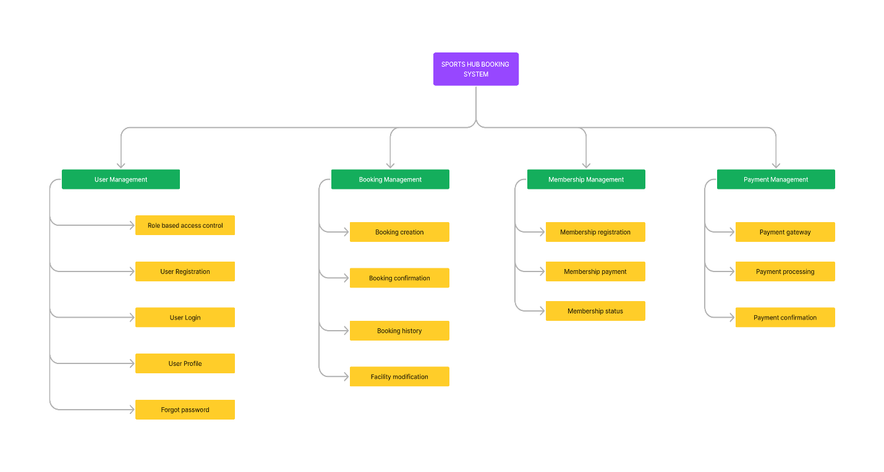WBS is a systematic and hierarchical method for breaking down large projects into smaller, more manageable tasks or work packages. Each layer of the work breakdown structure symbolizes a division of the project's scope, allowing project managers and teams to conceptualize, timetable, and oversee the project more efficiently.

Figure 3: WBS

### **2.4.2 Artefact in brief**

* **User Management:** In the sports booking system, user management covers features for registering new users, handling user authentication and approval, and managing user profiles, bookings, and personal preferences.
* **Payment Management:** Payment management in a sports booking system entails handling secure and seamless payment processing for reservation bookings, allowing users to make payments online, and preserving transaction records for transparency and accountability.
* **Membership Management:** In the sports booking system, membership management involves handling user membership registration process, renewal, and tracking the status of membership and benefits, allowing users to access unique features based on their membership level.
* **Booking Management**: Booking administration in the sports booking system comprises tools for administrators to manage for available sports facilities and users to look available sports facilities, pick desired time slots, make new bookings, and see booking history.

### **2.4.3 Justification of Software Development Methodology**

Software development is necessary when developing web applications since it is the process of designing, coding, and implementing the application's operations, features, and user interface. It combines developers' technical expertise, creativity, and problem-solving abilities to create functioning, user-friendly, and secure applications. Software development ensures that web applications generate value, enhance the experience of users, and are beneficial to the success of businesses and organizations in the digital age by identifying and addressing unique business demands. This system uses Scrum as a software development methodology. (Alliance Software, 2021)

* **Scrum:** Scrum is an agile software development process that emphasizes cooperation, adaptability, and iterative. It provides a systematic framework for managing complicated projects, producing high-quality software, and successfully adapting to changing requirements. Scrum is founded on transparency, inspection, and adaption principles, making it ideal for dynamic and fast-paced development environments. (The Home of Scrum, 2020). The phases of scrum methodology are:

1. Requirement Gathering
2. Sprint scheduling
3. Design and Development
4. Create and Implementation
5. Deployment and Testing

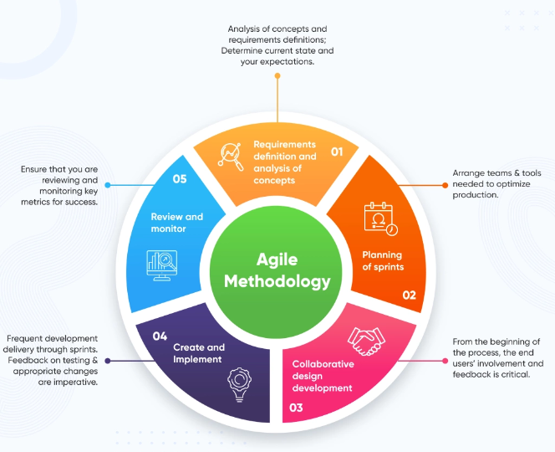

Figure 4: Agile Scrum methodology

### **2.4.4 Tools and Technologies**

* **Visual studio code:** It is widely regarded as one of the greatest code editors for software development, including system and application development. With its integrated terminal and IntelliSense feature, developers can efficiently execute commands and receive intelligent code completion suggestions. (Microsoft, 2015)
* **Python:** Python, a flexible and user-friendly high-level programming language, is well-known for its readability and simplicity. Python, created by Guido van Rossum and released in 1991, has a simple and basic syntax, making it a good choice for developers of all skill levels, from newbies to seasoned specialists.(Python software foundation, 2007)
* **Framework: - Flask:** Flask is a Python web development framework. Flask, known for its simplicity and flexibility, gives developers the opportunity to customize their applications and get started quickly with low overhead. Its modular architecture makes it simple to integrate extensions and plugins, making it easier to add features like authentication for users, payment systems, and database management. (Python flask, 2010)
* **HTML/CSS/JS:** These are three key web building technologies. HTML provides the structure and content of web pages by defining elements such as headings, paragraphs, images, and links with tags. When these technologies are used, they provide the core framework of modern web development, allowing developers to create visually beautiful, dynamic, and adaptive websites and online apps that improve the entire internet user experience. (CALIFORNIA INSTITUTE OF ARTS & TECHNOLOGY, 2021)
* **SQLite as Database management system:** It is that is lightweight, server less, and self-contained. It is a good solution for establishing the sports hub booking system because of its intrinsic nature, user-friendly design, and efficacy.
* **Git as version control system:** It functions as a distributed version control system for tracking changes to source code. It enables developers to efficiently communicate, organize, and maintain many versions of codebase. (Software freedom Conservancy, 2021)
* **API:** An API is a collection of principles and protocols that allows different software programs to connect and communicate with one another.(aws, 2020). This system uses a payment API to process payments, enabling reliable and secure payment transactions within my application and Gmail API to send link and receipt to registered mail.
* **Bootstrap:** Twitter created the well-known open-source front-end framework Bootstrap, which includes a set of pre-designed HTML, CSS, and JavaScript elements that enable the building of flexible and mobile-responsive websites and web applications.
* **Payment Gateway:** When selecting a payment gateway, it is critical to examine the target audience's payment preferences and habits. In Nepal, Khalti is a popular digital wallet and payment gateway. Integrating Khalti as a payment option may be beneficial. Users can utilize their Khalti accounts to make payments. Offering international card payment alternatives expands the possible customer base outside Nepal and makes the online application more accessible to a wider audience. Combining Khalti and foreign card payment choices might result in a dynamic payment gateway that allows consumers to select the method that best suits their needs and region. By providing a variety of payment alternatives, improves the user experience, promote confidence, and boost the overall success of the web service.

### **2.4.5 System Testing**

**Unit Testing:** Its goal is to validate specific programs or components for accuracy by examining the internal logic and architecture of the code.

**Integration Testing:** It ensures that various units or components of software perform together as intended when joined and interact with one another.

**Black-box Testing:** It is used to evaluate a software application's functionality and behavior without analyzing its internal code.

**User Acceptance Testing**: It is used to determine whether the software fulfils the expectations and requirements of the end-users, ensuring readiness for production deployment based on user feedback and validation.

# **3. Plan/Schedule**

## **3.1 Gantt chart**

It is a tool for visualizing project management that presents tasks, activities, and their associated timelines in the form of a horizontal bar chart. It provides a succinct and direct explanation of the project timetable, including the start and end dates of each and every activity as well as their interconnection. It assists in planning, organizing, and monitoring progress by allowing the identification of critical activities, efficient resource distribution, and effective control of project timeframes.

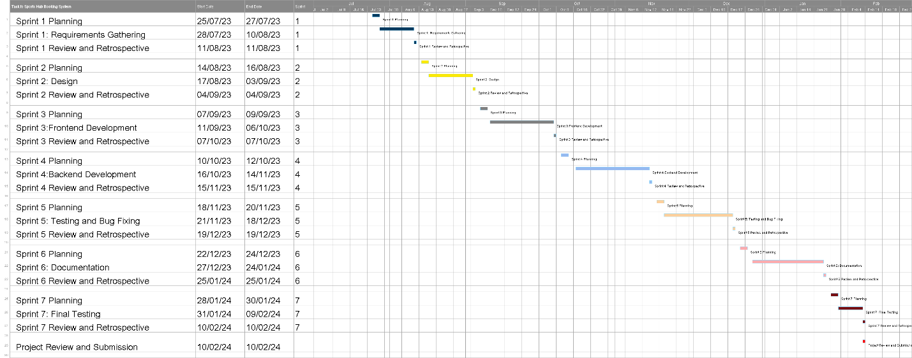

Figure 5: Gantt Chart

# **4. References**

Alliance Software, 2021. *An Introduction To Software Development Methodologies.* [Online]   
Available at: https://www.alliancesoftware.com.au/introduction-software-development-methodologies/  
[Accessed 2 August 2023].

Awang, A., Kassim, M. & Ab Ghani, N. S., 2020. Web design structure with wordpress content management for sports centre booking system. 20 September.

aws, 2020. *What Is An API (Application Programming Interface)?.* [Online]   
Available at: https://aws.amazon.com/what-is/api/#:~:text=API%20stands%20for%20Application%20Programming,other%20using%20requests%20and%20responses.  
[Accessed 30 july 2023].

CALIFORNIA INSTITUTE OF ARTS & TECHNOLOGY, 2021. *CIAT.* [Online]   
Available at: https://www.ciat.edu/  
[Accessed 30 July 2023].

MAKEMYTRIP PVT. LTD., 2000. *MAKEMYTRIP.* [Online]   
Available at: https://www.googleadservices.com/pagead/aclk?sa=L&ai=DChcSEwi7xrz2ncCAAxXQzBYFHa4WBqsYABAAGgJ0bA&ohost=www.google.com&cid=CAESZ-D2b6ZsuDBQ1KlDtyPoVqhw_zOr7ydw3pEFiKBU1vOE5g4NmHI38Dec5DbSsQ50JaufeEsbA5387cjLwgfX84GeupMKKutgushaifnDQKSmdtINPtjm9iaZZXRlgs1mW  
[Accessed 03 August 2023].

Mendis, O., 2020. *GoPlay - Sports Facility Reservation Application.* Negombo, Sri Lanka, IEEE.

Microsoft, 2015. *Code editing.* [Online]   
Available at: https://code.visualstudio.com/  
[Accessed 12 july 2023].

Python flask, 2010. *Python flask.* [Online]   
Available at: https://pythonbasics.org/what-is-flask-python/  
[Accessed 30 july 2023].

Python software foundation, 2007. *Python.* [Online]   
Available at: https://www.python.org/  
[Accessed 30 july 2023].

Software freedom Conservancy, 2021. *git.* [Online]   
Available at: https://git-scm.com/  
[Accessed 30 July 2023].

Spiryn, J., 2022. Top 10 loyalty programs for sports clubs. *OPEN LOYALITY.*

The Home of Scrum, 2020. *What is Scrum?.* [Online]   
Available at: https://www.scrum.org/resources/what-scrum-module  
[Accessed 2 August 2023].

Upper Hand, 2011. *Upper Hand.* [Online]   
Available at: https://upperhand.com/  
[Accessed 06 August 2023].

# **Appendix**

