**1) Adding Extra column to Existing Table**

Before :

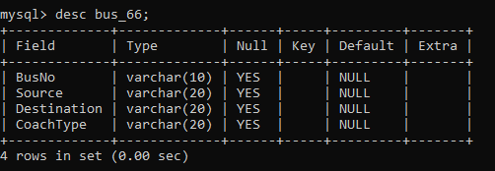

Query : alter table bus_66 add column NoOfSeats int;

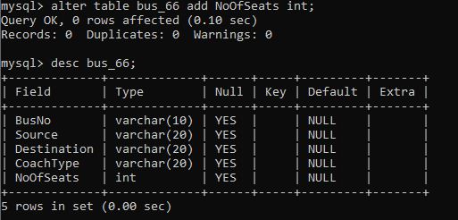

**2) UPDATE The destination for bus number TN203.**

Before :

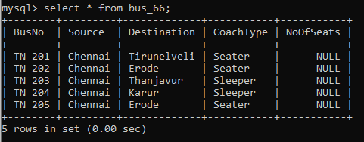

Query: update set Destination="Salem" where BusNo="TN 203";

**After**

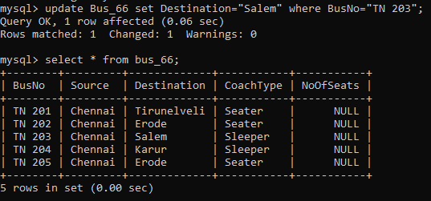

**3) Display unique PNR_NO of all passengers**

Query: select * from reservation_66;

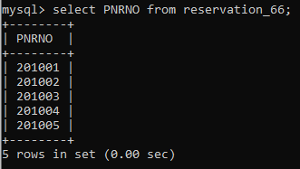

**4) Display all the names of male passengers.**

Query: select name from passenger_66 where sex='M';

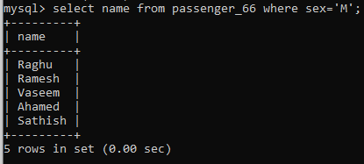

**5) Display the ticket numbers and names of all the passengers.**

Query: select ticketno,name from passenger_66;

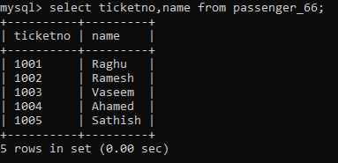

**6) Find the ticket numbers of the passengers whose name start with ‘r’**

**and ends with ‘h’.**

Query: select ticketno from passenger_66 where name like 'r%h';

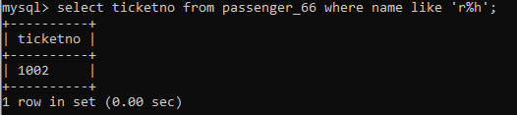

**7) Find the names of Passengers whose age is between 30 and 45.**

Query: select name from passenger_66 where age between 30 and 45;

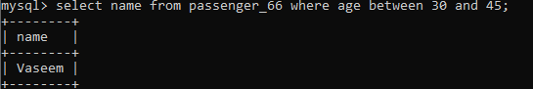

**8) Display all the passengers names beginning with ‘A’.**

Query: select * from passenger_66 where name like 'A%';

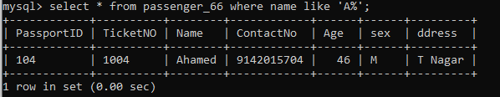

**9) Write a Query to display the information present in the passenger and cancellation tables**