**vGPGPU: Illinois Institute of Technology**

Virtualizing GPUs to Support MTC Applications Computer Science Department

<http://datasys.cs.iit.edu/> Data-Intensive Distributed Systems Laboratory

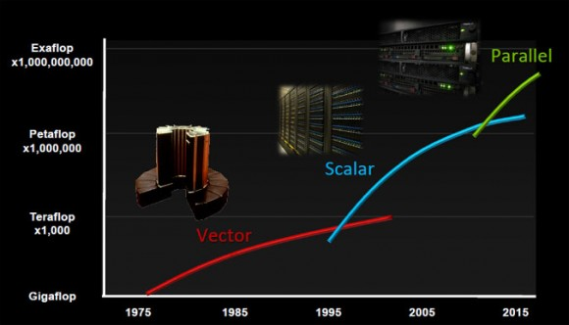As GPGPU acceleration within clusters and supercomputers becomes more common in the TOP500, with three of the top ten supercomputers in the world employing GPGPU hybrid architectures, researchers will be tailoring code to run efficiently on these types of systems. While the use of GPGPU is certainly advancing the field of Distributed Systems and High-Performance Computing, their programmability is significantly worse, forcing users to change the fundamentals of their algorithms from a MIMD approach to a SIMD approach. This work aims to explore the possibility of turning a GPU into a MIMD computing device through the use of virtualization, making the programming and porting of applications easier. This work will enable a large class of applications known as Many-Task Computing (MTC) to efficiently run on GPGPU computing accelerators.

### Proposed Work

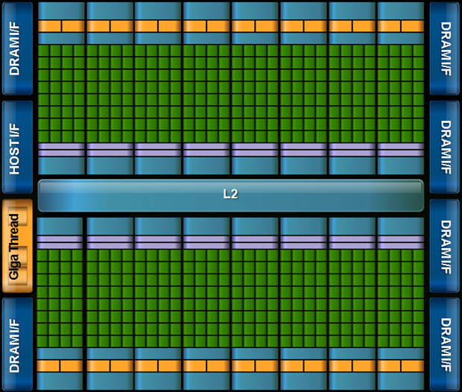Given that many GPUs have 100s to 1000s of cores already (the NVIDIA Fermi architecture at the left shows 512-cores), we are exploring methods of virtualizing GPUs into smaller computing elements, each with the ability to execute independent applications. In essence, this project aims to allow MIMD applications to be executed on SIMD hardware. The release of the Intel MIC accelerators offers even some opportunities to advance this project as the more general purpose cores supporting x86 instructions should be easier to program with a MIMD approach.

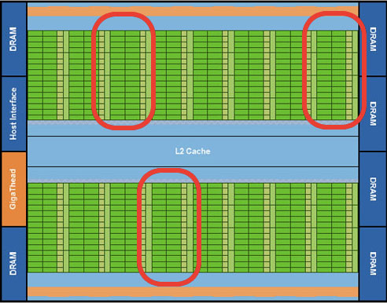

This work aims to take a single GPU and virtualize at the SM level. The image on the right shows the latest Fermi architecture with red highlights around particular SM’s. These SM’s would serve as separate GPU’s.

