**EXPERIMENT NO. 1**

**AIM**

To study various DDL commands - CREATE

**QUESTIONS**

Create the following Tables

**Table 1: DEPOSIT**

ACTNO VARCHAR2(5) PRIMARY KEY, FIRST LETTER MUST START WITH ‘D’ CNAME VARCHAR2(15) FOREIGN KEY REFERENCES CUSTOMER

BNAME VARCHAR2(20) FOREIGN KEY REFERENCES BRANCH AMOUNT NUMBER (8,2) NOT NULL, CANNOT BE 0

ADATE DATE

**Table 2: BRANCH**

BNAME VARCHAR2(20) PRIMARY KEY

CITY VARCHAR2(30) NOT NULL , any one of NAGPUR, DELHI, BANGALORE, BOMBAY

**Table 3: CUSTOMER**

CNAME VARCHAR2(15) PRIMARY KEY CITY VARCHAR2(20) NOT NULL ,

**Table 4: BORROW**

LOANNO VARCHAR2(8) PRIMARY KEY / FIRST LETTER MUST START WITH ‘L’ CNAME VARCHAR2(15) FOREIGN KEY REFERENCES CUSTOMER

BNAME VARCHAR2(20) FOREIGN KEY REFERENCES BRANCH AMOUNT NUMBER(8,2) NOT NULL, CANNOT BE 0

**INSERTION OF VALUES**

1.Inserting values to Branch

|  |  |
| --- | --- |
| VRCE | NAGPUR |
| AJNI | NAGPUR |
| KAROLBAGH | DELHI |
| CHANDNI | DELHI |
| DHARAMPETH | NAGPUR |
| MG ROAD | BANGALORE |
| ANDHERI | BOMBAY |
| NEHRU PALACE | DELHI |
| POWAI | BOMBAY |

2.Inserting values into Customer table

|  |  |
| --- | --- |
| ANIL | CALCUTTA |
| SUNIL | DELHI |
| MEHUL | BARODA |
| MANDAR | PATNA |
| MADHURI | NAGPUR |
| PRAMOD | NAGPUR |
| SANDIP | SURAT |
| SHIVANI | BOMBAY |
| KRANTI | BOMBAY |
| NAREN | BOMBAY |

3. Inserting values into Deposite table

|  |  |  |  |  |
| --- | --- | --- | --- | --- |
| Actno | Cname | Bname | Amount | Adate |
| D100 | ANIL | VRCE | 1000.00 | 1-MAR-95 |
| D101 | SUNIL | ANJNI | 500.00 | 4-JAN-96 |
| D102 | MEHUL | KAROLBAGH | 3500.00 | 17-NOV-95 |
| D104 | MADHURI | CHANDNI | 1200.00 | 17-DEC-95 |
| D105 | PRAMOD | MG ROAD | 3000.00 | 27-MAR-96 |
| D106 | SANDIP | ANDHERI | 2000.00 | 31-MAR-96 |
| D107 | SHIVANI | VIRAR | 1000.00 | 5-SEP-95 |
| D108 | KRANTI | NEHRU PLACE | 5000.00 | 2-JUL-95 |
| D109 | MINU | POWAI | 7000.00 | 10-AUG-95 |

4. Inserting values into borrow table

|  |  |  |  |
| --- | --- | --- | --- |
| L201 | ANIL | VRCE | 1000.00 |
| L206 | MEHUL | AJNI | 5000.00 |
| L311 | SUNIL | DHARAMPETH | 3000.00 |
| L321 | MADHURI | ANDHERI | 2000.00 |
| L371 | PRAMOD | VIRAR | 8000.00 |
| L481 | KRANTI | NEHRU PLACE | 3000.00 |

**PROCEDURE**

CREATE DATABASE DB1;

USE DB1;

CREATE TABLE BRANCH (

BNAME VARCHAR(20) PRIMARY KEY,

CITY VARCHAR(30) CHECK (CITY IN ('BOMBAY','BANGALORE','DELHI','NAGPUR')) NOT NULL

);

CREATE TABLE CUSTOMER (

CNAME VARCHAR(15) PRIMARY KEY,

CITY VARCHAR(20) NOT NULL

);

CREATE TABLE DEPOSIT(

ACTNO VARCHAR (5) CHECK (ACTNO LIKE 'D%') PRIMARY KEY,

CNAME VARCHAR (15) REFERENCES CUSTOMER (CNAME),

BNAME VARCHAR (20) REFERENCES BRANCH(BNAME),

AMOUNT DECIMAL (8,2) CHECK (AMOUNT>0) NOT NULL,

ADATE DATE

);

CREATE TABLE BORROW(

LOANNO VARCHAR (8) CHECK (LOANNO LIKE 'L%') PRIMARY KEY,

CNAME VARCHAR (15) REFERENCES CUSTOMER (CNAME),

BNAME VARCHAR (20) REFERENCES BRANCH (BNAME),

AMOUNT DECIMAL(8,2) CHECK (AMOUNT>0) NOT NULL

);

INSERT INTO BRANCH VALUES ('VRCE','NAGPUR');

INSERT INTO BRANCH VALUES ('AJNI', 'NAGPUR');

INSERT INTO BRANCH VALUES ('KAROLBAGH', 'DELHI');

INSERT INTO BRANCH VALUES ('CHANDNI', 'DELHI');

INSERT INTO BRANCH VALUES ('DHARAMPETH', 'NAGPUR');

INSERT INTO BRANCH VALUES ('MG ROAD', 'BANGALORE');

INSERT INTO BRANCH VALUES ('ANDHERI', 'BOMBAY');

INSERT INTO BRANCH VALUES ('NEHRU PALACE', 'DELHI');

INSERT INTO BRANCH VALUES ('POWAI', 'BOMBAY');

INSERT INTO CUSTOMER VALUES ('ANIL', 'CALCUTTA');

INSERT INTO CUSTOMER VALUES ('SUNIL', 'DELHI');

INSERT INTO CUSTOMER VALUES ('MEHUL', 'BARODA');

INSERT INTO CUSTOMER VALUES ('MANDAR', 'PATNA');

INSERT INTO CUSTOMER VALUES ('MADHURI', 'NAGPUR');

INSERT INTO CUSTOMER VALUES ('PRAMOD', 'NAGPUR');

INSERT INTO CUSTOMER VALUES ('SANDIP', 'SURAT');

INSERT INTO CUSTOMER VALUES ('SHIVANI', 'BOMBAY');

INSERT INTO CUSTOMER VALUES ('KRANTI', 'BOMBAY');

INSERT INTO CUSTOMER VALUES ('NAREN', 'BOMBAY');

INSERT INTO DEPOSIT VALUES ('D100', 'ANIL', 'VRCE', 1000.00, '1995-03-01');

INSERT INTO DEPOSIT VALUES ('D101', 'SUNIL', 'ANJNI', 500.00, '96-1-4');

INSERT INTO DEPOSIT VALUES ('D102', 'MEHUL', 'KAROLBAGH', 3500.00, '95-11-17');

INSERT INTO DEPOSIT VALUES ('D104', 'MADHURI', 'CHANDNI', 1200.00, '95-12-17');

INSERT INTO DEPOSIT VALUES ('D105', 'PRAMOD', 'MG ROAD', 3000.00, '96-3-27');

INSERT INTO DEPOSIT VALUES ('D106', 'SANDIP', 'ANDHERI', 2000.00, '96-3-31');

INSERT INTO DEPOSIT VALUES ('D107', 'SHIVANI', 'VIRAR', 1000.00, '95-9-5');

INSERT INTO DEPOSIT VALUES ('D108', 'KRANTI', 'NEHRUPLACE', 5000.00, '95-7-2');

INSERT INTO DEPOSIT VALUES ('D109', 'MINU', 'POWAI', 7000.00, '95-8-10');

INSERT INTO BORROW VALUES ('L201', 'ANIL', 'VRCE', 1000.00);

INSERT INTO BORROW VALUES ('L206', 'MEHUL', 'AJNI', 5000.00);

INSERT INTO BORROW VALUES ('L311', 'SUNIL', 'DHARAMPETH', 3000.00);

INSERT INTO BORROW VALUES ('L321', 'MADHURI', 'ANDHERI', 2000.00);

INSERT INTO BORROW VALUES ('L371', 'PRAMOD', 'VIRAR', 8000.00);

INSERT INTO BORROW VALUES ('L481', 'KRANTI', 'NEHRU PLACE', 3000.00);

**OUTPUT**

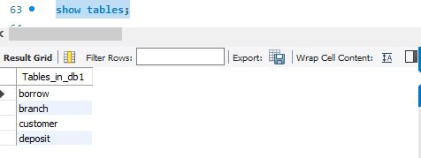

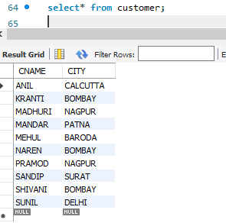 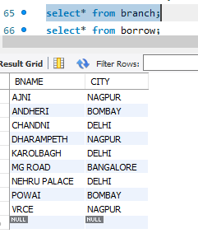

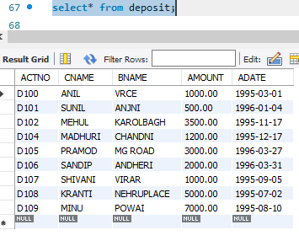 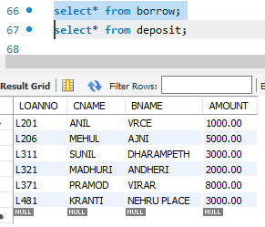

**EXPERIMENT NO. 2**

**AIM**

To familiarize with selecting data from single table

**QUESTIONS**

1. List all data from table deposite

2. List all data from borrow

3.List all data from customer

4.List all data from branch

5.Give account no and amount of deposite

6.Give customer name and account no of depositors

7.Give name of customers

8.Give name of branches

9.Give name of borrows

10.Give names of customer living in city Nagpur

11.Give names of depositors having amount greater than 4000

12.Give account date of Anil

13.Give name of all branches located in Bombay

14.Give name of borrower having loan number l205

15.Give names of depositors having account at VRCE

16.Give names of all branched located in city Delhi

17.Give name of the customers who opened account date ‘1-12-96’

18.Give account no and deposit amount of customers having account opened between dates ‘1-12-96’ and ‘1-5-96’

19.Give name of the city where branch KAROLBAGH is located

20.Give details of customer ANIL

**PROCEDURE**

1. List all data from table deposit

SELECT * FROM deposit

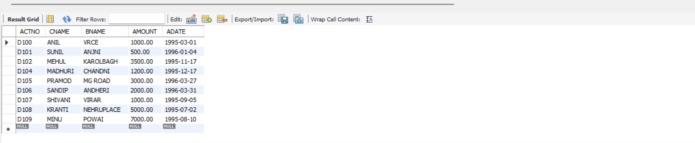

2. List all data from borrow

SELECT * FROM borrow

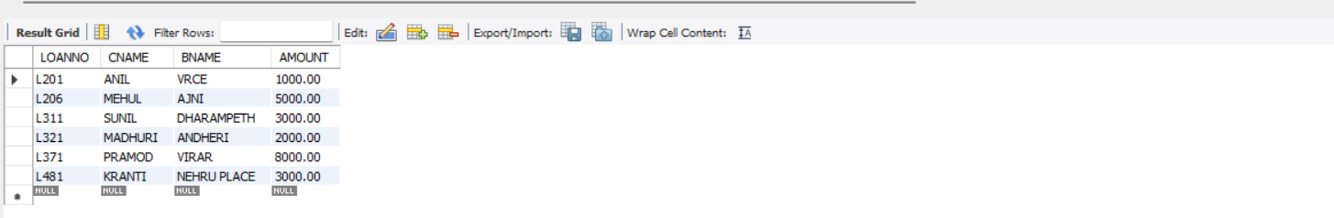

3. List all data from customer

SELECT * FROM customer

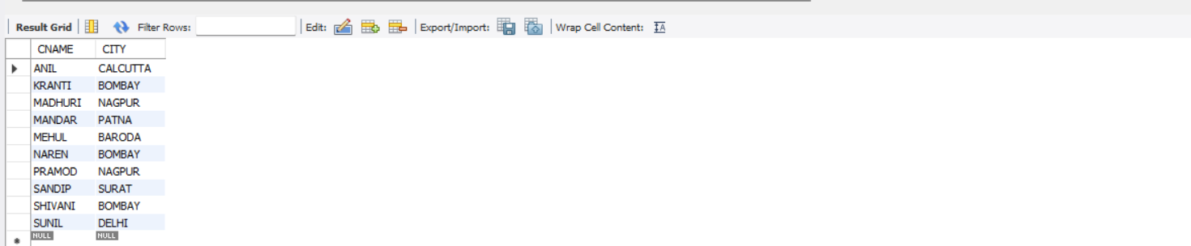

4. List all data from branch

SELECT * FROM branch

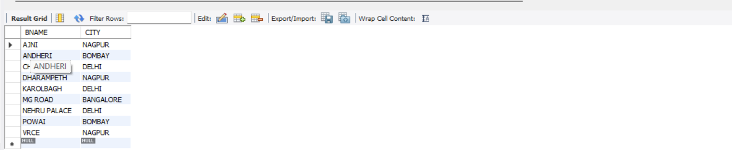

5. Give account no and amount of deposit-

SELECT ACTNO,AMOUNT FROM `deposit` ;

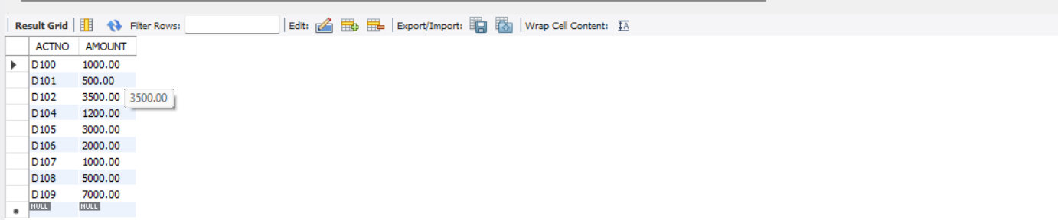

6. Give customer name and account no of depositors

SELECT ACTNO,CNAME FROM `deposit`;

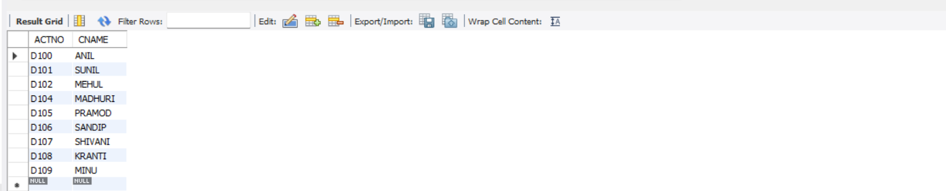

7. Give name of customers

SELECT CNAME FROM `customers` ;

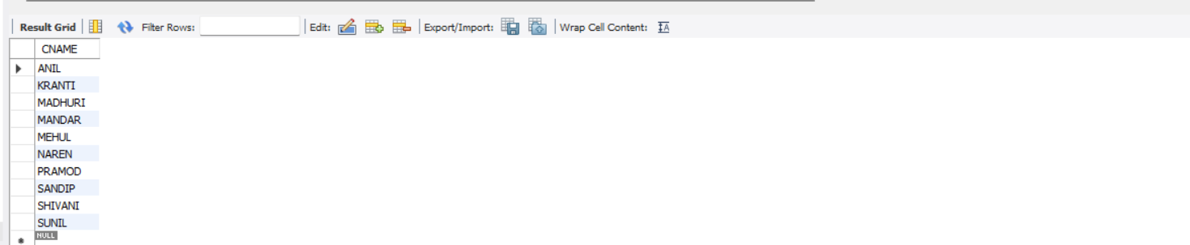

8. Give name of branches

SELECT BNAME FROM `branch`;

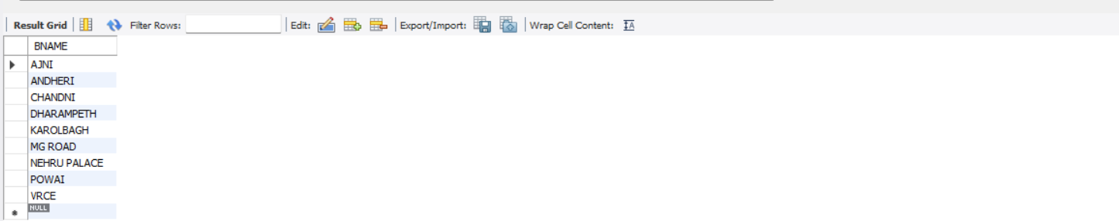

9. Give name of borrows

SELECT CNAME,BNAME FROM `borrow`;

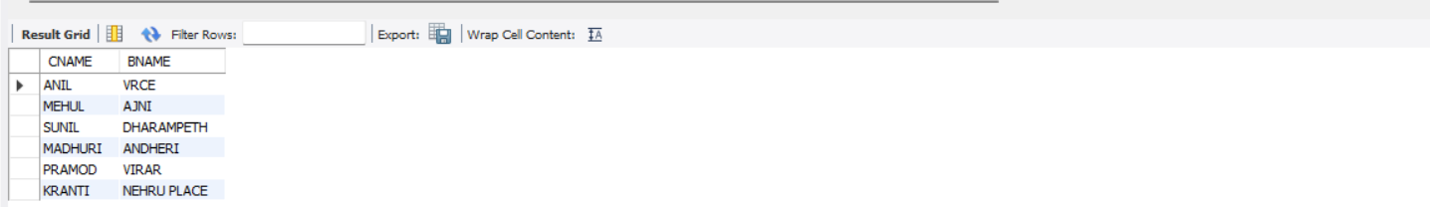

10. Give names of customer living in city Nagpur

SELECT CNAME FROM `customer` WHERE CITY='NAGPUR';

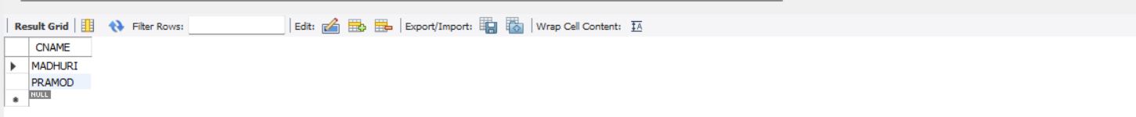

11. Give names of depositors having amount greater than 4000

SELECT CNAME,BNAME FROM `deposit` WHERE AMOUNT>4000;



12. Give account date of Anil

SELECT ADATE FROM `deposit` WHERE CNAME='ANIL';



13. Give name of all branches located in Bombay

SELECT BNAME FROM `branch` WHERE CITY= 'BOMBAY';

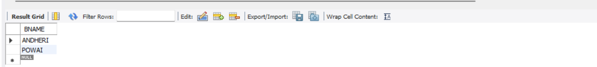

14. Give name of borrower having loan number l206

SELECT CNAME,BNAME FROM `borrow` WHERE LOANNO= 'L206';



15. Give names of depositors having account at VRCE

SELECT CNAME FROM `deposit` WHERE BNAME='VRCE';



16. Give names of all branched located in city Delhi

SELECT BNAME FROM `branch` WHERE CITY='DELHI';

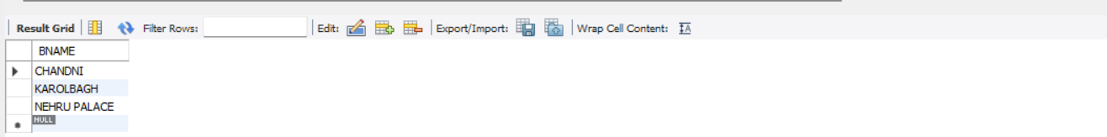

17. Give name of the customers who opened account date ‘1-12-96’

SELECT CNAME FROM `deposit` WHERE ADATE=2016-03-27;



18. Give account no and deposit amount of customers having account opened between dates ‘1-12-96’ and ‘1-5-96’

SELECT ACTNO, AMOUNT FROM DEPOSIT WHERE ADATE BETWEEN 96-05-01 and 96-12-01;



19. Give name of the city where branch KAROLBAGH is located

SELECT CITY FROM `branch` WHERE BNAME='KAROLBAGH';



20. Give details of customer ANIL

SELECT * FROM `customer` WHERE CNAME='ANIL';



**EXPERIMENT NO. 3**

**AIM**

To familiarize DDL Commands- ALTER,DROP,TRUNCATE,RENAME

**QUESTIONS AND PROCEDURE**

1. Create a table emp with attributes empno number(4)as primary key, ename char(10),hiredate, salary,commission and insert the following 5 rows of data

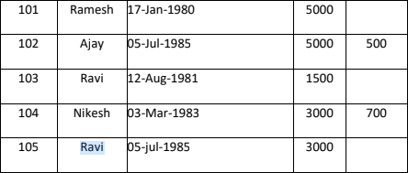

CREATE TABLE EMP(

empno INT PRIMARY KEY,

ename VARCHAR(10),

hiredate DATE,

salary INT,

commission INT

);

INSERT INTO emp(empno,ename,hiredate,salary) VALUES(101,"Ramesh","1980-01-17",5000);

INSERT INTO emp(empno,ename,hiredate,salary,commission) VALUES(102,"Ajay","1985-07-05",5000,500);

INSERT INTO emp(empno,ename,hiredate,salary) VALUES(103,"Ravi","1981-08-12",1500);

INSERT INTO emp(empno,ename,hiredate,salary,commission) VALUES(104,"Nikesh","1983-03-03",3000,700);

INSERT INTO emp(empno,ename,hiredate,salary) VALUES(105,"Ravi","1985-07-05",3000);

**Output**

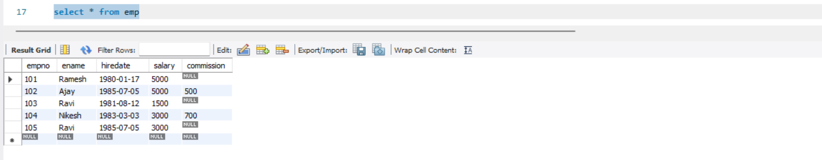2. Add check constraint (Salary <=5000)

ALTER TABLE emp ADD CHECK(salary<=5000);

**Output**

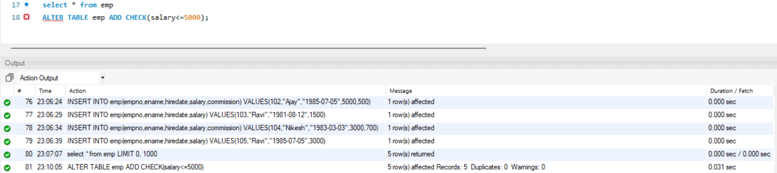

3. Add Check Constraint (length(empno<=3))

ALTER TABLE emp ADD CHECK (length(empno)<=3);

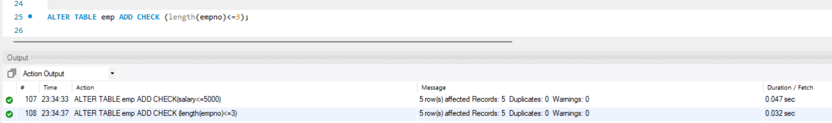

4. Modifying the structure of tables

a.Add new columns: sal number(7,2)

ALTER TABLE emp ADD COLUMN sal FLOAT (7,2);

SELECT * FROM emp;

**Output**

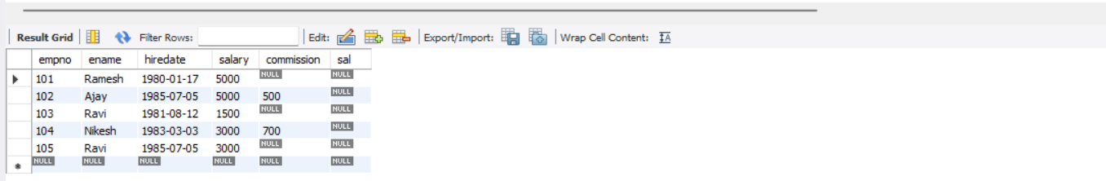

b.Dropping a column from a table: sal

ALTER TABLE emp DROP COLUMN sal;

SELECT * FROM emp;

**Output**

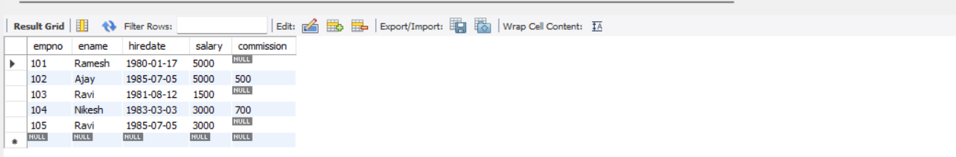

c.Modifying existing column :ename varchar2(15)

ALTER TABLE emp MODIFY COLUMN ename VARCHAR()15;

SELECT * FROM emp;

**Output**

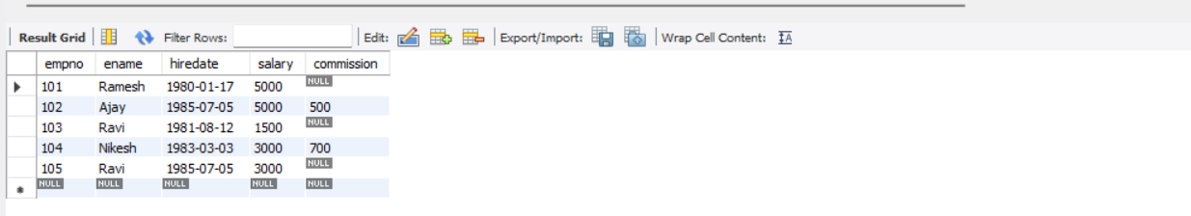

d.Renaming the tables: emp to emp1

ALTER TABLE emp RENAME TO emp1;

**Output**

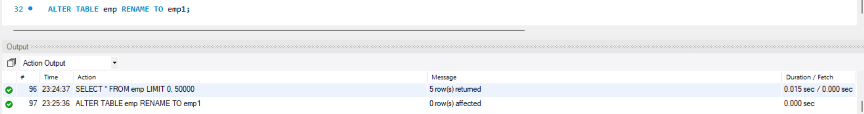

e.truncating the tables:emp1

TRUNCATE TABLE emp1;

SELECT * FROM emp1;

**Output**



f.Destroying tables:emp

DROP TABLE emp1;

**Output**

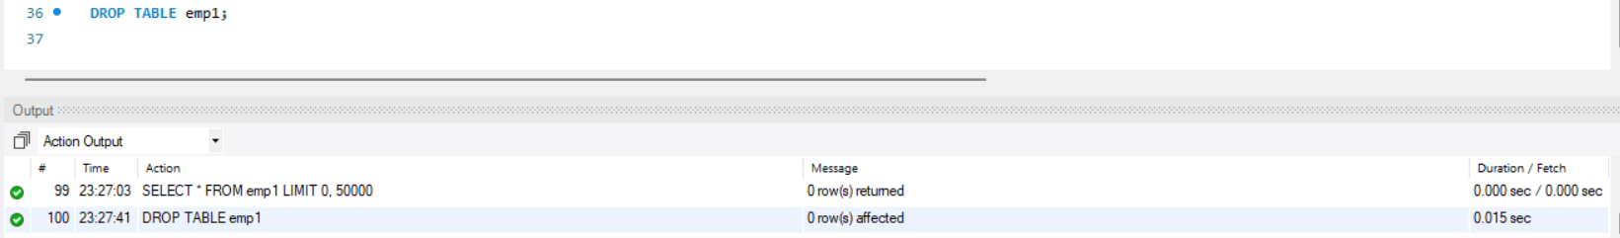

**EXPERIMENT NO.: 4**

**AIM**

To familiarize with set operations

**QUESTIONS AND PROCEDURE**

1. List all the customers who are depositors but not borrowers.

SELECT CNAME FROM deposit WHERE CNAME NOT IN (SELECT CNAME FROM borrow);

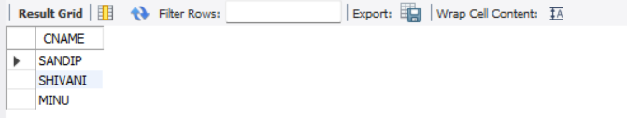

2. List all the customers who are both depositors and borrowers

SELECT CNAME FROM DEPOSIT UNION (SELECT CNAME FROM BORROW);

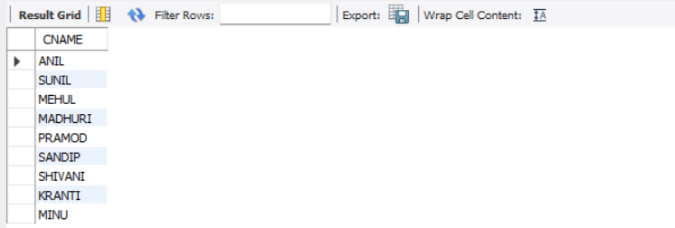

3. List all the depositors having deposit in all the branches where Sunil is having Account

SELECT D1.CNAME FROM DEPOSIT D1 WHERE D1.BNAME IN (SELECT D2.BNAME FROM DEPOSIT D2 WHERE D2.CNAME = 'SUNIL' );

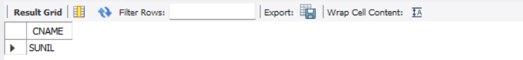

4. List all the customers living in city NAGPUR and having branch city BOMBAY or DELHI

SELECT C1.CNAME FROM CUSTOMER C1,DEPOSIT D1, BRANCH B1 WHERE C1.CITY = 'NAGPUR' AND C1.CNAME = D1.CNAME AND D1.BNAME = B1.BNAME AND B1.CITY IN ('BOMBAY','DELHI');

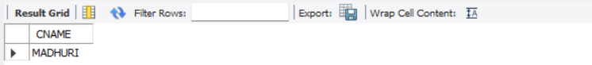

5. List all the depositors living in city NAGPUR

SELECT DISTINCT(CUSTOMER.CNAME) from CUSTOMER,DEPOSIT WHERE City='NAGPUR';

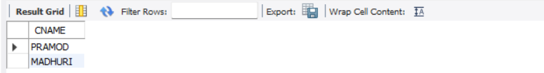

6. List all the depositors living in the city NAGPUR and having branch in city BOMBAY

SELECT C1.CNAME FROM CUSTOMER C1,DEPOSIT D1, BRANCH B1 WHERE C1.CITY = 'NAGPUR' AND C1.CNAME = D1.CNAME AND D1.BNAME = B1.BNAME AND B1.CITY IN ('BOMBAY');



7. List the branch cities of Anil and Sunil

SELECT B1.CITY FROM DEPOSIT D1, BRANCH B1 WHERE D1.BNAME = B1.BNAME AND D1.CNAME IN ('SUNIL' ,'ANIL');

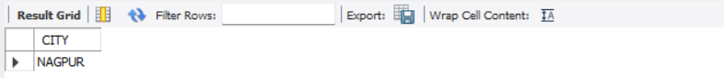

8. List the customers having deposit greater than 1000 and loan less than 10000.

SELECT DISTINCT D1.CNAME FROM deposit D1, borrow B1 WHERE D1.AMOUNT>1000 AND B1.AMOUNT<10000;

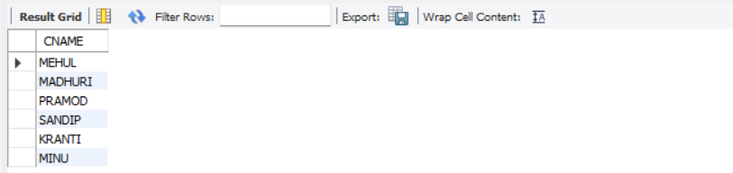

9. List the cities of depositors having branch VRCE.

SELECT B1.CITY FROM deposit D1, branch B1 WHERE D1.BNAME=B1.BNAME AND B1.BNAME='VRCE';

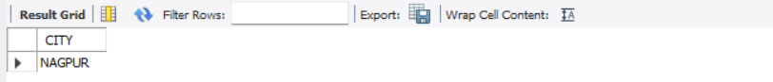

10. List the depositors having amount less than 1000 and living in the same city as Anil

SELECT D1.CNAME FROM deposit D1, customer C1 WHERE AMOUNT<1000 AND C1.CITY=(C1.CNAME='ANIL');

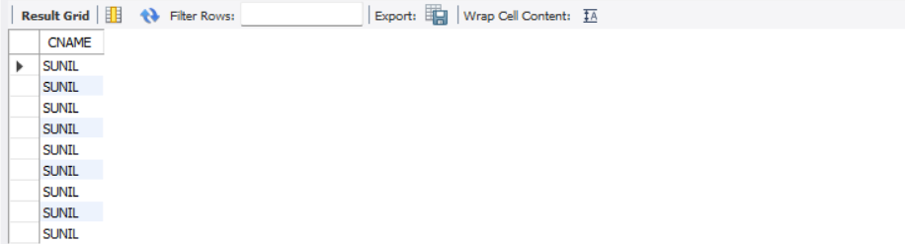

11. List all the cities where branches of Anil and Sunil are locate

SELECT B1.CITY FROM BRANCH B1 WHERE B1.BNAME IN (SELECT D1.BNAME FROM DEPOSIT D1 WHERE D1.CNAME IN ('ANIL','SUNIL'));

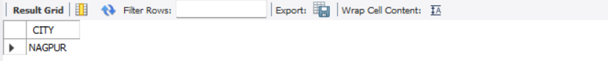

12. List the amount for the depositors living in the city where Anil is living

SELECT DISTINCT(D1.CNAME),D1.AMOUNT ,C1.CITY FROM deposit D1, CUSTOMER C1, BRANCH B1 WHERE D1.CNAME=C1.CNAME AND C1.CITY IN(SELECT C2.CITY FROM customer C2 WHERE C2.CNAME='ANIL');

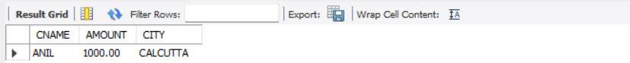

**EXPERIMENT NO. 5**

**AIM**

To familiarize with aggregate functions

**QUESTIONS AND PROCEDURE**

1. List total loan

SELECT SUM(AMOUNT) FROM BORROW;

2. List total deposit

SELECT sum(AMOUNT) from DEPOSIT;

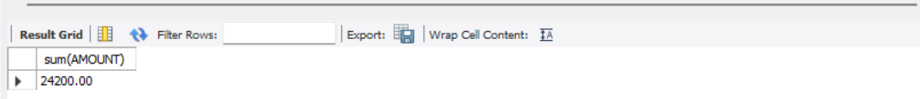

3. List total loan taken from KAROLBAGH branch

SELECT MAX(AMOUNT) FROM BORROW WHERE BNAME ='KAROLBAGH';



4. List total deposit of customers having account date later than 1-Jan-96

SELECT sum(AMOUNT) FROM DEPOSIT WHERE adate>’1995-03-01’;

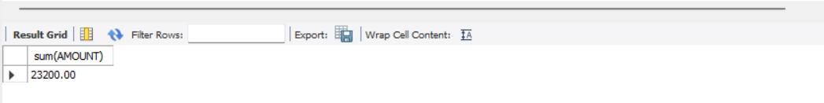

5. List total deposit of customers living in city NAGPUR

SELECT sum(d1.amount) FROM DEPOSIT d1, CUSTOMER c1 WHERE c1.city=”NAGPUR”

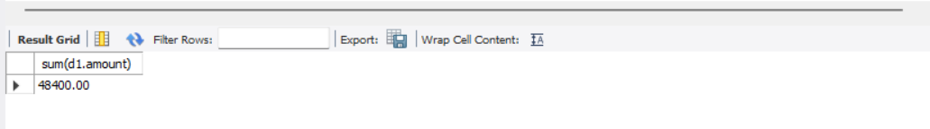

6. List maximum deposit of customer living in Bombay

SELECT max(d1.amount) FROM DEPOSIT d1, customer c1 WHERE c1.city=”BOMBAY”;

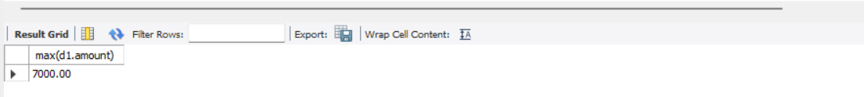

7. List total deposit of customer having branch in BOMBAY

SELECT SUM(amount) FROM DEPOSIT, BRANCH WHERE city=”BOMBAY”

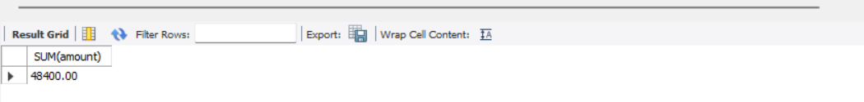

8. Count total number of branch cities

SELECT COUNT(DISTINCT(CITY)) FROM BRANCH;

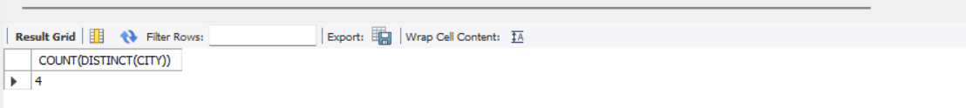

9. Count total number of customers cities

SELECT COUNT(CITY) FROM customer;

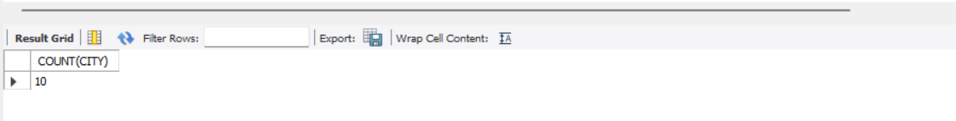

10. Give branch names and branch wise deposit

SELECT BNAME, SUM(AMOUNT) FROM DEPOSIT GROUP BY BNAME;

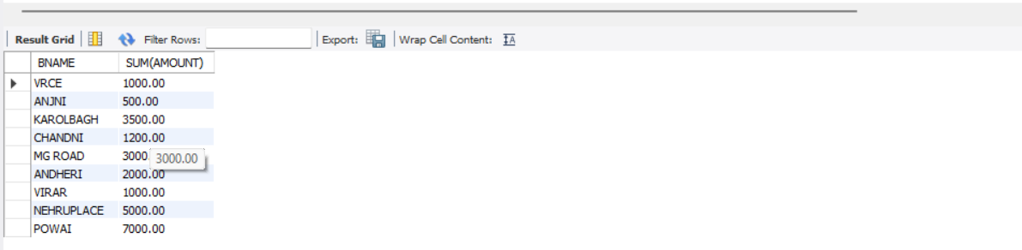

11. Give city wise name and branch wise deposit

SELECT c1.city, sum(d1.amount) FROM customer c1, deposit d1

12. Give the branch wise loan of customer living in NAGPUR

SELECT BNAME, sum(amount) FROM BORROW, CUSTOMER WHERE city=”NAGPUR”

13. Count total number of customers

SELECT count(cname) FROM customer;

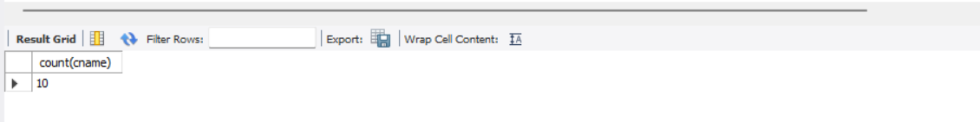

14. Count total number of depositors branch wise

SELECT BNAME, count(*) FROM DEPOSIT, CUSTOMER WHERE DEPOSIT.cname=

15. Give maximum loan from branch VRCE

SELECT max(amount) FROM BORROW WHERE bname=”VRCE”;

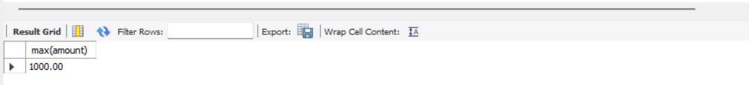

16. Give the number of customers who are depositors as well as borrowers

select cname from borrow

where cname in

(select cname from deposit);

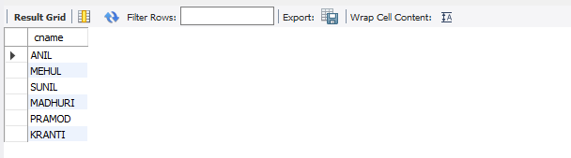

**EXPERIMENT NO. 6**

**AIM**

To familiarize with join or cartesian product

**QUESTIONS**

1.Give name of customers having living city BOMBAY and branch city NAGPUR

2.Give names of customers having the same living city as their branch city

3.Give names of customers who are borrowers as well as depositors and having city

NAGPUR.

4.Give names of borrowers having deposit amount greater than 1000 and loan amount

greater

than 2000.

5.Give names of depositors having the same branch as the branch of Sunil

6.Give names of borrowers having loan amount greater than the loan amount of Pramod

7.Give the name of the customer living in the city where branch of depositor Sunil is located.

8.Give branch city and living city of Pramod

9.Give branch city of Sunil and branch city of Anil

10.Give the living city of Anil and the living city of Sunil

**PROCEDURE**

1. SELECT D1.CNAME,D1.BNAME,C1.CNAME,C1.CITY,B1.CITY,B1.BNAME FROM DEPOSIT D1,CUSTOMER C1,BRANCH B1 WHERE C1.CITY = 'BOMBAY' AND

B1.CITY = 'NAGPUR' AND D1.CNAME = C1.CNAME AND D1.BNAME = B1.BNAME;

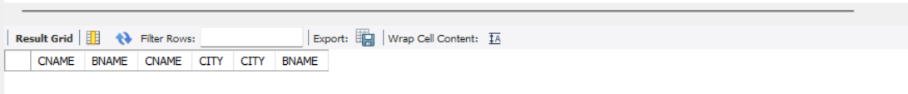

2. SELECT distinct(customer.CNAME), BRANCH.CITY FROM BRANCH, customer WHERE BRANCH.city = customer.city;

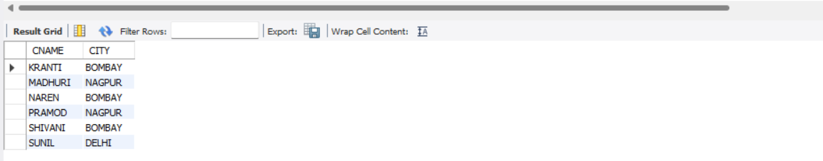

3. SELECT C1.CNAME FROM CUSTOMER C1,DEPOSIT D1,BORROW B1 WHERE C1.CITY='NAGPUR' AND C1.CNAME=D1.CNAME AND D1.CNAME = B1.CNAME;

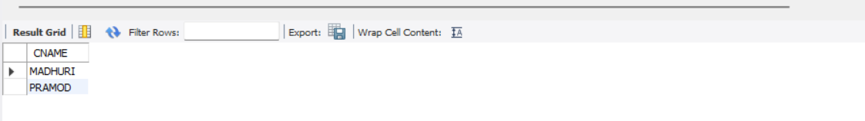

4. SELECT BR1.CNAME, BR1.AMOUNT, D1.CNAME, D1.AMOUNT FROM BORROW BR1,DEPOSIT D1 WHERE D1.CNAME = BR1.CNAME AND D1.AMOUNT >

1000 AND BR1.AMOUNT > 2000;

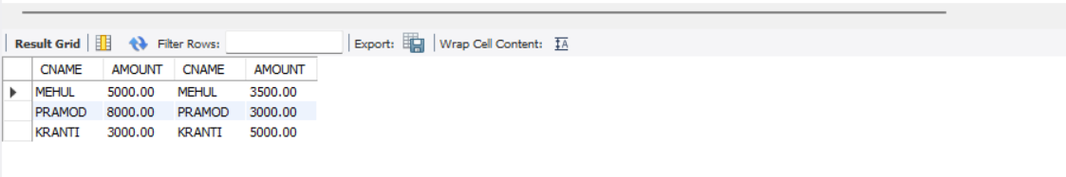

5. SELECT D1.CNAME FROM DEPOSIT D1 WHERE D1.BNAME IN (SELECT D2.BNAME FROM DEPOSIT D2 WHERE D2.CNAME = 'SUNIL');

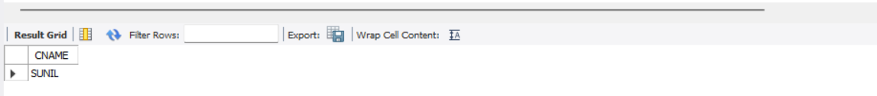

6. SELECT BR1.CNAME,BR1.AMOUNT FROM BORROW BR1 WHERE BR1.AMOUNT > ALL (SELECT BR2.AMOUNT FROM BORROW BR2 WHERE

BR2.CNAME = 'PRAMOD');

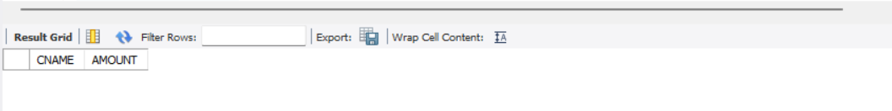

7. SELECT C.CNAME FROM CUSTOMER C WHERE C.CITY IN (SELECT B.CITY FROM BRANCH B WHERE B.BNAME IN (SELECT D.BNAME FROM DEPOSIT D

WHERE D.CNAME='SUNIL'));

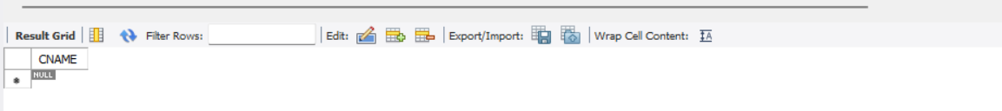

8. SELECT B1.CITY , C1.CITY FROM BRANCH B1,CUSTOMER C1, DEPOSIT D1 WHERE C1.CNAME = 'PRAMOD' AND C1.CNAME = D1.CNAME AND D1.BNAME =

B1.BNAME;

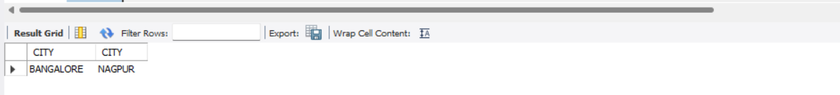

9. SELECT B1.CITY FROM DEPOSIT D1, BRANCH B1 WHERE D1.BNAME = B1.BNAME AND D1.CNAME IN ('SUNIL' ,'ANIL');

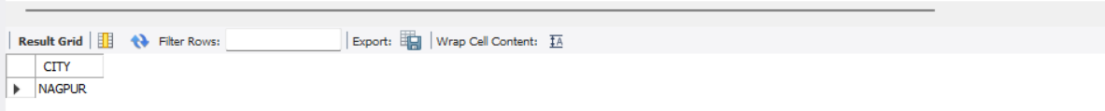

10. SELECT C1.CNAME, C1.CITY FROM CUSTOMER C1 WHERE C1.CNAME = 'ANIL' OR C1.CNAME = 'SUNIL’

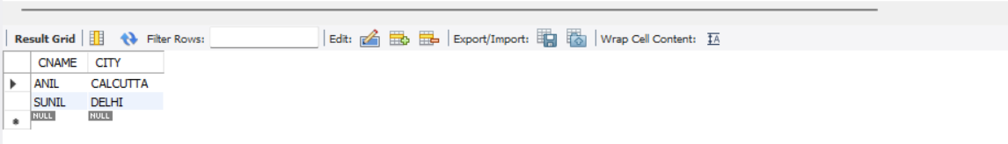

**EXPERIMENT NO. 7**

**AIM**

To familiarize with Group by and Having clause

**QUESTIONS AND PROCEDURE**

1. List the branches having sum of deposit more than 5000.

SELECT D.BNAME FROM DEPOSIT D, BRANCH B WHERE D.BNAME=B.BNAME AND B.CITY='BOMBAY' GROUP BY D.BNAME HAVING SUM(D.AMOUNT)>5000;



2. List the branches having sum of deposit more than 500 and located in city BOMBAY

SELECT D.BNAME FROM DEPOSIT D, BRANCH B ,Customer C WHERE D.BNAME=B.BNAME and C.city="Bombay" GROUP BY D.BNAME HAVING SUM(D.AMOUNT)>500 ;

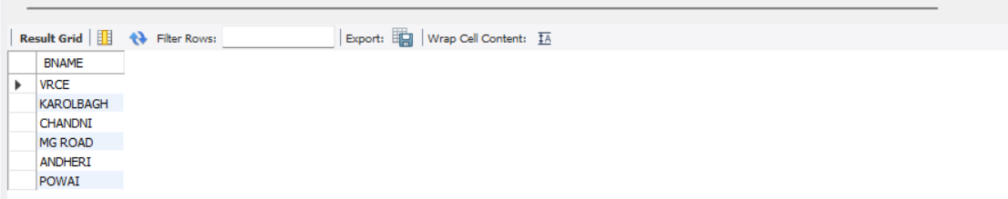

3. List the names of customers having deposited in the branches where the average deposit is

more than 5000.

select CNAME from deposit where AMOUNT=(select AVG(Amount) from DEPOSIT GROUP BY BNAME having AVG(Amount)>5000);

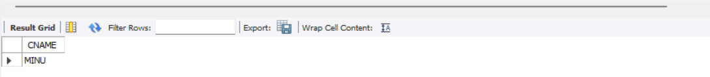

4. List the names of customers having maximum deposit

SELECT MAX(AMOUNT),CNAME FROM deposit;

5. List the name of branch having highest number of depositors?

SELECT D1.BNAME FROM DEPOSIT D1 GROUP BY D1.BNAME HAVING count(D1.CNAME) >= ALL (SELECT count(D2.CNAME) FROM DEPOSIT D2 GROUP BY D2.BNAME);

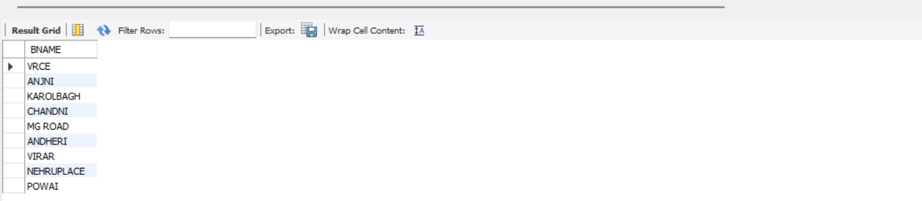

6. Count the number of depositors living in NAGPUR.

select count(deposit.cname)from deposit,CUSTOMER where CUSTOMER.CITY='nagpur';

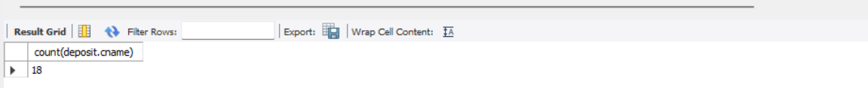

7. Give names of customers in VRCE branch having more deposite than any other customer in same branch

Select CNAME from deposit where BNAME='VRCE' and amount=(select max(AMOUNT) from deposit where BNAME='VRCE');

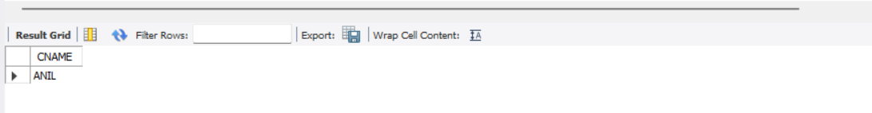

8. Give the names of branch where number of depositors is more than 5

SELECT BNAME from deposit GROUP BY BNAME HAVING COUNT(BNAME)>5;

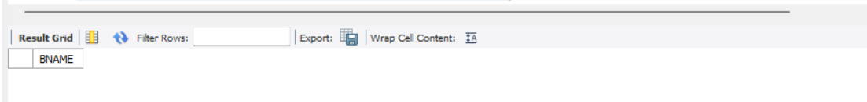

9. Give the names of cities in which the maximum number of branches are located

select C.CNAME ,count(B.BNAME) from CUSTOMER C inner join Branch B on C.CNAME=B.BNAME group by C.Cname order by count(B.BName) DESC;



10. Count the number of customers living in the city where branch is located

select count(b1.bname) From deposit d1 , borrow b1 , customer c1 Where c1.cname=d1.cname and d1.cname=b1.cname and c1.city in (select city from customer);

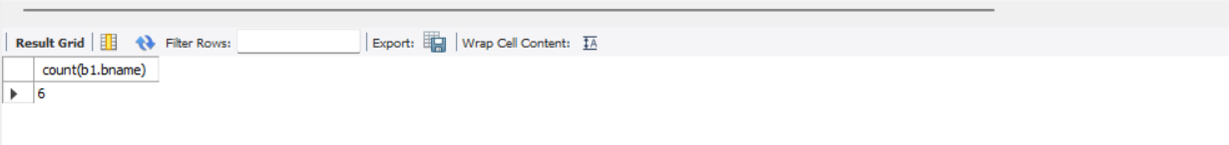

**EXPERIMENT NO. 8**

**AIM**

To have familiarize with trigger functions

**QUESTION**

Create a Trigger for employe table it will update another table salary while updating values

**OBJECTIVE**

To develop and execute a Trigger for After update/Delete/Insert operations on a table

**PROCEDURE**

step 1: start

step 2: initialize the trigger.

step 3: On update the trigger has to be executed.

step 4: execute the trigger procedure after updation

step 5: carryout the operation on the table to check for trigger execution.

step 6: stop

**PROGRAM**

CREATE TABLE `employe` (

`emp_id` int(11) NOT NULL,

`emp_name` varchar(45) DEFAULT NULL,

`dob` date DEFAULT NULL,

`address` varchar(45) DEFAULT NULL,

`designation` varchar(45) DEFAULT NULL,

`mobile_no` int(11) DEFAULT NULL,

`dept_no` int(11) DEFAULT NULL,

`salary` int(11) DEFAULT NULL, PRIMARY KEY (`emp_id`)

);

CREATE TABLE `salary` (

`employee_id` int(11) NOT NULL,

`old_sal` int(11) DEFAULT NULL,

`new_sal` int(11) DEFAULT NULL,

`rev_date` date DEFAULT NULL, PRIMARY KEY (`employee_id`)

);

CREATE DEFINER=`root`@`localhost` TRIGGER

`employee_db`.`employe_AFTER_UPDATE` AFTER UPDATE ON `employe` FOR EACH ROW

BEGIN

if(new.salary != old.salary) then

INSERT INTO salary (employee_id,old_sal,new_sal,rev_date) values (new.emp_id,old.salary,new.salary,sysdate());

END if; END

update employe set salary=234569 where emp_id=1; select * from salary;

OUTPUT