**Experiment No.: 1**

**Experiment No.: 1**

**Aim:** Installation of Docker

**CO5:** Acquire skill sets required for a DevOps

**Procedure:**

1. $sudo su
2. $um update –y
3. $yum install docker -y

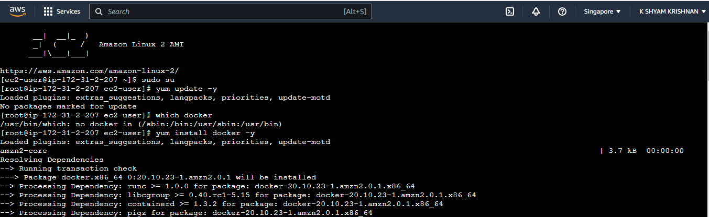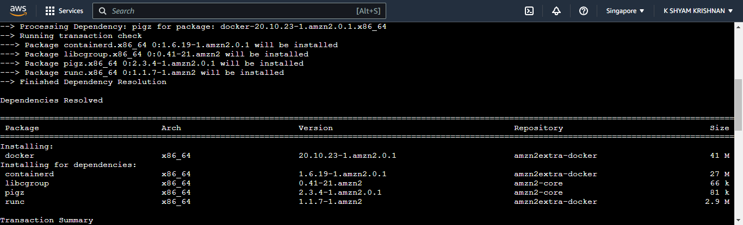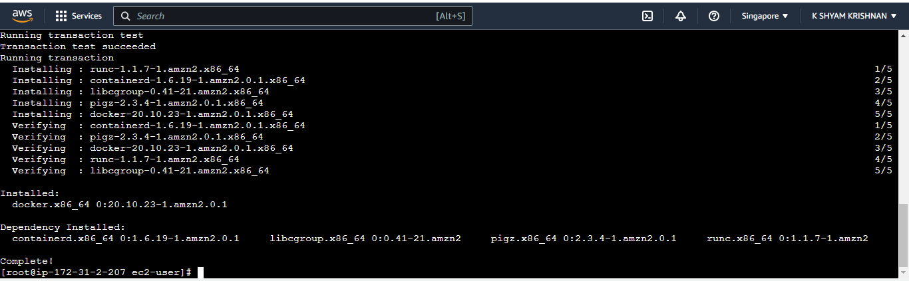4. $ which docker

5. $ docker info

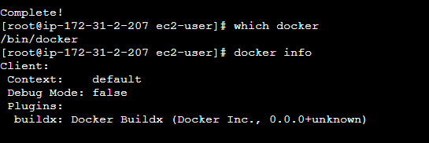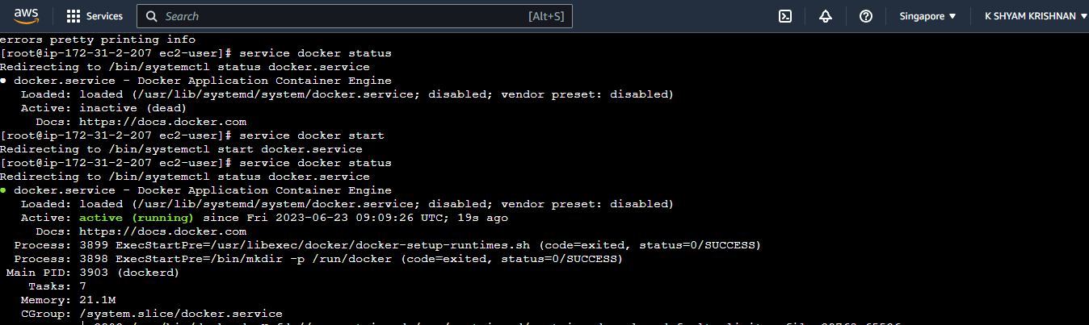

6. $ service docker status

7. $service docker start

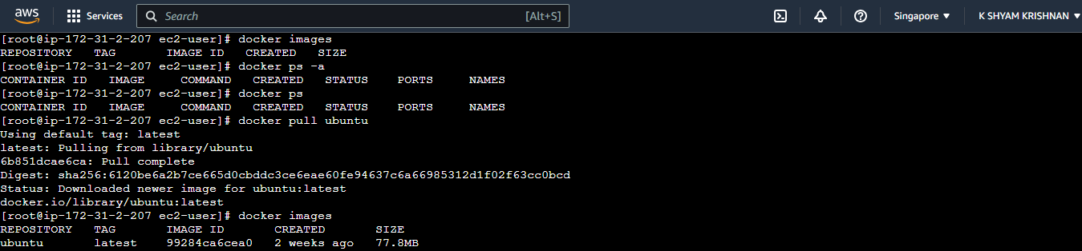

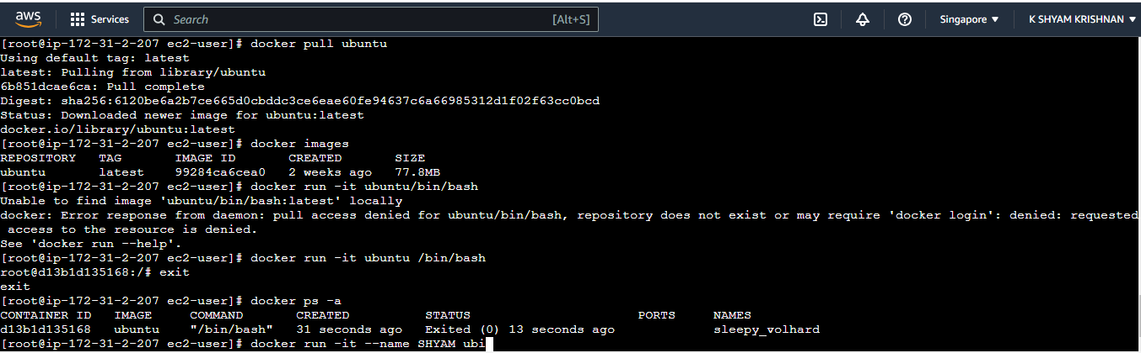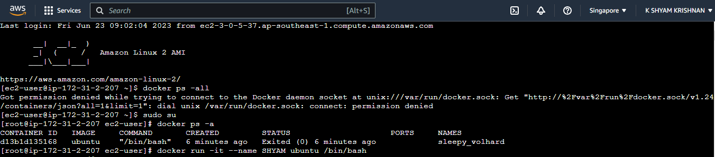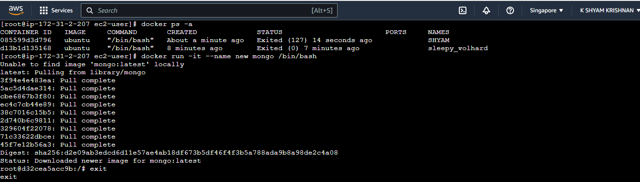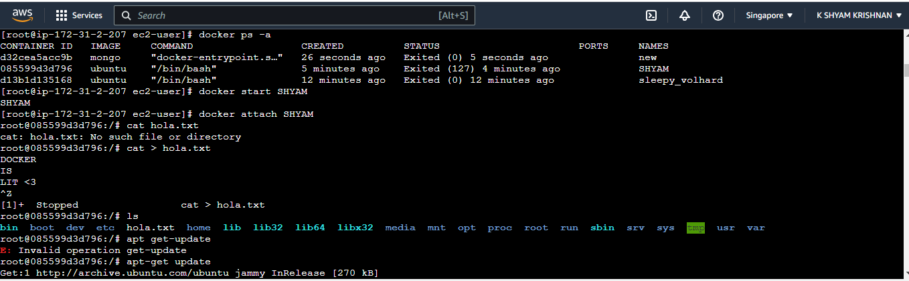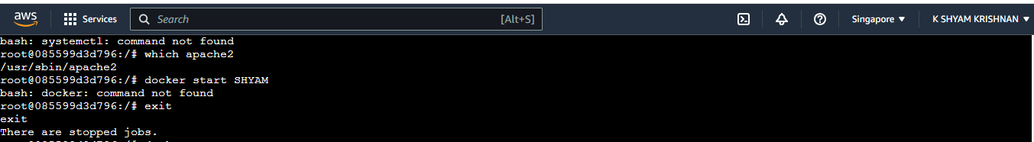

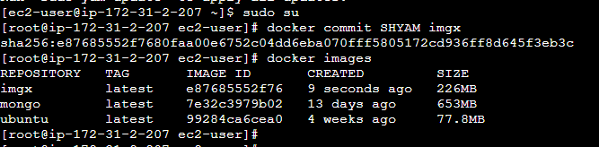

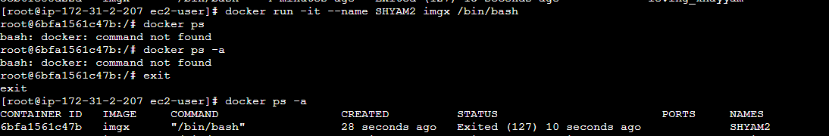

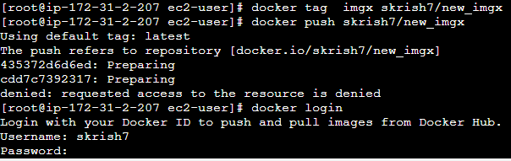

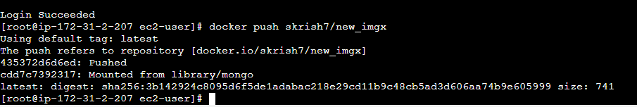

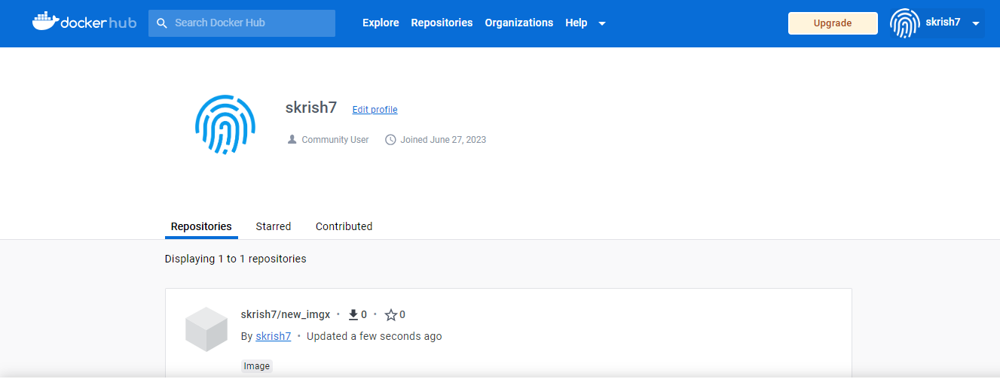

Mumbai

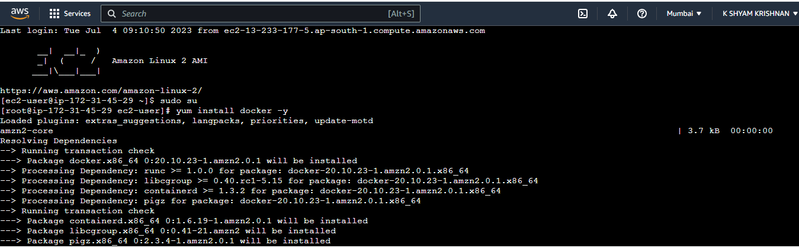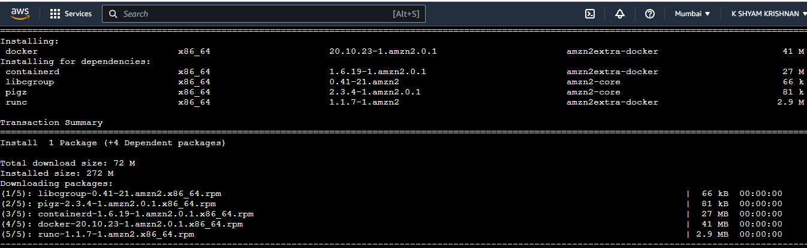

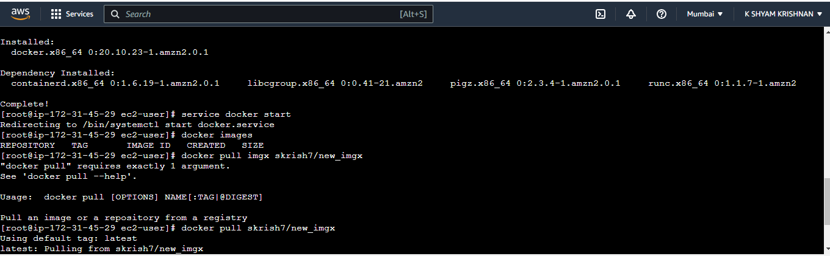

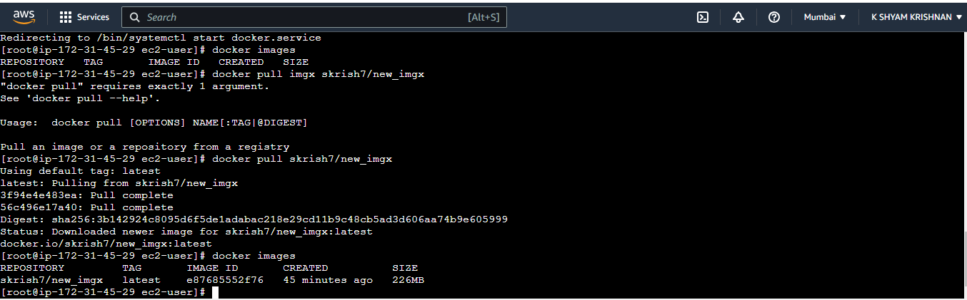

**Result:**

The program has been executed successfully and the result is obtained. Thus CO5 is attained.