**Experiment No.: 3 Date: 07-03-2023**

**Aim :** Familiarisation of Linux Commands.

**CO 2:** Perform System Administration task.

**Procedure:**

pwd (Print Working Directory)

To find out the path of the current working directory (folder) you are in.

**Output Screenshot**



history

To review the commands you have entered before. Command number to run a command from history.

**Output Screenshot**

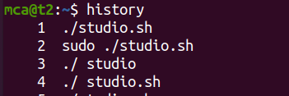

ls

The ls command is used to view the contents of a directory. By default, this command will display the contents of your current working directory.

**Output Screenshot**



*ls -a

This will show the hidden files



**Output Screenshot** 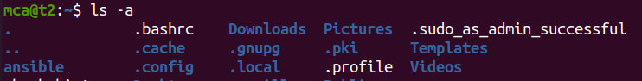

*ls -R

This will list all the files in the sub-directories as well

**Output Screenshot**

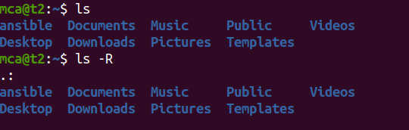

*ls –l (Long listing)

This command displays the contents of the current directory in a long listing format, one per line

**Output Screenshot**

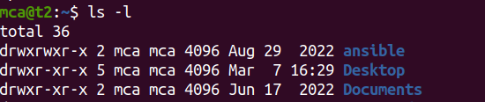

*ls -al

It will list the files and directories with detailed information like the permissions, size, owner, etc.

**Output Screenshot** 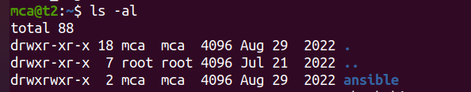

*ls -t

It will lists files sorted in the order of “last modified”.

**Output Screenshot**

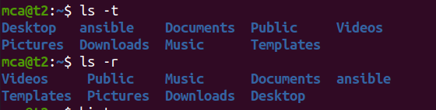

*ls -r

It will reverse the natural sorting order. Usually used in combination with other switches such as ls -tr. This will reverse the time-wise listing.

**Output Screenshot**



touch

The touch command allows you to create a blank new file through the Linux command line.

**Output Screenshot**

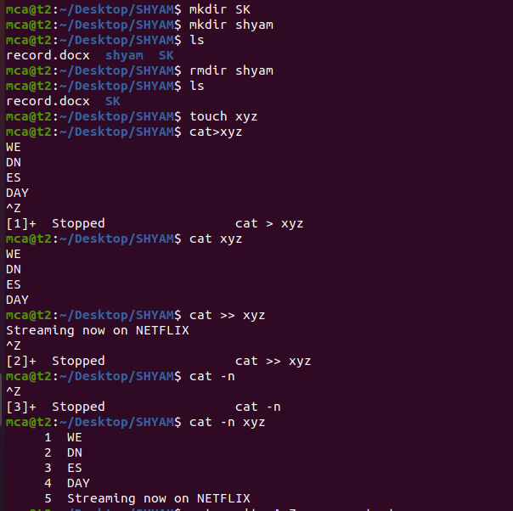

mkdir

Use mkdir command to make a new directory. Use the p (parents) option to create a directory in between two existing directories.

**Output Screenshot**



cp file1 file2

This command is used to copy files from the current directory to a different directory.

**Output Screenshot**

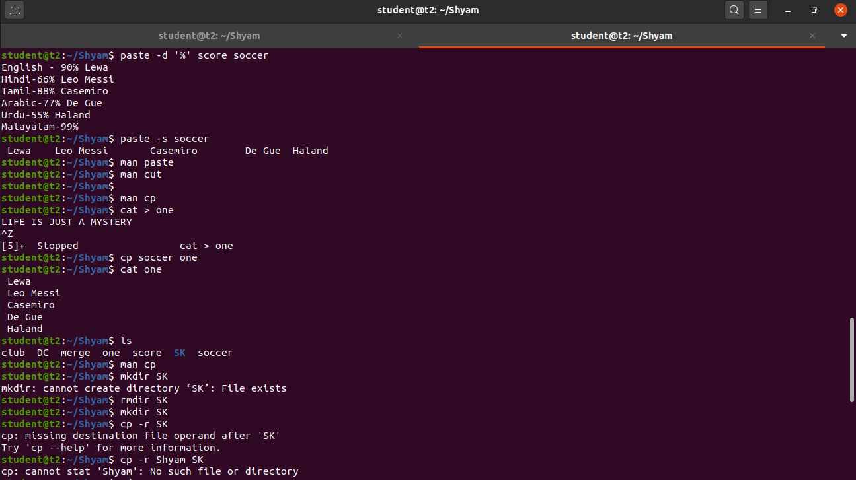

Cat >

To create a file.

**Output Screenshot**

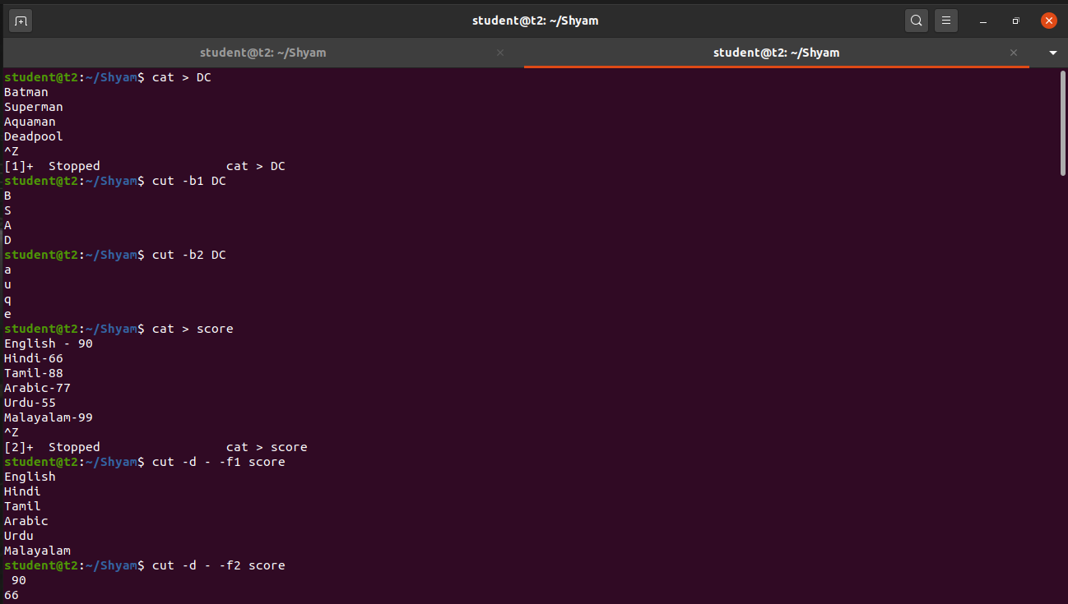

cat>>

This command will append (add something in the last of a file) something in your already existing file.

**Output Screenshot**

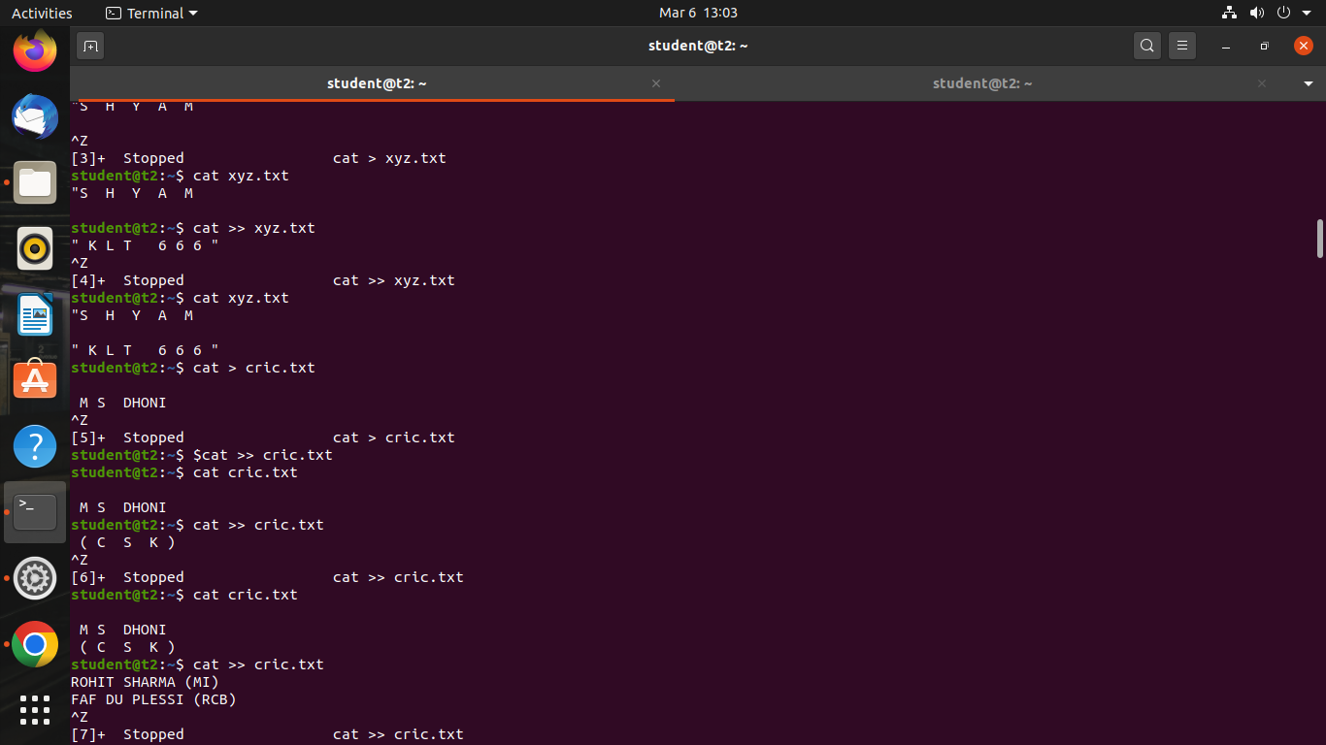

cat filename

This command will displays the contents of a file in the terminal.

**Output Screenshot**



cat -n

This command will display the contents of a file in the terminal, with line numbers displayed before each line.

**Output Screenshot**



cat a b

This command displays the contents of both files in the terminal, with the contents of file "a" displayed first, followed by the contents of file "b".

**Output Screenshot**

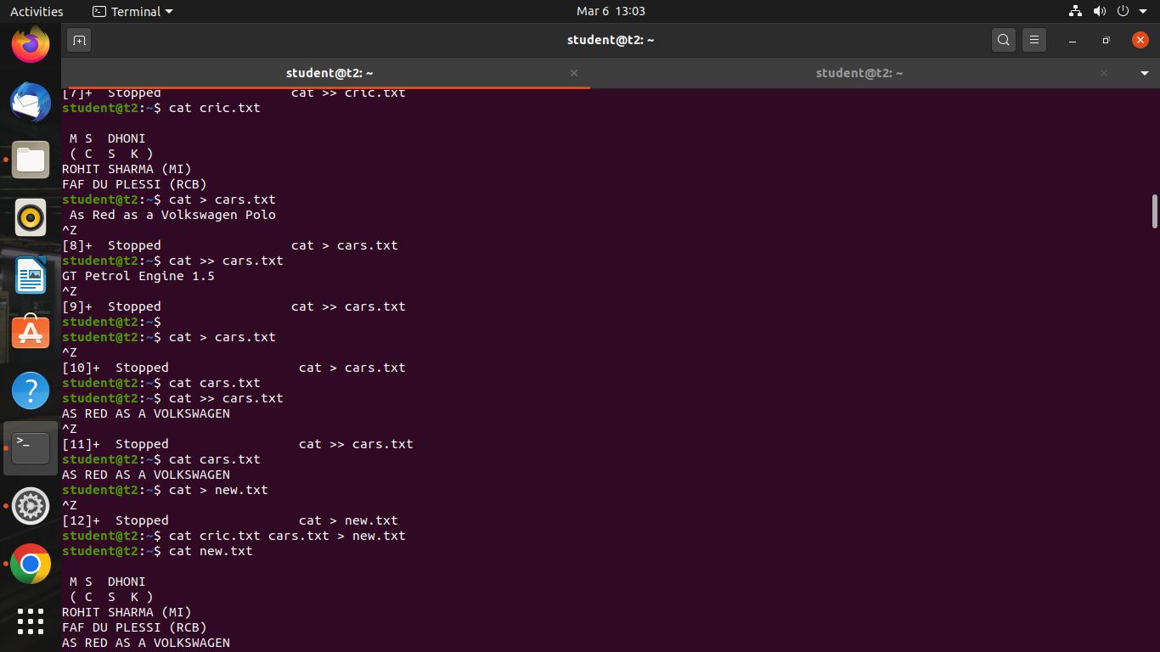

cat -E filename.txt – Display $ at end of each line

**Output Screenshot**

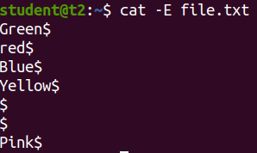

cd

This command is used to change the current working directory to a specified directory.

**Output Screenshot**

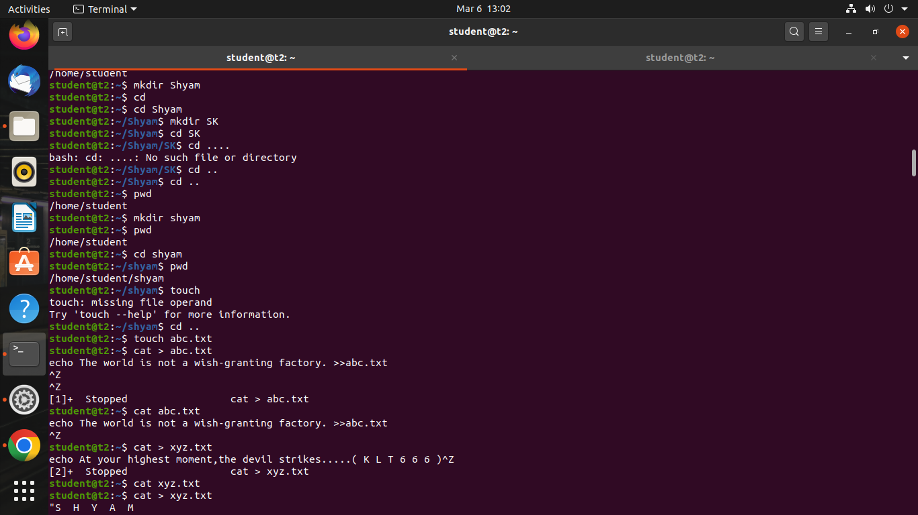

cd ..

This command is used to change the current working directory to the previous directory.

**Output Screenshot**



**Result**

The program was executed and the result was successfully obtained. Thus CO2 was obtained.

**Experiment No.: 4 Date: 07-03-2023**

**Aim :** Familiarisation of Linux Commands.

**CO 2:** Perform System Administration task.

**Procedure:**

cut -b1

This command is used to extract the first byte or character of each line from a file or output, where "b" stands for "byte" and "1" refers to the first byte or character position.

**Output Screenshot**



cut -b2

**Output Screenshot**



cut –c 1,2,3

This command is used to extract the characters or column of each line from a file or output, where "c" stands for "character" and "1,2,3" refers to the column positions.

**Output Screenshot**

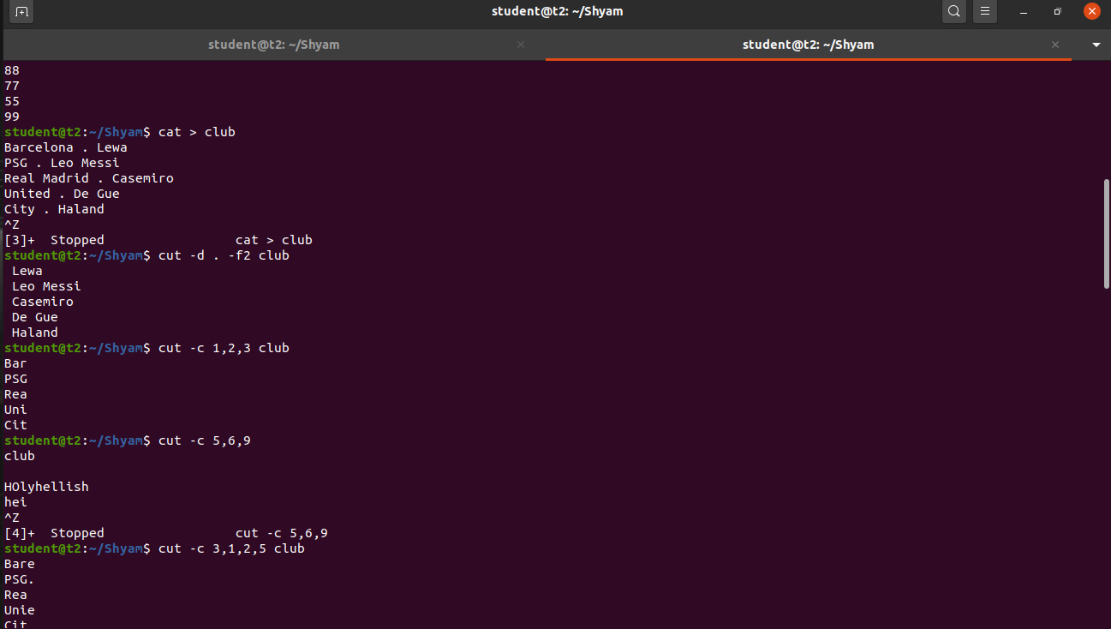

man

The command "man" is used to learn and understand about different commands right from the shell.

**Output Screenshot**



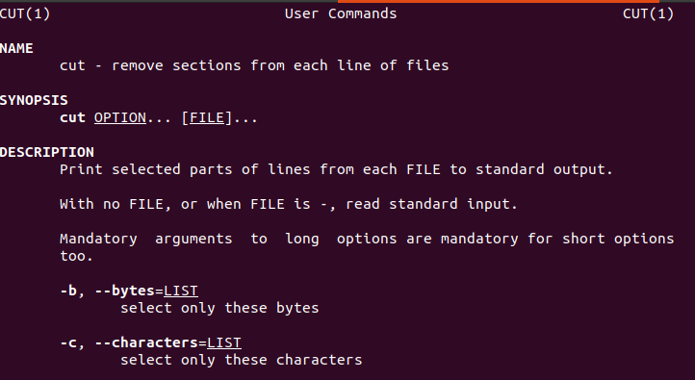

rmdir

The "rmdir" command is used to remove or delete an empty directory in a file system from the command line or terminal

**Output Screenshot**.



tr a-z

To convert the content into lower case letters

**Output Screenshot**

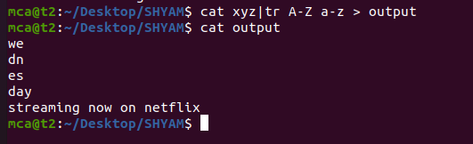

paste – The command is used to join files horizontally

**Output Screenshot**

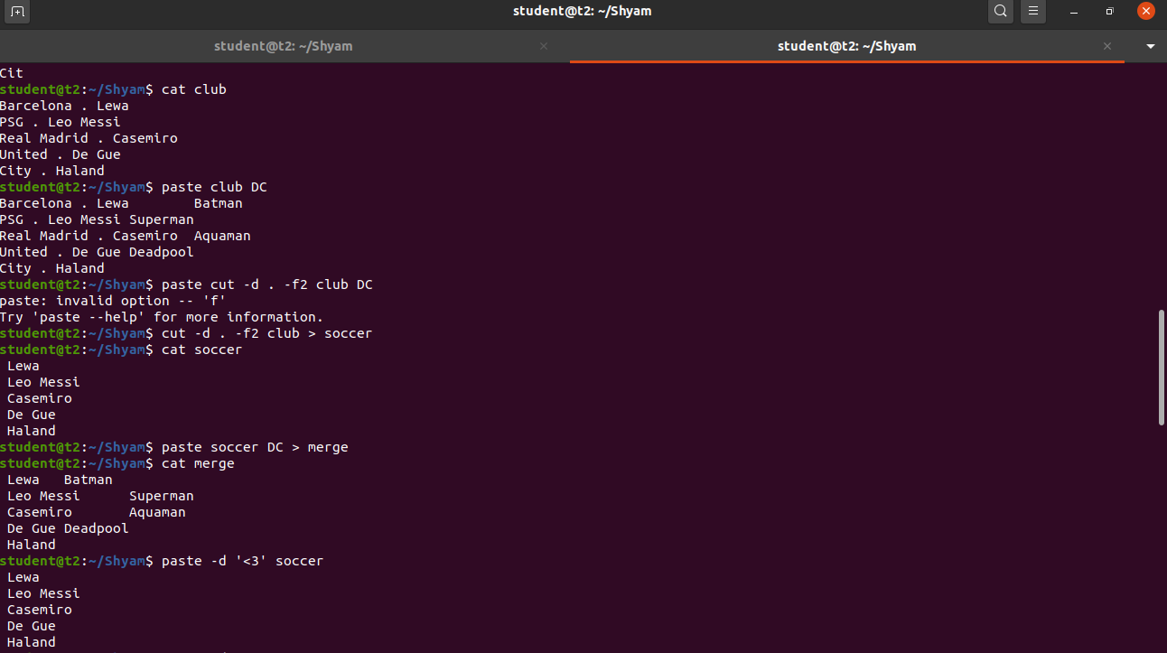

**Result**

The program was executed and the result was successfully obtained. Thus CO2 was obtained.

**Experiment No.: 5 Date: 13-03-2023**

**Aim :** Familiarisation of Linux Commands.

**CO 2:** Perform System Administration task.

**Procedure:**

1. read : read a line

$read

$ echo $REPLY

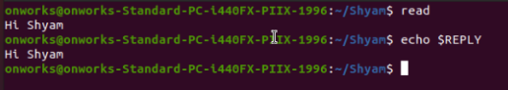

1.1. Read into variables

$ read var1 var2

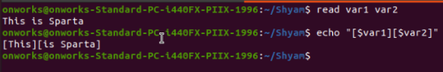

1.2 read multiple lines using backslash

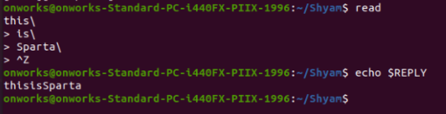

1.3 $read -p : Prompt something in the screen

$read -p “something ”

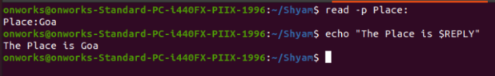

1.4 $read - n: read only a specific length of characters



1.5 $read -s : read secure data like passwords

$read -s -p “Enter password”

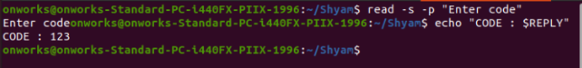

2. $wc filename: display the details of file

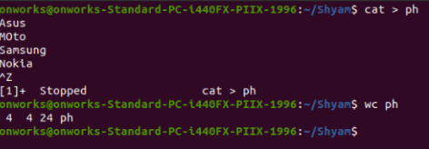

2.1 $wc -l : To display number of lines

$wc -l profile

2.2 $wc -m : To display number of bytes

$wc -m profile

2.3 $wc -c : To display number of characters

$wc -c profile

2.4 $wc -w: To display number of words

$wc -w profile

2.5 $wc -L : Length of the longest line

$wc -l profile

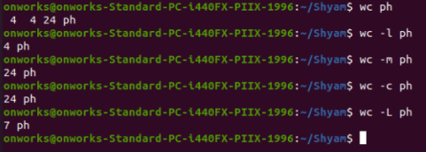

2.6 $more : command is used to view the text files in the command prompt, displaying

one screen at a time in case the file is large

$more myfile.txt

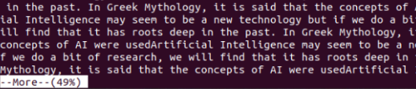

2.7 $more +/something : Search the pattern string

$more +/Deep myfile.txt



2.8 $more -d:help user to navigate , press space to continue, q to quit

$more -d myfile.txt

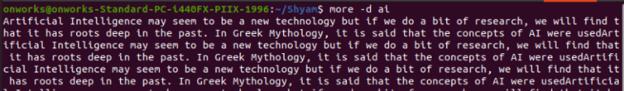

**Result**

The program was executed and the result was successfully obtained. Thus CO2 was obtained

**Experiment No.: 6 Date: 14-03-2023**

**Aim :** Familiarisation of Linux Commands.

**CO 2:** Perform System Administration task.

**Procedure:**

1. **Grep** - filter searches a file for a particular pattern of characters, and displays all lines that contain that pattern.

$grep amal hello.txt Output:

https://lh3.googleusercontent.com/oq3eCHUOW65F-Lfg_NqUC9coufjcne581oxEJPlo-n7FISpzofcoDzLlqWjEBAl5CzBurG3I-FCx5FciPVhA7dqcXpTccheuby0k7TWeAjtZNXwXgcoj_ic7toy1hjt1z4DIQnVL1_arqqzS2bOzQ-g

1. Grep -i -To perform case insensitive search

$grep -i Fluter file1 Output:

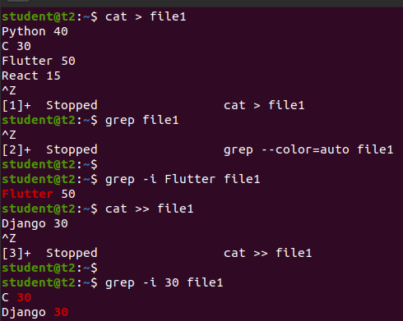

1. Grep -A1- To view the content searched along with one line after

$grep -A1 Fluter file1

Output:

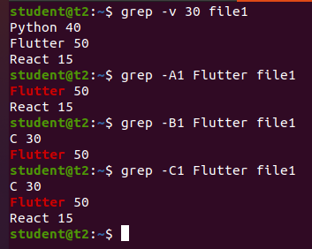

1. Grep -B1 -To view the content searched along with one line Before

$grep -B1 Fluter file1

Output:



1. Grep -C1 -To view the content searched along with one line after & Before

$grep -C1 Fluter file1

Output:



1. Head - To display the first lines of files . By default, it shows the first 10 lines

$head car

Output:

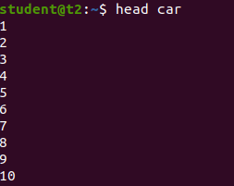

1. Head -number -To display the first n number of lines of files

$head -3 car

Output:

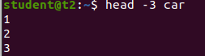

1. Tail -To display the last lines of files . By default, it shows the first 10 lines

$tail car Output:

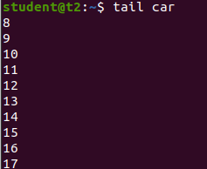

1. Tail -n - To display last n number of lines of files

$tail -3 car.txt Output:

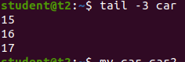

1. Mv -**mv** stands for move. **mv** is used to move one or more files or directories from one place to another

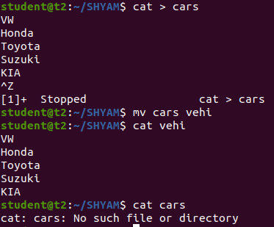

1. Mv -b -to create backup while moving file

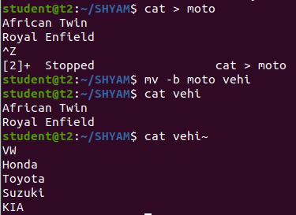

1. Mv i -to display the prompt Warning message

$mv - i ipl ipl2

Output:

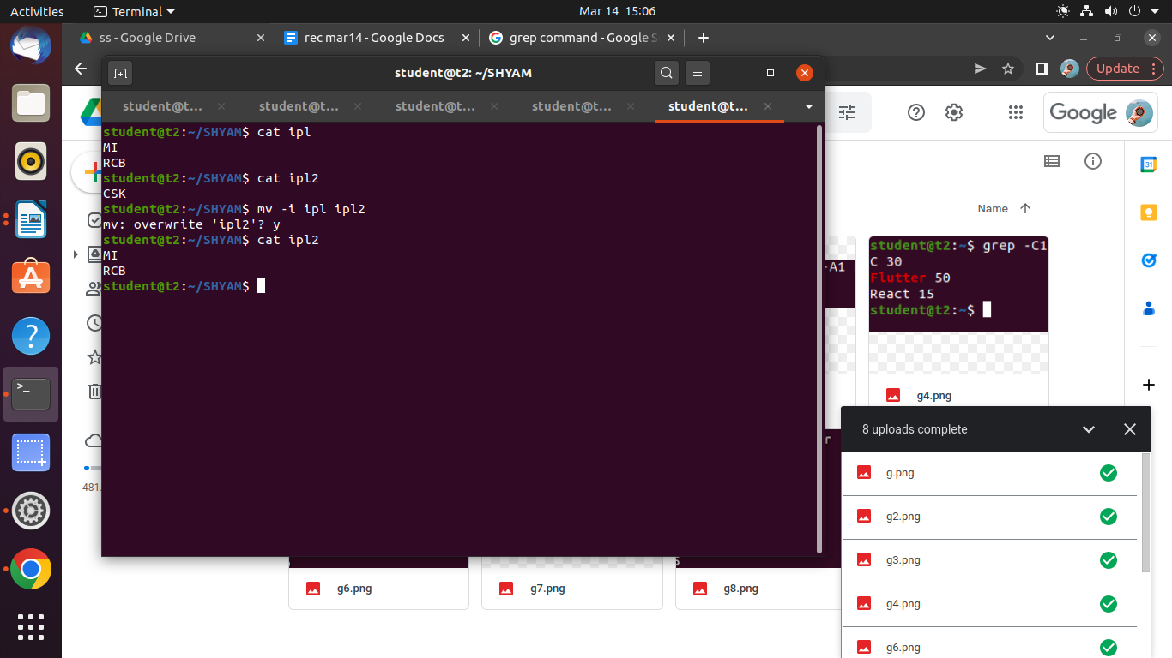

**Result**

The program was executed and the result was successfully obtained. Thus CO2 was obtained.

**Experiment No.: 7 Date: 20-03-2023**

**Aim :** Familiarisation of Linux Commands.

**CO 2:** Perform System Administration task.

**Procedure:**

1. Expr : Evaluate the given expression and display the result

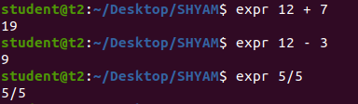

2. df : Get a report on system disk space usage

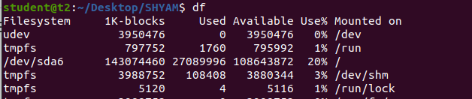

3. du : used to checks how much space a file or dir takes in the current directory

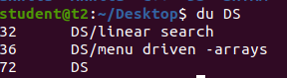

4. Create new user

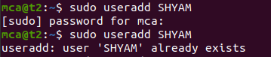

5.Change password of new user

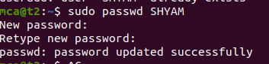

6. Group Add

sudo groupadd -g identifier - The groupadd command creates a new group account



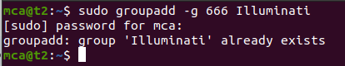

7 Sudo usermod -G : Add user to group

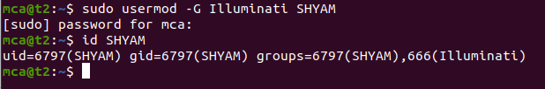

8. Compgen - To display all the groups

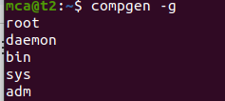

chmod : used to change the access permission of the file and directories.

It stands for change mod

Read – r

Write – w

Execute – x

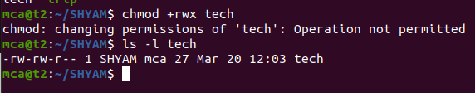

- (deny permissions)



+(allow permissions)

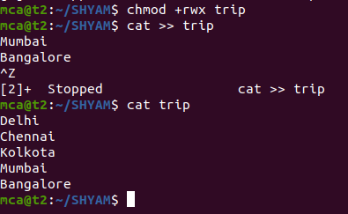

Chown : Used to change the file ownership or directory ownership for a user or group

And chown stands for change owner

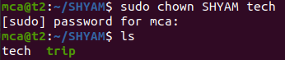

Delete user

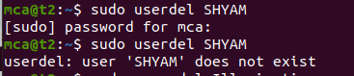

Delete group

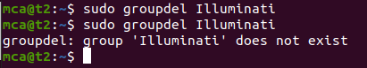

**Result**

The program was executed and the result was successfully obtained. Thus CO2 was obtained.

**Experiment No.: 8 Date: 21-03-2023**

**Aim :** Familiarisation of Linux Commands.

**CO 2:** Perform System Administration task.

**Procedure:**

$ip addr - to view the protocol address on a device.

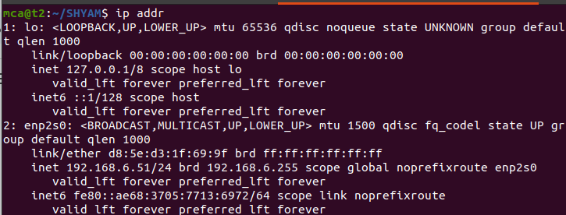

$ssh [user]@[ipaddress] - secure shell



sudo apt-get update

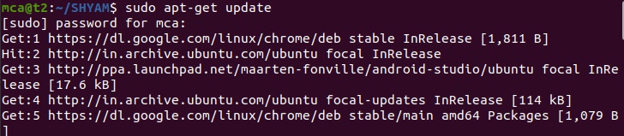

$ sudo apt-get install openssh-server

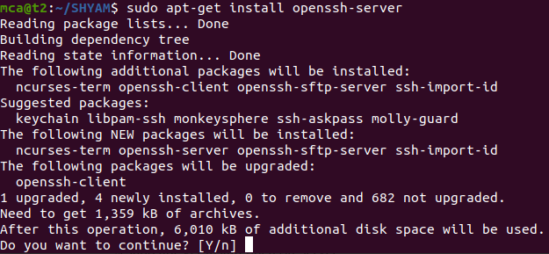

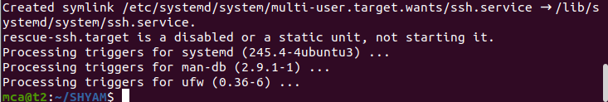

$sudo ufw allow 22

$ssh mca@[remote ip] - to connect with a remote host

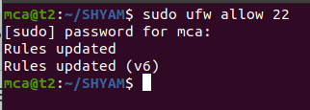

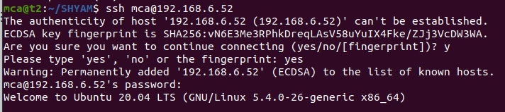

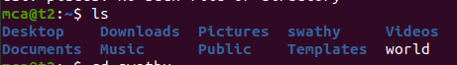

$ssh-keygen - to generate key

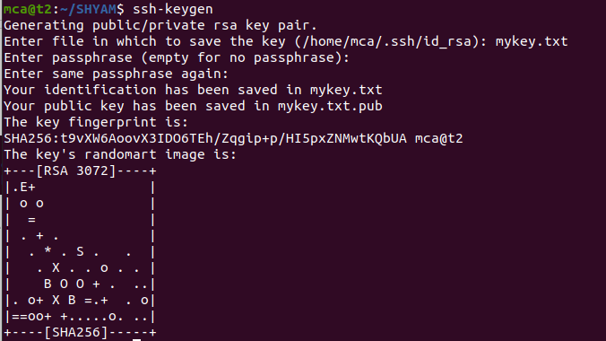

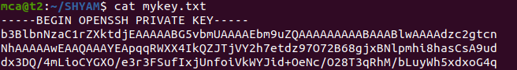

ps - report a snapshot of the current processes.

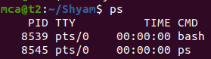

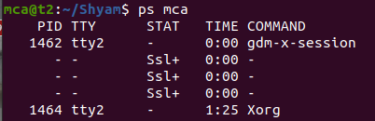

$ps -u [user] - to get info about current running applications.

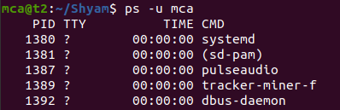

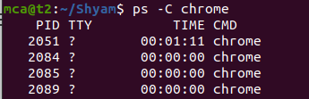

$ ps -f -p -

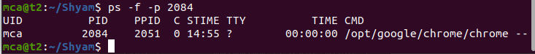

**Result**

The program was executed and the result was successfully obtained. Thus CO2 was obtained.