Go to Data Integration -> Expore -> New project
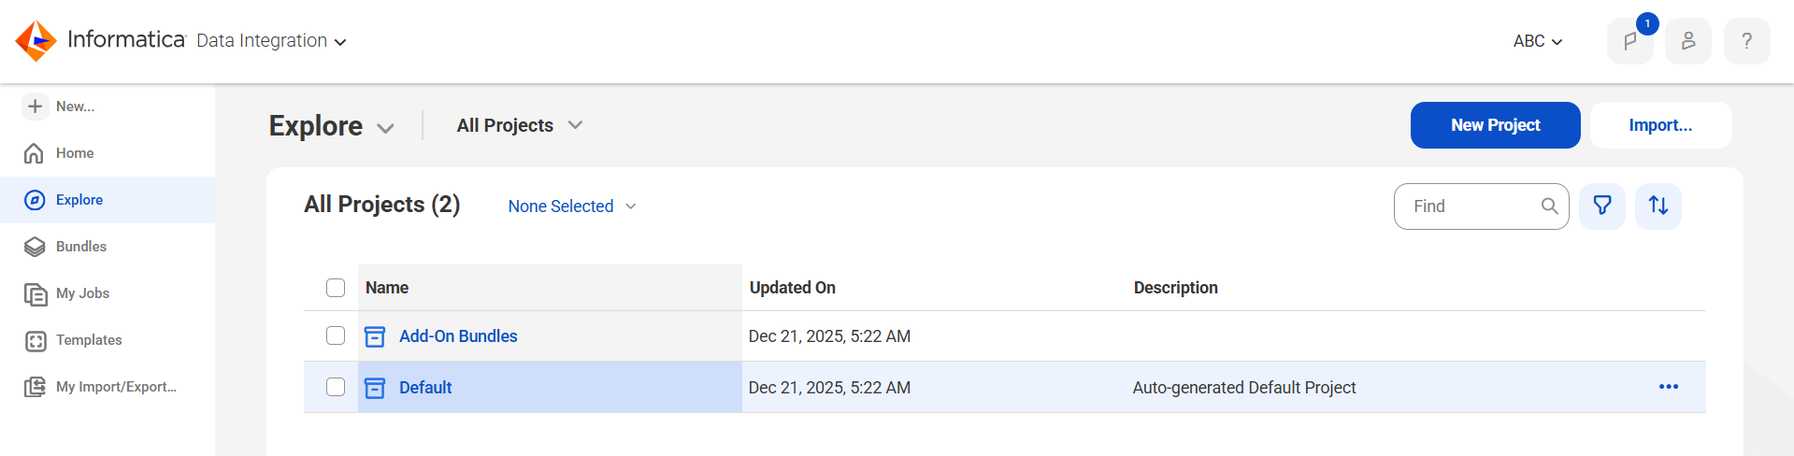
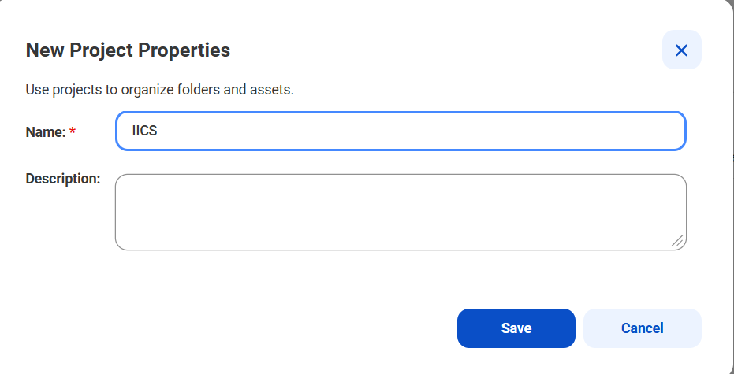
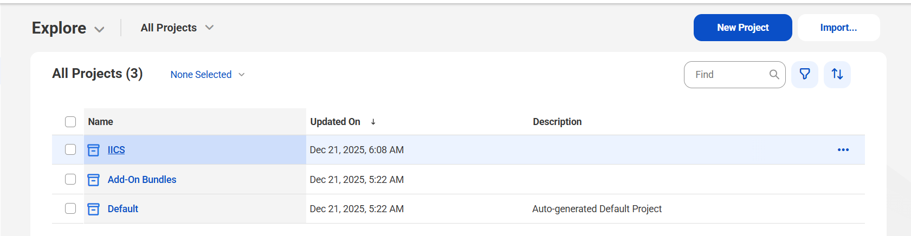

Go to IICS project and create new folder.
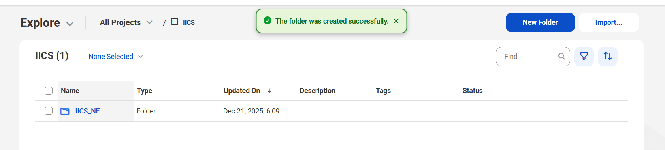

Go to IICS_NF folder -> click New -> Mappings -> mapping -> click create
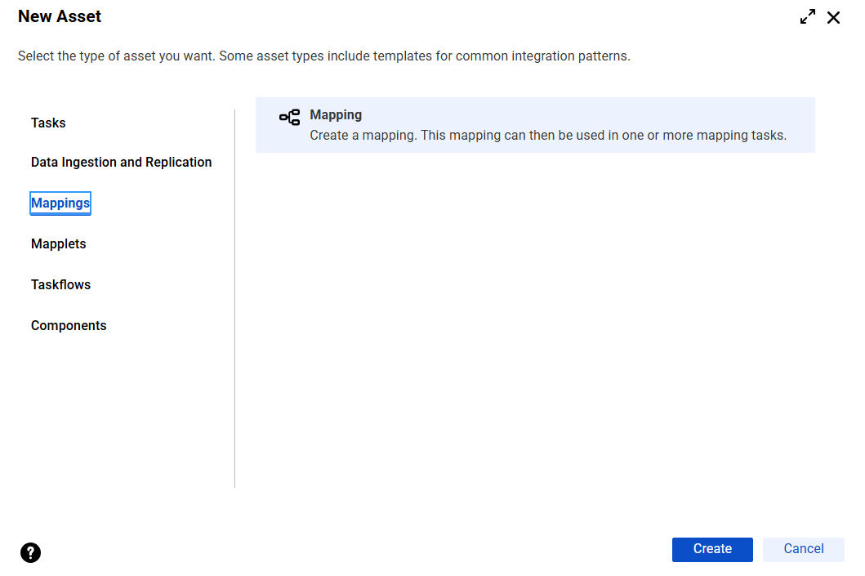

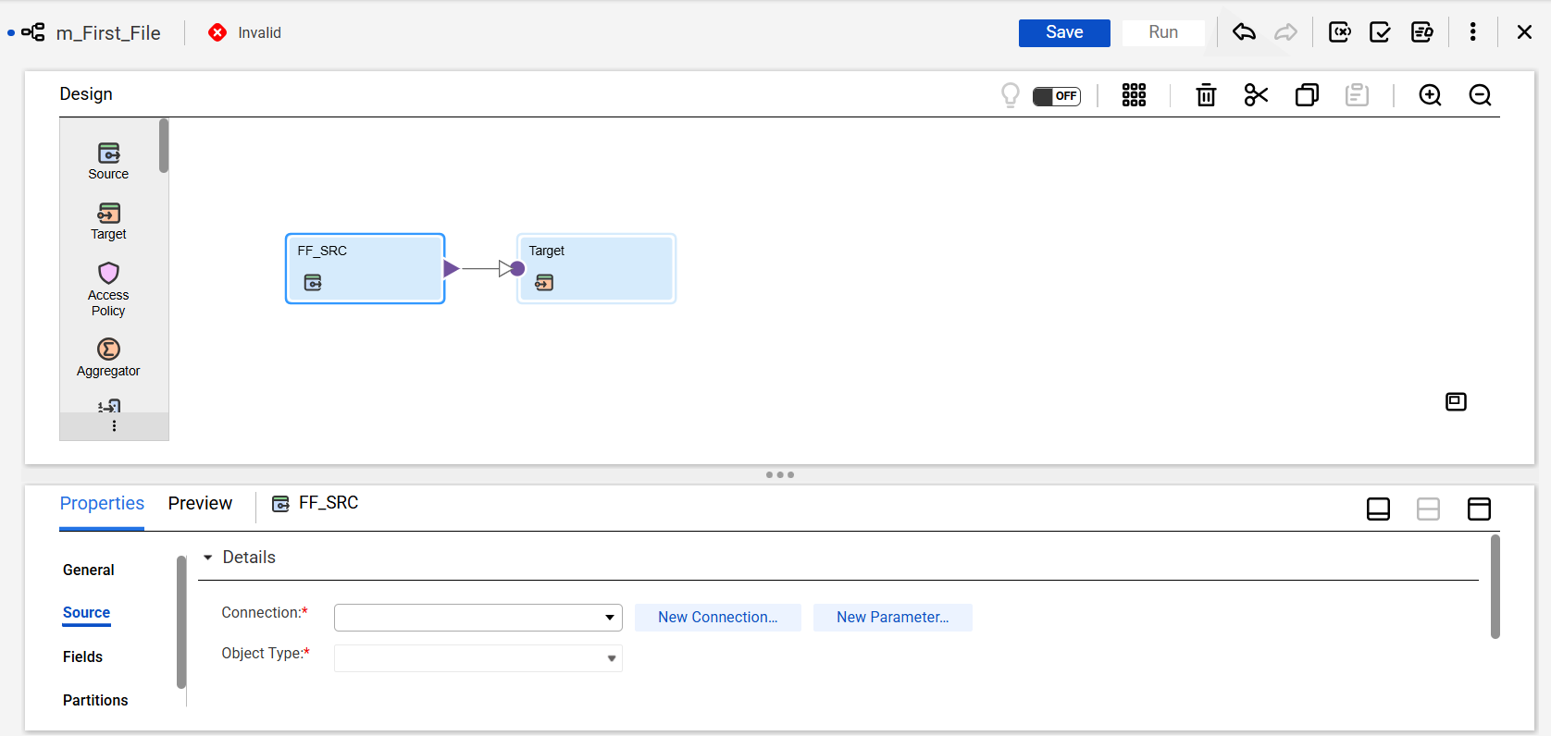

Click on New connection to create a connection for source and target.
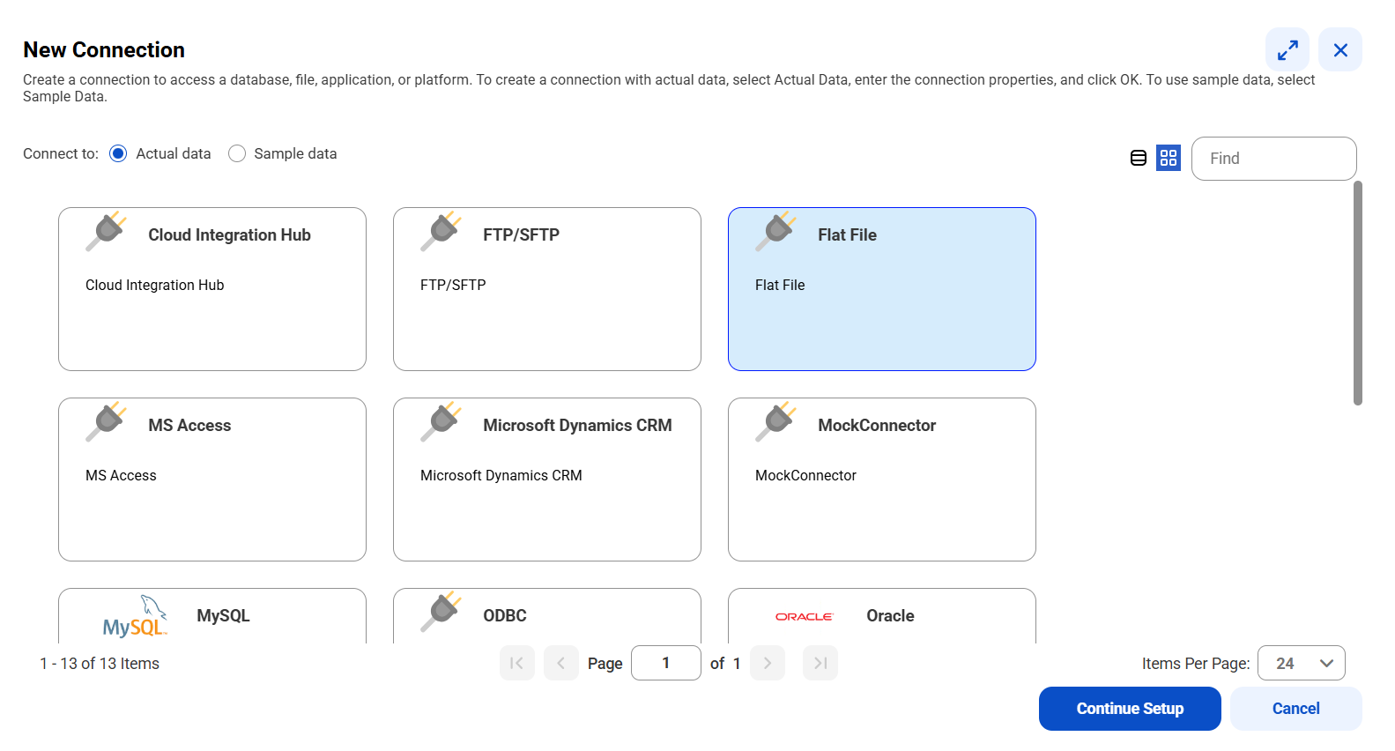

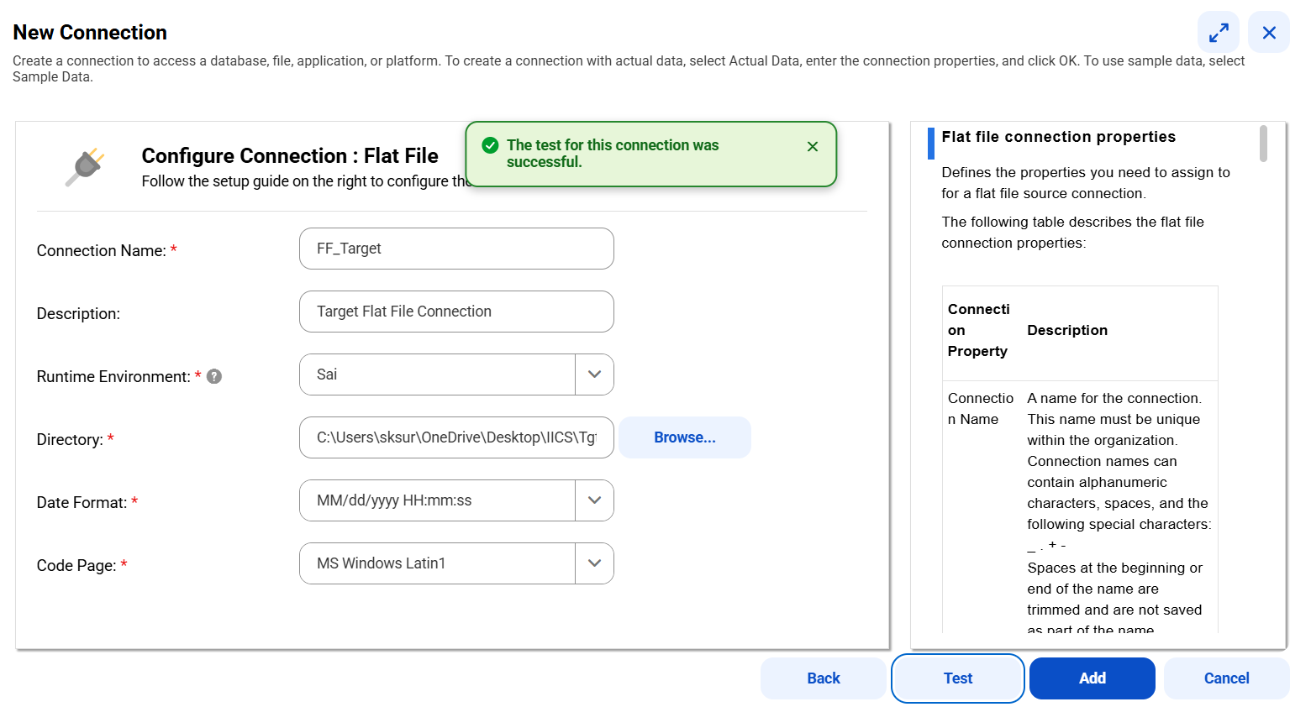

Created dummy flat file as source. 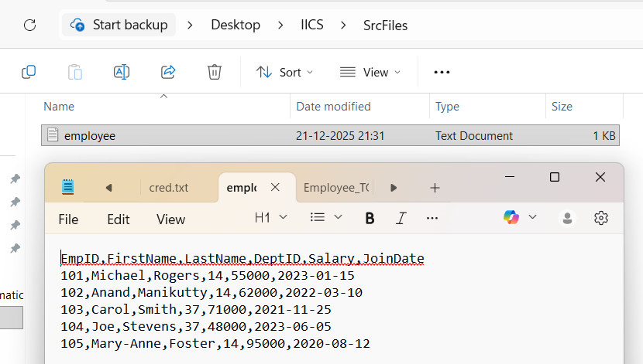

Create target flat file at runtime by
Target -> Click Select -> select “create new at runtime” -> give static file name
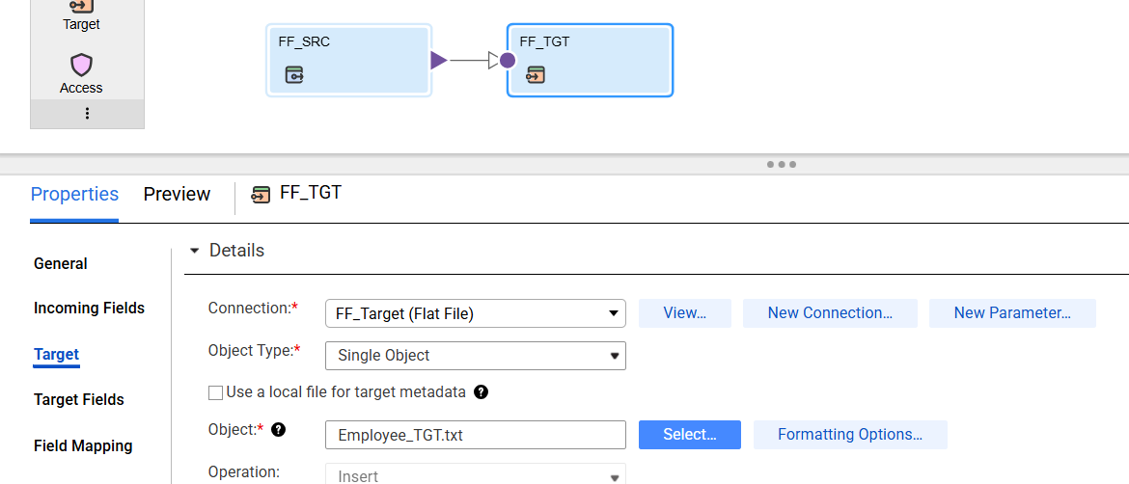

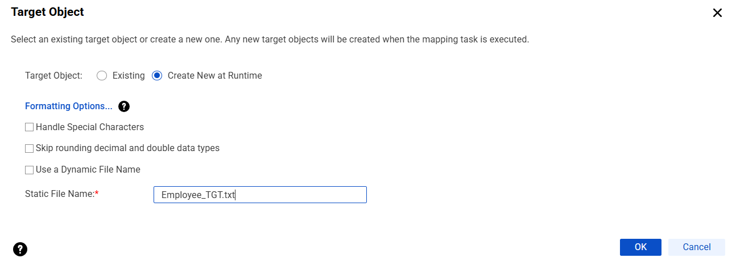
Saved the mapping and run the job.
Check the job status in my jobs.
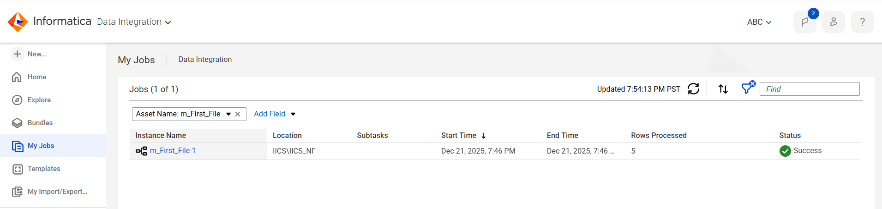
Target file is created with double quotes.
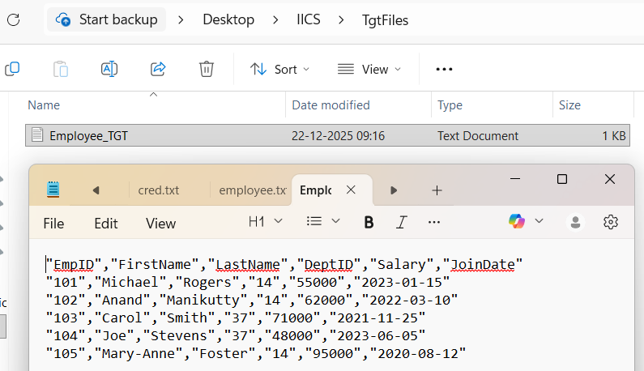

If you don’t want the double quotes remove the double quotes by
Target -> Click formating options -> select Text qualifier as None.
