Ranking in Oracle
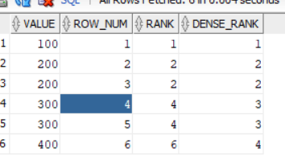
Source:
Scenario 1: Top 4 sales
Created a mapping and selected source and target.
Added rank transformation.
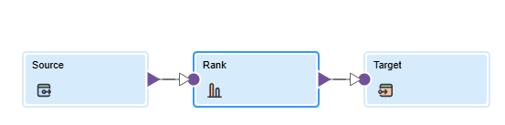
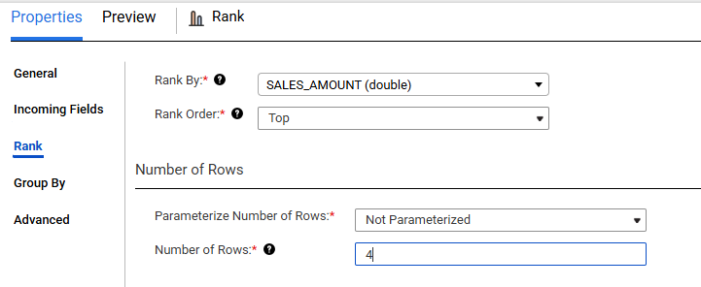

Mapped the fields in the target and ran the job.
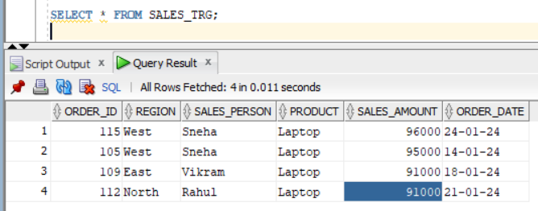’
It will load top 4 rows not top 4 sales.
Scenario 2: Highest Sale per Region
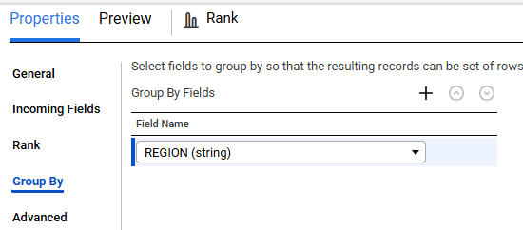
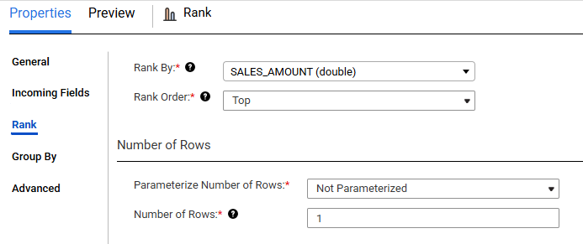
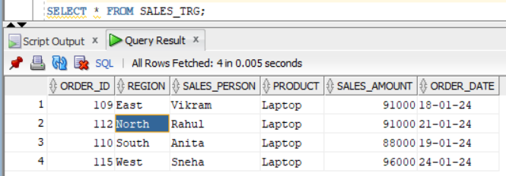

Scenario 3: Highest and lowest sales
Added one more rank transformation.
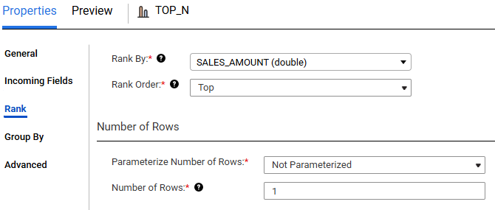
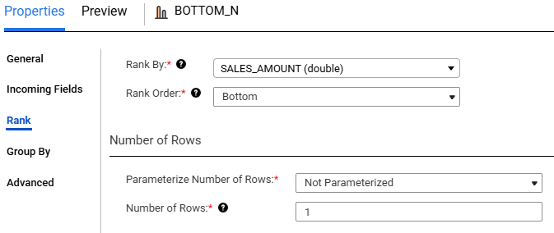

Connected both to the union transformation.
In Union field mapping selected type “Automatic”.
