Table DDL
Sources:
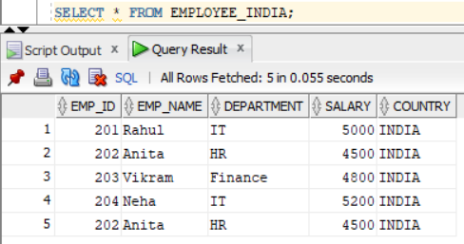
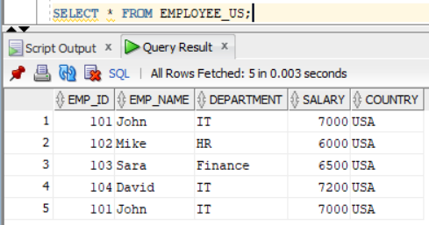
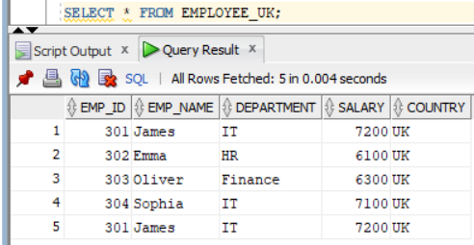
Created a mapping and created 3 source tables and connected all of them to union.
In union transformation, mapped each input group manually.
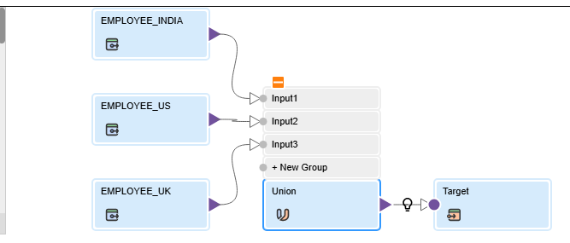
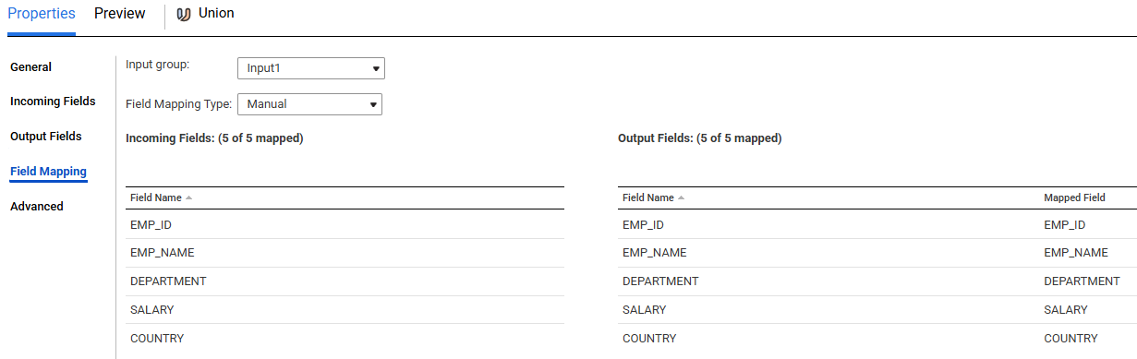
Connected union to target and mapped the fields and ran the job.
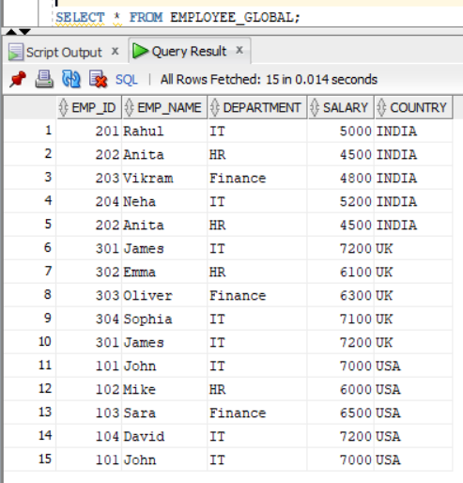

Scenario 2: Remove the duplicates
Added an aggregator transformation between union and target transformation.
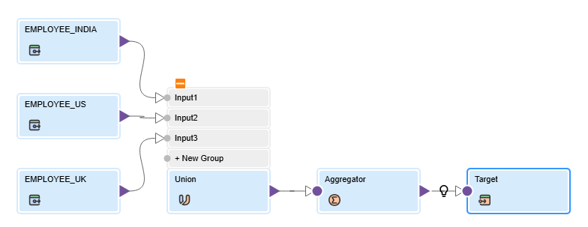
In aggregator, group by on all the fields.
