Created source and target tables.
CREATE TABLE CUSTOMER_STG (
CUST_ID NUMBER(10),
CUST_NAME VARCHAR2(50),
CITY VARCHAR2(50),
CREDIT_LIMIT NUMBER(10,2),
SIGNUP_DATE DATE
);
INSERT ALL
INTO CUSTOMER_STG VALUES (201, 'Rahul', 'Mumbai', 50000, TO_DATE('01-Jan-2020','DD-MON-YYYY'))
INTO CUSTOMER_STG VALUES (201, 'rahul', 'Mumbai', 50000, TO_DATE('01-Jan-2020','DD-MON-YYYY'))
INTO CUSTOMER_STG VALUES (201, 'Rahul', 'Mumbai', 50000, TO_DATE('01-Jan-2020','DD-MON-YYYY'))
INTO CUSTOMER_STG VALUES (202, 'Sneha', 'Delhi', 75000, TO_DATE('15-Feb-2019','DD-MON-YYYY'))
INTO CUSTOMER_STG VALUES (203, 'Arjun', 'Chennai', 60000, TO_DATE('10-Mar-2021','DD-MON-YYYY'))
INTO CUSTOMER_STG VALUES (203, 'arjun', 'Chennai', 60000, TO_DATE('10-Mar-2021','DD-MON-YYYY'))
INTO CUSTOMER_STG VALUES (204, 'Meena', 'Delhi', 45000, TO_DATE('20-Apr-2018','DD-MON-YYYY'))
INTO CUSTOMER_STG VALUES (205, 'karan', 'Mumbai', 90000, TO_DATE('05-May-2023','DD-MON-YYYY'))
INTO CUSTOMER_STG VALUES (206, 'Sneha', 'Delhi', NULL, TO_DATE('15-Feb-2019','DD-MON-YYYY'))
SELECT * FROM DUAL;
CREATE TABLE CUSTOMER_TRG (
CUST_ID NUMBER(10),
CUST_NAME VARCHAR2(50),
CITY VARCHAR2(50),
CREDIT_LIMIT NUMBER(10,2),
SIGNUP_DATE DATE
);
Scenario 1: Loading the records in descending order and treating the NULLs as low priority.
Created a dummy mapping.
Selected source, target and added sorter transformation.
Sorter properties -> sort -> selected ‘CREDIT_LIMIT’ descending.
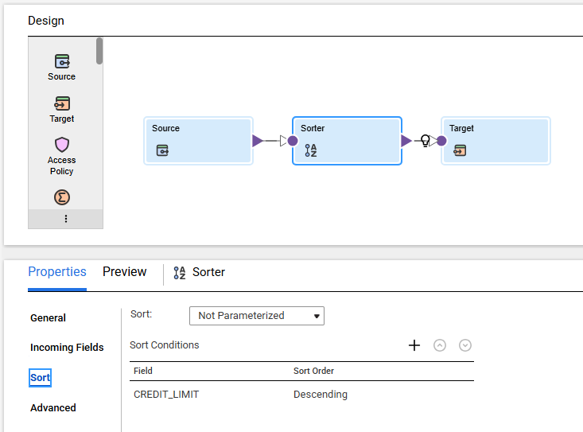
Sorter properties -> Advanced -> Checked ‘Null Treated Low’ box.
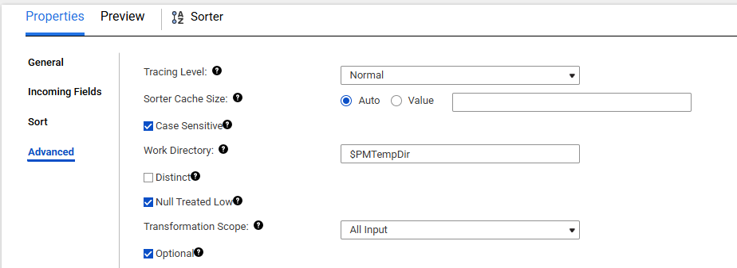

Source data:
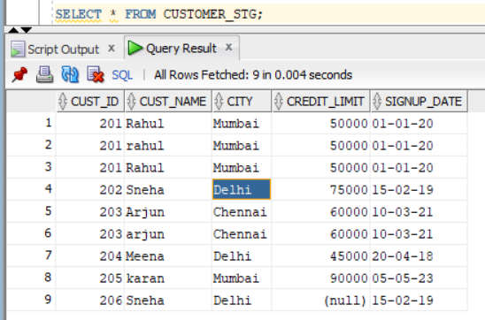

Target data:
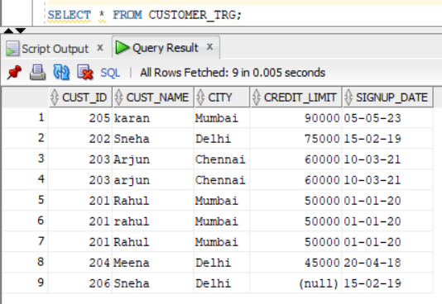

Scenario 2: Sort ascending based on CUST_NAME.
It will sort all the upper-case records first and lower case next.
Ascii values:
Upper case - 65–90
Lower case – 97-122
Numbers – 0 – 9
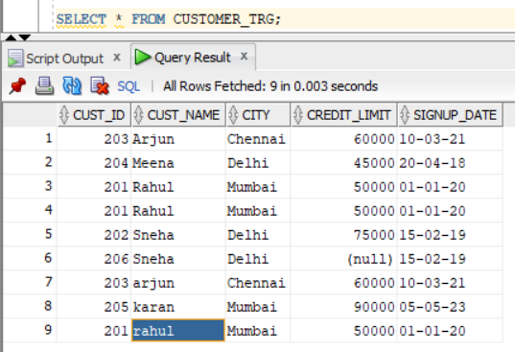

Scenario 3: Select Distinct
Sorter properties -> Advanced -> Checked ‘Distinct’ box.
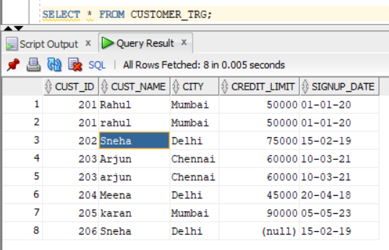
It will remove the duplicate records and also load the records in source order and ignore the sort order in sort.
To load the records in sorting order, add all the columns in sort property.
Scenario 4: Unchecked ‘Case Sensitive’ option, Added all columns in sort
