Created a dummy mapping
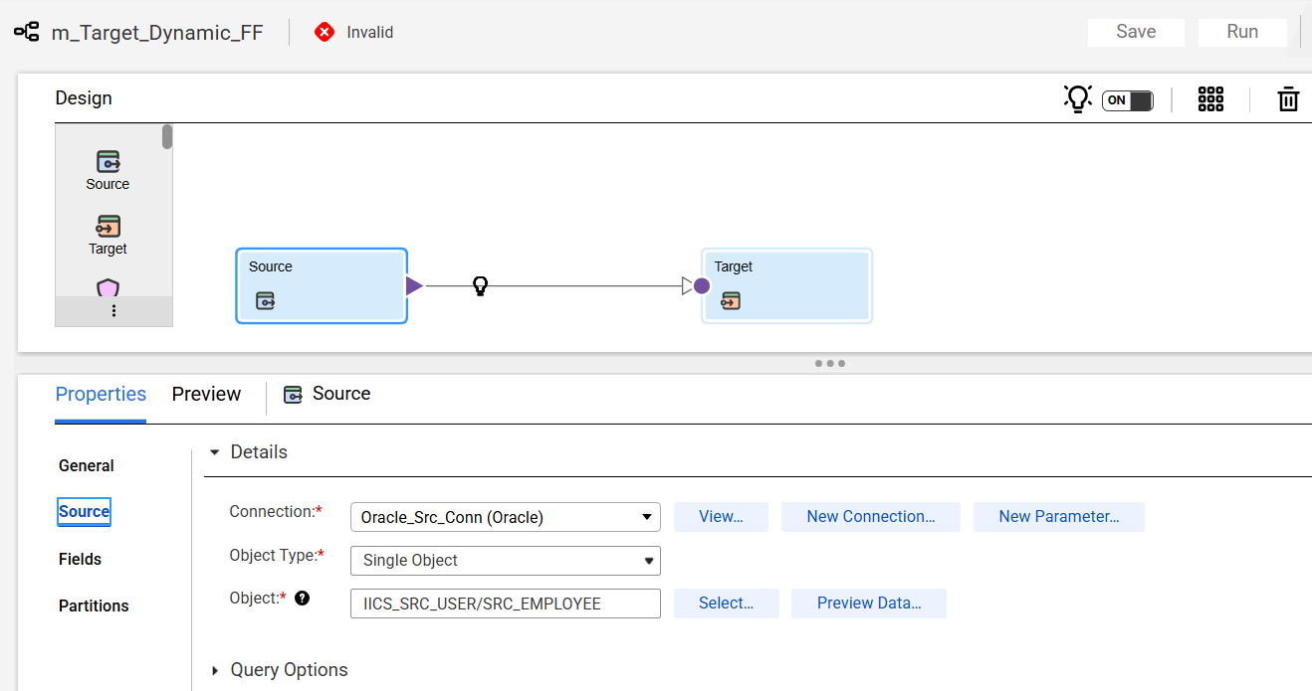
In target click on select in object.

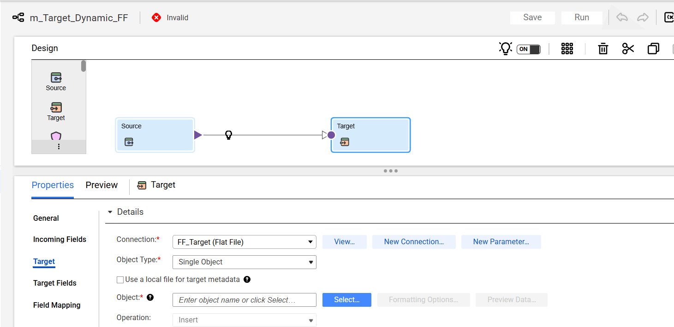
In the Options:
- Selected “Create New at Runtime”
- Checked “Use a Dynamic File name”
- Given the file format and click on validate
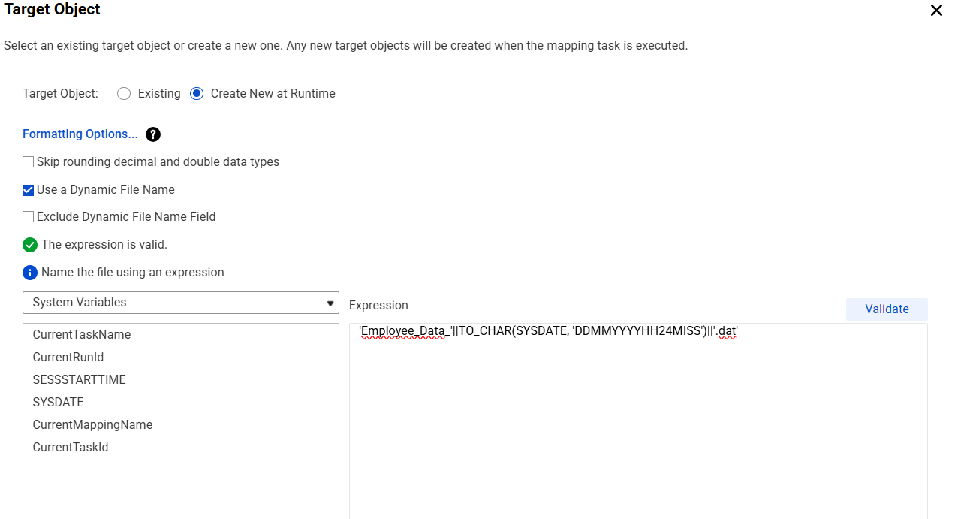
Saved the mapping and ran the job.
